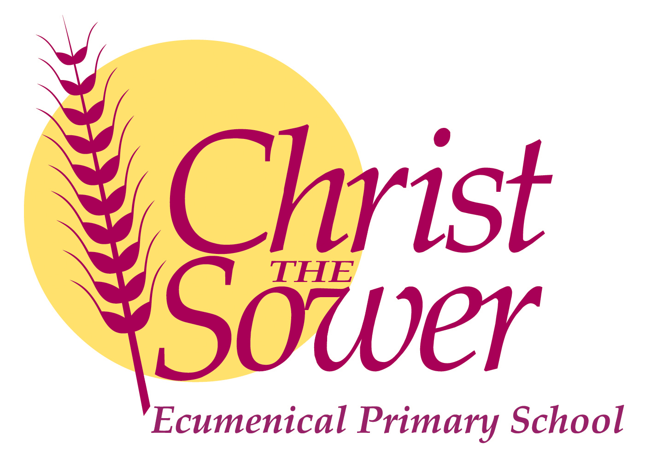

**Foundation Teacher Vacancy**

**Christ the Sower Ecumenical Primary School**

To start September 2021

MPS Full Time with a possibility to start 12th July 2021

**Closing Date: Wednesday 5th May 12.00 noon**

**Interview date: Tuesday 11th May**

We are looking to employ a Foundation class teacher to join us in our growing Foundation Stage. If you are ambitious, hardworking, vibrant, brave and resilient with a passion for teaching and developing children’s characters, then we would love to hear from you. This position would suit an early career teacher or an NQT.

We can offer teachers amazing children, engaged parents as well as high quality support and career development. We are committed to supporting you in our modern well equipped school in developing your career and ambition. We are part of the ODBST MAT, which is a growing academy trust that puts its faith into and recognises the uniqueness of all its individual schools.

So if you enjoy a challenge, are creative and fun, please get in touch to discuss your career opportunities here with us. Applicants are invited from all faiths and none. Visits to the school are encouraged.

For an application pack please contact Christine Smith [csmith@ctsmk.org.uk](mailto:csmith@ctsmk.org.uk) or on 01908 867356 or visit our website [www.ctsmk.org.uk](http://www.ctsmk.org.uk).

*Our school is committed to the safeguarding and welfare of our children. All appointments will be subject to full DBS Disclosure.*