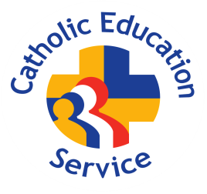
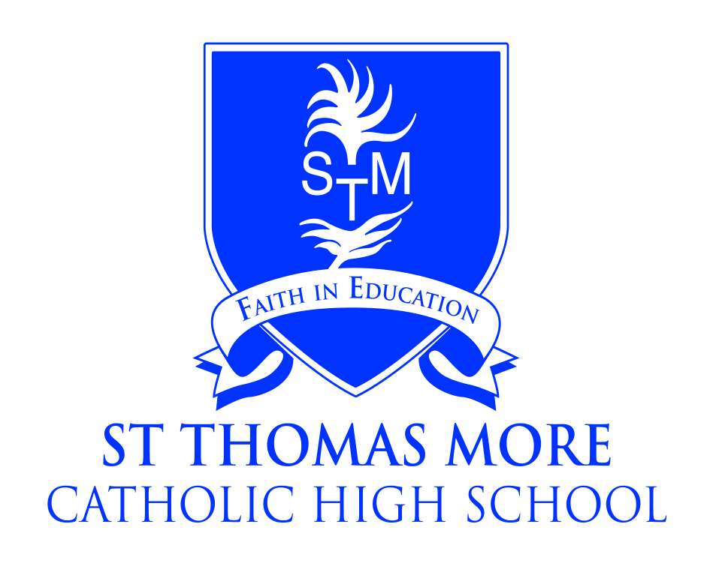

St Thomas More Catholic High School, Crewe
A Catholic Voluntary Academy

Teacher of French
Full Time Maternity Cover

Salary: Teachers Pay Scale
Required: March 2025

The Governors of St Thomas More Catholic High School are seeking to appoint a good honours graduate to teach French to the full ability range in Years 7-11.

Languages is an important subject at Key Stage 3 and all pupils have to choose a language at Key Stage 4 which they take to GCSE level. The successful applicant will be passionate about the subject, be well organised and willing to go the “extra mile” to ensure pupils achieve. This is an exciting opportunity for an inspiring teacher to contribute further to an already successful team and build on the high standards and encourage students across the age and ability range.

We are a friendly and caring community placing the academic progress and welfare of our students at the heart of everything we do.

Applications from newly-qualified and experienced teachers are welcomed.

Further details and recruitment documents are available from the school website:
www.st-thomasmore.cheshire.sch.uk

or by e-mailing:
recruitment@st-thomasmore.cheshire.sch.uk

Closing date: Friday 17th January 2025 at 12pm

Please send completed applications to recruitment@st-thomasmore.cheshire.sch.uk
Please do not apply online or download Cheshire East’s Application Form.

The academy is committed to safeguarding children and successful candidates will be subject to an Enhanced DBS check. Our commitment to safeguarding is underpinned by robust processes and checks which are in place.

