Exton and Greetham CE Primary School
part of
The Rutland Learning Trust

Required for September 2021 -
Full-time Class Teacher MPS
(temporary for 1 year)
The role would be suitable for NQTs and applications from NQT candidates would be welcomed.

We are looking for an enthusiastic, passionate, creative, and dynamic newly qualified teacher to join our happy, caring school family as it grows in size.

We can provide an exciting opportunity to work in a supportive atmosphere as part of an innovative and friendly staff team. The successful candidate would be joining our team at a very exciting time in our development.

Closing date: Friday 23rd April 2021at noon.
Interviews to be held in the week commencing 26th April 2021

To arrange a visit, request an application pack, or for more details, please contact the school office.
Application packs are also available at www.extonschool.co.uk where you can also find out more about our school.

Contact details: Mrs Lynn Almond
Exton and Greetham CE Primary School

Website: www.extonschool.co.uk Tel: 01572 812380 Email: extonoffice@rltschools.com

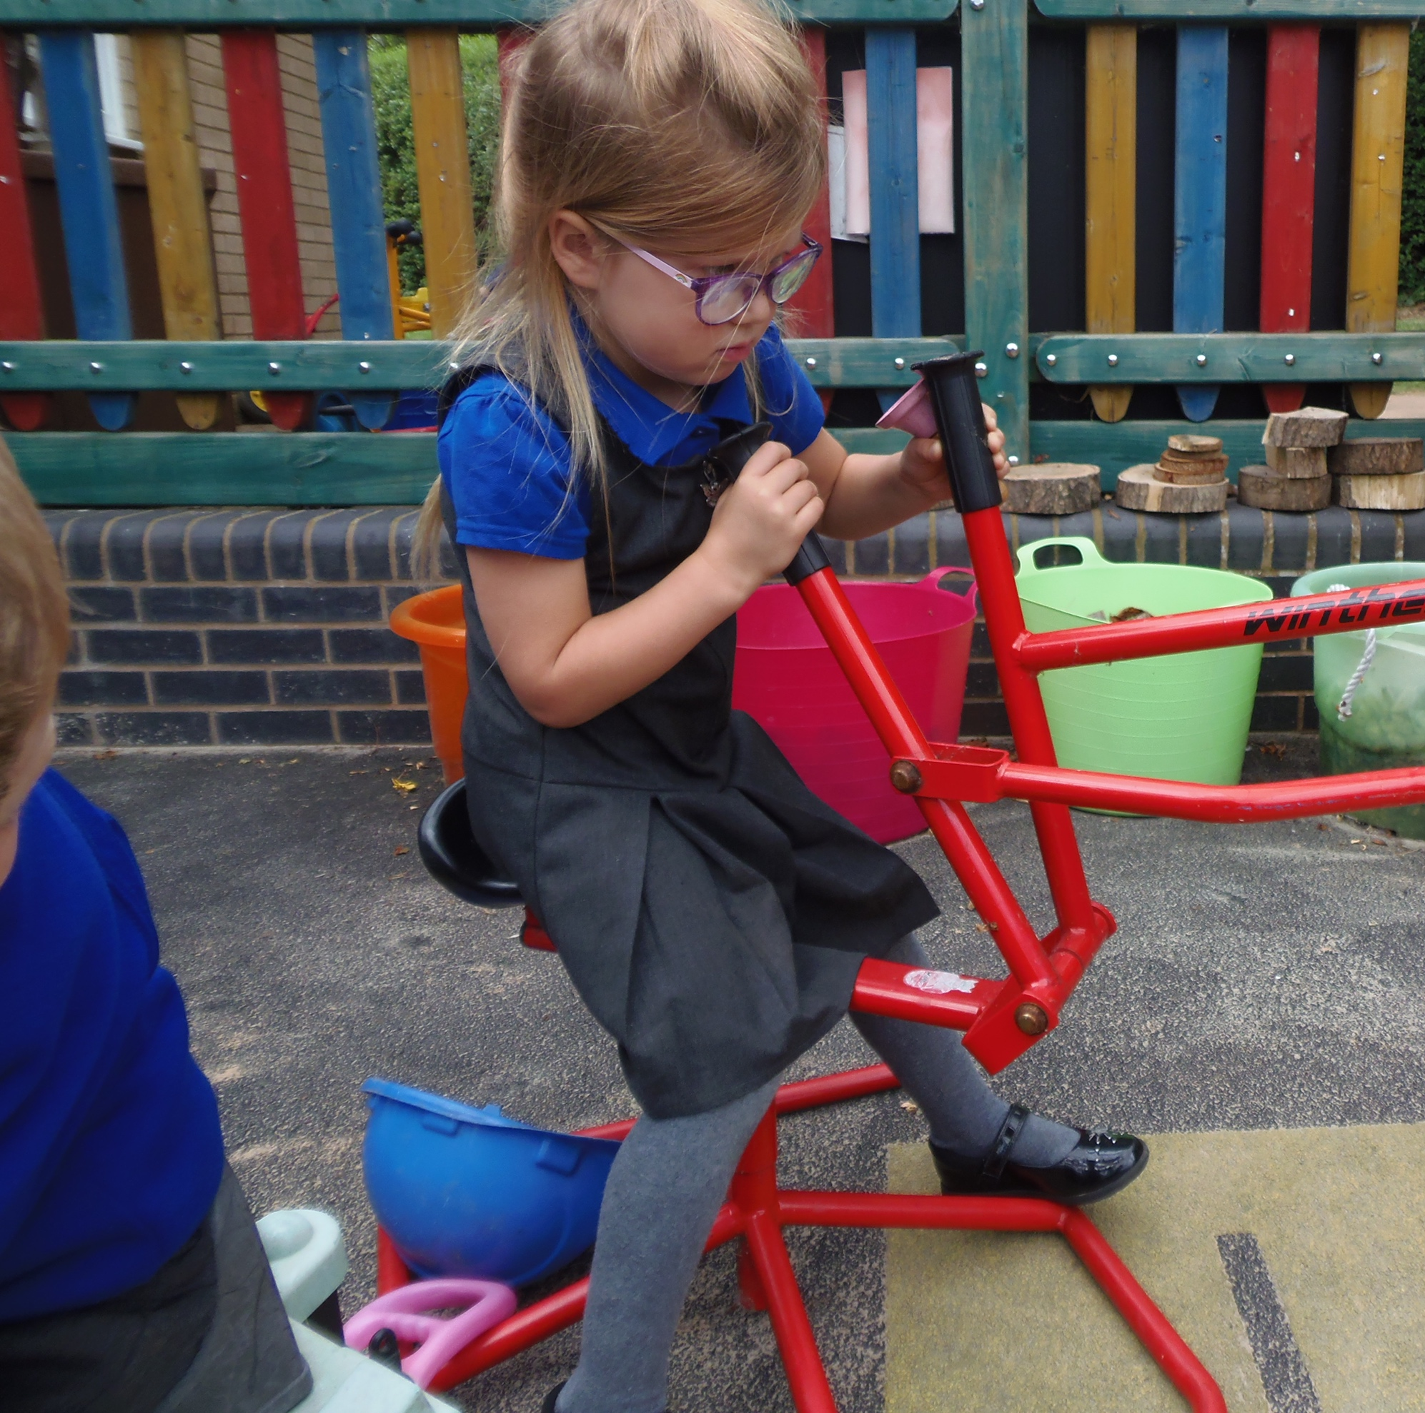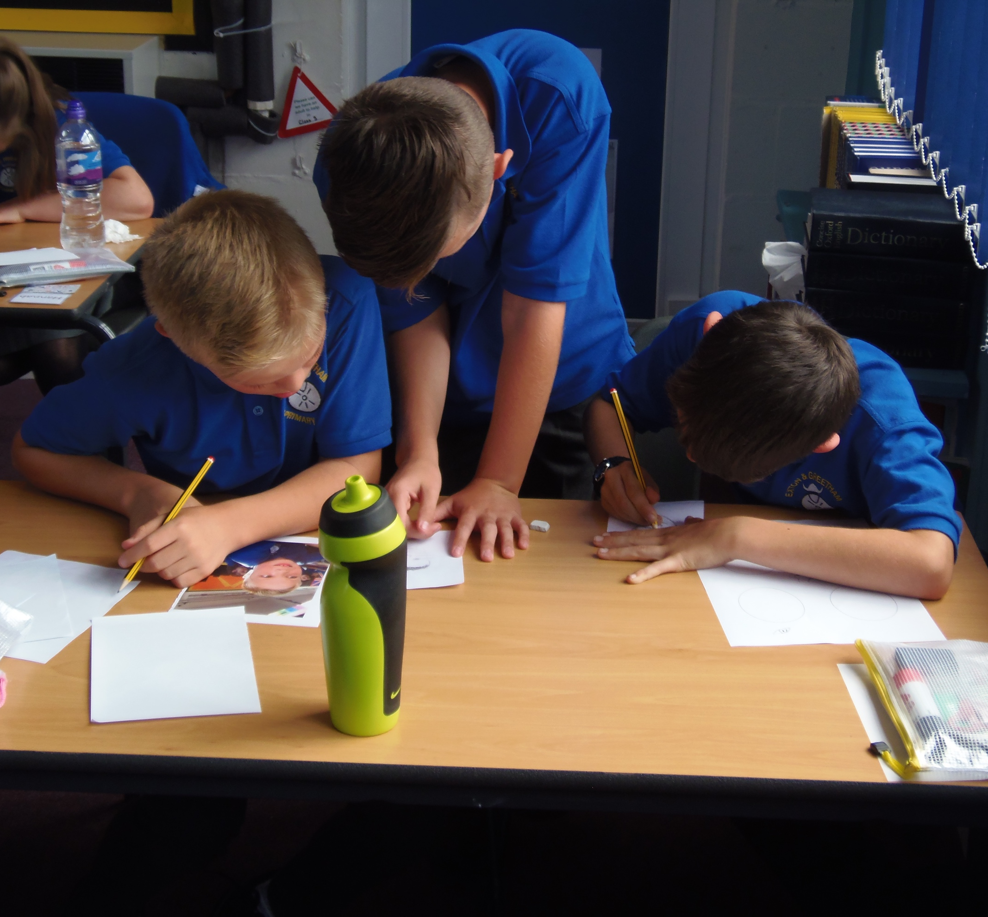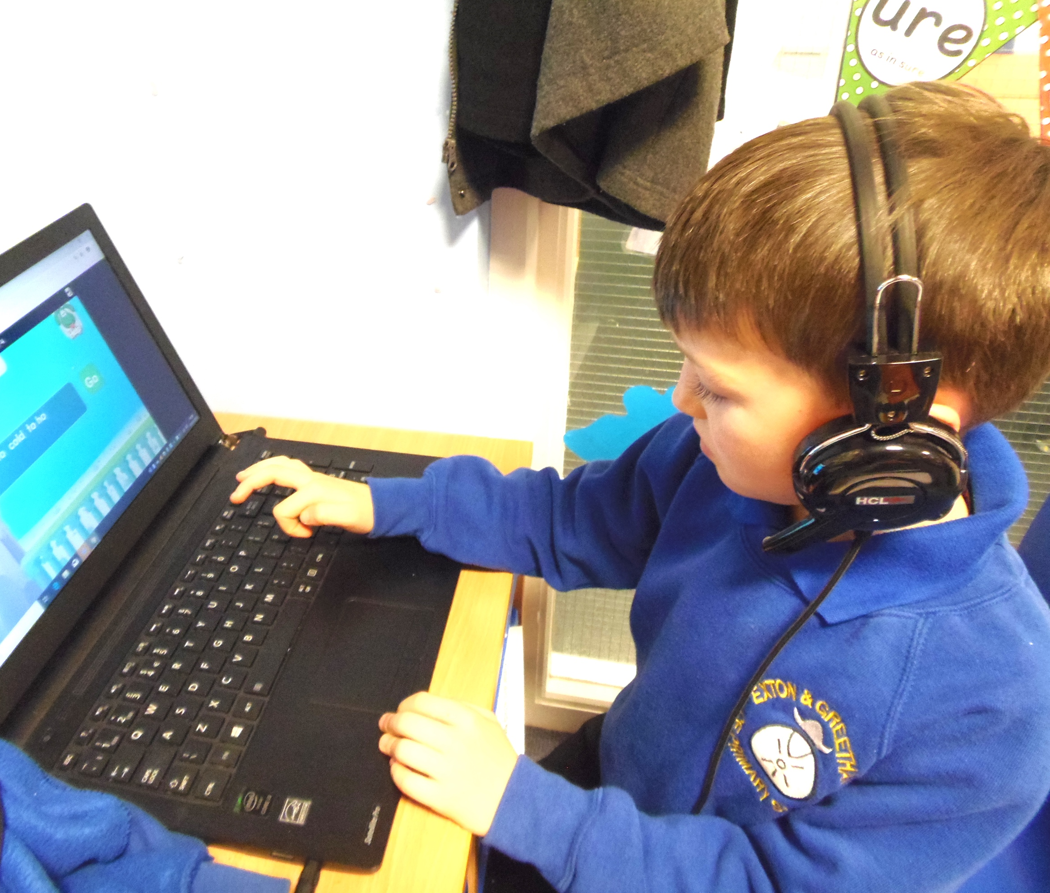

Our school is committed to safeguarding and promoting the welfare of children and young people and therefore the applicant will be subject to an enhanced DBS Disclosure Check.

