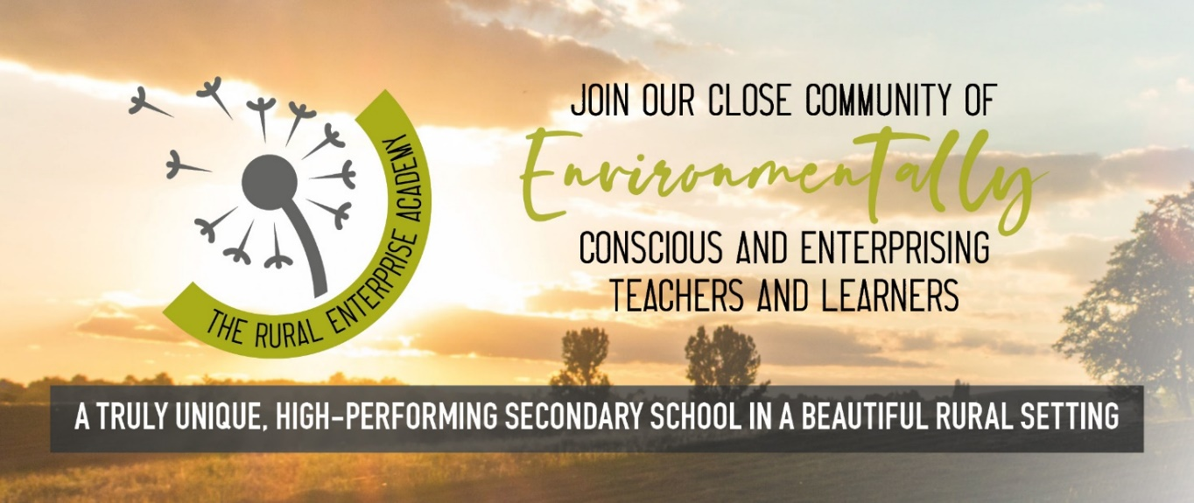

Welcome
Thank you for your interest in The Rural Enterprise Academy. We are a truly unique secondary school rooted in a safe rural setting just south of Penkridge, Staffordshire. We engage in a full and challenging environmentally-focussed curriculum across Key Stages 3 and 4.

What we can offer you
The Rural Enterprise Academy is a truly unique secondary school with a huge amount to offer staff and students alike. By joining us you will benefit from:
- Becoming part of our close team of around 20 teaching and learning experts
- A tremendous breadth of opportunities to develop your career and take ownership of whole-school initiatives
- Developing strong relationships with our small cohorts of students
- Specialist training in Visible Learning
- A chance to teach in a genuinely different secondary school
- A vibrant teaching environment with access to excellent learning facilities inside and outside the classroom
- Working with young people who care passionately about the environment

More about our school
Our learners study a broad and balanced curriculum, based upon the national curriculum, but with a specific environmental focus throughout. They are able to study through a blend of indoor and outdoor learning across our specialist campus with access to fantastic facilities such as a fishery, horticulture facilities and equine centre – all housed at South Staffordshire College with whom we share our beautiful, peaceful site. We offer a wide range of qualifications at BTEC and GSCE backed up by a comprehensive careers guidance, enrichment and educational visits programme.
The Rural Enterprise Academy is a small school with only two classes of 30 students per year from Year 7 to Year 11. All students and staff know each other and as such we attract many students who thrive in a quieter, smaller environment than the usual hustle and bustle of a large secondary school. We form a close community of like-minded teachers and learners and together are able to achieve fantastic results.
We are a committed Visible Learning school, and as part of Penk Valley Academy Trust, collaborate closely with schools in our local area, specifically with feeder schools and with Wolgarston High School. All staff in the trust receive top-class Visible Learning training and are given the tools they need to become expert teachers with an excellent work-life balance. You can find out more about Penk Valley Academy Trust and Visible Learning at www.penkvalley.co.uk

See for yourself
As The Rural Enterprise Academy is such a unique school we are looking for unique staff to join us. Our staff love working here, with many staff having been with us since we opened nearly a decade ago.
We recognise that a school like ours has to be the right fit – for parents, for students and for staff – and that’s why we always ask for prospective applicants to visit us and see the school in person. We are open for visits every day of the week 9am-5pm, so please get in touch today and book your visit by calling 01785 333360 or emailing enquiries@ruralenterpriseacademy.com

I look forward to receiving your application to join us at The Rural Enterprise Academy.
Alice Corrigan
Principal, The Rural Enterprise Academy

