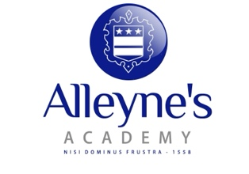

Faculty of Business and ICT

We are an extremely successful faculty with a consistent record of very good results, with an increased number of students opting for our wide variety of courses, year on year.

The ICT and Business Faculty currently offers the following courses:

ICT | Business
- Tech Award Digital IT | - Technical Award in Enterprise
- BTEC National IT | - GCSE Business Studies
- GCSE Computer Science | - A Level Business Studies
- A Level Computer Science | - BTEC National Business

We also offer the Young Enterprise scheme to Year 12 students. Our teams have been incredibly successful in recent years, with three teams reaching the national finals. We also take part in the Cyber Discovery competition with our IT and Computer Science students which has again been proven to be a very successful extra curricular activity.

We utilise examples from organisations and make visits where possible, such as to Drayton Manor with Year 10 and Paris and New York with Year 12 Business.

The Faculty is responsible for the effective delivery of our work experience programmes for both Key Stage 4 and 5.

