
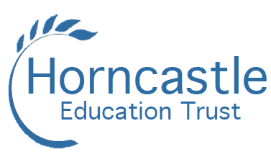
BANOVALLUM SCHOOL

FULL-TIME TEACHER OF MATHEMATICS
MPS

Required for 1 September 2023 a well-qualified and enthusiastic teacher with the
highest aspirations for the students in their care to teach Mathematics at Banovallum
School, Horncastle. Applicants should be able to teach the full range of abilities and
ages in an 11 – 16 setting.

Applications from ECTs or from more experienced teachers are welcome. The school has well established induction arrangements.

The successful candidates will be expected to:
- aspire to be outstanding in their classroom practice;
- have excellent communication skills, be able to articulate her/his expectations;
- have flexibility and an abundance of energy.

An information pack is available from the school and can be downloaded from www.horncastleeducationtrust.org. Send your completed form along with a covering letter telling us about your experience and the skills you could bring to our trust. Applications can be made in writing or by email to admin@banovallumschool.co.uk

The closing date is Tuesday 20 June 2023

About us…
Horncastle Education Trust comprises five local schools; Banovallum School, Frithville Primary School, New York Primary School, Huttoft Primary & Nursery School and Queen Elizabeth's Grammar School. The Trust was formed from a genuine desire to work more closely together following the success of existing partnership work between the schools. Having both secondary and primary schools that are geographically close is something we take a pride in as a Trust.

We believe that every student whatever their background has the right to flourish, to achieve and to succeed and everything undertaken by Horncastle Education Trust should have this ambition at its heart.

The Trust is committed to safeguarding and promoting the welfare of children and young people and expects all staff and volunteers to share this commitment. The post is subject to enhanced DBS disclosure, medical and reference checks and all pre-employment checks are in line with ‘Keeping Children Safe in Education’.

We are committed to promoting equality, diversity and inclusion within our recruitment process.

Banovallum School
Boston Road, Horncastle, Lincolnshire LN9 6DA
Tel: 01507 522232 www.banovallumschool.co.uk

