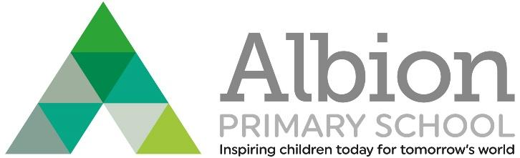

Albion Primary School
Albion Street,
London SE16 7JD
Tel: 020 7237 3738
Headteacher Karl Bardouille
finance@albion.southwark.sch.uk
www.albionprimaryschool.co.uk
@AlbionPrimary
GENERAL ADMIN OFFICER
FULL TIME
NJC Grade 4, P4 – P9 - £23,421 - £25,602 FTE
(pro rata - £21,655 - £23,672)
PERMENANT CONTRACT
TERM TIME + 3 WEEKS

We are offering an exciting opportunity for a highly organised and motivated individual with the passion and commitment to build on the impressive achievements of our school and act as a driver for further improvement. The Post is of a permanent contract to start as soon as possible and will be an interesting, varied and an exciting working in vibrant and busy school office, your role will be working on the main reception, being the first and main point of contact for parents and visitors, supporting families and building strong and relationships with stakeholders at all levels to provide an outstanding administrative service. You will support Senior Leaders with work being carried out as well as with the day to day and cyclic duties ensuring the smooth running of the school office.

The successful candidate will be highly organised with a high attention to detail, be able to manage a varied workload and act on initiative, with strong verbal and written communication skills. Experience of working within school environment or office based role is essential.

We offer:
- Well behaved children who have a love of learning at our school
- A friendly and supportive team with high morale who all champion children’s well-being
- Specialist teachers/tutors eg. Dance, Music and PE, reducing teacher planning and assessment
- A very well resources and attractive environment
- Exceptional CPD opportunities through our tailored programme
- Skilled teaching assistant support in each class
- A strong ethos of high expectations and challenge for the whole community
- Excellent professional development and career enhancement opportunities
- Excellent induction and a support programme for all staff new to the school
- A chance to work in a diverse, inclusive and vibrant community with excellent transport links
Albion Primary School, Albion Street, London SE16 7JD | 020 7237 3738 | www.albionprimaryschool.co.uk

“Albion Primary School provides an outstanding quality of education and serves its local community exceptionally well.” Ofsted 2011

Visits are warmly welcome. This is an exciting time to join our school. If this role sounds like the job for you and if you would like any more information, please do not hesitate to contact our School Business Manager, Aurelia Redmond – finance@albion.southwark.sch.uk , or arrange an informal telephone conversation (02072373738) ahead of making your application.

Closing date: Friday 16th September 2022
Interviews: Tuesday 27th September 2022

Application packs are available to download from this advert, by email or from our website.
CVs will not be accepted.

The school is registered in accordance with the General Data Protection Regulation (GDPR) and the Data Protection Act 2018 (DPA 2018) as currently set out in the Data Protection Bill. The school is required to share some data with the Local Authority the DfE.

Albion Primary School, Albion Street, London SE16 7JD | 020 7237 3738 | www.albionprimaryschool.co.uk

Albion Primary School is committed to safeguarding and promoting the welfare and well-being of young people and expects all staff and volunteers to share this commitment.
Albion Primary School is a Safeguarding school. The successful applicant will be subject to appropriate checks and undertake an enhanced DBS and where appropriate to the post, a requirement to complete a Childcare Disqualification declaration.
Applicants will be considered on the basis of suitability regardless of sex, race, marital status or disability. Disabled applicants who meet the essential criteria will be interviewed.

