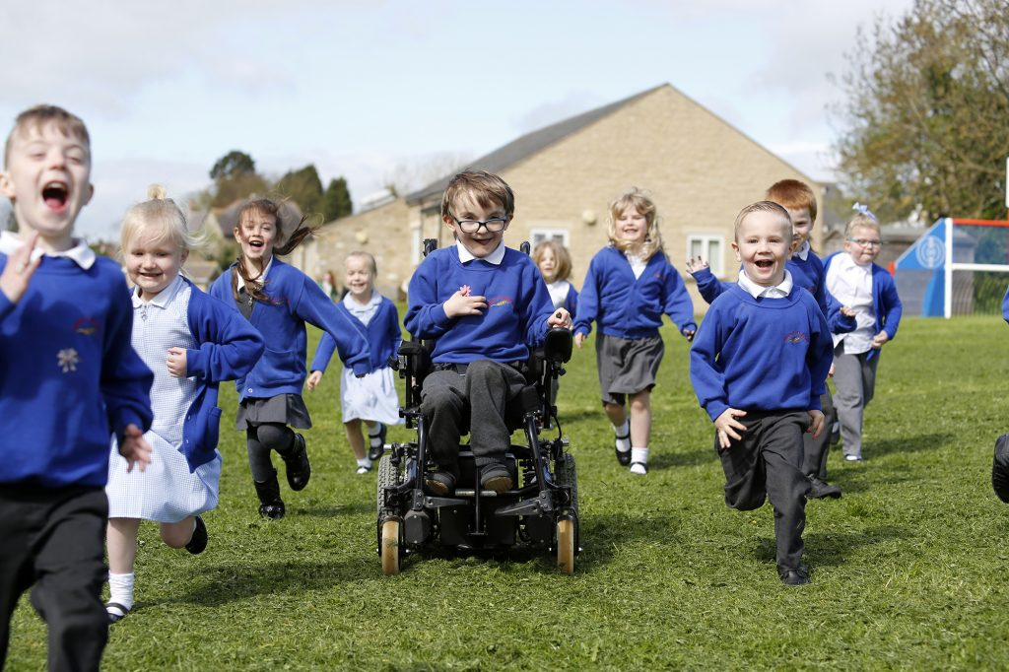

Barton Church of England Primary School
General Teaching Assistant 1:1 support
Part time 17.5 hpw initially
Candidate Information Pack
Closing date: 8am Monday 18th October
Short Listing: Monday 18th^{th} October
Interviews: Thursday 21st October

Welcome to
Dales Academies Trust, North Yorkshire

Dear candidate
Thank you for taking your time to download our application pack and expressing your interest in the position of General Teaching Assistant at Barton Church of England Primary School, a school within Dales Academies Trust (Dales).
This pack has been developed to provide you with a summary of all the information you need to consider when applying for a job within Dales.
Within the pack you will find a job description, a person specification, information about the school and the Trust, as well as details of how to apply for this post should you choose to make an application.
We wish you every success with your application and we look forward to meeting you in the near future.

Damian Chubb
CEO

GTA Grade C (2-4)
Required for September 2021
Part time 17.5 hrs

NOR 37

The Head Teacher and Governors of Barton Church of England Primary School are seeking to appoint an experienced, enthusiastic and inspirational GTA working 1:1 and as part of a team in Class 3.

Grade/Band GTA SEN, Grade C, Scale point 2-4
Minimum Age Requirement N/A
Vacancy Hours Part-time position 17.5 hours per week, Term Time Only
Working hours 5 mornings and Monday afternoon
Contract Type Fixed term until July 22 with likelihood of extension
Weekend Working N/A
Application Closing Date Midday Monday 18th October
Salary Range NJC Pay Structure
Shortlisting Date to be confirmed
Interview Date Thursday 21st October
Venue for Interview Barton Church of England Primary School

Advert Details
Barton promotes the highest standards for all of our children. The Governors are seeking to appoint an enthusiastic and outstanding individual to take on the role of GTA as soon as possible to work 1:1 with a child in Year 4 to support their behaviour and learning. This is an exciting opportunity for a motivational teaching assistant to join our highly skilled and friendly staff.

The role will include:-
- Working to support teaching and learning by working 1:1 the pupil under the direction of teaching staff, and may be responsible for some learning activities within the overall teaching plan. May work in the classroom or appropriate location within the school, with access to support and guidance as required.
- Under the general direction of the teacher, participate in establishing and maintaining effective relationships with the pupils, parents/carers and with other agencies/professionals
- Provide 1:1 support to the pupil in their social and emotional wellbeing
- Pay due regard to professional boundaries, maintaining appropriate levels of confidentiality
- Assist in escorting and supervising the pupils on educational visits and out of school activities
- Undertake break supervision as required

We are looking for a candidate who is:
- An enthusiastic and hard-working team player
- Energetic, motivated, positive with a can-do attitude
- Committed to high-standards and expectations
- Creative, interesting and willing to take risks
- Resilient and flexible
- Personable with a good sense of humour
- Willing to support the Christian ethos of the school
- A clear understanding of the KS1 curriculum would be an advantage.

What we can offer:
- Happy and welcoming pupils, staff, governors and parents
- Pupils with good behaviour and a thirst for knowledge
- A warm, collegiate and supportive environment in which to work, learn and develop
- High quality Continuous Professional Development and Leadership development opportunities
- Opportunity to work in collaboration with other schools and be part of the establishment of the Dales Academies Trust
- A chance to be part of a caring, Christian environment with exciting visions for the future

The successful candidate will become part of a team that is enthusiastically driving the schools forward and building upon their achievements and strengths. We are a warm, inclusive family school with a strong Christian ethos, a sense of community and a commitment to excellence for all children in our care. We aim to ensure that our children feel safe, happy and achieve their potential as a unique individual and as a learner. Christian values are at the heart of all that we do.

We are committed to safeguarding and promoting the welfare of children, young people and vulnerable adults. We expect all staff and volunteers to share this commitment. The school is also committed to safer recruitment procedures. This post is subject to an Enhanced Disclosure and Barring Check.

We welcome visitors to our lovely school would really like to meet you prior to your application. If you would like to request an application pack or arrange a visit to the school, please contact the school office and speak to Mrs Liz Proudfoot (01325 377246 or email admin@barton.dalesmat.org).

Background
Barton Church of England Primary School

Barton CE School is a very happy and unique small school providing Nursery places and wrap around care for children from 3 – 11 years. We are part of ‘Cornerstone Schools’, a close collaboration of four schools which also includes Ravensworth, East Cowton and Kirkby Fleetham Church of England Schools. We work under the leadership of one Headteacher and one leadership team, whilst ensuring that the individual identities of each school are cherished.
School Leaders work together to provide an exceptional curriculum and enrichment opportunities and we believe that every child should be encouraged to achieve the highest standards possible, in an atmosphere where all success, great or small, is properly celebrated.
Our children love school and have the confidence to grow in responsibility and independence and leave us as flourishing citizens, equipped for a journey of lifelong learning. We hope you come and visit us and we look forward to welcoming you into our Barton family.
Dales Academies Trust
Dales Academies Trust is a Multi Academy Trust (MAT) with sponsor status, for the northern church schools of the Anglican Dioceses of Leeds and York.
As with the other church MATs across both dioceses, the Trust is open to church and non-church schools with a core purpose of providing an inclusive education for children of any ability, culture, gender, sexuality, faith or no faith. The ethos will be derived from and informed by the Church of England’s commitment to education and schooling over more than 200 years.

The Diocese of Leeds commissioned Bradford Diocesan Academies Trust (BDAT) to set up the new MAT for North Yorkshire and appointed the BDAT Chief Executive Officer (CEO) interim CEO of the new Trust. A dedicated CEO for Dales was appointed in September 2017 and a Finance Officer shortly afterwards; BDAT continues to support the developing Trust.
To date Dales consists of the following schools:

- All Saints Church of England Academy (Secondary) | - Kirkby Fleetham Church of England Primary School
- Barton Church of England Primary School | - Middleton Tyas Church of England Primary School
- Croft Church of England Primary School | - Ravensworth Church of England Primary School
- Eppleby Forcett Church of England Primary School | - Richmond Church of England Primary & Nursery School
- East Cowton Church of England Primary School  - Ainderby Steeple Church of England Primary School  - Carnagill School | - South Otterington Church of England Primary School  - Thornaby Church of England Primary  - St Francis of Assisi Church of England Primary school

Barton Church of England Primary School Details

Our vision statement “Building futures with love” is at the heart of all we do and our staff are committed to ensuring that all children are able to be the very best that they can be. We provide an exciting, rich and varied curriculum to challenge and inspire our pupils and give them every opportunity to flourish. We value academic and personal success and have high expectations of behaviour and effort. Our children have fun together and work hard together.
Our School is a charming Victorian building located in the village of Barton in North Yorkshire. Just a few minutes from the A1, Barton is 6 miles to the south of Darlington and 7 miles north of Richmond.

Our school caters for children aged 3 – 11 years old and consists of three classes and a nursery. We pride ourselves on being a supportive, caring school with a strong Church of England ethos and good links with the community – “The small school with the big heart!”.

There is an active Friends of the School organisation, and parents are actively involved in school life.

Please see the person specification and job description below. Visits to school are welcome and encouraged. Please telephone the school secretary, Mrs Liz Proudfoot to arrange a convenient time. Completed application forms should be returned to the Head Teacher, Mrs Helen Dudman, by email to admin@barton.dalesmat.org or to arrive no later than 8am Monday 18th October.

It is expected that interviews for the post will be held on Thursday 21st October. Dates and times to be confirmed. Please alert referees that we may request references at short notice.

The following headings may be helpful in completing your letter of application.

- Qualifications for the post.
- Experience and how this may apply to the post.
- Personal strengths, abilities and skills in support of your application.
Details of the interview arrangements will be sent out to those on the shortlist. Thank you in advance for completing your application.

Yours sincerely
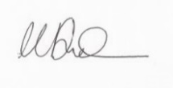
Mrs Helen Dudman
Head Teacher
In relation to Data Protection, Information Security and Confidentiality, all staff are required to comply with the school's policies and supporting documentation in respect of these issues.

Terms and Conditions

The employer for this post is the Dales Academies Trust.

The post is based at Barton C E Primary School

An Enhanced DBS is required for this post.

If you would value an informal discussion about the post, please contact Helen Dudman, Executive Head Teacher of Barton CE School on 01325 377246
If you would like to apply for this position, please complete the application form and submit it to admin@barton.dalesmat.org

BARTON CHURCH OF ENGLAND PRIMARY SCHOOL

JOB DESCRIPTION

POST: |  | General Teaching Assistant (GTA)
GRADE: |  | Band C
RESPONSIBLE TO: |  | Line Manager/Associate Headteacher /Executive Headteacher
STAFF MANAGED: |  | None
POST REF: |  | Teaching Assistants
JOB PURPOSE: | To work with teachers to support teaching and learning by working with individuals or small groups of pupils under the direction of teaching staff, and may be responsible for some learning activities within the overall teaching plan. May work in the classroom or appropriate location within the school, with access to support and guidance as required.
ACCOUNTABILITIES / MAIN RESPONSIBILITIES
Supporting Learning & Development | - Support pre planned learning/behaviour activities as directed by the teacher  - Using agreed structured observation as directed by the class teacher to feedback on learning, behaviour, participation and achievement, to support the planning and evaluation of the learning process in respect of groups and individual students  - Interact with pupils in ways that support the development of their ability to think and learn, including the use of careful questioning  - Assist teachers in the implementation of appropriate behaviour management and teaching & learning strategies  - Support pupils in their social and emotional wellbeing, in implementing related programmes, including social, health and physical needs  - Assist in escorting and supervising pupils on educational visits and out of school activities  - Undertake break supervision as required
Communication | - Under the general direction of the teacher participate in establishing and maintaining effective relationships with pupils, parents/carers and with other agencies/professionals  - Communicate effectively with all pupils, families, carers and other agencies / professionals
Sharing information | - Share information confidentially about pupils with teachers and other professional as required  - Pay due regard to professional boundaries, maintaining appropriate levels of confidentiality  - Participate in staff meetings
Safeguarding and Promoting the Welfare of Children/Young People | - Carry out tasks associated with pupils’ personal hygiene, (including personal intimate care) and welfare, including physical and medical needs, whilst encouraging independence  - Be responsible for promoting and safeguarding the welfare of pupils in line with policy and legislation, raising concerns as appropriate
Administration/Other | - Prepare classroom materials and learning areas, and undertake minor clerical duties e.g. photocopying and displaying pupils work  - Support the use of ICT and adhere to relevant policies  - Supervise and provide access arrangements for pupils sitting internal and external examinations and tests as required, ensuring that examinations comply with the Examination Board Regulations  - Participate in appraisal, training and other learning activities
Health & Safety | - Be aware of and implement your health and safety responsibilities as an employee and where appropriate any additional specialist or managerial health and safety responsibilities as defined in the Health and Safety policy and procedure  - Work with colleagues and others to maintain health, safety and welfare within the working environment
Data Protection | - To comply with the Dales Academies Trust’s policies and supporting documentation in relation to Information Governance this includes Data Protection, Information Security and Confidentiality
Equalities | - Promote inclusion and acceptance of all pupils  - Within own area of responsibility work in accordance with the aims of the Equality policy, treating people with respect for their diversity, culture and values
Customer Service | - The Dales Academies Trust requires a commitment to equity of access and outcomes, this will include due regard to equality, diversity, dignity, respect and human rights and working with others to keep vulnerable people safe from abuse and mistreatment  - The Dales Academies Trust requires that staff offer the best level of service to their customers and behave in a way that gives them confidence. Customers will be treated as individuals, with respect for their diversity, culture and values
Date of Issue: | Summer 2021

PERSON SPECIFICATION

JOB TITLE: General Teaching Assistant

Essential upon appointment | Desirable on appointment (if not attained, development may be provided for successful candidate)
Knowledge
- An awareness of child/young person’s development and learning  - An understanding that children/Young people have differing needs | - Good understanding of child development and learning processes  - Knowledge of Behaviour management techniques  - Knowledge of Child Protection and Health & Safety policies and procedures  - Knowledge of inclusive practice
Experience
- Experience appropriate to working with children in an learning environment
Qualifications
- Relevant NVQ Level 2/Level 3 qualification or equivalent | - Relevant NVQ level 3  - Appropriate first aid training (Dependent on the schools needs - insert as appropriate)
Occupational Skills  - Good written and verbal communication skills: able to communicate effectively and clearly and build relationships with a range of staff, children, young people, their families and carers  - Good reading, writing and numeracy Skills | - Basic ICT Skills
Personal Qualities
- Demonstrable interpersonal skills.  - Ability to work successfully in a team.  - Confidentiality  - Flexibility  - Able to use own initiative | - Creativity  - Sense of humour
Other Requirements
- Enhanced DBS Clearance
- To be committed to the school’s policies and ethos
- To be committed to Continuing Professional Development
- Motivation to work with children and young people
- Ability to form and maintain appropriate relationships and personal boundaries with children and young people
- Emotional resilience in working with challenging behaviours and attitudes
- Ability to use authority and maintaining discipline
- An empathy for equality & diversity
- The ability to converse at ease with customers and provide advice in accurate spoken English is essential for the post

