


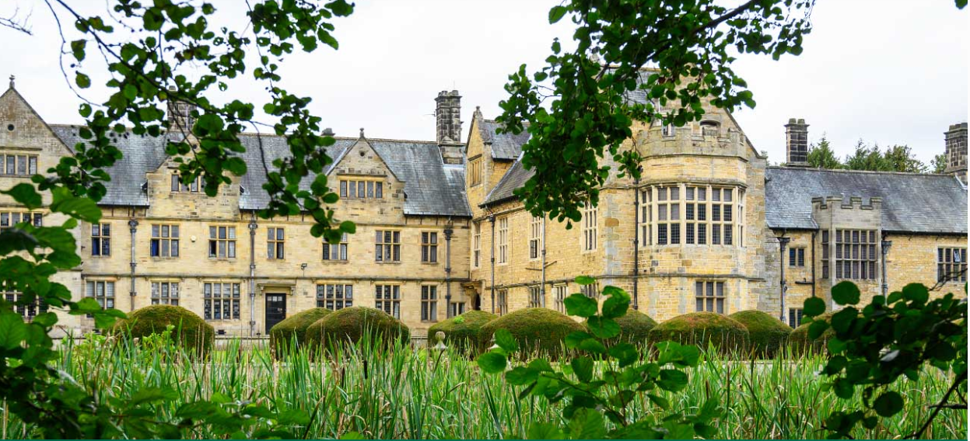
Welburn Hall School
General Teaching Assistant

WELBURN HALL SCHOOL

ABOUT US

Welburn Hall is a special school/college for children and young people aged 8 to 19 years with a wide range of special educational needs.

Set in over 20 acres of stunning countryside, Welburn Hall School is situated in the market town of Kirkbymoorside; nestled on the edge of the North York Moors National Park. With dedicated staff, fantastic facilities and beautiful buildings, we create a calm and inspiring place to learn, live and work.

As a North Yorkshire Council maintained special school, we have a strong reputation for excellence; offering a dynamic, innovative and unique learning journey for pupils aged 8 to 19 years, with a wide range of physical disabilities or learning difficulties. Welburn Hall also boasts a vibrant and successful 6th Form College, catering for young people between the ages of 16 and 19.

Our aim is to ensure all pupils and students have the opportunities they need to reach their full potential for academic achievement, independence and personal development. We pride ourselves in being a warm and friendly school; our staff are our greatest resource and are highly valued for the contribution and difference they make to the lives of our pupils. Our ethos and core values of respect, perseverance and excellence support this model and are lived out in the daily work of the school.



OUR VISION & VALUES

Welburn hall school will become recognised locally and nationally as an excellent school with ambitions for life-long independence for all students.

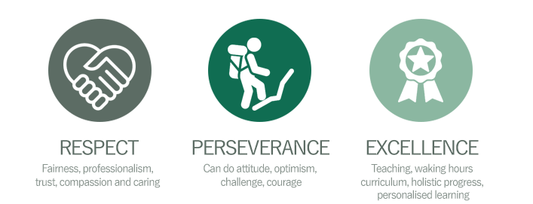
We have three core values which embody our school community.


OUR PUPILS
We have wonderful pupils, who brighten every day and make it a blessing to work at Welburn Hall school. Our curriculum has been developed to ensure it meets the needs of all our pupils and offers a blend of formal and informal learning. We want to enable successful learners, who enjoy learning, make progress and achieve their aspirational goals.

As pupils progress and transition into adulthood, we want to develop confident individuals who can live safe, healthy and fulfilling lives as independently as possible and are responsible citizens, who can make a positive contribution to society and their communities. Our prospectus can be found here.

OUR STAFF

The work we do here, and the development of our school would be impossible without our staff, who are an amazing team of dedicated and highly skilled people.
We are very proud of what we’ve achieved so far on our journey, and we are supported by an incredibly able and involved governing body.
Further information on our Governors can be found here.

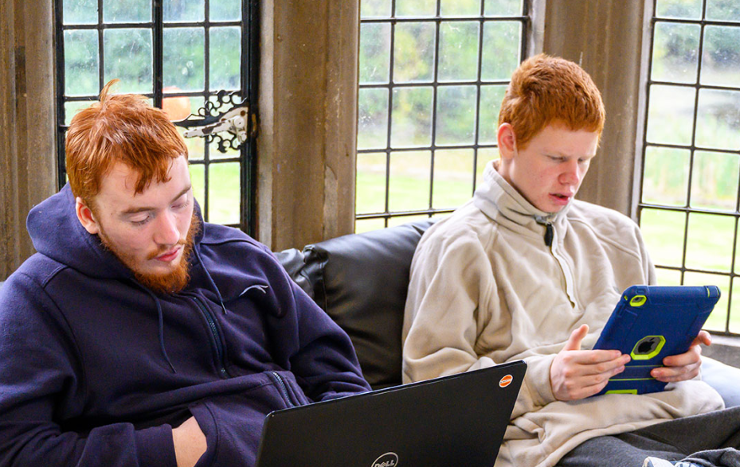

“Staff, both teaching and non-teaching, know their pupils well. Strong bonds have been forged between staff and pupils. Relationships are at the heart of the school…Staff expect pupils to achieve, which they do. Not least, this is because pupils are understood, treated and respected as individuals”

Ofsted 2022

“Welburn Hall School is a warm and caring school. All staff want the very best for the
pupils who attend. As such, ambitions are high.”
Ofsted 2022
“Thank you doesn't even cover what I can say to you all; it's about 1% of what you all deserve but I don't know how to say the other 99%, just know I would if I could find the words.”

A Welburn Hall School parent

APPLICATION PROCESS


The closing date for all applications is 11:59pm Wednesday 13th May 2026

Interviews will be held Thursday 21st May

Please apply online via the NYC Jobs Page.

Please contact us should you require an application in a different format.

An email will be sent to candidates with details of the shortlisting outcome.

Queries
Please contact Chloe Bullen on 01609 536 964 or via chloe.bullen@northyorks.gov.uk
Chloe has been engaged to support us with recruiting to this exciting opportunity.
When applying please take into account the following:

Employment History
In line with KCSIE requirements, please complete your full employment history to ensure any gaps in your education and career history are accounted for.

Suitable References
When completing your application, please provide two employment referees. Generally, this should be your current and most recent Headteacher or line manager.

Please note if your former Headteacher or line manager has since left, please use an alternative current senior staff member as they need to be in post at your former location to be able to confirm your details in full.

Unfortunately, we cannot accept personal references or personal email addresses.

Please get in touch for any queries if you are unsure.

Supporting Information
The supporting information section of your application should clearly evidence your ability to meet the requirements we have outlined in the job description & person specification. This will be used to shortlist applicants for this role and therefore it is imperative that you provide evidence as requested.

JOB DESCRIPTION

Post title: | General Teaching Assistant – Special School
Grade: | E
Responsible to: | HLTA / Teacher / Member of school leadership team
Staff managed: | None
Directorate: | Children and Young People's Service
School name:
Job family: | E - Education/School
Date of issue: | August 2023

Context Statement
- This school is committed to safeguarding and promoting the welfare of our pupils and young people. We have a robust Child Protection Policy and all staff will receive training relevant to their role at induction and throughout employment at the School. We expect all staff and volunteers to share this commitment. This post is subject to a satisfactory enhanced Disclosure and Barring Service criminal records check for work with children.

- Required to work within a special school with pupils with challenging or complex difficulties to assist them with others to overcome barriers to learning.
- Due to the nature of the children’s needs, the postholder must be able to meet the physical demands and duties of the role
- All school employees are responsible for contributing to a learning environment that is innovative, engaging, happy and fulfilling for all pupils, and for ensuring all pupils’ safety and welfare.
- This job description includes the duties and responsibilities of working in a special school and incorporates the previous SEN allowance which is no longer applicable.
- Enhanced DBS clearance required

Job Purpose: | - Under the direction and support of senior staff, the post holder is required to work with teachers as part of a professional team to support teaching and learning for pupils with a range of needs including: moderate, severe, profound and multiple learning difficulties, behavioural, social, mental, emotional, communication, sensory or physical difficulties.
Operational Issues: | - Support the delivery of pre-planned learning/behaviour activities as directed by the teacher, adjusting activities according to pupils’ responses as appropriate  - Using agreed structured observation as directed by the class teacher to feedback on learning, behaviour, participation and achievement, to support the planning and evaluation of the learning process in respect of groups and individual students  - Interact with pupils in ways that support the development of their ability to think and learn, including the use of careful questioning  - Assist teachers in the implementation of appropriate behaviour management and teaching & learning strategies  - Support pupils in their social and emotional wellbeing, in implementing related programmes, including social, health, emotional and physical needs  - Work alongside teachers in in escorting and supervising pupils on educational visits and out of school activities  - Observe pupil’s performance and behaviour, drawing any issues to the teacher’s attention  - Undertake rota duties as required  - Support learning by preparing classroom materials and learning areas, and undertaking minor clerical duties e.g. photocopying and displaying pupils work  - Support the use of ICT and adhere to relevant policies  - Supervise and provide access arrangements for pupils sitting internal and external examinations and tests as required, and assist in ensuring that examinations comply with the Examination Board Regulations  - Carry out tasks associated with pupils’ personal needs, including toileting, hygiene, dressing, feeding, (including personal intimate care) and welfare, including physical and identified health needs (under the direction of senior staff), whilst encouraging independence  - Act as a second signatory as required to assist others in the administration of emergency and daily medication to pupils  - Assist in moving and handling individuals using specialist equipment as required  - Work with pupils on therapy or care programmes, designed and overseen by a therapist or care professional
Communications: | - Maintain good working relationships with external agencies, other professionals, staff, parents/carers as appropriate e.g. to provide updates on progress  - Use other appropriate forms of communication when needed  - Communicate and establish effective relationships with the children & young people, using appropriate communication aids and methods where appropriate  - Provide support and encouragement to children & young people
Resource Management and Skills Development: | - Required to use, clean and maintain specialist equipment e.g. specialist chairs, walking devices, lifting equipment and communication aids after appropriate training.  - Maintain suitable learning environments setting up activities in a morning and tidying away at the end of the day.  - Participate in staff meetings  - Participate in the performance management process  - Participate in training and other learning activities to keep knowledge and skills up to date
Safeguarding: | - To be committed to safeguarding and promote the welfare and wellbeing of children, young people, raising concerns as appropriate.  - Be responsible for promoting and safeguarding the welfare of pupils in line with policy and legislation, raising concerns as appropriate  - Understand and evaluate risks to safeguard the welfare of the children & young people  - Comply with safer working practices
Systems and information: | - Share information confidentially about pupils with other staff, parents/carers, internal and external professional as appropriate  - Pay due regard to professional boundaries, maintaining appropriate levels of confidentiality  - Support the teacher in monitoring, assessing and recording pupil progress  - Contribute to maintaining accurate pupil records linked to daily routine e.g. toileting, medication
Planning and Organising: | - Assist the teacher in planning and organising learning activities for pupils  - Contribute to the planning, organising and implementing individual development and care plans for pupils, and contribute to reviews

Person Specification:
Essential | Desirable
Knowledge and Experience  - An awareness of child/young person’s development and learning  - An understanding that children/Young people have differing needs  - An awareness of the needs of children and young people with learning, sensory and physical difficulties  - Experience of working with children and young people | - Knowledge of child protection legislation and safeguarding procedures  - Knowledge of Health & Safety legislation and procedures for reporting accidents  - Knowledge of behaviour management techniques  - An understanding of independent learning and inclusion of all pupils  - Knowledge of complex associated needs e.g. behaviour, medical, physical, sensory, autism  - Experience of working with children and young people with learning, sensory or physical difficulties in a learning environment
Occupational Skills  - Ability to work successfully in a team.  - Confidentiality  - Good written and verbal communication skills: able to communicate effectively and build good relationships with all teachers, children, young people, families and carers  - Good reading, writing and numeracy skills  - Demonstrable ICT skills and ability to use them as part of the learning process  - Observation skills  - Ability to informally risk assess conditions and make appropriate decisions in emergency situations  - Ability to prevent and /or manage challenging behaviour.  - Caring skills  - Ability to be solution focused  - Ability to relate to children & young people | - Creativity
Behaviours
- link
Professional Qualifications  - NVQ level 2 qualification in supporting teaching and learning or equivalent or achievement within a reasonable timescale.  - Willingness to undertake training to meet the requirements of the role e.g. manual handling, first aid training | - Working towards or willingness to undertake NVQ level 3 in a relevant subject  - First Aid qualification  - Level 2 qualification or equivalent to evidence good numeracy and literacy skills
Other Requirements  - To be committed to the school’s policies and ethos  - To be committed to Continuing Professional Development  - Motivation to work with children and young people  - Ability to form and maintain appropriate relationships and personal boundaries with children and young people  - Emotional resilience in working with challenging and injurious behaviours and attitudes  - Ability to use authority and maintaining discipline  - An empathy for equality & diversity  - Flexibility | - Creativity

APPLYING FOR A JOB WITH NORTH YORKSHIRE COUNCIL

IMPORTANT ADVICE ON COMPLETING THIS APPLICATION

Your application form plays an important part in your selection. Please ensure you address all the essential requirements listed in the specifications. The following advice should help you to complete the application form as effectively as possible.
Data Protection
The information that you state on this application form will be used by the school and the Council to consider you for a job vacancy. To find out about how we use your personal data for the purposes of recruitment please see our Privacy Notice at www.northyorks.gov.uk/working-us.

Rehabilitation of Offenders
The post you are applying for requires you to have an enhanced Disclosure and Barring Service criminal records check for work with children, with a barred list check if you work in regulated activity. This check for disclosure of criminal history will include spent convictions, pending prosecutions / current court proceeding and police enquiries.

Should you be shortlisted, you will be asked to disclose full details of your criminal history prior to your interview. This includes any information deemed relevant as part of Keeping Children Safe in Education which may arise in an online search undertaken on shortlisted candidates. This information may be discussed with you at your interview in order to assess job related risks, but we emphasise that your application will be considered on merit and ability and you will not be discriminated against unfairly. Failure to disclose this information will result in any offer of employment being withdrawn.

Please also see the policy statement on the Recruitment of Ex-offenders below.

Information in Support of your Application
Every post advertised is supported by a full person specification. The specification lists all the essential skills, experience and qualifications which are necessary for the job and the criteria against which you will be assessed, both through your application form and at interview.

As part of the application process, you may have been asked to demonstrate within this application form how you meet some or all of the criteria or key competencies outlined in the person specification. Rather than simply repeating your career history, look at the skills and experience required by the job and provide evidence that you possess them by giving specific and detailed examples which include a focus on outcomes and on your own contribution to the scenario. Try to use different and varied examples wherever possible.

When completing these sections, do not forget the skills and experience you have gained outside full-time work. Outlining your previous work experience or other responsibilities may help you to uncover skills which you have taken for granted and which are clear signs of your ability to do the job.

Canvassing
You must not try to influence an elected Council Member, any council employee or a member of the school governing body, to act in your favour, as this will disqualify you. If you are related to a Councillor, a Council employee or a governor you must indicate this in the relevant section of the application form.

POLICY STATEMENT ON THE RECRUITMENT OF EX-OFFENDORS

1. As an organisation assessing applicants’ suitability for positions which are included in the Rehabilitation of Offenders Act 1974 (Exceptions) Order using criminal record checks processed through the Disclosure and Barring Service (DBS), this school complies fully with the DBS code of practice and undertakes to treat all applicants for positions fairly.

2. This school undertakes not to discriminate unfairly against any subject of a criminal record check on the basis of a conviction or other information revealed.

3. This school can only ask an individual to provide details of convictions and cautions that it is legally entitled to know about. Where a DBS certificate can legally be requested (where the position is one that is included in the Rehabilitation of Offenders Act 1974 (Exceptions) order 1975 as amended, and where appropriate Policy Act Regulations as amended) this school can only ask an individual about convictions and cautions that are not protected.

4. This school is committed to the fair treatment of its staff and potential staff, regardless of race, gender, religion, sexual orientation, responsibilities for dependents, age, physical/mental disability or offending background.

5. This school has this written policy on the recruitment of ex-offenders, which is made available to all DBS applicants at the start of the recruitment process.

6. This school actively promotes equality of opportunity for all with the right mix of talent, skills and potential and welcome applications from a wide range of candidates, including those with criminal records. Candidates are selected for interview based on their skills, qualifications and experience and criminal record information is only requested from short-listed candidates.

7. A disclosure is only requested from the DBS after a thorough risk assessment has indicated that one is both proportionate and relevant to the position concerned. For those positions where a criminal record check is identified as necessary, all application forms, job adverts and recruitment briefs will contain a statement that a DBS certificate will be requested in the event of the individual being offered the position.

8. This school ensures that all those who are involved in the recruitment process have been suitably trained to identify and assess the relevance and circumstances of offences.

9. This school also ensures that they have received appropriate guidance and training in the relevant legislation relating to the employment of ex-offenders, e.g. the Rehabilitation of Offenders Act 1974.

10. At interview, or in a separate discussion, this school ensures that an open and measured discussion takes place on the subject of any offences or other matter that might be relevant to the position. Failure to reveal information that is directly relevant to the position sought could lead to withdrawal of an offer of employment.

11. This school makes every subject of a criminal record check submitted to DBS aware of the existence of the code of practice and makes a copy available on request.

This school undertakes to discuss any matter revealed on a DBS certificate with the individual seeking the position before withdrawing a conditional offer of employment

