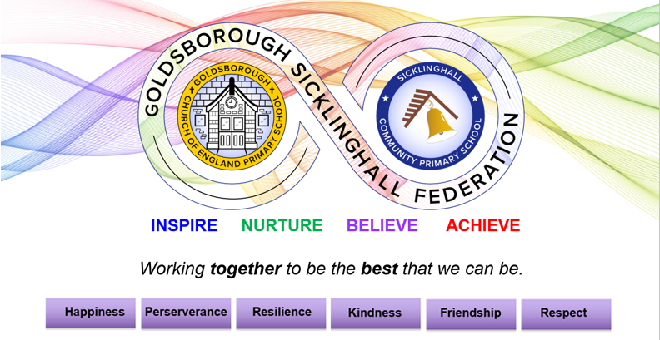

JOB ADVERT FOR A GENERAL TEACHING ASSISTANT – FEDERATED CONTRACT
GRADE C – 35 Hours – based at Sicklinghall
Monday – Friday: 8:30am – 4pm
Start Date: September 2022 – we would hope the candidate could do some transition days to meet the children and the Team prior to starting.
About us
Here at Sicklinghall Community Primary School we offer a vibrant and inspirational curriculum in an idyllic village setting close to Wetherby. As part of the Goldsborough Sicklinghall Federation, our united team work relentlessly to ensure that every child in our schools receives the best education and the best support to meet the SEMH and SEND needs.
Our ethos is very much about helping the children to be the best that they can be by developing the skills that are essential to them becoming upstanding members of the community. We believe that when you develop the personal characteristics for learning first, children have the confidence to shine.
Working with children is the best job in the world and as a school we encourage all staff to lead interventions and to organise exciting projects across both sites in our federation. Each member of staff must strive to deliver excellence within their setting.
This is a hugely exciting time for our school as we develop the curriculum further with staff training and new and improved resources at the heart of our journey; our children only have one chance at their primary education and in challenging times, we must let our passion guide us as we strive to ensure it is inspiring and engaging for every single pupil.
Our Opportunity
We believe that outstanding Teaching Assistants can help develop the learning characteristics for a child’s whole academic career. This role has become available due to one of our excellent staff members securing a place to start Teacher Training in September 2022.
We are looking to appoint an inspirational Teaching Assistant, driven and dedicated to embedding curriculum knowledge in practical and exciting ways that challenge and engage all learners in KS2. With tailored support from your new colleagues and leaders, we will further develop you and give you the skills, encouragement and experience within the profession to excel as a Teaching Assistant within our unique federation setting. All we ask in return is flexibility, commitment, a love of learning, initiative and pride in your work as you create those remarkable ‘lightbulb’ moments for our children.
We are looking for:
- A skilled professional who has an engaging and dynamic style of leading interventions.
- A Teaching Assistant with an understanding of SEND and SEMH and the complex needs that make up any cohort of children.
- A Teaching Assistant with experience of working in KS2.
- A person who can build trust with a pupil and develop their independence.
- A professional who is able to manage their time effectively to meet the complex needs of any cohort to ensure that interventions and GTA jobs are fulfilled to a high standard.
- Someone who has the drive and ambition to make sure our children achieve their very best, promoting excellence within the class and sharing expertise across the federation.
- A character who has the drive to lead change to ensure that all children succeed.
- A Teaching Assistant with a flair for primary education who will embrace the challenges of supporting children in a mixed age class.
- A positive character who has initiative and is self-motivated, willing to embrace change.
- A Teaching Assistant who will notice the children and intervene accordingly, offering ideas and suggestions.
- A character who demonstrates flexibility to meet the needs of the federation.

We can offer you:
- A warm, happy school where we value each individual child and the community in which it stands;
- Happy, enthusiastic and well-behaved children, eager to learn;
- A school within a federation offering the opportunity to work with like-minded colleagues;
- An opportunity for you to thrive as you continue your journey as a professional, accessing high quality
support, training and resources our school leaders have to offer.
We encourage you to come and see our wonderful school; to arrange a visit, please email Mrs McCarthy, the school administrator who will be delighted to show you around.
Please use the school websites and Twitter account (@GS_Federation) to gather information.
A video of our school and a Virtual Tour video can be found here:
You can read an article about our Federation on page 4 of the Yorkshire Post Headstart Magazine by clicking here.
We reserve the right to close this vacancy early should we receive an overwhelming response of candidates who meet the requirements.
All candidates are advised to submit their application ahead of the deadline. Candidates must ensure that they refer to the job description and person specification before making an application so that their application meets the criteria.
Advertisement open date: 13th June 2022. Closing date: Sunday 26 June 2022
Shortlisting Monday 27th June 2022, Interviews 29th June and 4th July.
Application Forms should be submitted directly to adminscps@gsfederation.com
The date of commencement for this post will be September 2022 (providing all safeguarding checks have been completed and returned to school). Ideally, we would like to plan some transition days to get to know the children / class. If you are available sooner, please mention this in your application.
Ensure that you outline as much experience possible to meet at least the majority or the Essential requirements and most of the desirable requirements. Use your application to showcase the skills you have to meet the bullet points in the ‘We are looking for:’ section.

