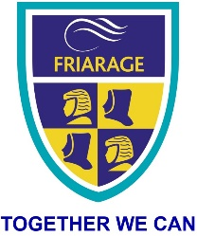
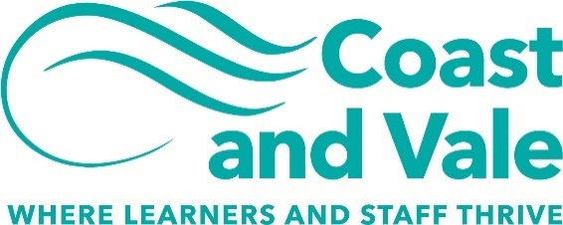

General Teaching Assistant (Fixed term)
Friarage Community Primary School
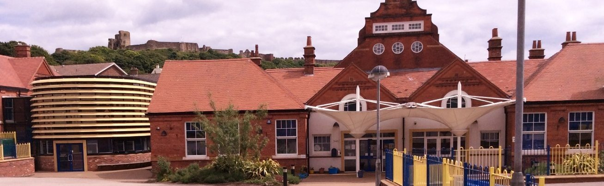
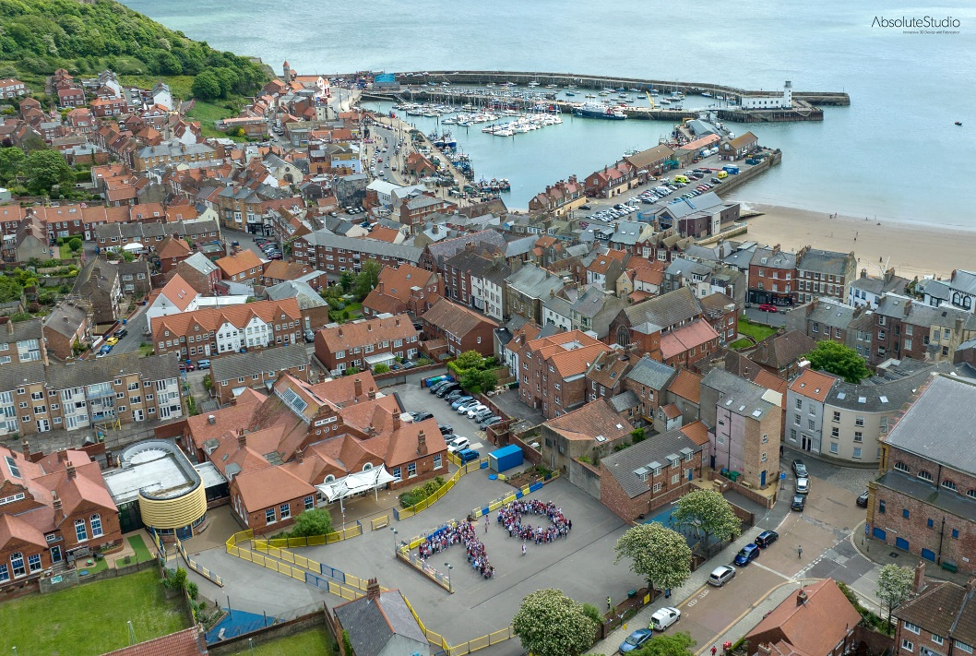

Dear applicant,
Allow me to extend a warm welcome from all governors, staff and children of Friarage Community Primary School. I am delighted you have shown interest in joining us and I look forward to sharing with you what makes our school a very special place to work.
I am proud to be the Headteacher of an inclusive school, which provides a nurturing, safe and inspiring place of learning at the very heart of Scarborough town. At our very core, you will find teamwork and commitment, which makes our vision of ‘together we can’ a reality.
The school is unique; it serves a diverse community with 35 – 40% of its pupils having English as an additional language. The school is proud of how it supports all its pupils to learn and succeed.
You will find a real buzz about our school and a palpable sense of energy, excitement and a love of teaching and children. We are looking for a colleague who shares the same ethos and
values, understands our local context and can provide the inspired teaching our children thrive on and deserve!
This is an exciting time to join us. As part of the Coast and Vale Learning Trust we are working together to share, learn and create a primary hub our area can be proud of. Through our Trust we are able to access the support and resources from The Scarborough Teaching Alliance, which means as a staff member you have a wide range of colleagues, tools and resources to help you develop not just in the classroom but beyond.
I hope that you will take the time to come and see and experience for yourself the welcoming atmosphere and purposeful learning environment that makes our vision a reality.
Good luck with your application. I look forward to reading it.
Cheryl Cappleman
Headteacher

Dear applicant,
Coast and Vale Learning Trust is a growing family of schools based on the North Yorkshire Coast. We converted from our lead secondary school (Scalby School), welcomed Newby & Scalby Primary School in 2018 and in 2019 welcomed Friarage Community Primary as our first sponsored school. We welcomed Lady Lumley’s School in 2021, and our ambition is to continue to welcome new schools into our Trust where we can add capacity, resources, improvement and make sure all our young people have access to the very best education
We are growing organically and firmly building on the school improvement journeys of Scalby School, Newby & Scalby Primary and Friarage Primary. As a Trust we have added to our central team which includes our Chief Operating Officer, Trust Finance Services Manager and school improvement colleagues working within our lead schools.
Our Trust is currently based at Scalby School in Scarborough with both our founding secondary and primary schools being judged ‘good’ by Ofsted. Our success in making sure that our staff are our greatest resource, with ongoing investment into our teaching and support staff teams has placed us in a good position to meet current educational challenges.
Coast and Vale Learning Trust aims to improve education in the locality through establishing coherent and collaborative practice across schools and other educational institutions in the area.
In seeking to realise its mission statement and achieve its strategic objectives, the Coast and Vale Learning Trust board are committed to:
- The principle of meaningful educational partnership between primary and secondary schools.
- Expanding the number of schools in the MAT where this enhances the education of youngsters already under the care of the Trust and can realistically improve it in the joining school.
- Sustainable and measured growth as a Trust.
- Collaborative working with other stakeholders and institutions for the benefit of local youngsters whether they are in the Trust or not.
Choosing where to work and who to work for is one of the vitally important decisions in life. In choosing to work for Coast and Vale Learning Trust you are joining a team of colleagues dedicated to transforming the lives of 3000 children and young people. Our work is an important part of who we are, how we express ourselves, and working with young people is a tremendous privilege and at the same time a challenge and an adventure.
At Coast and Vale Learning Trust we believe that in order to transform young lives we need the highest quality staff who feel cared for and valued. Whether you are a teacher or receptionist, an IT technician or school leader, we want you to grow and develop in your role and to find your stay with the trust a fulfilling time in your working life.
Whenever you see the Coast and Vale logo you should spot the strapline “where learners and staff thrive.” Many organisations spend a great deal of time and effort in developing a strapline, yet at Coast and Vale we are more concerned about turning the strapline into reality. The word thrive indicates a place of healthy growth, plants thrive in the right environment and so we want to see our schools to be environments where learners (children as young at three up to young people aged eighteen) grow and develop and reach their potential. We also want to place the development of all our staff at the heart of what we do.
You will not be joining a single school, rather a family of schools that can thrive together, share resources and help each other through difficult times. We believe in ‘servant leadership’ where the principles of service underpin all we do. CEO
Coast and Vale Learning Trust structure
All the staff working for Coast and Vale are line managed by the leadership of one of our five schools or by leadership of the central team. The central team does not work in a specific school context, but for the whole trust.
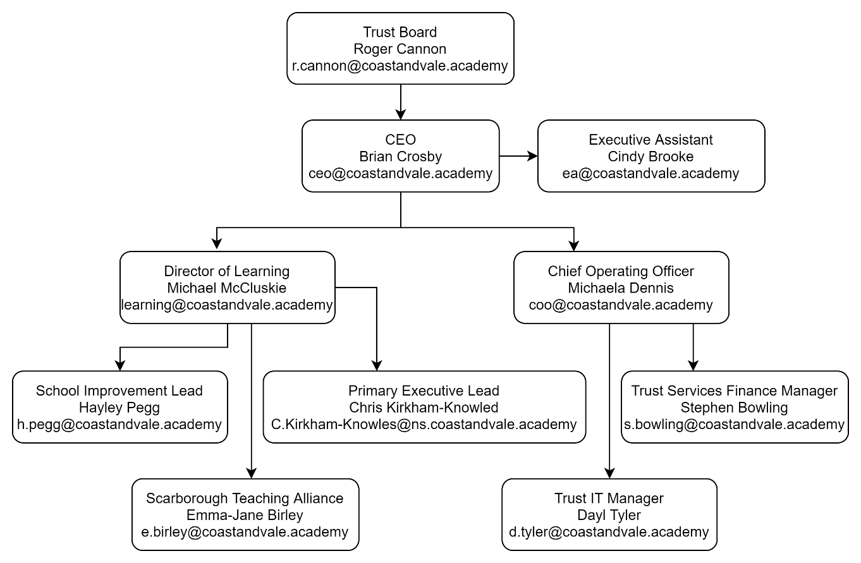

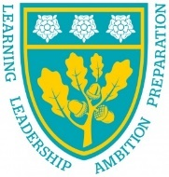
Our schools

Scalby School
Scalby School is a successful and popular 11-16 community school with approximately 1000 students currently on roll. In recent years it has become the school of choice in our local community. We were judged ‘good’ by Ofsted in 2019 and have repeatedly achieved results well above the national average over the last decade. Our P8 score in 2019 placed us in the top 20% of schools nationally again. We are proud of our broad and balanced GCSE based curriculum.
A ‘Good’ school in every area according to Ofsted in 2012 and in 2019. We are constantly looking at ways to improve our learning offer and are very ambitious improving the school further. Our aim is to provide a ‘Great’ education for the young people in our beautiful coastal community.
To learn more about us please visit - www.scalby.coastandvale.academy
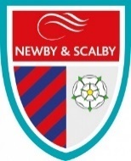

Newby & Scalby Primary School
We are the school of choice in our community and we are within commutable distance of Whitby, Teesside, York and surrounding areas. Ofsted in 2018 judged us to be ‘good’ in all areas and as a school we are very much outward facing both in terms of teaching and learning, and in constantly thinking about how we can improve. As a result, our pupils achieve well. For example, in 2019, 84% of the year 6 cohort reached age related expectations in reading, writing and mathematics combined, compared to the national average of 65%.
Since our “good” Ofsted in 2018, we continue to build on our successes and we are a family and a team, where everyone is given the challenge and support to be the best they can possible be in a safe, welcoming and positive environment. Children and staff will work and play together developing skills so that we all become ambitious and reflective lifelong learners as well as being respectful and respected members of the community.
To learn more please visit - www.newbyandscalby.coastandvale.academy

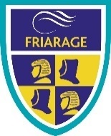

Friarage School
Friarage School is a large Inclusive Primary School in the Castle Ward area of Scarborough; it has approximately 330 pupils on roll ranging from 3 to11yrs. 38% of its pupils have English as an additional language and 50% of its pupils are in receipt of pupil premium funding.
Our school motto is ‘Together we can’ and this team ethos is at the heart of everything we do. Children and staff work together, developing skills so that we all become ambitious and successful learners as well as being respectful and respected members of the community.
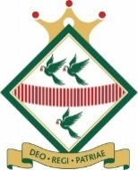
To learn more please visit - www.friarage.coastandvale.academy

Lady Lumley’s Secondary School
Lady Lumley’s is an 11-18, mixed comprehensive, community school of 900 students serving the town of Pickering, surrounding villages and warmly welcomes students from Scarborough to Rosedale. We strive to ‘Be our best’, working to improve the experience for all students, staff, and the community. Our broad and balanced curriculum is ambitious for all, and we place great value in academic qualifications alongside the arts and practical subjects. Set in an idyllic location, we make the most of fantastic sporting facilities and run an immensely popular Duke of Edinburgh experience alongside over 30 Enrichment clubs. Our students and staff are loyal to Lady Lumley’s and strive to improve our learning journey, whilst celebrating success.
To learn more please visit - www.ladylumleys.coastandvale.academy

Application Process
The closing date for all applications is: Wednesday 29th June 2022 at 4pm and Interviews will be held as soon as possible after the closing date.
Visits are warmly welcomed. Please contact Helen Poole, to arrange.
Completed applications must be returned to Helen Poole at helen.poole@northyorks.gov.uk
If you think you’re the person for the job, please complete an application form, with either your supporting statement included or attached separately to the email address above by the closing date.
We are committed to safeguarding and promoting the welfare of children and young people and expects all staff and volunteers to share this commitment.
A copy of the Safeguarding Policy is available here:
www.friarage.coastandvale.academy/about-our-school/school-policies/
This post is exempt from the Rehabilitation of Offenders Act 1974 and the appointment is subject to a satisfactory enhanced level disclosure and S128 clearance from the Disclosure & Barring Service (DBS).

JOB DESCRIPTION
POST: | General Teaching Assistant (GTA)
GRADE: | SCP 2-4
RESPONSIBLE TO: | Head Teacher
STAFF MANAGED: | None
ACCOUNTABILITIES / MAIN RESPONSIBILITIES
Supporting Learning  & Development | - To work with named pupils as part of an Inclusion Team which will be directed by the class teacher and/or SENCO supporting learning and SEMH needs.  - To assist the class teacher/SENCO/Inclusion Team with the planning, development and delivery of suitable programs of work for the pupil/pupils.  - To help support and motivate the pupil/pupils, clarifying instructions, encouraging independent learning and behavior.  - To develop knowledge and understanding of the specific academic, physical and emotional, behavioral, medical needs of the child/children and respond to them effectively.  - Consistently and effectively implement agreed behavior management strategies.  - Assisting escorting and supervising pupils on educational visits and out of school activities.  - Undertake break supervision as required.  - To assist with general school duties which may include: setting up areas for learning, preparing resources, displays, tidying and clearing away. Supervising children entering or leaving school premises.
Communication | Under the general direction of the teacher or SENCO participate in establishing and maintaining effective relationships with pupils, parents/carers and with other agencies/professionals  - Communicate effectively with all pupils, families, carers and other agencies / professionals
Sharing information | - Share information confidentially about pupils with teachers and other professional as required  - Pay due regard to professional boundaries, maintaining appropriate levels of confidentiality  - Participate in staff meetings
Safeguarding and  Promoting the  Welfare of  Children/Young  People | - Carry out tasks associated with pupils’ personal hygiene, (including personal intimate care) and welfare, including physical and medical needs, whilst encouraging independence  - Be responsible for promoting and safeguarding the welfare of pupils in line with policy and legislation, raising concerns as appropriate
Administration/Other | - Prepare materials and learning areas, and undertake minor clerical duties e.g. photocopying and displaying pupils work  - Support the use of ICT and adhere to relevant policies  - Supervise and provide access arrangements for pupils sitting internal and external examinations and tests as required, ensuring that examinations comply with the Examination Board Regulations  - Participate in appraisal, training and other learning activities  - To contribute to the overall ethos/work/aims of the school
Health & Safety | - Be aware of and implement your health and safety responsibilities as an employee and where appropriate any additional specialist or managerial health and safety responsibilities as defined in the Health and Safety policy and procedure  - Work with colleagues and others to maintain health, safety and welfare within the working environment
Data Protection | - To comply with the County Council’s policies and supporting documentation in relation to Information Governance this includes Data Protection, Information Security and Confidentiality
Equalities | - Promote inclusion and acceptance of all pupils  - Within own area of responsibility work in accordance with the aims of the Equality policy, treating people with respect for their diversity, culture and values
Customer Service | - The County Council requires a commitment to equity of access and outcomes, this will include due regard to equality, diversity, dignity, respect and human rights and working with others to keep vulnerable people safe from abuse and mistreatment  - The County Council requires that staff offer the best level of service to their customers and behave in a way that gives them confidence. Customers will be treated as individuals, with respect for their diversity, culture and values

Person Specification

Essential upon appointment | Desirable on appointment (if not attained, development may be provided for successful  candidate)
Knowledge  - An awareness of child/young person’s development and learning, including SEMH needs.  - An understanding that children/Young people have  differing needs | - Good understanding of child development and learning processes  - Knowledge of Behaviour management techniques  - Knowledge of Child Protection and Health & Safety policies and procedures  - Knowledge of inclusive practice
Experience
- Experience appropriate to working with children in a learning environment
Qualifications  - Relevant NVQ Level 2 qualification or equivalent  - GCSE Grade C or above in Maths and English (or equivalent) | - Relevant NVQ level 3
Occupational Skills  - Good written and verbal communication skills: able to communicate effectively and clearly and build relationships with a range of staff, children, young people, their families and carers  - Good reading, writing and numeracy skills | - Basic ICT Skills
Personal Qualities  - Demonstrable interpersonal skills.  - Ability to work successfully in a team.  - Confidentiality  - Flexibility  - Resilience  - Patience  - Ability to form and maintain appropriate relationships and personal boundaries with children and young people. | - Creativity
Other Requirements
- Enhanced DBS Clearance
- To be committed to the school’s policies and ethos
- To be committed to Continuing Professional Development
- Motivation to work with children and young people
- Ability to form and maintain appropriate relationships and personal boundaries with children and young people
- Emotional resilience in working with challenging behaviours and attitudes
- Ability to use authority and maintaining discipline
- An empathy for equality & diversity

