
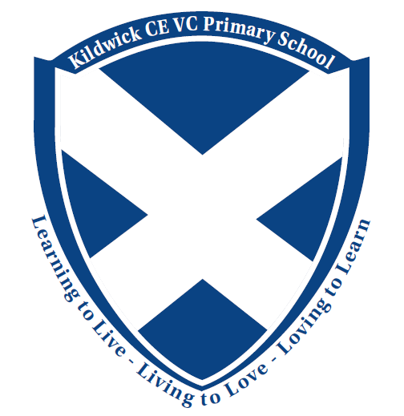
Kildwick CE VC Primary School
Priest Bank Road
Kildwick
BD20 9BH

Tel - 01535 633682
Email - office@kildwickce.uk
Website

Headteacher - Mr T Whitehead











General Teaching Assistant Reception / Year Two Maternity Cover (Year 1/2) Mixed Class – March 23rd 2026

Grade: CD

Salary Range (From and To): Grade CD GTA, pay point 4 to 6, MSA pay point grade B, pay point 2

Minimum Age Requirement: 18

Vacancy Hours: Term Time 30 hours (GTA) plus 2.5 MSA hours. Monday-Friday Contract Type: Fixed Term Time Only

Weekend Working: No

Location: Kildwick CE VC Primary School

Application Closing Date: Wednesday 28th January, by 5pm

Interview Date: W/B Monday 2nd February

Venue for Interview: Kildwick CE VC Primary School

Start date: Monday 23rd March

Kildwick CE (VC) Primary School are seeking an enthusiastic and proactive Teaching Assistant to join our dynamic Year One and Two mixed-age class for a fixed term maternity cover.

In this fulfilling role, you’ll support young children on their school journey—helping to spark curiosity, build their confidence, and nurture a lifelong love of learning. Working alongside a dedicated class teacher, you’ll help create an engaging, inclusive, and supportive learning environment tailored to the needs of every child.

If you bring patience, creativity, and a genuine passion for working with children, we’d love to hear from you!
The successful candidate will:

- Be a skilled classroom practitioner who is passionate about learning and believes in the potential of all children
- Show empathy and understanding of the Christian ethos of the school
- Be a highly organised, hardworking and professional role model
- Have a positive attitude and be prepared to take initiative
- Have high expectations of themselves and all school pupils
- Have exceptional interpersonal and behaviour management skills
We can offer the successful candidate:

- Happy, talented children who have fun all the way to the end of year 6!
- A welcoming friendly village school, set on the edge of the Yorkshire Dales
- A small but talented and supportive staff team
- High levels of governor and parental support
- A commitment to your professional development & promotion
- An innovative curriculum
Kildwick Primary School is committed to safeguarding and promoting the welfare of children, young people and adults. We expect all staff and volunteers to share this commitment. Enhanced DBS, proof of qualifications and appropriate references will be required.

Application forms should be emailed for the attention of Mr Tim Whitehead to office@kildwickce.uk / headteacher@kildwickce.uk

Closing Date:
The closing date for the return of completed applications forms is Wednesday 28th January 2026 by 5pm.

Invites for interview
Interviews will be held in school week beginning 2nd February 2026.

If you wish to have an informal discussion or visit the school, then please ring or email the school office to arrange a convenient day and time.

Yours sincerely

Tim Whitehead
Headteacher

