NORTH YORKSHIRE COUNTY COUNCIL
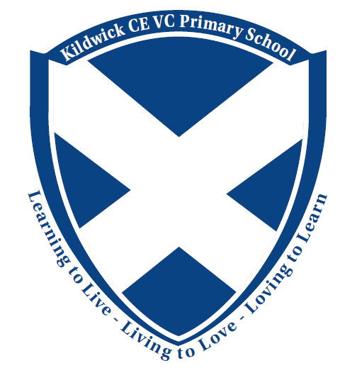
Kildwick CE VC Primary School Telephone: 01535 633682
Priest Bank Road
Kildwick Email: admin@kildwick.n-yorks.sch.uk
Keighley
West Yorkshire BD20 9BH Web Address: www.kildwickceschool.org.uk

Mr T Whitehead
Headteacher
Kildwick CE VC Primary School
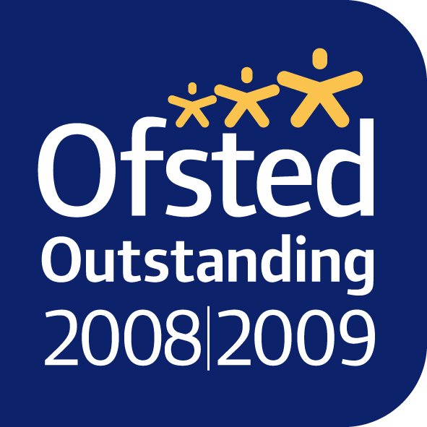




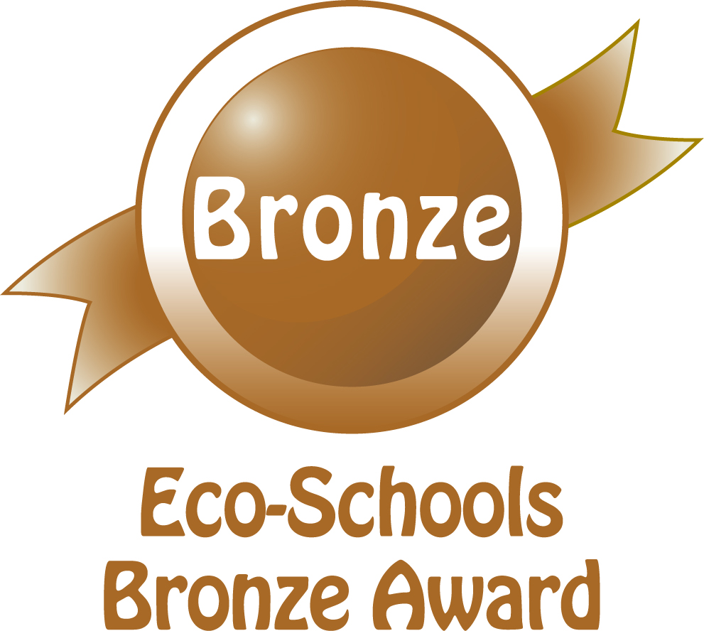



General Teaching Assistant (Maternity) – To commence September 2022 (or soon after)

Thank you for applying for the post of Teaching Assistant at our school at our school. Application forms should be emailed for the attention of Mr Tim Whitehead to office@kildwickce or posted to the above address.

Closing Date:
The closing date for the return of completed applications forms is Monday 13th June 2022.

Candidates should assume that if they have not received any correspondence by Friday 17th June that they have been unsuccessful this time.

Invites for interview
Invites for interview and information regarding the interview process will be emailed to successful applicants following shortlisting on Monday 13th June; interviews will be held in school week beginning 20th June.

If you wish to have an informal discussion about the vacancy, then please ring the school office to leave your name and number and someone will call you back. Informal visits can be arranged individually by calling the above number.

Yours sincerely,

Tim Whitehead
Headteacher

