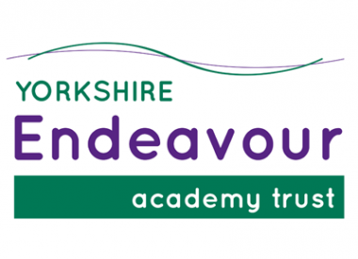

Come and join us as our new Teaching Assistant (SEMH)

- Have a positive impact on our children in school;
- Access high quality professional development opportunities;
- Have your ideas and aspirations nurtured.

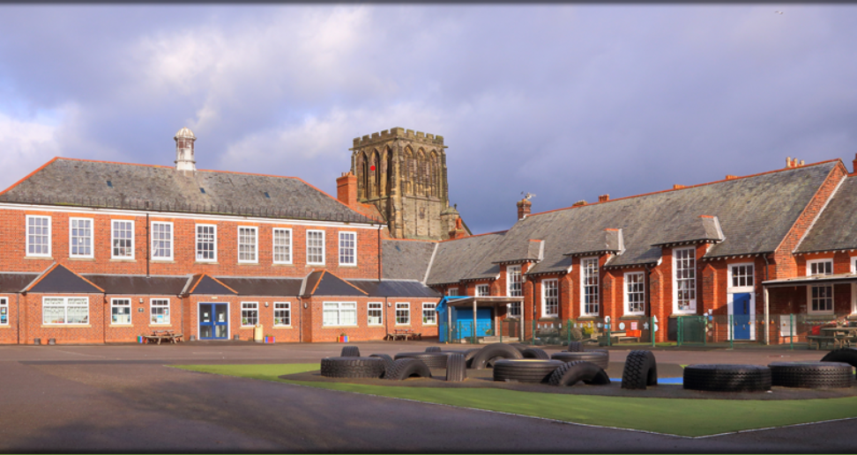

General Teaching Assistant (SEMH)
West Cliff Primary School

Required to start in January 2022
Recruitment Information Pack
Yorkshire Endeavour Academy Trust
Waterstead Lane, Whitby, YO21 1PZ

Contents

Welcome from the Headteacher 3
Our vision and values 4
Context of the school 5
Our English Hub 6
Application process 7
Job Description and Person Specification 8-12

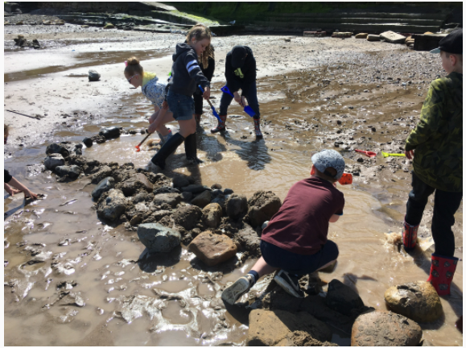
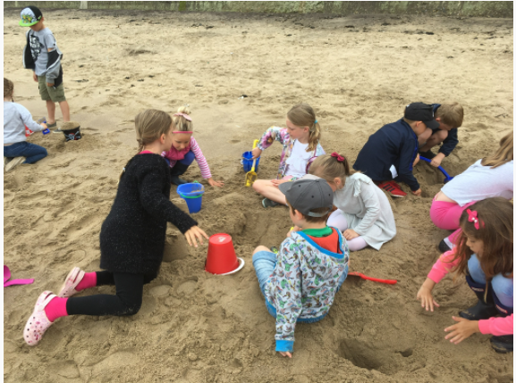

Dear applicant,

Allow me to extend a warm welcome from all governors, staff and children of West Cliff Primary School. I am delighted you have shown interest in joining us and I look forward to sharing with you what makes our schools very special places to work.

Our children are delightful, happy, confident and energetic. They are passionate about their learning and enjoy a wide curriculum, with access to 1:1 iPads, outdoor learning areas and well-stocked libraries. Through the pandemic, they have demonstrated incredible resilience, adapting to new ways of learning, including contributing to live virtual lessons. Our children have many talents and we pride ourselves in providing lots of opportunities for every child to contribute to the wider school community.

This is an exciting time to join us. As part of the Yorkshire Endeavour Academy Trust, our team are working in partnership across the Whitby area to share, learn and inspire. Through our Trust we are able to access support, training and resources from the Esk Valley Alliance and Yorkshire Endeavour English Hub, which means staff members have a wide range of colleagues, tools and resources to help them develop not just in the classroom but beyond.

I hope that you will take the time to find out more about our schools. Good luck with your application. I look forward to reading it.

Christina Zanelli, Headteacher of West Cliff Primary School/CEO of YEAT

Yorkshire Endeavour Academy Trust
Our Vision and Values

Vision
We firmly believe in celebrating and preserving the diversity within our member academies, whilst ensuring that all of our people, pupils, staff, parents and carers have access to the very best opportunities, with real and effective tangible outcomes to enable them to exceed their expectations and fulfil their potential.

Aims and Values
The Endeavour MAT is a family of primary schools who believe that by learning and growing together we can:
- Ensure that all our children, regardless of their starting point, receive an outstanding education that prepares them for the world.
- Nurture a culture and climate of mutual respect.
- Be a safe and inclusive place for children.
- Create opportunities for all our staff to develop and shine.
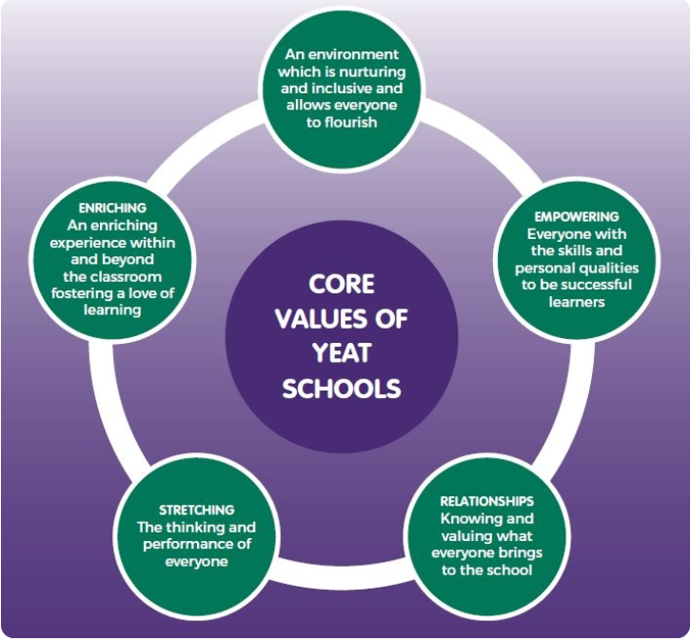
Whilst collaboration is at the core of our practice we believe that this works best when each school has a unique identity and place at the heart of their community. It is through our differences that we can challenge and support each other to do the best for our children.

Context of the school
West Cliff Primary School
West Cliff Primary School is a warm and friendly community school that provides education from children aged 2-11. It currently has 210 children on roll, divided into 8 classes (one for each year group). One of our classes is a nursery class that takes children from 2 years old. The school mainly takes children from the west side and the centre of Whitby - but is accessible from all parts of the town.
We pride ourselves on providing a warm and welcoming environment for children and adults alike, and we strive to provide the very best standard of education possible for our children.
The school has a before and after school club (The Ocean Fun Club), offering wraparound care for children from 7.45 until 5.15. This is open to all children including our nursery children.
We are a Beach School as we believe that the beach is a fantastic resource that can be used, to both learn and have fun on. More details at Beach Schools - West Cliff Primary School (west-cliff.n-yorks.sch.uk).
Dorothy’s journey
In 2019, we purchased a double decker bus and were delighted when the previous owner drove it up to Whitby and parked ‘Dorothy’ on the school playground.
She was in reasonable condition but needed a full overhaul to meet our vision of being a bright, welcoming environment for children to access wellbeing sessions, phonic interventions and other activities.
With the support of local companies, staff members, parents and friends of the school, Dorothy was – over several months – transformed into a fantastic and inspiring place to learn, talk and feel safe.
Dorothy’s daily use
Dorothy is used on a daily basis by a variety of children from across the school. The space is used for a variety of activities, including phonic interventions, Compass Buzz sessions, art therapy, lunchtime clubs and much more besides.
Find out more about life at West Cliff by visiting our website: Home - West Cliff Primary School (west-cliff.n-yorks.sch.uk) or viewing our active Facebook page.

Yorkshire Endeavour English Hub
In September 2018, the DfE appointed 32 English Hub schools across England to support other schools to deliver excellent early language and phonics teaching in Reception and Key Stage 1.
The Yorkshire Endeavour English Hub is one of the chosen 32 schools working in Scarborough, Whitby, Ryedale, the East Riding, York and Hambleton.
We have supported a wide range of schools by organising open events to share good practice; providing bespoke training for new subject leaders; and undertaking audits of phonics and early reading provision.

OUR PRIORITIES
The hub focuses on three priority areas:

Early language development
Providing evidence-based approaches to early language development and closing the word gap in school-based early years settings.

Age-appropriate phonics provision
Encouraging best practice in systematic synthetic phonics teaching from school-based early years provision to the end of Key Stage 1, and as the primary reading strategy throughout the school. This includes:
- Encouraging fidelity to a single systematic synthetic phonics programme
- Supporting the effective use of decodable books in the early stages of learning to read, as a way of establishing phonic decoding;
- Supporting effective practice in formative assessment in relation to phonics/early reading.

Promoting a love of reading
Encouraging reading for enjoyment by supporting whole school reading approaches, reading to children at least once a day and encouraging reading at home, developing teacher knowledge of children’s literature.

To learn more about us please visit our website at https://www.yeat.co.uk

Application Process
The closing date for all applications is Thursday 2nd December 2021 at 9am

Interviews will be held as soon as possible after the closing date.

Completed applications must be returned to Garry Morrison at garry.morrison@northyorks.gov.uk

If you do not receive confirmation of receipt of your application within one working day please call Garry on 07814935700

If you think you are the person for the job, please complete the enclosed application form with a covering letter, no more than two sides of A4, and send to the email address above by the closing date.

An email will be sent to shortlisted candidates with details of the interview process. If you have not heard from us within a week of the closing date please assume your application has been unsuccessful.

Queries
Informal chats with our Headteacher are welcomed. Please contact Garry to organise.

We actively welcome you to contact Garry at North Yorkshire County Council to chat through the role and talk informally about the school/post and how working here will make a real difference to the children and young people on the coast.

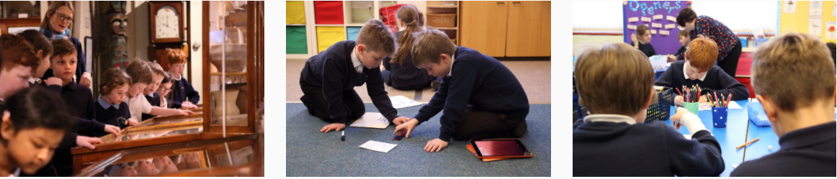

Job Description

POST: |  | General Teaching Assistant (GTA)
GRADE: |  | Grade C plus SEN allowance, points 2 - 4
RESPONSIBLE TO: |  | Head Teacher
STAFF MANAGED: |  | None
POST REF:
JOB PURPOSE: | To work, under the direction of the class teacher and other appropriate staff, in assisting in and contributing to the planning, delivery and evaluation of the learning process. The post holder will work in classes, or other appropriate locations with access to support and guidance, supervising groups and /or individual pupils.  To assist in the induction and development of classroom support staff as required.
ACCOUNTABILITIES / MAIN RESPONSIBILITIES
Supporting Learning & Development | - Support pre planned learning/behaviour activities as directed by the class teacher  - Using agreed structured observation as directed by the class teacher to feedback on learning, behaviour, participation and achievement, to support the planning and evaluation of the learning process for children.  - Interact with pupils in ways that support the development of their ability to think and learn, including the use of careful questioning  - Assist teachers in the implementation of appropriate behaviour management and teaching & learning strategies  - Support pupils in their social and emotional wellbeing, in implementing related programmes, including social, health and physical needs  - Assist in escorting and supervising pupils on educational visits and out of school activities  - Undertake break supervision as required  - To encourage pupils to interact with others and engage in activities led by the teacher
Communication | - Under the general direction of the teacher participate in establishing and maintaining effective relationships with pupils, parents/carers and with other agencies/professionals  - Communicate effectively with all pupils, families, carers and other agencies / professionals
Sharing information | - Share information confidentially about pupils with teachers and other professionals as required  - Pay due regard to professional boundaries, maintaining appropriate levels of confidentiality  - Participate in staff meetings
Safeguarding and Promoting the Welfare of Children/Young People | - Carry out tasks associated with pupils’ personal hygiene, and welfare, including physical and medical needs, whilst encouraging independence  - Be responsible for promoting and safeguarding the welfare of pupils in line with policy and legislation, raising concerns as appropriate
Administration/Other | - Prepare classroom materials and learning areas, and undertake minor clerical duties e.g. photocopying and displaying pupils work  - Support the use of ICT and adhere to relevant policies  - Supervise and provide access arrangements for pupils sitting internal and external examinations and tests as required, ensuring that examinations comply with the Examination Board Regulations  - Participate in appraisal, training and other learning activities  - To contribute to the overall ethos/work/aims of the school
Health & Safety | - Be aware of and implement your health and safety responsibilities as an employee and where appropriate any additional specialist or managerial health and safety responsibilities as defined in the Health and Safety policy and procedure  - Work with colleagues and others to maintain health, safety and welfare within the working environment
Data Protection | - To comply with the Trust’s policies and supporting documentation in relation to Information Governance, including Data Protection, Information Security and Confidentiality
Equalities | - Promote inclusion and acceptance of all pupils  - Within own area of responsibility, work in accordance with the aims of the Equality policy, treating people with respect for their diversity, culture and values
Customer Service | The Trust requires a commitment to equity of access and outcomes, this will include due regard to equality, diversity, dignity, respect and human rights and working with others to keep vulnerable people safe from abuse and mistreatment  - The Trust requires that staff offer the best level of service to their customers and behave in a way that gives them confidence. Customers will be treated as individuals, with respect for their diversity, culture and values

Person Specification

JOB TITLE: General Teaching Assistant

Essential upon appointment | Desirable on appointment (if not attained, development may be provided for successful candidate)
Knowledge
- An awareness of child/young person’s development and learning  - An understanding that children/young people have differing needs | - Good understanding of child development and learning processes  - Knowledge of behaviour management techniques  - Knowledge of Child Protection and Health & Safety policies and procedures  - Knowledge of inclusive practice
Experience
- Experience appropriate to working with children with special educational needs in a learning environment.
Qualifications
- Relevant NVQ Level 2 qualification or equivalent  - GCSE Grade C or above in Maths and English (or equivalent) | - Relevant NVQ level 3
Occupational Skills  - Good written and verbal communication skills: able to communicate effectively and clearly and build relationships with a range of staff, children, young people, their families and carers  - Good reading, writing and numeracy skills | - Basic ICT Skills
Personal Qualities
- Demonstrable interpersonal skills.  - Ability to work successfully in a team.  - Confidentiality  - Flexibility  - Resilience  - Patience  - Ability to form and maintain appropriate relationships and personal boundaries with children and young people. | - Creativity
Other Requirements
- Enhanced DBS Clearance
- To be committed to the school’s policies and ethos
- To be committed to continuing professional development
- Motivation to work with children and young people
- Ability to form and maintain appropriate relationships and personal boundaries with children and young people
- Emotional resilience in working with challenging behaviours and attitudes
- Ability to use authority and maintain discipline
- An empathy for equality & diversity

