**General Teaching Assistant with SEND Allowance**

**Childhaven Community Nursery School**

**Recruitment Information Pack**



## Contents

About the School 3

Application Process 4

Job Description and Person Specification 5 – 8

Applying for a job with North Yorkshire Council 9



**Childhaven Community Nursery School**

*Discover, Play, Learn – Providing Outstanding Early Education*

 An OUTSTANDING school in the heart of Scarborough, at Childhaven, we are committed to supporting our children develop into resilient, independent life-long learners. We were judged to be OUTSTANDING by Ofsted in 2012,2015, 2019, and then again in 2024!

We provide a vibrant, welcoming and inspirational setting and serve the communities around the Scarborough Town. We are one of only 3 maintained nursery schools in North Yorkshire and we offer children a unique start to their education. Children aged between 2 and 4 play and learn together in our wonderful Victorian building and garden.

As a lead school within the Scarborough Teaching Alliance we share best practice and are committed to training the next generation of teachers and support staff.

Thank you for your interest in joining our team. This is an exciting time for us as we strengthen and develop our nurturing provision for our children, as we support children with a wide range of additional needs.

We look forward to receiving your application.



## Application Process

**Please apply via NYC Jobs**

The closing date for all applications is **9am, Thursday 10th July 2025**

**Interviews will be held** **Monday 14th July**

An email will be sent to candidates with details of the shortlisting process.

We do not accept CV’s.

Please get in touch if you require the form to be sent in a different format.

**Queries**

Please contact Chloe Bullen on 01609 536 964 or via [chloe.bullen@northyorks.gov.uk](mailto:chloe.bullen@northyorks.gov.uk)

Chloe has been engaged to support us with recruiting to this exciting opportunity.

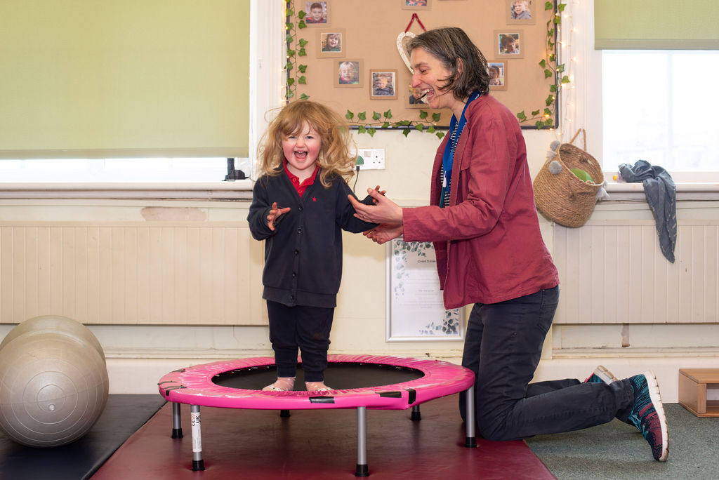

**Job Description**

|  |  |
| --- | --- |
| **Post title:** | General Teaching Assistant – Early Years |
| **Grade:** | CD |
| **Responsible to:** | Head Teacher / Senior Advanced Teaching Assistant / Higher Level Teaching Assistant/ SENCO/Inclusion Manager |
| **Staff managed:** | None |
| **Directorate:** | Children’s and Young People’s Service |
| **School name:** |  |
| **Job family:** | E - Education/School |
| **Date of issue:** | August 2023 |
| **Context Statement** | Postholder will work in an early years setting within a school or in a linked setting. Enhanced DBS clearance is required. This role involves spoken communications so a confident use of English Language is required. |

|  |  |  |
| --- | --- | --- |
| |  |  | | --- | --- | | **Job Purpose:** | **Support learning and development of groups of children, within the planning framework developed by the teachers.**  **Work collaboratively within the nursery team, complementing the work of teachers, and key workers.** | |

|  |  |
| --- | --- |
| Operational Management: | * Work within the framework of core provision plans, medium and short term plans to support children’s learning and development. * Make observations as required and contribute to the on-going observational assessment of children’s learning and development. * Engage with children to develop sustained, shared thinking, and promote the characteristics of effective learning, as defined in the EYFS. * Support children during lunchtimes. |
| Communications: | * Under the general direction of the teacher participate in establishing and maintaining effective relationships with pupils, parents/carers and with other agencies/professionals. * Communicate effectively with all pupils, families, carers and other agencies / professionals |
| Resource Management: | * Prepare and maintain the learning environment, with reference to provision plans and identified enhancements. * Carry out routine tasks to support the work of teacher, HLTAs and ATAs. * Support the use of ICT and adhere to relevant policies. * Participate in appraisal, training and other learning activities |
| Systems and information: | * Share information confidentially about pupils with teachers and other professional as required. * Pay due regard to professional boundaries, maintaining appropriate levels of confidentiality. * Participate in staff meetings. |
| Safeguarding: | * Carry out tasks associated with pupils’ personal hygiene, (including personal intimate care) and welfare, including physical and medical needs, whilst encouraging independence. * Be responsible for promoting and safeguarding the welfare of pupils in line with policy and legislation, raising concerns as appropriate. |

|  |  |
| --- | --- |
| Person Specification: |  |
| Essential | **Desirable** |
| Knowledge and Experience   * An awareness of child/young person’s development and learning * An understanding that children/Young people have differing needs * Experience appropriate to working with children in a learning environment | * Good understanding of child development and learning processes * Knowledge of Behaviour management techniques * Knowledge of Child Protection and Health & Safety policies and procedures * Knowledge of inclusive practice |
| Occupational Skills   * Good written and verbal communication skills: able to communicate effectively and clearly and build relationships with a range of staff, children, young people, their families and carers * Good reading, writing and numeracy Skills * The ability to converse at ease with customers and provide advice in accurate spoken English is essential for the post | * Basic ICT Skills |
| Behaviours   * [link](https://www.northyorks.gov.uk/your-council/our-role-structure-and-objectives#accordion-content-0-0) |  |
| Professional Qualifications   * Relevant NVQ Level 2 qualification or equivalent | * Relevant NVQ level 3 * Appropriate first aid training |
| Other Requirements   * To be committed to the setting’s policies and ethos * To be committed to Continuing Professional Development * Motivation to work with children and young people * Ability to form and maintain appropriate relationships and personal boundaries with children and young people * Emotional resilience in working with challenging behaviours and attitudes * Ability to use authority and maintaining discipline * Confidentiality * Demonstrable interpersonal skills * Ability to work successfully in a team * Flexibility | * Creativity |



**APPLYING FOR A JOB WITH NORTH YORKSHIRE COUNCIL**

**IMPORTANT ADVICE ON COMPLETING THIS APPLICATION**

Your application form plays an important part in your selection. Please ensure you address all the essential requirements listed in the specifications. The following advice should help you to complete the application form as effectively as possible.

**Data Protection**

The information that you state on this application form will be used by the school and the Council to consider you for a job vacancy. To find out about how we use your personal data for the purposes of recruitment please see our Privacy Notice at [www.northyorks.gov.uk/working-us](http://www.northyorks.gov.uk/working-us).

**Rehabilitation of Offenders**

The post you are applying for requires you to have an enhanced Disclosure and Barring Service criminal records check for work with children, with a barred list check if you work in regulated activity. This check for disclosure of criminal history will include spent convictions, pending prosecutions / current court proceeding and police enquiries.

Should you be shortlisted, you will be asked to disclose full details of your criminal history prior to your interview. This includes any information deemed relevant as part of Keeping Children Safe in Education which may arise in an online search undertaken on shortlisted candidates. This information may be discussed with you at your interview in order to assess job related risks, but we emphasise that your application will be considered on merit and ability and you will not be discriminated against unfairly. Failure to disclose this information will result in any offer of employment being withdrawn.

Please also see the policy statement on the Recruitment of Ex-offenders below.

**Information in Support of your Application**

Every post advertised is supported by a full person specification. The specification lists all the essential skills, experience and qualifications which are necessary for the job and the criteria against which you will be assessed, both through your application form and at interview.

As part of the application process, you may have been asked to demonstrate within this application form how you meet some or all of the criteria or key competencies outlined in the person specification. Rather than simply repeating your career history, look at the skills and experience required by the job and provide evidence that you possess them by giving **specific and detailed examples** which include a focus on outcomes and on your own contribution to the scenario. Try to use different and varied examples wherever possible.

When completing these sections, do not forget the skills and experience you have gained outside full-time work. Outlining your previous work experience or other responsibilities may help you to uncover skills which you have taken for granted and which are clear signs of your ability to do the job.

**Canvassing**

You must not try to influence an elected Council Member, any council employee or a member of the school governing body, to act in your favour, as this will disqualify you. If you are related to a Councillor, a Council employee or a governor you must indicate this in the relevant section of the application form.

**Policy Statement on the Recruitment of Ex-offenders (Source** [**www.gov.uk**](https://www.gov.uk/government/publications/dbs-sample-policy-on-the-recruitment-of-ex-offenders/sample-policy-on-the-recruitment-of-ex-offenders)**)**

1. As an organisation assessing applicants’ suitability for positions which are included in the Rehabilitation of Offenders Act 1974 (Exceptions) Order using criminal record checks processed through the Disclosure and Barring Service (DBS), this school complies fully with the DBS [code of practice](https://www.gov.uk/government/publications/dbs-code-of-practice) and undertakes to treat all applicants for positions fairly.
2. This school undertakes not to discriminate unfairly against any subject of a criminal record check on the basis of a conviction or other information revealed.
3. This school can only ask an individual to provide details of convictions and cautions that it is legally entitled to know about. Where a DBS certificate can legally be requested (where the position is one that is included in the Rehabilitation of Offenders Act 1974 (Exceptions) order 1975 as amended, and where appropriate Policy Act Regulations as amended) this school can only ask an individual about convictions and cautions that are not protected.
4. This school is committed to the fair treatment of its staff and potential staff, regardless of race, gender, religion, sexual orientation, responsibilities for dependents, age, physical/mental disability or offending background.
5. This school has this written policy on the recruitment of ex-offenders, which is made available to all DBS applicants at the start of the recruitment process.
6. This school actively promotes equality of opportunity for all with the right mix of talent, skills and potential and welcome applications from a wide range of candidates, including those with criminal records. Candidates are selected for interview based on their skills, qualifications and experience and criminal record information is only requested from short-listed candidates.
7. A disclosure is only requested from the DBS after a thorough risk assessment has indicated that one is both proportionate and relevant to the position concerned. For those positions where a criminal record check is identified as necessary, all application forms, job adverts and recruitment briefs will contain a statement that a DBS certificate will be requested in the event of the individual being offered the position.
8. This school ensures that all those who are involved in the recruitment process have been suitably trained to identify and assess the relevance and circumstances of offences.
9. This school also ensures that they have received appropriate guidance and training in the relevant legislation relating to the employment of ex-offenders, e.g. the Rehabilitation of Offenders Act 1974.
10. At interview, or in a separate discussion, this school ensures that an open and measured discussion takes place on the subject of any offences or other matter that might be relevant to the position. Failure to reveal information that is directly relevant to the position sought could lead to withdrawal of an offer of employment.
11. This school makes every subject of a criminal record check submitted to DBS aware of the existence of the [code of practice](https://www.gov.uk/government/publications/dbs-code-of-practice) and makes a copy available on request.
12. This school undertakes to discuss any matter revealed on a DBS certificate with the individual seeking the position before withdrawing a conditional offer of employment.