INFORMATION PACK
Altrincham Grammar School for girls
Geography Teacher
Full-time
Required 01 November 2021
Fixed-term maternity cover until 17th July 2022 in the first instance
Bright Futures Educational Trust
Bright Futures Educational Trust (The Trust) is a multi-academy trust set up in 2011. The Trust is made up of a richly diverse group of schools in Greater Manchester and Blackpool. We are passionate about working together within and beyond the Trust to achieve our aspirational vision: the best for everyone, the best from everyone. We are an organisation that is underpinned by values of: community, integrity and passion. In everything we do, we remember that we are accountable to the children, families and communities that we serve.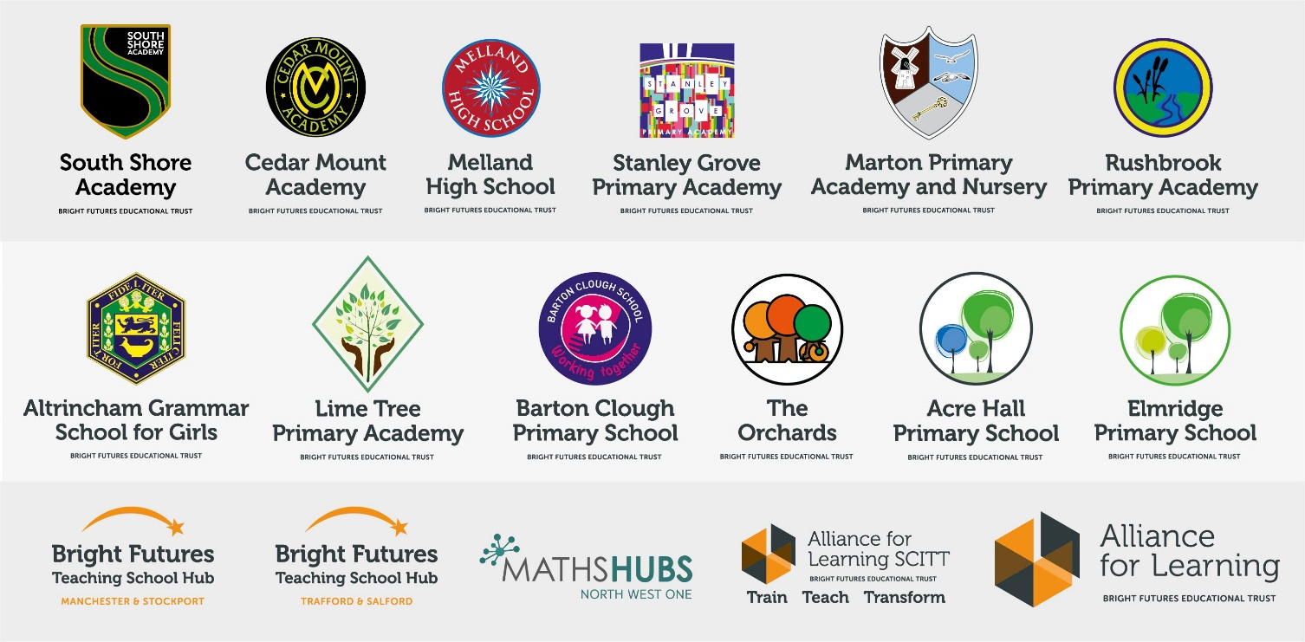
Our schools have their own identities and form one organisation and one employer, Bright Futures Educational Trust. Bright Futures’ Board of Trustees maintains strategic oversight of the Trust and delegates some of its responsibilities to the Executive Team, Principals and local governing bodies. We place a high value on integrity and probity and take seriously our accountabilities for making the best use of public money. How decisions are made is described in our delegation framework. You can find out more about the Trustees and the Executive Team on our website: http://bfet.co.uk/about-us/.

The central team, comprises the Executive Team: John Stephens, CEO; Edward Vitalis, Chief Operating Officer; Gary Handforth, Director of Education; Lisa Fathers, Director of Teaching School and Partnerships and Lynette Beckett, Director of HR & Strategy. The focus of these roles is to work with schools, providing high quality and timely guidance, leadership, challenge and support. In addition to the executive team, we have central operations for finance, HR, educational psychology and Digital Technologies. Please see our website brochure which explains our central operations: Working together for a Bright Future.
Bright Futures Development Network is another important outward facing component of our organisation. Underneath this umbrella we have 5 network hubs. ‘The Alliance for Learning’ (AFL) which provides school improvement services and CPD to over 700 schools (http://allianceforlearning.co.uk/); a North West Maths’ hub providing mathematics training and coaching to 500 schools: a SCITT (School Centered Initial Teacher Training) which is the largest in the North West. After significant national reforms to the teaching school policy, Bright Futures was designated with two new large-scale Teaching School Hubs in 2021. The areas we serve are Manchester, Stockport, Salford and Trafford.

Collaboration and strong relationships form one of the ‘commitments’ in our Strategy and all components of the Bright Futures’ family work closely together. Our Strategy was developed collaboratively and can be found on our website: Our Strategy.

Altrincham Grammar School for Girls
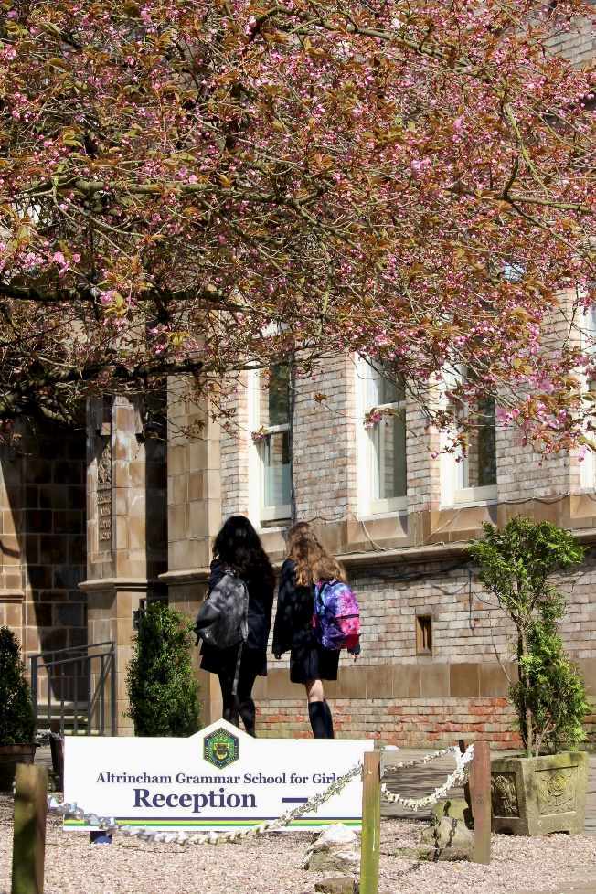
Altrincham Grammar School for Girls (AGGS) is a highly successful single sex 11 -18 academy in the South Trafford area. AGGS was in the first cohort of schools to be designated a national teaching school in 2011. AGGS is the lead school in ‘The Alliance for Learning’, which comprised schools of every type and phase, plus universities, throughout a wide geographical area. The impact of teaching school activities has been felt within the Trust and far beyond. We have a reputation for excellence regionally and nationally, of which we are very proud.

AGGS is committed to providing equal opportunity in recruitment and employment to all individuals. We will consider candidates without regard to race, ethnicity, gender, religion, sexual orientation and identity, national origin, age, military or veteran status, disability or any other legally protected status; and without discrimination based on socioeconomic, marital, parental or caregiving status, or any of the previously listed characteristics or statuses.

We value the diversity of our staff and reject any form of harassment, discrimination or victimisation. The Bright Futures Educational Trust vision is: ‘the best for everyone, the best from everyone’. To achieve this, we create and maintain a work environment and culture where people from different backgrounds, and with varying lifestyles, interests, opinions and responsibilities, treat each other with dignity and respect. It is a climate in which our staff feel safe and are inspired and motivated to be their best.

Our school is dedicated to sustaining and promoting diversity with respect to recruitment, promotion, training and general treatment during employment. We are actively seeking to extend the diversity of our staff. Furthermore, we welcome candidates who have not had previous experience of working in a grammar school.

We aim to ensure that our recruitment processes set up all candidates for success. At interview our aim is to provide a positive experience. We don’t want to catch anyone out, but rather to provide the opportunity for all candidates to be themselves and show us what they are capable of.

Why work for us?

We offer a great opportunity to join an organisation which really lives its values. Our working environment is very inclusive and whilst you can expect to be challenged in your role, you will be supported through professional learning, treated fairly and with dignity and respect. Please see the Equality, diversity and inclusion statement on our website: http://bfet.co.uk/vacancies

Terms and Conditions

Salary: Main Pay Range/Upper Pay Range. (Teachers school terms and conditions)
Location of work: Altrincham Grammar School for Girls
Pension: Teachers Pension Scheme: https://www.teacherspensions.co.uk/

Other: We offer salary sacrifice schemes for purchasing cycles and technology, through monthly interest free salary deductions.
How to Apply

We can only accept completed application forms, rather than CVs. This is because the regulatory guidelines of Keeping Children Safe in Education, require us to check various details of job applicants and an identical application format for each candidate enables us to do this.
Applications forms and criminal disclosure forms will need to be completed by 12 o’clock midday on 4th October 2021 using the link Teacher of Geography Application Form.

The selection will take place on 11th October 2021.

Applicants who are not contacted during this period may assume that they have not been successful but are thanked for their interest. Unfortunately, we are unable to provide feedback to unsuccessful applicants who are not called for interview.

Keeping Children Safe in Education

Bright Futures Educational Trust is committed to safeguarding and promoting the welfare of children and young people and we expect all staff and volunteers to share this commitment. This post is exempt from the Rehabilitation of Offenders Act 1974; pre-employment checks will be carried out and references will be sought for shortlisted candidates and successful candidates will be subject to an enhanced DBS check and other relevant checks with statutory bodies.

Data Privacy

You can the details of how we use the personal data that you provide us with in our Job Applicants’ privacy notice on our website: http://bfet.co.uk/wp-content/uploads/2018/07/BFET-Applicant-privacy-notice-002.pdf
JOB DESCRIPTION

Geography Teacher (Maternity cover)

In geography, students are taught in groups without any setting. The curriculum is designed to be relevant and engaging. The department follows the national curriculum at Key Stage 3, the Edexcel B specification at GCSE and the Edexcel specification at A Level. Uptake in the subject is high and attainment is excellent.

In 2019, 39% of students achieved a grade 9 at GCSE and 82% of students achieved grades 7-9. At a Level, 25% of students achieved an A* and 100% of students achieved grades A*-B.

The Geography Department is housed in a contemporary building, where it has three dedicated teaching rooms and shares an office with the History Department. Each teaching room has a computer and a data projector.

The department integrates a wide range of fieldwork into the curriculum. Key Stage 3 includes day visits to North Wales and Salford Quays. GCSE includes day visits to the Lake District and Manchester, and A Level includes a four day residential trip to North Yorkshire. The department has also run a five day fieldtrip to Iceland in recent years.

School-wide Responsibilities
- Being aware of and acting upon relevant school policies and, in particular, those associated with child protection/safeguarding children and health and safety issues.
- Being responsible for maintaining a clean and tidy environment.
- Attending relevant meetings as required.
- Acting as a role model for the pupils in school.
- Acting as an ambassador for school and ensuring that the school’s high standards are promoted at all times.

Additional Specific Responsibilities
- Carry out duties of a form tutor.
- Support the school in its open evenings and award evenings.
- Support the school in its Entrance Examination.

General Duties
- Carry out a share of supervisory duties in accordance with published schedules. Fulfil the conditions of employment of school teachers as laid down in the Pay and Conditions Document.
- Any other relevant duties requested by the Principal.

PERSON SPECIFICATION

 | Essential | Desirable
Qualifications,  Educational,  Training | - Good Honours Degree and/or teaching qualification in geography  - Qualified teacher status  - Recent relevant in-service training
Relevant  Experience | - Successful teaching experience, including the teaching of geography at Key Stage 3 and GCSE  - Contributions to the work of a geography department, including lesson planning | - Experience of teaching geography at advanced level  - Experience as a form tutor
Knowledge, skills,  abilities | - Excellent, up to date, geographical knowledge and understanding  - An enthusiasm for geography and the ability to generate this in others  - High standards of geography teaching and learning in the classroom  - Very good oral and written communication skills  - Ability to manage a class effectively and promote excellent behaviour  - Excellent ICT skills, including some understanding of GIS  - Ability to work as part of a team  - Ability to plan, organise, review and adapt  - Willingness to contribute to extra-curricular geography activities
Teaching School | - A commitment to further training and a willingness to participate in the facilitation programmes  - Willingness for lessons to be observed as part of our school monitoring processes and teaching school brief (e.g. learning walks).  - Willingness to be engaged in school to school support and other collaborations
Safeguarding | - Commitment to demonstrating a responsibility for safeguarding and promoting the welfare of young people.
Others | - Commitment to the aims and ethos of the school  - Willingness to be involved in fieldwork/residential visits  - Willingness to be involved in school working parties or research groups  - Commitment to pastoral care  - A commitment to maintaining confidentiality and discretion inside and outside school  - Willingness to be involved in extra-curricular activities  - Flexibility and a willingness to be involved in change  - A positive approach to challenges, which seeks solutions to problems and addresses difficulties with cheerfulness and good humour

