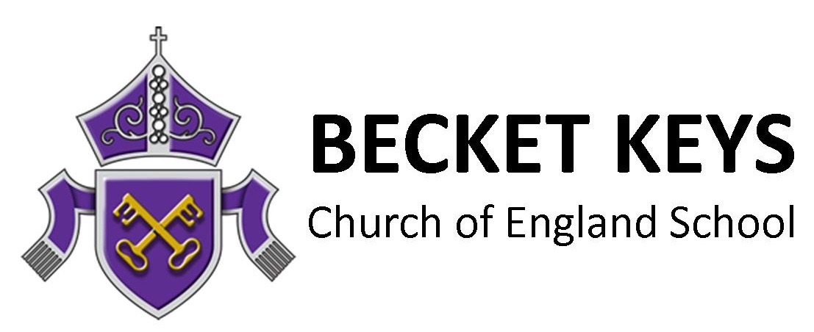

Geography Teacher MPS Fringe Area Start September 2022 Full Time

The Post

It is an exciting time at Becket Keys Church of England School (Outstanding, 2014). We are working hard to build upon the exam successes of our founding cohorts, whilst also establishing our new 6th Form into its sixth year.

As part of our growth plan, we are seeking a teacher for our highly successful Geography Department. If you can deliver rigorous and engaging teaching to students, we want to hear from you! ECTs would be welcome to apply; we have an excellent track record of supporting teachers in the early stages of their career. However, we also would benefit from someone joining the team who has recent A level teaching experience, so more experienced staff are also encouraged to consider this opportunity.

Our Geography curriculum is extremely engaging to teach and can be viewed on the school website. All of our students study either History or Geography as a compulsory GCSE and thus the profile of this subject is very strong in the school.

The appointee will be committed to our high expectations and core values – we welcome applications from teachers irrespective of their faith or belief. However, we ask for applicants to appreciate and respect the beliefs of others and have strong moral principles.

Staff of the school benefit from priority admission for their children. Our admissions policy effectively guarantees staff a place in the school for their children. With over 800 applications for our 150 places each year, this is a significant perk! In addition, staff will be provided with a comprehensive induction programme and laptop, childcare vouchers are available, and childcare is available at a neighbouring provision with discounted rates for staff members.

For further information about our school, please visit our website at www.becketkeys.org. Please email us at vacancies@becketkeys.org if you would like to discuss this role further. Visits are encouraged, so please email us for details of our forthcoming tours.

GCSE Results 2019:

Progress 8: +0.32

Attainment 8: 55.9 (National Average: 46.5)

% Achieving grade 5 or above in English and Mathematics: 59% (National Average 43%)

Ebacc Average Points Score: 5.12 (National Average: 4.06)

To Apply
Please complete both our application form and email it with a personal statement to vacancies@becketkeys.org.

Becket Keys is committed to safeguarding and promoting the welfare of children and young people. The successful candidate will be subject to an enhanced DBS check.
Closing date:

Noon, Friday 20th May. Please apply promptly as interviews will held as soon as possible.

