**Information for Applicants**

**Geography Teacher (Maternity Cover)**

**T1 – T9 (£28,000 - £43,685)**

**1.0 FTE**

**Mat Cover Contract**

**Required 1st September 2023**

**Closing date: 9am Monday 27th March 2023**

**Interview date: TBC**

**Welcome to The Bishop Fraser Trust from the Chief Executive, Tania Lewyckyj**

The Bishop Fraser Trust is Multi Academy Trust which was set up on the 1st December 2017. Our family of schools are as follows;

* St James’s Church of England High School (11-16)
* Canon Slade School (11-18)
* Bolton St Catherine’s Academy (3-16)
* Bury Church of England High School (11-16)
* St Catherine’s Church of England Primary (Horwich) (3-11)

The Trust’s vision is based on our strongly held Christian values: **“To allow all children to experience ‘Life in all it’s fullness’, no matter what their starting point.”** We offer a high quality, inclusive and distinctive education within a caring and nurturing environment based on our Christian values, recognising the uniqueness of each child.

Our schools are situated in Bolton and Bury. We are an outward facing Trust and constantly look to learn and collaborate with others. We also have an excellent provision via our Train Teach Lead Partnership (TTLP), which offers excellent CPD and school to school support. Our links with Manchester Diocese, GMLP and the Bolton Learning Partnership continues to be strong.

We are now developing our primary sector and hope to welcome at least two more primary schools over the next 12 months.

We became a Trust to secure the special nature of our individual schools as we do not think that one size fits all. We also wanted to secure our ethos and distinctiveness, enabling us to work together and to become the Trust of choice for local families and staff. Our employees are very important to us as we rise or fall by the professionalism and dedication of our staff.

It is an absolute privilege to have the opportunity to make a difference in the lives of our young people. From 2 to 18 years old, we have the potential to enhance life chances in all of our schools and improve the local communities at the same time. Our focus is on more than exams; it is about the development and wellbeing of the whole child, allowing them to effectively thrive in this fast-moving world in which we live. If this is the first time you have heard about us, we hope you are inspired and feel that you could thrive within our positive and aspiring Trust.



**Tania Lewyckyj**

**Chief Executive Officer**

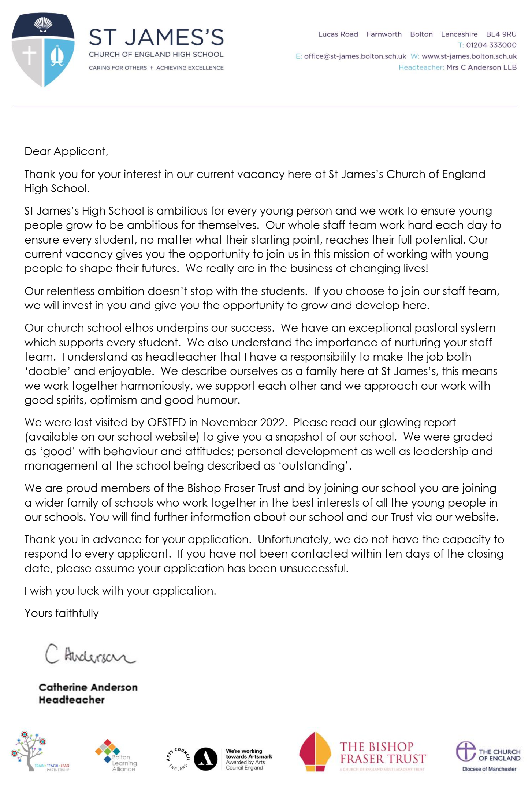

**About St James’s Church of England High School**

**St James’s Church of England High School**

St James’s is a Church of England Secondary School, judged ‘Good’ with Outstanding features by Ofsted.

The school motto of **‘Caring for Others † Achieving Excellence’** is central to everything we do. When young people join the school, they become part of the school family and through this develop their potential through academic success, personal and social development and self -discipline, based on the beliefs and values of Christian faith.

The school curriculum offers a personalised approach, meeting the needs and abilities of each young person, whether they are high attainers or have special educational needs.

It is very important that students feel confident and secure at school and display the Christian values of respect for self and others. The whole school, including its Pastoral Care provision, was rated ‘Outstanding’ by Ofsted and the school takes pride in the close links it has with parents and carers. Work within the community, locally and internationally, allows students to see how they can take an active role in society and make a difference in the world.

Pupils and parents are expected to be fully supportive of the Christian principles which form the foundation of the education and care provided. The school intake reflects the commitment of parents to our Christian foundation and also recognises other faiths and service to others.

**Department Information**

**Geography Department**

The Geography department is currently made up of two full-time teachers and one part-time teacher, with additional lessons delivered by two SLT with a specialism in geography. It is a committed team with experienced teachers.

The department is housed in its own block which comprises of three classrooms. All classrooms have an interactive screen, visualiser and whiteboard. Most staff enjoy the benefit of their own teaching room. As the department expands, staff are required to swap or share rooms to meet timetabling needs. The department is well resourced with digital/interactive resources, a wide range of texts along with a large stock of commercially and school produced materials.

Geography is a dynamic and thought-provoking subject at St James’s, covering current global issues affecting both humans and the environment. Across our curriculum, students will take a worldwide journey to discover; the challenge of natural hazards, the management of urban Issues, the impact of globalisation/development, the changing physical landscape, climate change and weather and climate.

Throughout this journey our aim is to create “Good Geographers”. Knowledge is built to widen understanding of issues that impact the world that our pupils are growing up in. Underpinning this is Geography SWAT. We develop pupils’ ability to Speak, Write, Act and Think like a Geographer. This includes; map skills, graphical skills, literacy, numeracy and the skill of revision. These skills are embedded throughout the curriculum and are an integral part of the geography department drive to develop not only skilled geographers, but also lifelong learners; facilitating our pupils to strive for ‘Achieving Excellence’. Our curriculum aims to foster a love for the subject by delivering lessons that are engaging, challenging and examine the misconceptions / stereotypes that can often blur our view of the wider world; supporting the school’s central ethos of ‘Caring for Others’.

The geography teaching schedule is currently Y7, 3 hours per fortnight, Y8 4 hours per fortnight, Y9 3 hours per fortnight, Y10 4 hours per fortnight and Y11 5 hours per fortnight. The department’s success has been proven over a period of time. 9-4 are consistently above national average and 9-7s % remain one of the highest in school. In 2022 81% achieved 9-4 in Geography, with 28% of pupils achieving a 9-7 grade. Geography is proud of its high GCSE numbers which for next year are in excess of 120 pupils.

Central to the work of the Geography department is the student. As a team the department collaborates closely to deliver challenging, innovative, interesting and fun learning experiences to foster a love of geography, a genuine curiosity of the world and academic progress in the subject. The core philosophy of the department is to develop a climate for progress for all pupils through developing strong, caring relationships with pupils, an environment where to fail is seen as an opportunity to learn and students are supported to develop their knowledge and understanding.

Underpinning all of the fantastic work in the geography department is the staff. The department works collaboratively on all aspects of school life and supports each other in a caring environment that is committed to excellence.

**Staff Testimonials at St James’s Church of England High School**

We asked staff if they would be willing to share their views on working at St James’s Church of England High School with others who may be interested in joining our family, here are a few of their comments:

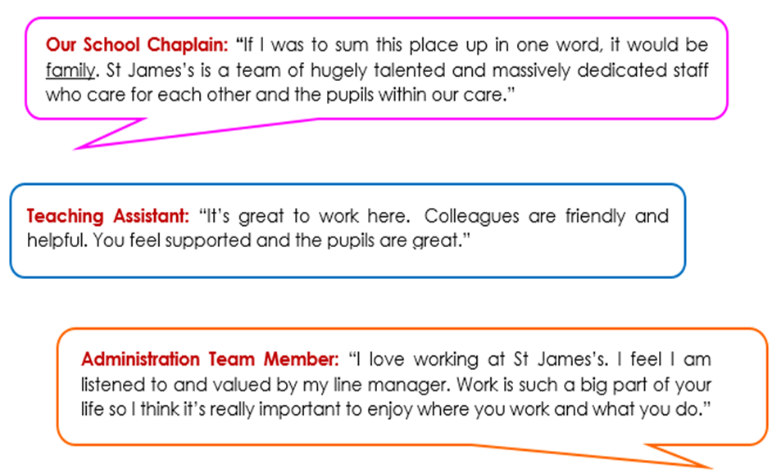

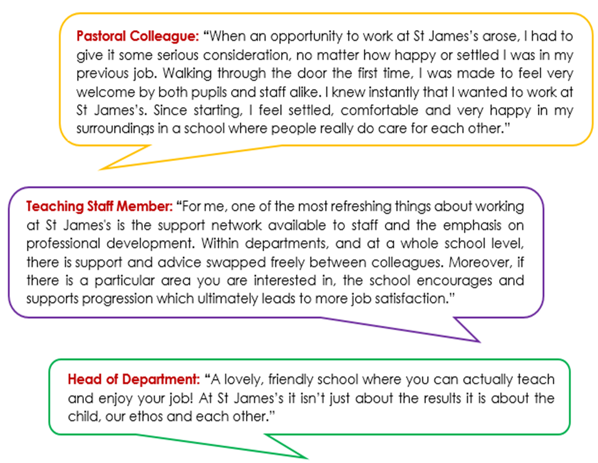

**How to apply**

We hope that you have enjoyed reading about The Bishop Fraser Trust and our school and that you will feel able to apply for this post.

We aim to recruit staff who:

* + are excited by their role and by the prospect of working with young people, even those who are less well motivated;
  + love the processes of learning and teaching and are keen to continually develop their own skills;
  + recognise that teaching can be a demanding job but react positively to those demands with resilience;
  + wish to make a real difference in the lives of others;
  + will subscribe to the ethos of the Trust and ‘go the extra mile’ in terms of time and commitment to get the very best from our young people;
  + are quick to praise and slow to criticise; and are not afraid to admit to seeing themselves as potential leaders of the future.

**To apply, please complete the application form attached and email this to** [**recruitment@thebishopfrasertrust.co.uk**](mailto:recruitment@thebishopfrasertrust.co.uk)

Please do not send CV’s or open references as part of your application as these will not be considered.

It is important that you provide a complete employment history from when you left full time education. If the application form is not fully completed or has unexplained gaps in your employment history, your application will not be considered. Copies of your qualifications will be required at the interview stage; please do not send these with your application.

Please also include within the body of your application form **a statement of no more than two sides of A4** to explain why you want to work at our school, why you are the best candidate for this post and what you would contribute to our Trust and school, with examples from your recent work if possible. We are keen to learn about your impact and your educational philosophy.

We will not be able to consider late applications.

In accordance with the General Data Protection Regulations, the details provided in the application form will be used for selection and interview procedures, and for employment records if your application is successful. Our recruitment privacy notice with further details is available both on our school website.

If you do not hear from the school within two weeks of the closing date, then please assume that your application has been unsuccessful on this occasion.

The school has an Equal Opportunities Policy**.**  If you are disabled, please give details of how we can ensure that you are offered a fair selection and interview process or if you would prefer, please contact [recruitment@thebishopfrasertrust.co.uk](mailto:recruitment@thebishopfrasertrust.co.uk)to discuss any requirements.

Successful candidates will be asked to provide, prior to taking up the appointment, documentary evidence (including National Insurance number) showing their entitlement to work in the UK. We will also carry out reference checks, an enhanced DBS and declaration of health check.