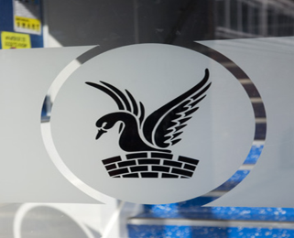
Carshalton Boys
Sports College

About our school
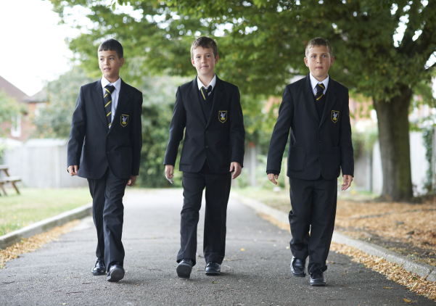
Carshalton Boys Sports College is a popular, oversubscribed 11-19 comprehensive school offering places to students of all aptitudes and abilities.

Our students make exceptional progress and their academic attainment is outstanding. While these are important we also understand that the development of the whole child is crucial and this is a major emphasis in our school. We ensure that our students take PRIDE in everything they do whilst developing the skills and attributes that prepare them for all aspects of their lives.

We have high expectations in terms of behaviour, with a firm, fair code of conduct which is applied consistently and that is understood by students, teachers and parents. Positive, high profile rewards mean that our students develop good working relationships with their teachers, leading to outstanding success at every level.

What we teach the boys
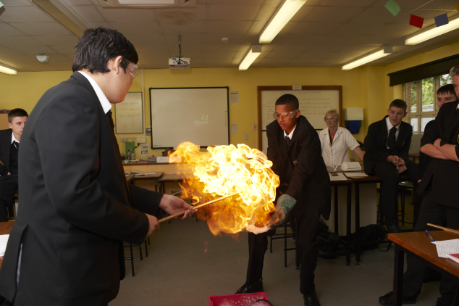
We offer a broad and balanced curriculum designed to meet the needs of every individual, and personalised to ensure that every student achieves success. Our curriculum ensures that students are challenged to meet high targets, and allows progression to sixth form and beyond. Many of the students in our rapidly expanding sixth form go on to study at high calibre, red-brick universities.

Our extracurricular programme includes a wide variety of Arts and Sports activities as well as those in the fields of Science, Technology and Maths. Residential and day trips include skiing, surfing, European city visits, art galleries, concerts, theatre and field trips around the UK.

Our school is a very special place and both staff and students are proud of the ethos and culture we have developed together. If you would like to take the opportunity to join us we welcome applications from boys of all abilities into years 7-11, and from girls and boys in to our sixth form.

KS3 - Year 7
All pupils study the same curriculum in year 7. Year 7 follows a two-week timetable.

Curriculum provision across the two-week timetable is English (7 hours per fortnight), Mathematics (7 hours), Science (7 hours) and PE (5 hours). Pupils follow a carousel of Technology subjects (4 hours). The subjects within this carousel include Food Studies, Design & Technology and Computer Science. Pupils follow the same subject for ten weeks before changing. Additionally, pupils are taught Modern Foreign Languages (4 hours per fortnight), Geography (3 hours), History (3 hours), Performing Arts (4 hours), Social Science (3 hours), Art (2 hours) and PSHE (1 hour).

KS3 – Year 8
All pupils study the same curriculum in year 8. Year 8 follows a two-week timetable.

Curriculum provision across the two-week timetable is English (7 hours per fortnight), Mathematics (7 hours), Science (8 hours) and PE (5 hours). Pupils follow a carousel of Technology subjects (4 hours). The subjects within this carousel include Food Studies, Design & Technology and Computer Science. Pupils follow the same subject for ten weeks before changing. Additionally, pupils are taught Modern Foreign Languages (4 hours per fortnight), Geography (3 hours), History (3 hours), Performing Arts (3 hours), Social Science (3 hours), Art (2 hours) and PSHE (1 hour).

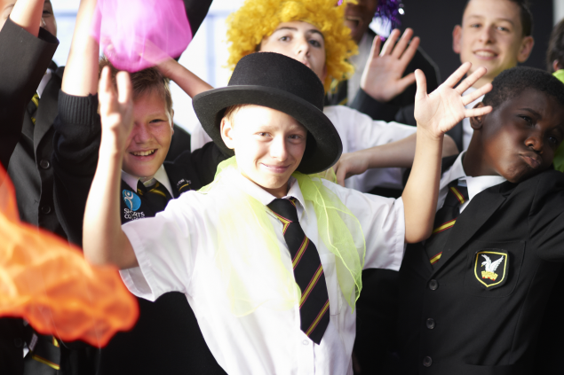
KS4 Year 9
Pupils begin their GCSE or Vocational subjects in year 9 and follow different pathways dependent on the choices that they made in year 8. Year 9 follows a two-week timetable.

Curriculum provision across the two-week timetable is English (8 hours per fortnight), Mathematics (8 hours), Science (9 hours) and PE (5 hours). Pupils are also separated into 4 option blocks and follow one subject in each block. Each subject is taught for 5 hours across the fortnight. The subject choices include at least one Ebaccalaureatte choice plus the option of History, Geography, Computer Science, Spanish, French, IT, Construction, Engineering, Food Studies, Product Design, Graphical Design, PE, Music, Art, Drama, Citizenship, Psychology, Business Studies, Photography, PRE and Media Studies. Pupils with SEND opt for the SEN module in one of the option blocks. Additionally, pupils are taught PSHE (1 hour).

KS4 Year 10
Pupils continue to follow different pathways dependent on the GCSE or Vocational subject choices that they made. Year 10 follows a two-week timetable.

Curriculum provision across the two-week timetable is English (8 hours per fortnight), Mathematics (8 hours), Science (7 hours) and PE (2 hours). Pupils are also separated into 4 option blocks and follow one subject in each block. Each subject is taught for 6 hours across the fortnight. The subject choices include at least one Ebaccalaureatte choice plus the option of History, Geography, Computer Science, Spanish, French, IT, Construction, Engineering, Food Studies, Product Design, PE, Music, Art, Drama, Sociology, Citizenship, Business Studies, Psychology, Photography, Economics and Media Studies. Pupils with SEND opt for the SEN module in one of the option blocks. Additionally, pupils are taught PSHE (1 hour).

KS4 Year 11
Pupils continue to follow different pathways dependent on the GCSE or Vocational subject choices that they made. Year 11 follows a two-week timetable.

Curriculum provision across the two-week timetable is English (8 hours per fortnight), Mathematics (8 hours), Science (9 hours) and PE (2 hours). Pupils are also separated into 4 option blocks and follow one subject in each block. Each subject is taught for 6 hours across the fortnight. The subject choices include at least one Ebaccalaureatte choice plus the option of History, Geography, Computer Science, Spanish, French, IT, Construction, Engineering, Food Studies, Product Design, PE, Music, Art, Drama, Sociology, Citizenship, Business Studies, Photography and Economics. Pupils with SEND can opt for the SEN module in one of the option blocks. Additionally, pupils are taught PSHE (1 hour).

In Year 11 pupils also receive a period 6 lesson in each subject on Mondays, Tuesdays, Wednesdays and Blue Thursdays.

KS5 – Year 12 & Year 13

Pupils follow different pathways dependent on their entry profile, ambition, and career projections. A Level and vocational qualifications are taught in a variety of subject areas. Year 12 and 13 follows a two-week timetable. Each subject is taught for 8 lessons per fortnight. Most students select three subjects to study and some choose four.

A Level subjects include; Art, Biology, Chemistry, Criminology, Economics, English Literature, Further Mathematics, Geography, Government & Politics, History, Mathematics, Media Studies, Music, PE, Photography, Physics, Product Design, Psychology, Sociology and Spanish. Vocational subjects include; Applied Science, Business Studies, Information Technology and Sport.

Each student will be involved in Study Skills lessons (1 hour) as well as having timetabled Private Study sessions. Pupils who did not gain a grade 4 in English or Mathematics GCSE will re-sit the qualification as part of their programme.

CBSC links with Chelsea Football Club, and leads a football academy in conjunction with them. Students can trial at the beginning of Year 12 to be part of this programme which is inclusive of their overall timetable.

Expectations



At Carshalton Boys we are proud to have an ethos rooted in our WE BELIEVE principles which promote inclusivity, kindness and aspiration

We encourage all our students to be the best version of themselves. We want students to feel proud of their achievements at school and their contribution to our whole school community

KS4
English GCSE 4+ = 71% Maths GCSE 4+ = 75%
English GCSE 5+ = 52% Maths GCSE 5+ = 54%
English GCSE 7+ = 17% Maths GCSE 7+ = 19%

English and maths GCSE 4+ = 66%
English and maths GCSE 5+ = 43%
English and maths GCSE 7+ = 11%

KS5 (100% pass rate)
A*-C / (M+) = 89% / 82.7%
A*-B / (M+) = 52% / 82.7%
A*/-A / (D/D*) = 22% / 74%
A* / (D*) = 7% / 32%

What Ofsted say about our school
An inspection of Carshalton Boys Sports College was carried out on 18th & 19th October 2022. A summary of their findings are listed below:
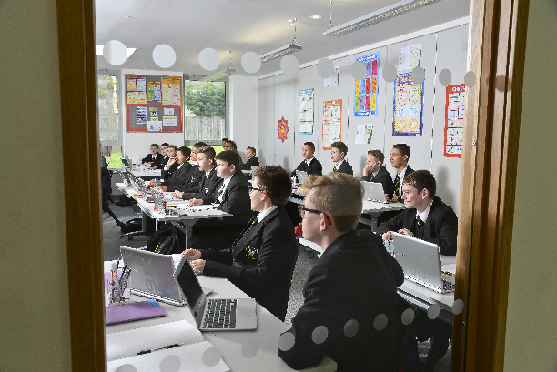
- Parents and carers speak very highly about the school. Almost all would recommend it
- They emphasise the high quality of pastoral care and support given to their children
- Pupils are safe, happy and looked after well
- Pupils behave well and show positive attitudes to their learning
- Staff enjoy working with pupils
- Sixth Form students feel well supported with their academic studies
- A warm atmosphere
- CBSC Power is an active group of pupils
- In most subjects there are ambitious expectations of what pupils will learn
- Teachers have strong subject knowledge, give clear explanations when presenting information to pupils
- Leaders teach pupils about the world around them
- Staff morale is high
- Staff receive lots of training to develop their teaching expertise

The full inspection report can be found here:

https://www.carshaltonboys.org/news/?pid=8&nid=2&storyid=282

Extra-Curricular Activities

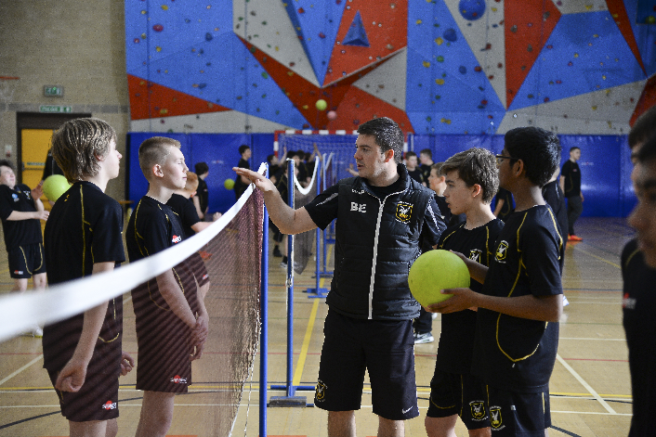
We endeavour to put on a full and inclusive extra-curricular programme of sports and activities that caters for all abilities and interests. We dominate England’s Handball scene, sending six UK representatives to Sweden recently to play for the national Handball team. Our work in art, drama, media studies and music has brought awards, excellent public exam results and uncommonly high levels of participation throughout the school. Our boys benefit from activities as varied as helping to design new playground facilities to visiting Ecuador and campaigning against the closure of a local hospital. Our staff work creatively to make sure that students can access many activities both inside and outside the classroom which are designed to increase confidence and responsibility and to provide experience that would not normally be available.

Pastoral Organisation
The pastoral care offered to our students at Carshalton Boys Sports College is designed to support them in becoming independent, enquiring and creative young people, enabling them to take PRIDE in themselves, their work and their school. We aim to provide a personalised learning experience for our young people that responds to each person's needs, talents and interests.

Our experienced and talented pastoral teams play a central role in supporting every student's social and academic development.

​Students have a tutor and tutor group who they see every day and who form their immediate family in school. Each year group has a Learning Coordinator and Pastoral Support Officer whose role is to coordinate the activities of the group, support the tutor team and take responsibility for the welfare of group members.

The school is arranged into three sections:

Lower School – Years 7 & 8
Upper School – Years 9 & 10
Senior School – Years 11, 12 & 13

The Principal, supported by a Vice-Principal, three Deputy Principals three Assistant Principals, are responsible for the total welfare of each student in the school.

Working with us
Carshalton Boys Sports College (CBSC) is on a mission to find passionate and inspirational staff to join us. If you would relish the challenge of assisting us in leading the school in the next stage of its journey towards excellence we look forward to hearing from you. Join us on our growth and mission to make a real difference in children’s lives and help them to achieve to the best of their abilities.
Benefits
- Pleasant working environment with easy access from London
- Access to Employee Assistance Programme
- Wellbeing Afternoons (where staff, subject to cover requirements and attendance, can leave school early for one afternoon in the academic year
- Staff without responsibilities allowed to undertake PPA from home
- Excellent sporting facilities
- Cycle to Work scheme
- Childcare Voucher Scheme
- Membership of Teachers Pension Scheme/Local Government Pension Scheme
- First class training and development opportunities with a bespoke CPD programme designed to address individual, departmental and whole-school development needs.
- An outstanding two year programme to support Early Career Teachers.
- Opportunities to develop; academically and pastorally
- Supportive, friendly staff and a committed and loyal Trust Board.
