JOB DESCRIPTION
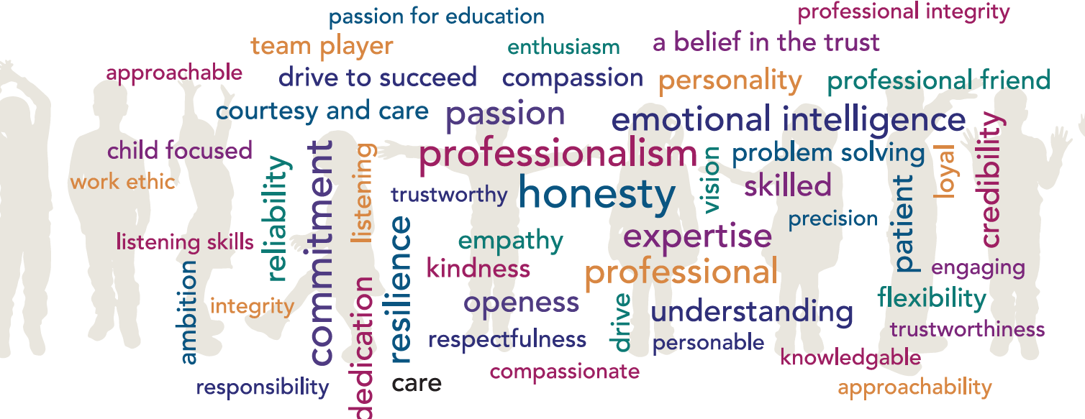

Job Title: Governance Professional to the Trust Board

Grade: Grade 6

Accountable to: Chair of Trustees and CEO

Place of Work: Hamwic Education Trust head office and other appropriate venues

FTE: 20 hours per week during term time plus 4 weeks during school holidays, spread over the year as required

Role Remit

- To act as Governance Professional to the Trust Board, Members and all other sub committees of the Trust Board other than the Local Governance Committees (LGCs) providing advice and guidance on governance, constitutional and procedural matters.
- Provide effective organisational and administrative support to the Trust Board and relevant sub committees (as noted above) ensuring the Board of Trustees is properly constituted and works in compliance with the appropriate legal and regulatory frameworks and understands the potential consequences of non-compliance.
- Work with the Head of Governance on the strategic development and alignment of robust governance arrangements at all levels across the Trust. This includes the Scheme of Delegation, Trust governance procedures, the Trust code of conduct and terms of reference.
- Work with the Deputy CEO on company secretarial activity in relation to Trust Board governance.

Key Responsibilities:

To act as clerk to the Trust Board, relevant Sub Committees and the Members:
- Prepare the agendas for the Trust Board, the above Committees and Members meetings, in conjunction the CEO, Trust Board Chair, Committee Chairs and relevant members of the Senior Leadership Team.
- Ensure the accurate and timely preparation and distribution of meeting papers, actions and minutes for all Board, Committee and Members meetings.
- Attend all Board, Committee and Members meetings to ensure quoracy, take the minutes and record any actions; follow up on agreed action points with those responsible and advise the appropriate chair of progress.
- Provide impartial advice to the Trust Board, the specified Committees and Members on governance matters and act as first point of contact regarding procedural and other related matters seeking advice from third parties where necessary.
- Develop and implement annual governance agendas and plans for the Trust Board, Committees and Members meetings.
- Work closely with the DCEO/CFO and Chair of the Audit & Risk Committee to ensure the maintenance and reporting of the Trust risk register.
- Regularly review terms of reference for both the Board and the above specified Committees
- Work closely with and support the Chair of the Trust Board as required.

To ensure that the Trustee Board and relevant Sub Committees are properly constituted and function effectively:
- Advise the Board on succession planning for Trustees and Members, including the impact on the Board’s skills mix and Expert Trustee roles.
- Work with the Chair on the recruitment of Trustees and Members.
- Upkeep and maintain the register of business interests and terms of office for Trustees and Members liaising with the Head of Governance to ensure this information is updated at Companies House.
- Ensure all new Members and Trustees receive appropriate induction and they have access to appropriate documentation, including Code of Conduct.
- Support Trustees in the completion of their annual training requirements as well as developing responses to ad hoc training needs, in conjunction with relevant parties both internal and external.

Ensure that the Trust remains compliant:
- Undertake a monthly review of the Trust website to ensure it holds all statutory documentation and information relating to governance matters and that this is up to date.
- Support the DCEO in carrying out company secretarial duties in relation to Trust Board governance.
- Work with the Head of Governance on the annual review of the Scheme of Delegation and present to the Board and Members for approval.
- Ensure that any statutory filings, in relation to governance, are filed with Companies house, Education & Skills Funding Agency, The Department for Education and any other stakeholder organisation.
- Be responsible for updates, specific to Trustees, at Companies House and GIAS as required.
- Take ownership of policy review, in relation to any policies specific to the Trust Board.
- Know where to access appropriate legal advice and support (e.g. charity and company law) and seek necessary advice and guidance from third parties, including changes to Trustee responsibilities as a result of changes in relevant legislation.

Other Duties:
At an appropriate level, according to the job role, grade and training received, all employees in HET are expected to:
- Support the aims, values, mission and ethos of HET and participate to the one team approach, All About the Child and What About Sam?
- Attend and contribute to staff meetings and training days as required, and identify areas of personal practice and experience to develop
- Take appropriate responsibility for safeguarding and children’s welfare and be aware of confidential issues linked to home/child/teacher/academy and keep confidences appropriately
- The post holder at all times, whether or not in the employ of our schools or HET and except where such information is in the public domain maintain the strictest secrecy with regard to the business affairs of our schools or HET and its customers/stakeholders, products and product lists
- Be aware of health and safety issues and act in accordance with the Health and Safety Policy
- To liaise with other staff, contractors and outside agencies/organisations as appropriate

The post holder may be expected to carry out duties other than those given in the job description where the level of responsibility is similar, and he/she has appropriate qualifications or received appropriate training to carry out these duties.

PERSON SPECIFICATION

Our Managed Service Team have identified the traits above that they feel any Hamwic employee should have, with professionalism, honesty, emotional intelligence and commitment being the top traits.

Qualifications:

- Expected to hold a level four qualification or equivalent and hold or be working towards a post graduate degree level governance qualification.

Experience:

Skills and Knowledge:

- Works effectively and builds strong relationships with multiple stakeholders, including the Chair, Board of Trustees, Executive Team, Head of Governance (Lead Governance Professional), Senior Leaders, School Leaders, LGC Governance Professionals, Governors and other colleagues.
- Knowledge of the English schools’ system and awareness of current thinking and thought leadership relating to governance of schools and academy trusts (Desirable).
- Has working knowledge of governance law and practice in state schools and ideally understanding of charity law and governance in other sectors (Desirable).
- Excellent presentation and facilitation skills.
- Creative thinker who can also influence others productively.
- Strong listening, verbal, written and IT skills.
- Keeps knowledge up to date with regular CPD, engaging with networks etc.
- Understands wider compliance principles such as data protection, safeguarding etc. (Desirable)

Personal Attributes:

- Can work independently, planning ahead and making decisions, knowing when to check in with others.
- Calm and resilient under pressure.
- Organised and both literate and numerate.
- High personal integrity and commitment to the principles of public life.
- A deep commitment to the vision, values and ethos of HET
- A strong team player with good interpersonal skills and the ability to work effectively as part of a growing organisation
- Ability to work well under pressure and in a calm, professional manner
- High levels of tact, diplomacy, discretion, persuasion and respect for confidential information

