ADVERT
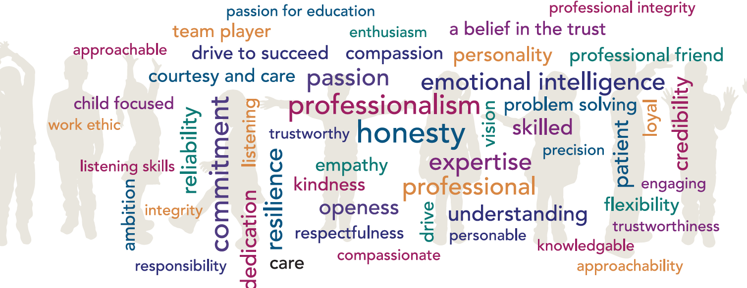
ROLE: Governance Professional to the Trust Board
LOCATION: Hamwic Education Trust head office and other appropriate venues
FTE: 20 hours per week during term time plus 4 weeks during school holidays, spread over the year as required (43 working weeks)
SALARY: Grade 8 (£34,834 to £38,223) FTE. ACTUAL SALARY - £17,924 to £20,184
CLOSING DATE: Friday 26th July 2024
INTERVIEW DATE: Wednesday 14th August 2024
START DATE: September 2024

With the creation of this new post, an exciting opportunity has arisen for a Governance Professional to the Trust Board. Working with the Chair of the Board of Trustees you will help develop the working and effectiveness of the Board in improving educational outcomes for over 12,000 students.

JOB/PERSON SUMMARY:
Acting as the Governance Professional to the Trust Board, Members and all other sub committees of the Trust Board you will provide advice and guidance on governance, constitutional and procedural matters.

Providing effective organisational and administrative support to the Trust Board you will ensure the Board of Trustees is properly constituted and works in compliance with the appropriate legal and regulatory frameworks and understands the potential consequences of non-compliance.

In liaison with the Head of Governance you will work both on the strategic development and alignment of robust governance arrangements at all levels of across the Trust.

If you are a positive, flexible individual with strong communication skills, and would relish the opportunity to support our Trust Board, Members and Sub Committees of the Trust Board, we would like to hear from you.

WE ARE SEEKING A PROFESSIONAL INDIVIDUAL WHO:

- Has excellent presentation and facilitation skills
- Has strong listening, verbal, written and IT skills
- Is a creative thinker who can also influence others productively
- Is able to prioritise their workload
- Is able to work effectively and independently, planning ahead and making decisions
- Displays high levels of tact, diplomacy, discretion, persuasion and respect for confidential information
- Must have excellent organisation and planning skills.

WE CAN OFFER YOU:

- Excellent CPD opportunities and Training and Development Programmes
- An individual induction programme supported by a mentor
- Eligibility to join the Local Government Pension Scheme
- Free eye tests up to the value of £25 for users of VDU equipment and contribution up to the value of £60 towards the purchase of glasses specifically for the use of display screen equipment (where all conditions are met)
- Access to the Trust Health and Wellbeing pages
- Access to a staff benefits portal through Vivup
- Free confidential telephone and face to face counselling for staff and family members

APPLICATION PROCEDURE:
Should you wish to apply for this vacancy please complete the application form which can be found at www.hamwic.org and return to recruitment@hamwic.org. CV’s will only be accepted with a completed application form.

SAFEGUARDING:
All schools with the Trust are committed to safeguarding and promoting the welfare of children and young people and expect all staff and volunteers to share this commitment.

We will ensure that all our recruitment and selection practices reflect this commitment. All successful candidates will be subject to Disclosure and Barring Service checks along with other relevant employment checks.

THE HAMWIC EDUCATION TRUST:
The Hamwic Education Trust is the Trust for schools that form part of Jefferys Education Partnership, Edwin Jones Partnership, Ridings Partnership, Greenway Partnership, Mayflower Partnership and Hillary Partnership. The Trust and its schools offer unique opportunities for those individuals that excel in education.

We aim to deliver an outstanding education to our pupils and to do so we must employ outstanding people.
We offer a training pathway for all employees including teachers, support staff and our middle and senior leaders.

Our staff have opportunities to work on cross phase projects and to work in other schools within the Trust in order to gain invaluable experience and enhance their skills.

