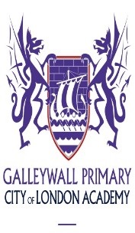

www.galleywall.co.uk

Graduate Teaching Assistants

Have you recently graduated?
Are you thinking about teaching in the future?

Galleywall is small jewel at the heart of a growing family of outstanding schools, sponsored by the prestigious City of London. Through this link we are able to work in partnership with ‘Guildhall School of Music and Drama’ and other prominent institutions within the City. Our rich and broad curriculum stimulates creativity and sparks children's imagination. At the heart of our skills based curriculum is an emphasis on literacy and drama, creativity and the arts, independent enquiry, reflective thinking and collaboration.

We need enthusiastic teaching assistants who will work to nurture the dreams and aspirations of our children. We are looking for graduate teaching assistants who have passion, who are forward thinking and who love working with children. In return we will offer you excellent opportunities for professional development. Galleywall is growing and we intend to train the leaders of the future. A degree qualification will allow the right candidates to be supported to apply for our Schools Direct programme through UCAS in the future thus gaining Qualified Teacher Status.
Visits to Galleywall are positively welcomed
If you would like to speak with the Headteacher Sarah Parbhu, please just give us an email and we will get back to you.
Start date – asap
Teaching Assistant - 35 hours per week
Full- time equivalent salary: £19,439 (TTO calculation to be applied)
Application packs are available on the school’s website or email: vacancies@galleywall.co.uk

Closing date for applications: 23rd September 2021
Interviews: Week beginning: 27th September 2021

