Come and join us as our new General Teaching Assistant (SEND) where you can

- Have a positive impact on our children in school;
- Access high quality professional development opportunities;
- Have your ideas and aspirations nurtured.

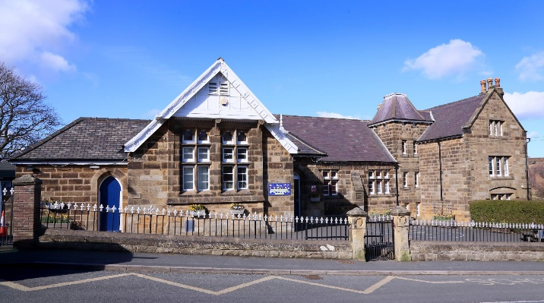

General Teaching Assistant (SEND)
Castleton Primary School
30 hours per week term time only
1 Year Fixed Term

Required to start from September 2022
Recruitment Information Pack
Yorkshire Endeavour Academy Trust
Waterstead Lane, Whitby, YO21 1PZ

Contents

Welcome from the Headteacher 3
Our vision and values 4
Context of the schools 5
Our English Hub 6
Application process 7
Job Description and Person Specification 8-12

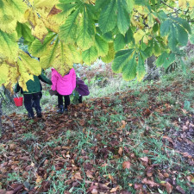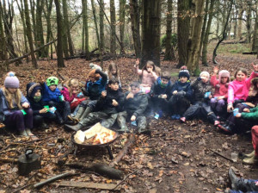

Dear applicant,

Allow me to extend a warm welcome from all governors, staff and children of Castleton Community Primary School. I am delighted you have shown an interest in joining us and I look forward to sharing with you what makes our school a very special place to work.

Our children are delightful, happy, confident and energetic. They are passionate about their learning and enjoy a wide curriculum, with access to 1:1 iPads, outdoor learning areas and a well-stocked library. Our children have many talents and we pride ourselves in providing lots of opportunities for every child to contribute to the wider school community. We are looking for an General Teaching Assistant (SEND) who loves seeing children learn and thrive, and who can bring passion and enthusiasm to our small and friendly team.

Our staff are passionate about their work and supportive of each other. Flexibility is crucial, particularly within our small school setting, and the successful candidate will need to be willing to adapt to the changing needs of the school.

This is an exciting time to join us. As part of the Yorkshire Endeavour Academy Trust, our team are working in partnership across the Whitby area to share, learn and inspire. Through our Trust, we are able to access support, training and resources from partners such as the Yorkshire Endeavour English Hub, which means staff members have a wide range of colleagues, tools and resources to help them develop, not just in the classroom but beyond.

I hope that you will take the time to find out more about our school. Good luck with your application. I look forward to reading it.

Kirsty Hird, Headteacher of Castleton and Glaisdale Primary Schools

Yorkshire Endeavour Academy Trust
Our Vision and Values

Vision
- Ethical action for a world class education.
- Nurturing relationships at the heart of our communities.
- Brave leadership in a changing landscape.

Values
- Providing world-class education to all children through an ambitious curriculum.
- Encouraging curiosity and a lifelong love of learning.
- Wrapping around our community through an inclusive nurturing approach.
- Taking pride in local heritage whilst preparing our children to be global citizens.
- Collaborating with partners in education and universal services to support each child’s unique journey.
- Highlighting and sharing excellent educational practice for the benefit of all.
- Growing and developing people in all roles to be their very best.

Context of the school
Castleton Community Primary School
Castleton currently has 53 pupils on roll across two classes: Acorns (EYFS/KS1) and Oaks (KS2). Outdoor learning is a key feature of our provision and children have regular opportunities to participate in a range of outdoor activities. Hidden behind our historic building are extensive grounds, which include tiered gardens featuring a pond, greenhouse, adventure play area, stage, quiet zone, forest school site and an outdoor classroom. Our children are also interested in music and the arts. Our parents are very keen to be involved in the life of the school and we have an active PTFA.
For more information about Castleton, please visit our website: https://www.castletonprimaryschool.co.uk/ or see our Facebook page

Application Process
The closing date for all applications is 9am on Monday 20th June

Interviews will be held as soon as possible after the closing date.

Completed applications must be returned to Garry Morrison at garry.morrison@northyorks.gov.uk

If you do not receive confirmation of receipt of your application within one working day please call Garry on 07814935700.

If you think you’re the person for the job, please complete the enclosed application form with your supporting statement, no more than two sides of A4, and send to the email address above by the closing date.

An email will be sent to shortlisted candidates with details of the interview process. If you have not heard from us within a week of the closing date please assume your application has been unsuccessful.

Queries
Informal chats with our Headteacher Kirsty Hird are welcomed. Please contact Garry to organise.

We actively welcome you to contact Garry at North Yorkshire County Council to chat through the role and talk informally about the school/post and how working here will make a real difference to the children and young people on the coast.

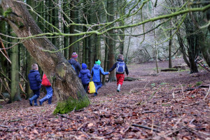

Job Description

Job Description

POST: |  | General Teaching Assistant (GTA)
GRADE: |  | Grade C plus SEN allowance, points 2 - 4
RESPONSIBLE TO: |  | Head Teacher
STAFF MANAGED: |  | None
POST REF:
JOB PURPOSE: | To work, under the direction of the class teacher and other appropriate staff, in assisting in and contributing to the planning, delivery and evaluation of the learning process. The post holder will work in classes, or other appropriate locations with access to support and guidance, supervising groups and /or individual pupils.  To assist in the induction and development of classroom support staff as required.
ACCOUNTABILITIES / MAIN RESPONSIBILITIES
Supporting Learning & Development | - Support pre planned learning/behaviour activities as directed by the class teacher.  - Using agreed structured observation as directed by the class teacher to feedback on learning, behaviour, participation and achievement, to support the planning and evaluation of the learning process for children.  - Interact with pupils in ways that support the development of their ability to think and learn, including the use of careful questioning.  - Assist teachers in the implementation of appropriate behaviour management and teaching & learning strategies.  - Support pupils in their social and emotional wellbeing, in implementing related programmes, including social, health and physical needs.  - Assist in escorting and supervising pupils on educational visits and out of school activities.  - Undertake break supervision as required.  - To encourage pupils to interact with others and engage in activities led by the teacher.
Communication | - Under the general direction of the teacher participate in establishing and maintaining effective relationships with pupils, parents/carers and with other agencies/professionals.  - Communicate effectively with all pupils, families, carers and other agencies / professionals.
Sharing information | - Share information confidentially about pupils with teachers and other professionals as required.  - Pay due regard to professional boundaries, maintaining appropriate levels of confidentiality.  - Participate in staff meetings.
Safeguarding and Promoting the Welfare of Children/Young People | - Carry out tasks associated with pupils’ personal hygiene, and welfare, including physical and medical needs, whilst encouraging independence.  - Be responsible for promoting and safeguarding the welfare of pupils in line with policy and legislation, raising concerns as appropriate.
Administration/Other | - Prepare classroom materials and learning areas, and undertake minor clerical duties e.g. photocopying and displaying pupils work.  - Support the use of ICT and adhere to relevant policies  - Supervise and provide access arrangements for pupils sitting internal and external examinations and tests as required, ensuring that examinations comply with the Examination Board Regulations.  - Participate in appraisal, training and other learning activities.  - To contribute to the overall ethos/work/aims of the school.
Health & Safety | - Be aware of, implement your health and safety responsibilities as an employee, and where appropriate any additional specialist or managerial health and safety responsibilities as defined in the Health and Safety policy and procedure.  - Work with colleagues and others to maintain health, safety and welfare within the working environment.
Data Protection | - To comply with the Trust’s policies and supporting documentation in relation to Information Governance, including Data Protection, Information Security and Confidentiality.
Equalities | - Promote inclusion and acceptance of all pupils.  - Within own area of responsibility, work in accordance with the aims of the Equality policy, treating people with respect for their diversity, culture and values.
Customer Service | - The Trust requires a commitment to equity of access and outcomes, this will include due regard to equality, diversity, dignity, respect and human rights and working with others to keep vulnerable people safe from abuse and mistreatment.  - The Trust requires that staff offer the best level of service to their customers and behave in a way that gives them confidence. Customers will be treated as individuals, with respect for their diversity, culture and values.

Person Specification

Essential upon appointment | Desirable on appointment (if not attained, development may be provided for successful candidate)
Knowledge
- An awareness of child/young person’s development and learning.  - An understanding that children/young people have differing needs. | - Good understanding of child development and learning processes  - Knowledge of behaviour management techniques  - Knowledge of Child Protection and Health & Safety policies and procedures  - Knowledge of inclusive practice
Experience
- Experience appropriate to working with children with special educational needs in a learning environment. | - Experience of working with children with social, emotional and mental health needs.
Qualifications
- Relevant NVQ Level 2 qualification or equivalent  - GCSE Grade C or above in Maths and English (or equivalent) | - Relevant NVQ level 3  - Team Teach/Positive Behaviour Management certificate
Occupational Skills  - Good written and verbal communication skills: able to communicate effectively and clearly and build relationships with a range of staff, children, young people, their families and carers.  - Good reading, writing and numeracy skills. | - Basic ICT Skills
Personal Qualities
- Demonstrable interpersonal skills.  - Ability to work successfully in a team.  - Confidentiality  - Flexibility  - Resilience  - Patience  - Ability to form and maintain appropriate relationships and personal boundaries with children and young people. | - Creativity
Other Requirements
- Enhanced DBS Clearance
- To be committed to the school’s policies and ethos.
- To be committed to continuing professional development.
- Motivation to work with children and young people.
- Ability to form and maintain appropriate relationships and personal boundaries with children and young people.
- Emotional resilience in working with challenging behaviours and attitudes.
- Ability to use authority and maintain discipline.
- An empathy for equality & diversity

