Job Description  Kimberley Primary & Nursery School | 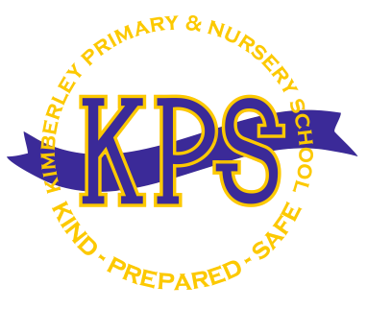

1. Title of Post: | Head Cook

2. Accountable and Responsible to: | Head Teacher

3. Grade: | Scale 3

4. Main Purpose of the Job:

To be responsible for the supervision and smooth running of the school kitchen, including hygiene, training of staff and all day-to-day operations including the cooking, preparation and serving of meals.

5. Main Responsibilities of the Job:

Managing and supervising a small team of kitchen staff, including induction, delegation of work, including cooking, cleaning, service of food required.

To carry out all general duties involved in the production and service of the school meal including general kitchen duties, e.g., washing up, cleaning the kitchen, its surrounds and equipment

Manage all necessary procedures and systems to ensure that all environmental health, hygiene, nutritional guidelines comply with relevant legislations.

To prepare menus that comply with school food nutritional standards.

Operate day-to-day administration, record keeping, ordering and purchasing of provisions, materials and equipment, stock control, daily record sheets, costing, staff record sheets, requisitioning of equipment and reporting of repairs to premises.

Preparation of dining area, setting up and cleaning before and after meals in collaboration with midday supervisors.

Respond to the changing dietary requirements of our school, seeking advice where appropriate

Requisition (order) goods to pre-determined levels within pre-determined budgets and be accountable for viable business performance at site level, seeking support where necessary from the central Trust team
To assist with any extra catering/hospitality required by the school other than the school meal.

Carrying out any other reasonable duties within the overall function of the job.

6. General
Contribute to and support the school ethos and represent the school in a welcoming and professional manner at all times.
To comply with the requirements of Safeguarding, Data Protection, Health and Safety, Equal Opportunities, Financial Procedures and other relevant legislations and school policy
To be responsible for your own professional development and attend training where required
Undertaking any other duties which may reasonably be regarded as within the confines of the duties and responsibilities/grade of the post as defined.

Essential/
Desirable
Qualification Criteria
Basic Food Hygiene Certificate | E
Intermediate Food Hygiene certificate | D
NVQ2 in catering and hospitality or equivalent | E
Experience
Experience of working within a school kitchen or small scale catering experience | E
Experience of administration and budgeting, including stock control and ordering | E
Personal Characteristics
Able to work within a busy environment and set priorities | E
Ability to work under pressure | E
Adaptability and flexible | E
Excellent time management and organisational skills | E
Awareness of security and health and safety issues | E
Ability to communicate effectively with a range of people including staff, pupils | E
Helpful, positive, calm and caring nature | E
Able to establish good working relationships with colleagues and pupils | E
Able to follow instructions accurately but make good judgements and lead when required | E
Ability to work in a confidential manner
Able to maintain a safe, calm and happy ethos | E
Committed to the safeguarding and welfare of all pupils in the academy | E
A commitment to abide by and promote the school’s equal opportunities, health and safety and child protection | E
Willingness to undertake training in any area identified
Specific skills
Ability to work as part of a team
Good communications skills, written and oral | E
Competent with computers and other technology | E
Understand the importance of confidentiality and discretion | E

All staff must have the right to work in the UK and will be subject to a DBS check prior to taking up appointment.

