

Head of Academy
Discovery Special Academy
Job Ref: DSA385

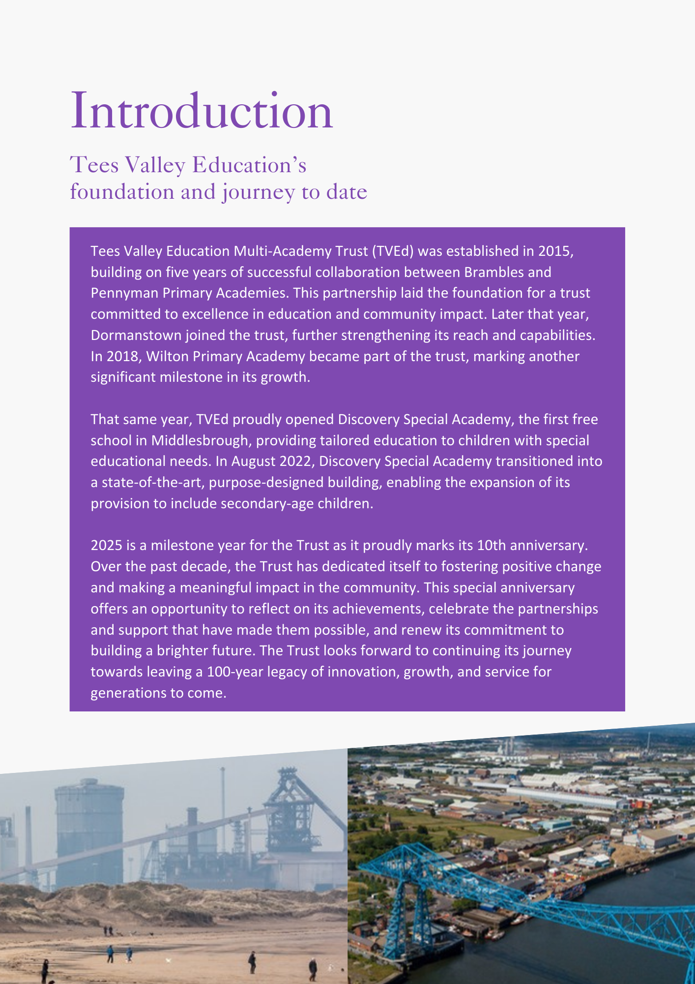

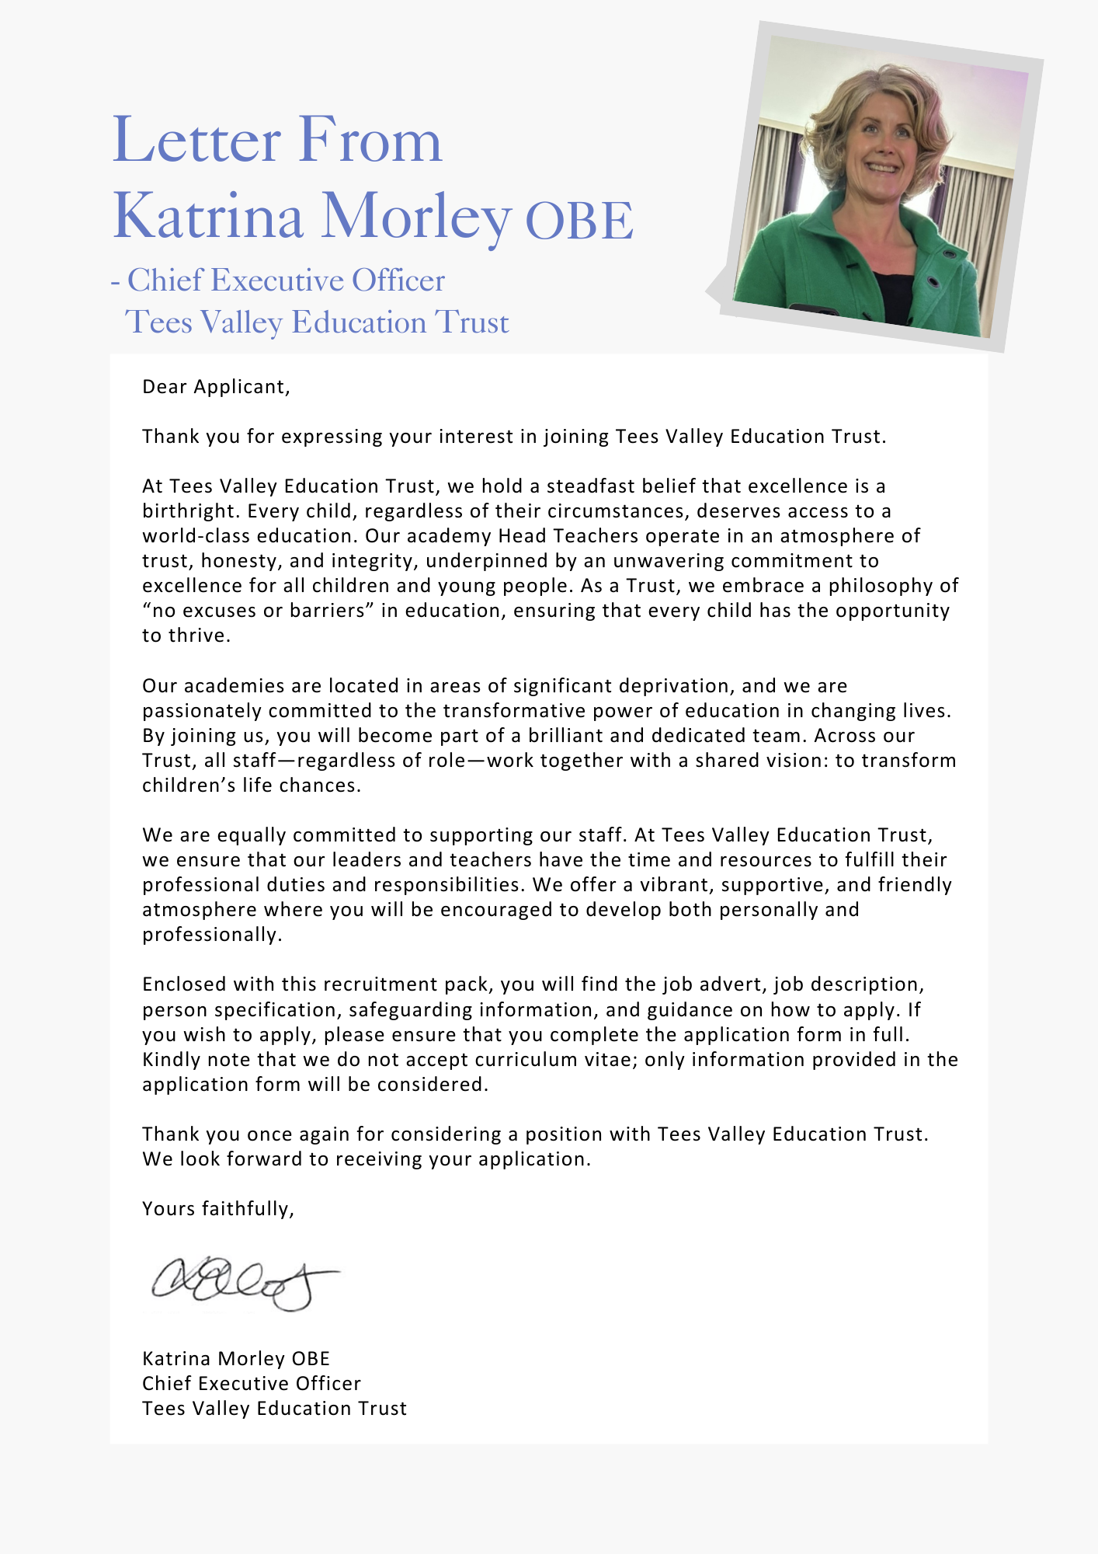

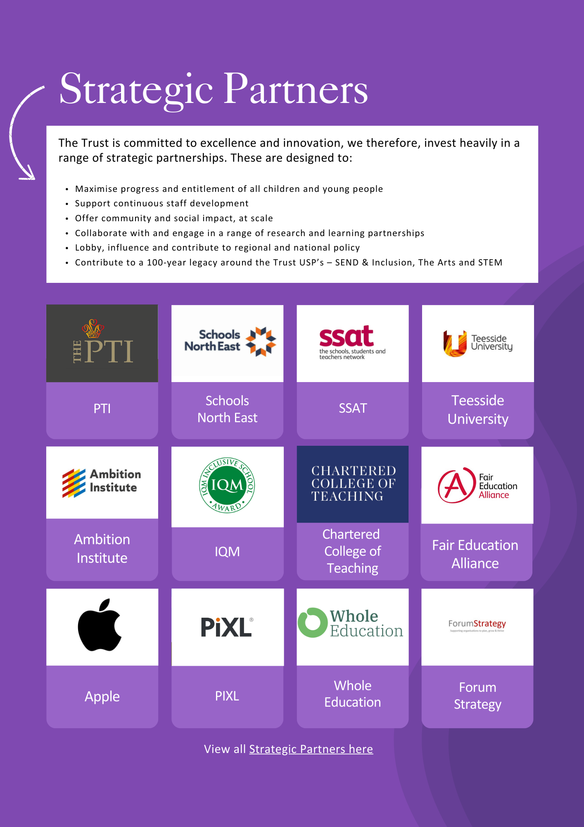





ADVERTISEMENT

Head of Academy
Status: Permanent, full time
Required: September 2026
Salary: L18 to L123 £78,701 to £88,950
Hours: 32.5
Reporting to: Executive Headteacher
Academy base: Discovery Special Academy

About the Trust
The Trust was established in 2015 and provides education and enrichment activities to more than 1200 children across five Academies, located in Middlesbrough and Redcar and Cleveland local authority areas. Academies within the Trust are:
- Brambles Primary Academy (2 to 11 years),
- Discovery Special Academy (2 to 16 years),
- Dormanstown Primary Academy (2 to 11 years),
- Pennyman Primary Academy (2 to 11 years), and
- Wilton Primary Academy (3 to 11 years).

About the role we are looking to appoint:
Following the retirement of the current postholder, the Trust is seeking to appoint an exceptional Head of Academy to provide strong, visible leadership for Discovery Special Academy. This is a key senior role, working in close partnership with the Executive Headteacher to secure excellent outcomes for pupils, sustain high standards of behaviour, attendance and safeguarding, and ensure the highest quality of provision for children and young people aged 2–16.
The successful candidate will build on the academy’s strengths and lead the next phase of improvement, underpinned by a culture of creativity, curiosity, care, courage and commitment. They will ensure that all pupils experience meaningful access to learning and enrichment, supported by ambitious curriculum leadership, strong inclusive practice and effective engagement with families and multi-agency partners.
Working closely with the Executive Headteacher, academy leadership team, Trust colleagues, children, families and external partners, the Head of Academy will provide strategic and operational leadership that improves teaching and learning, strengthens systems and processes, and secures consistently high standards across the academy.
What we are looking for:
We are seeking to appoint a pro-active, enthusiastic and highly effective senior leader who is deeply committed to inclusive education and who has a strong track record of improving outcomes for children and young people, including pupils with SEND. The successful candidate will be an inspirational role model, with high expectations of pupils and staff, and the ability to translate vision into consistent, day-to-day excellence across Discovery Special Academy.
As Head of Academy, you will provide strategic and operational leadership for the quality of education, behaviour and attendance, personal development and safeguarding, working in close partnership with the Executive Headteacher and academy leadership team. You will use evidence and data intelligently to evaluate impact, secure continuous improvement, and ensure that pupils’ needs are met through ambitious curriculum leadership, strong inclusive practice and effective deployment and development of staff.
You will be an excellent communicator who builds strong relationships with pupils, families, staff, governors and external partners. Through robust systems, reflective practice and visible leadership, you will ensure high standards are consistently upheld across the academy and that every pupil is supported to thrive, achieve and belong.
What the Trust will provide the successful candidate with:
- A workplace where all staff are valued and treated with respect as outlined within the Trust’s Diamond Standards
- A passionate, enthusiastic and supportive Leadership Team
- A listening and learning organisation where all staff are encouraged to be curious and share ideas for the Trust/academies/team to improve
- Hard working, committed and dedicated staff who strive to gain the best outcomes for all children across the Trust’s academies
- Dedicated approach to children’s learning to encourage them all to be the best they can be
- Career enhancement opportunities within areas of interest as well as supporting ongoing professional development and training specific to job role
- Dedicated line manager to discuss work streams and capacity
- Free access to the Trust’s Wellbeing offer, which includes counselling, access to GP, Mindfulness and so much more.
- Free parking
- Enrolment into the local government pension scheme with employer contribution of 16% from April 2026
- All teaching contracts are employed on standard teaching pay and conditions (burgundy book) and enrolled in teachers pension scheme with an employer contribution of 28.68%.
- Benefits of the Trust’s Staff Charter which can be found at TVED Staff Charter.
Safeguarding requirements for the role:
Tees Valley Education Multi Academy Trust is committed to safeguarding and promoting the welfare of children. All appointments will be subject to a satisfactory enhanced DBS check.
This post is exempt from the Rehabilitation of Offenders Act 1974 and, therefore, all convictions, cautions and bind-overs, including those regarded as “spent” must be declared. The Trust’s Recruitment of Ex-Offender policy can be requested or visit the Trust’s website.
Applications are invited from prospective candidates who demonstrate that they can meet the essential criteria set out in the person specification and who have the vision, values and tenacity to join an outstanding team and help continue the journey towards excellence.

JOB DESCRIPTION
Head of Academy

JOB PURPOSE
The National Standards of Excellence for Headteachers (2015) define high standards within a self-improving school system. These standards are designed to inspire public confidence, raise aspirations, secure high academic standards in the nation’s schools, and empower the teaching profession.
The Head of Academy strategically and operationally supports the Executive Headteacher in delivering exceptional outcomes for pupils at Discovery Special Academy. As Head of Academy, you will lead the delivery of education and standards of behaviour and attendance, ensuring high-quality provision, robust safeguarding, strong staff development and effective day-to-day operational leadership across the academy.

ETHICS AND PROFESSIONAL CONDUCT
As a leader within Tees Valley Education Trust, the Head of Academy is expected to demonstrate consistently high standards of principled and professional conduct and to model the Trust values in daily practice.

STRATEGIC LEADERSHIP
- Support the Executive Headteacher to develop and deliver the academy vision, culture and strategic priorities, based on robust evidence, consultation and performance information.
- Create an environment in which all staff are required to treat all people fairly, equitably, and with dignity and respect.
- Lead by example as a visible presence around the academy and promote effective, proportionate communication and ways of working.
- Support the Executive Headteacher in structuring staffing appropriately to engage the best from everybody and to secure sustainable improvement.
- Implement a culture of open classrooms and reflective practice to share strong pedagogy and continuously improve provision.
- Inspire, encourage and support staff to develop their own skills and subject knowledge, and to support each other, and ensure all staff are held to account for their daily professional conduct and practice.

QUALITY OF EDUCATION
- Be responsible for the day-to-day management of pupils, staff, resources and the academy environment to promote achievement and wellbeing.
- Maintain a consistent focus on attainment and progress, ensuring assessment practice is strong and that staff use information effectively.
- Ensure excellent teaching through a secure understanding of how pupils learn and the core features of successful curriculum design and classroom practice, implementing a culture and ethos of challenge and support.
- Ensure the academy environment, including classrooms, reflects and supports high-quality learning and meets the needs of all learners so all staff and children are enabled to achieve success and their full potential.
- Ensure statutory requirements are met and pupils can access a broad, balanced and relevant curriculum.
- Oversee systems for monitoring and developing teaching and learning and ensure improvement actions are implemented and evaluated.
- Ensure exceptional quality provision for the academic, spiritual, moral, social, emotional, cultural and health well-being of all pupils and families.
- Work closely with parents/carers, the community and partner agencies to meet pupils’ academic, social, emotional, cultural and health needs.
- Develop and deliver high-quality CPD to build staff expertise, strengthen curriculum implementation and improve outcomes for all pupils.

FINANCE, SUSTAINABILITY AND COMPLIANCE
- Ensure the academy’s systems, organisation and processes are efficient and fit for purpose, upholding the principles of transparency, integrity and probity.
- Be responsible, on a day-to-day basis, for the internal organisation, management and control of the academy, working in partnership with the Executive Headteacher.
- Manage and organise the day-to-day use of the building and grounds so they meet curriculum and health and safety requirements.
- Regularly review the allocation and utilisation of staff and physical resources, providing constructive feedback and recommendations to the Executive Headteacher for optimising their use to support pupil achievement and wellbeing.
- Identify areas where targeted investment could enhance teaching and learning, such as updating classroom technology or investing in professional development, and present evidence-based proposals to the Executive Headteacher for consideration in budget planning.
- Monitor the impact of resource deployment on educational outcomes and collaborate with the Executive Headteacher to suggest adjustments, ensuring that spending decisions are aligned with the academy’s priorities and statutory requirements.

PEOPLE STRATEGY
- Monitor the performance of staff in a rigorous, fair and transparent way; address under-performance, support improvement and recognise excellent practice.
- Lead and manage delegated staff, including appraisal and performance management of mainscale and UPS teachers.
- Ensure high quality professional development based on analysis of data and performance to support academy priorities.
- Ensure high quality training and sustained professional development for all staff, including trainee teachers, Newly Qualified Teachers and Recently Qualified Teachers.
- Distribute leadership effectively, building strong teams with clear accountabilities holding senior and middle leaders to account.
- Support recruitment, retention and deployment to ensure the academy has the capacity and expertise to meet its priorities.
- Lead day-to-day HR including staff attendance, performance and development.
- Monitor and support staff by identifying and addressing areas for development and building on their strengths.
- Identify emerging talents, coaching current and aspiring leaders in a climate where excellence is the standard, leading to clear succession planning.
- Ensure that all staff carry out their professional duties in accordance with their job description and with national guidance and regulation, and moral duties in accordance with the outstanding expectations at the Academy and across the Trust.

GOVERNANCE AND ACCOUNTABILITY
- Actively support the Local Academy Committee (LAC) to understand its role and deliver its functions effectively.
- Translate strategic academy priorities into clear action plans with measurable outcomes for presentation to the executive headteacher and trust board.
- Assist other leaders within the academy, staff and governors to rigorously evaluate progress towards targets and outcomes and report at Challenge Board.
- Support robust self-evaluation and preparation for internal and external accountability activities.
- Ensure key statutory information is published and maintained to a high standard through academy communications channels.
- Inspire and influence others - within and beyond the academy - to believe in the fundamental importance of education in young people’s lives and to promote the value of education.
- Develop and encourage working partnerships with a wide variety of stakeholders, in the best interests of the children within the academy.
- Assist the Executive Headteacher in ensuring that all academy policies are regularly appraised where appropriate and updated with staff and governor involvement.
- Ensure that the academy website and on-line communication tools are regularly updated and maintained to a high standard to promote academy within the local, national and global community.

SYSTEM LEADERSHIP AND CIVIC RESPONSIBILITY
- Maintain a safe, calm and well-ordered environment for all pupils and staff, focused on safeguarding, behaviour and high outcomes.
- Implement strategies that maintain exceptionally high standards of behaviour and attendance at the academy.
- Develop effective relationships with parents/carers and external agencies (including Social Care and Health) to improve outcomes for pupils.
- Promote purposeful partnerships with other schools and organisations that enhance provision and opportunities for pupils at Discovery Special Academy.
- Maintain the academy and Trust values in everyday work and practice.
- Maintain the complexities associated with areas of deprivation and the link to educational performance.
- Support the Executive Headteacher and governors in creating and maintaining good working relationships amongst all members of the school community.
- Lead the development and implementation of innovative teaching and learning strategies that support continuous improvement across the academy.
- Foster a culture of collaboration and professional development among staff to share best practices and build capacity within the academy and across the Trust.
- Champion the academy’s engagement in local, regional, and national initiatives that contribute to the wider educational community and raise the profile of the academy.
- Ensure effective use of data and evidence to inform decision-making, drive academy improvement, and support accountability at all levels.
GENERAL RESPONSIBILITES
As a Leader within the Trust, you are also expected to:
- Undertake any additional duties as could be reasonably required.
- Work at any location across the Trust
- Ensure a deputy or suitable person is available to assume responsibility for the job holder, when absent from the Academy.
- Undertake additional training and other learning activities and performance development as required
- Develop familiarity with relevant legislation such as UK General Data Protection Regulation (UK GDPR) and Health and Safety at Work etc. Act 1974 to ensure the Trust is fully always protected.
PERSON SPECIFICATION
Head of Academy
QUALIFICATIONS | E/D
Degree or relevant qualification and experience. | E (1)
Qualified Teacher Status. | E (2)
Evidence of further professional development | E (3)
Evidence of Leadership development courses | D (1)
EXPERIENCE
Successful recent experience as a senior leader within a school/academy setting | E (4)
Outstanding teaching across a variety of age ranges. | E (5)
Evidence of outstanding impact on progress of all learners, including pupils with SEND | E (6)
Experience of working within the framework for the Code of Practice 2014 (SEND) | E (7)
Experience of monitoring and improving teaching, learning and curriculum implementation | E (8)
Evidence of developing, monitoring and evaluating key aspects of academy provision including supporting the identification of priorities based on data analysis and performance outcomes | E (9)
Experience of managing resources and contributing to budget planning/monitoring | E (10)
Experience of working in a highly political environment and liaising with senior leaders in local authorities, DfE, Trust Board and other strategic stakeholders. | D (2)
KNOWLEDGE, ABILITIES AND SKILLS
A proven track record as an effective leader with high expectations and strong accountability | E (11)
A sound understanding of national data analysis systems and how these relate to a specialist setting. | E (12)
Strong understanding of assessment and data use to improve outcomes | E (13)
An ability to support the development of outstanding and creative leadership and teaching at academy level | D (3)
Outstanding organisational skills with the ability to self-direct as well as work successfully within a multidisciplinary team. | E (14)
Highly successful experience of leading and managing whole academy developments regarding teaching & learning, raising standards of attainment and achievement across the academy | E (15)
The ability to work productively and positively with a range of colleagues both internally and externally, upholding the Trust values and ethos. | E (16)
Able to use accountability measures to ensure that effective teaching and learning strategies raise pupil attainment and achievement, and impact on wider life outcomes within SEND | E (17)
Excellent interpersonal skills. | E (18)
Experience of conducting staff induction, mentoring and performance management for impact. | E (19)
Working Knowledge of the governance arrangements of a multi-academy Trust and the interrelationship with DfE and ESFA/external stakeholders. | D (4)
Working knowledge of the mechanisms of the Trust/ Challenge Board and the ability to support and contribute to strategic reporting | D (5)
Tenacity, enthusiasm and drive. | E (20)
Ability to/willingness to contribute to the whole academy and Trust context (including INSET) and with external bodies. | E (21)
A role model for learning, actively seeking professional development opportunities. | E (22)
Political awareness of both national and regional agendas (for example, disadvantage, SEND and community development). | E (23)
Commitment to attending conferences and events, representing the Trust; delivering training; and pursuing ongoing professional learning. | E (24)
Experience forging supportive and, when necessary, challenging relationships both internally and externally to consistently drive academy improvement and children’s life chances. | E (25)

E – Essential D – Desirable

HOW TO APPLY AND EXPLANATORY NOTES OF THE PROCESS

An application form is attached below. Application packs can be downloaded or printed directly from the Trust website www.teesvalleyeducation.co.uk or requested from the academy. Only applications via the Trust’s official application form will be accepted. Please do not submit a CV as substitute for part or full application form, the information will not be accepted or considered.
If you are submitting your completed application form by e-mail to recruitment@discoveryspecialacademy.org.uk - please be aware the academy cannot be responsible for any formatting anomalies when printing. If you are unable to submit an electronic application form, handwritten or electronic printed copies should be posted or hand delivered to the following address for the attention of Miss Jennifer Duncan.
Discovery Special Academy
Sandy Flatts Lane
MIDDLESBROUGH
TS5 7YN

Shortlisting Process
After the closing date, short listing will be conducted by a panel, who will match your skills/experience against the criteria in the Person Specification. You will be selected for interview entirely on the contents of your application form, so please read the Job Description and Person Specification carefully before you complete your form.
Shortlisted candidates will receive:
- Letter confirming interview details.
- Details of original ID documentation is required to confirm candidates. Photocopies or certified copies are not accepted.
- Criminal Record Self-Declaration Form, which must be brought on the day of the interview in the sealed envelope provided.

References for successful Candidate/s
We may seek references for shortlisted candidate/s and we may also approach previous employers for information to verify particular experience or qualifications before the interview. Any relevant issues arising from references will be taken up post interview.

Interview process
In addition to candidates’ ability to perform the duties of the post, the interview will also explore issues relating to safeguarding and promoting the welfare of children, including:
- Motivation to work with children and young people
- Ability to form and maintain appropriate relationships and personal boundaries with children and young people
- Emotional resilience in working with challenging behaviours
- Attitudes to use of authority and maintaining discipline

Conditional Offer: Pre-Employment Checks
Any offer to a successful candidate will be conditional upon:
- Verification of right to work in the UK
- Receipt of at least two satisfactory references (if these have not already been received)
- Verification of identity checks and qualifications
- Satisfactory enhanced DBS check
- Verification of professional status such e.g. QTS Status, NPQH (where required)
- Satisfactory completion of a Health Assessment
- Satisfactory completion of the probationary period (where relevant)
- Where the successful candidate has worked or been resident overseas in the previous five years, such checks and confirmations as may be required in accordance with statutory guidance.
Please contact the academy office on 01642 2248333 to arrange a visit with Jennifer Duncan.
For your information, the recruitment timetable is detailed below:

Closing date: Thursday 14th May 2026 at 9:00am
Shortlisting date: Thursday 14th May 2026
Interview date: Monday 18th May 2026
UK General Data Protection Regulation
Refer to our privacy policy on how we will process your personal data including how you can request to access your personal data via Tees Valley Education website: http://www.teesvalleyeducation.co.uk.

EQUALITIES INFORMATION AND OBJECTIVES STATEMENT

As an academy we ensure that our vision, values and ethos meet the expectations of the equality and diversity guidelines and legislation set out by the Equality and Human Rights Commission. This includes the following 9 protected characteristics:
- Age
- Disability
- Gender Reassignment
- Marriage and Civil Partnerships
- Pregnancy and Maternity
- Race
- Religion or belief
- Sex
- Sexual Orientation

Objectives Statement
- To support children’s sensory, academic and communication skills to enable them to develop holistically.
- To ensure high expectations across all aspects of the academy (as outlined in objective 1) to ensure children make the best progress according to their individual starting points.
- To continue to monitor attendance of all groups of children in the academy.
- To review levels of parental and pupil engagement in learning and academy life, across all activities and ensure equality and fairness in access and engagement.
- To ensure the academy environment is as accessible as possible to pupils, staff and visitors.


