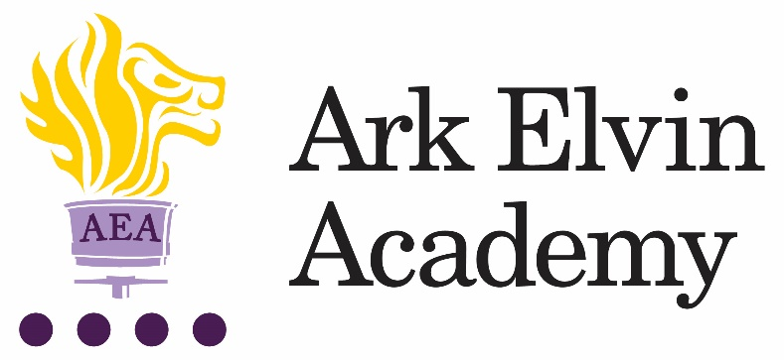

Head of Art
At Ark Elvin Academy we are proud of the excellent education we offer each of our pupils. Our team of enthusiastic, high expectations staff have transformed our school and we are just as excited about the next step in our school improvement journey as we work together to deliver the outstanding education our community need and deserve. We are deeply committed to our mission:
“To ensure that every pupil leaves Elvin confident, articulate, and culturally aware; able to pursue careers they are passionate about, contribute to society and live happy, healthy and fulfilled lives.”
In our last OFSTED inspection (October 2019) it was recognised that:
“Pupils, parents and staff all agree that Ark Elvin Academy has improved out of all recognition. Pupils are proud of the school.”
“The headteacher and leaders have very high expectations…… Staff want all pupils to succeed in every area of their lives, not just academically.”
“The school is a calm, safe and supportive place for pupils. Pupils behave very well in lessons. They get on well with one another and with adults.”
We are a large non-selective secondary school in the London borough of Brent, with excellent transport links to central London. We are committed to ensuring teachers can focus on teaching and have the opportunity to refine and develop their practice in the classroom and develop their leadership skills, we have:
- twice as many training days as is standard
- weekly professional development for all staff.
In recruiting our next Head of Art we are seeking the following from applicants:
- A commitment to serving our diverse community in Brent
- A passion for their subject, curriculum development and teaching and learning
- High expectations for themselves and our pupils
- A keenness to learn and develop as both a subject teacher and a leader
- A team player with high standards of professionalism.
You will become part of a close knit professional community of enthusiastic colleagues who benefit from the training, guidance and support from the Ark network, one of the country’s top performing school groups.
You will be leading a small dynamic art team with big ambitions! Our Art department has state of the art facilities including a kiln, two art studios and purpose build storage facilities. Our current head of art has led art with expertise and great results over the last four years. Following his promotion, we are looking for subject expert whose passion for art and all things creative will lead our team forward to develop both our core art curriculum and an ambitious extra curricular offer. Our children are passionate about art and are keen to get involved in all aspects of this creative curriculum.
We are interested in hearing from candidates with a range of experience –so whether you are looking for your first step into subject leadership or you are already an experienced head of art we know that Elvin is a great place to work and would love for you to get in touch to find out more.
We passionately believe in our six pillars and they drive all our thinking and our school improvement at Elvin:
Strong Discipline
Calm, purpose, and order are established through the consistency of expectations and explicit teaching of discipline.
High Quality Teaching
Teachers are subject experts with an excellent understanding of the intellectual journey they are taking their pupils on and have mastery in effective teaching skills.
Mastery Curriculum
Our curriculum design enables pupils to make rapid progress and develop a framework of knowledge and understanding in each subject area that provides a solid foundation for further study.
Raising aspirations and enrichment
Pupils understand the opportunities that a school and university education will afford them in terms of careers and quality of life. Pupils develop their passions and interests through an Our extensive enrichment programme.
Character development
Pupils develop the characteristics that support their academic achievement, create thoughtful citizens and allow them to make reflective choices over their personal lives.
Developing leaders
All members of staff see themselves as leaders within an aligned community of professionals and are systematically trained in best practice. We create high performing teams to drive our school improvement.
Ark Elvin is on an exciting improvement journey – join us and be part of that change.
Interested in finding out more? Please email our HR advisor, Chantel: c.mutongole@arkelvinacademy.org for an initial conversation and to arrange a call with our principal, Rebecca Curtis.
Closing date: Monday 23rd May 2022
Interviews: Week beginning 23rd May 2022
Start date: September 2022
Salary: Ark Main/Upper Pay Range (£32,960 - £53,341) + TLR2B - £4,784

Ark is committed to safeguarding children; successful candidates will be subject to an enhanced DBS check

Job Description: Head of Art

Reports to: Vice Principal

The Role
Reporting to the Vice Principal, the Head of Department is responsible for developing and leading an exciting curriculum which enables the highest level of pupil progress and attainment. The role involves managing the professional community of Art teachers to ensure high attainment and to develop a love of learning in all pupils. The Head of Art will be a member of a strong middle leadership team, making a significant contribution to the quality of learning and teaching across the academy, supporting our school improvement.

Key responsibilities
The full remit of the post will be negotiated dependent on the skills and experience of the candidate appointed. Specific responsibilities are subject to change.

The Subject Leader will take responsibility for the following specific roles within their wider role as a middle leader of the school:
- Coordinate Art across the academy
- Lead the professional community of Art teachers
- Plan, resource and teach Art lessons and sequences of lessons to the highest standard that ensure real learning takes place and pupils make excellent progress
- Provide a nurturing classroom and academy environment that helps pupils to develop as learners
- Help to maintain discipline across the whole academy
- Contribute to the effective working of the academy

Teaching and Learning
- Lead on the planning and preparation of effective schemes of learning and base lessons
- To teach engaging and effective lessons that motivate, inspire and improve pupil attainment
- To use regular assessments to set targets for pupils, monitor pupil progress and respond accordingly to the results of such monitoring
- To produce/contribute to oral and written assessments, reports and references relating to individual and groups of pupils
- To develop plans and processes for the classroom with measurable results and evaluate those results to make improvements in pupil achievement
- To ensure that all pupils achieve at least expected progress and the majority of pupils make more than expected progress
- To maintain regular and productive communication with pupils, parents and carers, to report on progress, sanctions and rewards and all other communications
- To provide or contribute to oral and written assessments, reports and references relating to individual pupils and groups of pupils
- To direct and supervise support staff assigned to lessons and when required participate in related recruitment and selection activities
- To implement and adhere to the academies behaviour management policy, ensuring the health and well-being of pupils is maintained at all times
- To participate in preparing pupils for external examinations.

Academy Culture
- To support the academy’s values and ethos by contributing to the development and implementation of policies, practices and procedures
- To help create a strong academy community, characterised by consistent, orderly behaviour and caring, respectful relationships
- To help develop a school/department culture and ethos that is utterly committed to achievement and good discipline
- To be alert and active on issues relating to pupil welfare and child protection
- To support and work in collaboration with colleagues and other professionals in and beyond the school, covering lessons and providing other support as required.
Other
- To undertake, and when required, deliver or be part of the appraisal system and relevant training and professional development
- To undertake, within reason, other various responsibilities as directed by the Head of Department or Principal.
Person Specification: Head of Art
Qualification Criteria
- Qualified to teach and work in the UK
- Degree in an applicable subject

Knowledge, Skills and Experience
- Experience of raising attainment in a challenging classroom environment
- Experience of leading a team and/or developing others
- Experience of having designed, implemented and evaluated effective, imaginative and stimulating Schemes of Work
- Experience of improving the quality of teaching and learning through the development of schemes of work and high-quality resources
- Experience of leading successful enrichment which inspire and motivate learners
- Experience of interpreting complex student data to drive lesson planning and student progress
- Excellent understanding of both subject and general teaching pedagogy
- Effective and systematic behaviour management
- Knowledge of the national secondary education system, examinations and curriculum

Personal Characteristics
- Genuine passion for and a belief in the potential of every student
- Deep commitment to Ark’s mission of providing an excellent education to every student, regardless of background
- Excellent interpersonal, planning and organisational skills
- Resilient, motivated and committed to achieving excellence
- Reflective and proactive in seeking feedback to constantly improve practice
- Commitment to regular and on-going professional development and training to establish outstanding classroom practice
- Commitment to and understanding of professionalism in line with the National Teaching Standards

Other
- Commitment to equality of opportunity and the safeguarding and welfare of all students
- Willingness to undertake training
- This post is subject to an enhanced DBS check

Ark is committed to safeguarding and promoting the welfare of children and young people in our academies. In order to meet this responsibility, we follow a rigorous selection process. This process is outlined here, but can be provided in more detail if requested. All successful candidates will be subject to an enhanced Disclosure and Barring Service check.

