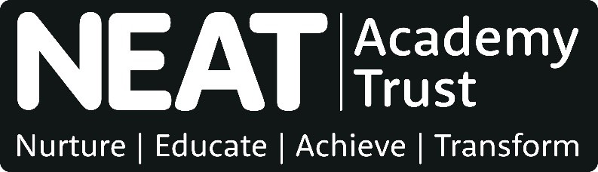

Person Specification

JOB TITLE: | Curriculum Leader – Art & Technology
DATE: | May 2022
STATUS: | Final

CRITERIA | Essential/ Desirable | Application | Tasks | Interview | Vetting  Checks  ks
Knowledge and qualifications
- Qualified teacher status | E | ✓ |  |  | ✓
- BA degree in the subject area (or related to the subject area) | E | ✓ |  |  | ✓
- Evidence of designing and teaching effective lessons and learning activities across the relevant curriculum, age and ability ranges including personalising learning to meet individual needs | E | ✓ | ✓ |  | ✓
- Good Knowledge and understanding of National Curriculum and/or Post 16 curriculum relevant to point 3 above | E | ✓ |  | ✓
- Evidence of personal commitment to lifelong learning | E | ✓ |  | ✓
- Evidence of applying up to date working knowledge and understanding of teaching, learning and behaviour | E | ✓ |  | ✓
- Through understanding of how young people team and the core features of an effective curriculum | E |  | ✓ | ✓
- Evidence of relevant and on-going professional development | E | ✓ |  | ✓
Experience
- Successful track record as a teacher that demonstrates high quality teaching and learning and positive impact on learner outcomes. | E | ✓ |  |  | ✓
- Evidence of teaching KS3, KS4 and KS5 | E | ✓ |  | ✓
- Experience of contributing to the design, delivery and evaluation of an area of a school curriculum | E | ✓ |  |  | ✓
- Experience of working collaboratively with peers across own school to achieve shared priorities | D | ✓ |  |  | ✓
Skills and competencies
- Ability to safeguard and promote the welfare of children including motivation to work with children, forming and maintaining appropriate relationships and personal boundaries with children and young people, emotional resilience in working with challenging behaviours and attitudes to use of authority and maintaining discipline | E |  |  | ✓ | ✓
- Demands ambitious standards and high expectations for all learners | E |  | ✓ | ✓
- Understanding to enable teaching in KS5 | D |  | ✓ | ✓
- Effectively manages own behaviour and relationships with others to provide appropriate support and challenge | E |  | ✓ | ✓
- Effectively manages own behaviour and relationships with others to provide appropriate support and challenge | E |  | ✓ | ✓
- Effective oracy and written communication skills for a range of audiences | E |  | ✓ | ✓
- Willing and able to contribute to extra-curricular activities | D | ✓ |  | ✓
- Willing and able to contribute to whole school development initiatives/school improvement/planning self-evaluation | D | ✓ |  | ✓
- Ability to safeguard and promote the welfare of children including motivation to work with children, forming and maintaining appropriate relationships and personal boundaries with children and young people, emotional resilience in working with challenging behaviours and attitudes to use of authority and maintaining discipline | E |  |  | ✓ | ✓
Other
- No disclosure about criminal convictions, barring or misconduct that is considered to make the candidate unsuitable for this particular role | E | ✓ |  | ✓ | ✓
- No concerns about medical fitness or attendance that is considered to make the candidate unsuitable for this particular role | E |  |  |  | ✓
- Embraces and displays the NEAT values: aspirational, collaborative, inclusive, innovative, has integrity, responsible | E | ✓ |  | ✓

