Head of Art  TLR2  Commencing September 2022  A UNIQUE CHANCE TO BUILD YOUR OWN TEAM AND CURRICULUM WITHIN A GROWING ACADEMY | 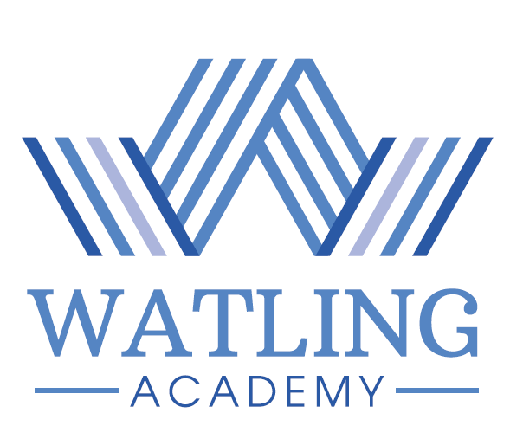

Are you inspirational, highly motivated and enthusiastic? Are you looking for the next exciting step in your career?

We are seeking a suitably qualified, committed individual with a passion for positively impacting upon our students in our growing, vibrant and dynamic school, Watling Academy. As the Head of Art you will be a curriculum lead who is responsible for leading and developing this area, ensuring the curriculum is fit for purpose and teaching and learning continuously enhanced.

You will have excellent subject knowledge and a passion for your subject. You will be prepared to go the extra mile for our students and to develop colleagues within your team. You may be operating at key stage level or similar and looking for the next step in your career. You will receive mentoring, coaching and support to develop the knowledge and skills to enable you to become an experienced Head of Department, appointing, leading and developing your team as the Academy grows.

Watling Academy is a purpose-built secondary school in its second year of operation, located within the Whitehouse development on the western expansion area of Milton Keynes. The Academy will have 1800 students when at full capacity. Watling Academy is part of the Denbigh Alliance MAT.

If you would like to join our team then please visit our website, www.watling.academy for more information and how to apply.

Application forms only will be accepted - please do not send CVs.
The school is committed to safeguarding and promoting the welfare of children and expects all staff to share this commitment. An enhanced DBS will be required for all successful applicants.

E-mail: recruitment@thedenbighalliance.org.uk
Head of School: Mr I Bacon
Closing date: 9:00am on Monday 8th November 2021
Interviews: Tuesday 16th November 2021

