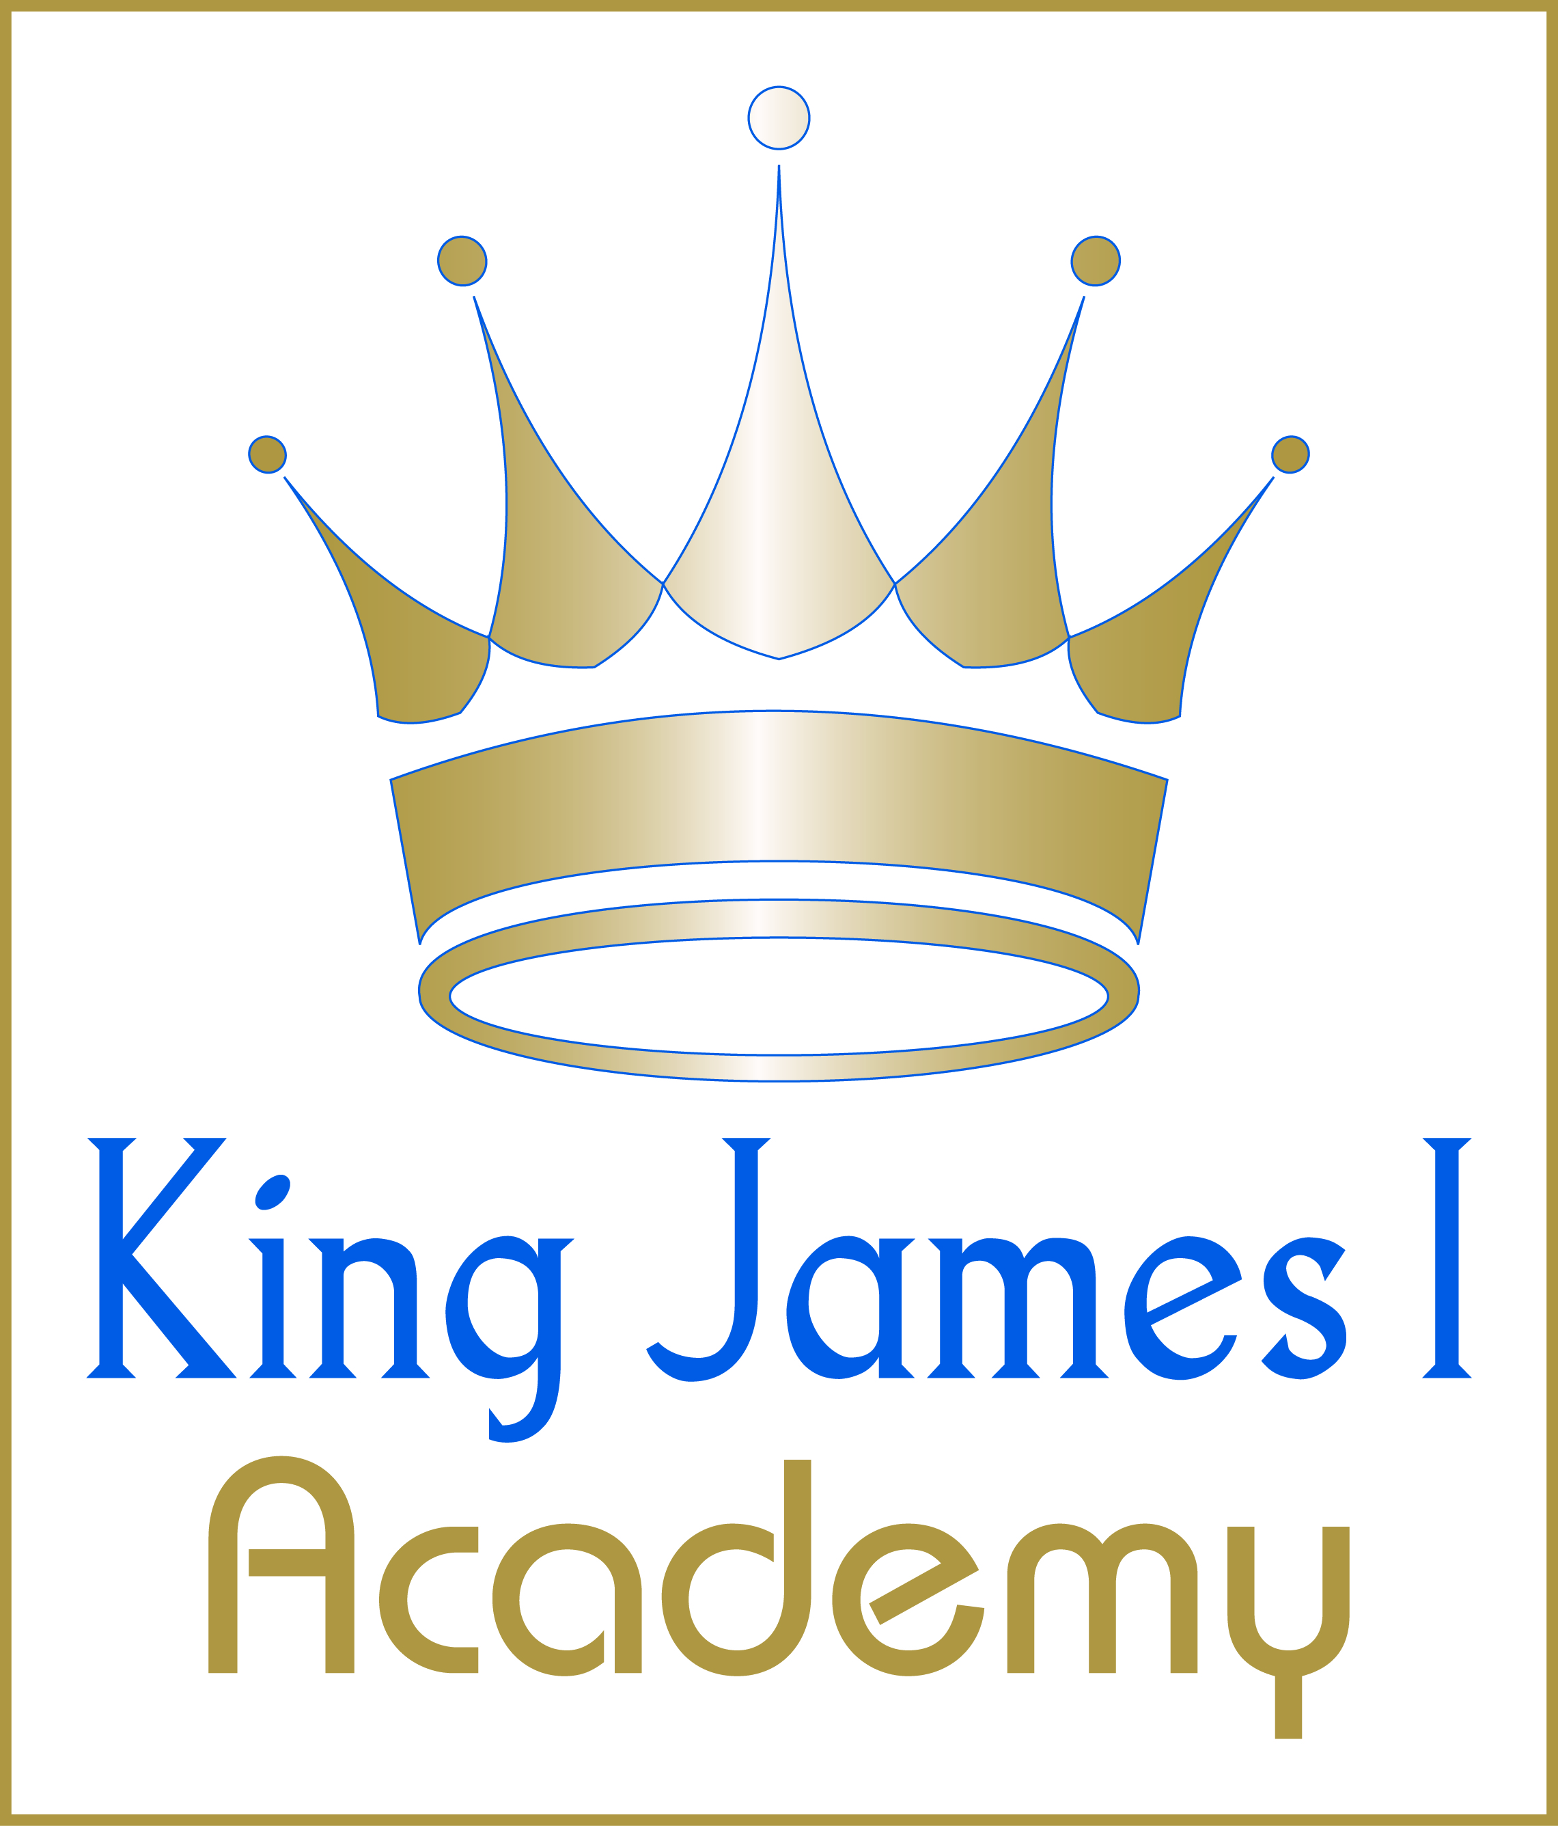
JOB DESCRIPTION
Job title: Head of Department – Business and Enterprise
Salary: MPS/UPS +TLR2a
Contract type: Full Time
Reporting to: Headteacher
Main purpose
The Head of Department will take responsibility for providing leadership and management in Business and Enterprise to secure high quality teaching, the effective use of resources, and excellent outcomes for all students in Business and Enterprise.
Duties and responsibilities
- To support the ethos and values of King James I Academy.
- To lead in teaching Business and Enterprise, ensuring the highest of standards and the achievement of all students in the subject.
- To ensure outstanding curriculum provision which is well structured and enables students to develop an excellent understanding of key facts and processes and a deep understanding and love for the subject.
- To ensure that the subject makes an outstanding contribution to whole school priorities, including appropriate application of the Literacy and Numeracy Policies.
- To ensure effective provision and develop outstanding teaching and learning, attainment and progress across the subject.
- To implement the Academy’s Assessment and Feedback policy effectively in the department, with a particular focus on impact.
- To keep abreast of developments in Business and Enterprise to ensure that changes and developments in course content are introduced and delivered in a timely manner.
- To ensure that all assessment within Business and Enterprise is high quality and robust
- To have an excellent understanding of the Department’s effectiveness, and to interpret data to inform targets, tackle underachievement and prioritise areas for improvement quickly and effectively
- To lead on to standards verification, in line with the BTEC Business / Enterprise programmes
- To facilitate enrichment and intervention programmes for students as appropriate
- To ensure high standards of behaviour within the subject area; in classrooms, corridors and across the Academy in general
- To develop a culture in the department where students show initiative and resilience to challenges.
- To ensure positive relationships are maintained with all stakeholders, including students, parents and governors
Please note that this list of duties is illustrative of the general nature and level of responsibility of the role. It is not a comprehensive list of all tasks that the Head of Business and Enterprise will carry out. The postholder may be required to undertake other duties appropriate to the level of the role.

The Academy is committed to safeguarding children. All candidates will need to demonstrate a commitment to the welfare and safety of children and young people. Any offer of employment will be conditional upon receipt of two supportive references and the successful completion of pre-employment checks. An application to the Disclosure and Barring Service will be submitted when the successful candidate has accepted the position.
Please visit the Disclosure and Barring Service Code of Practice for further information:
https://assets.publishing.service.gov.uk/government/uploads/system/uploads/attachment_data/file/474742/Code_of_Practice_for_Disclosure_and_Barring_Service_Nov_15.pdf

King James I Academy is an Equal Opportunities Employer. We want to develop a more diverse workforce and we positively welcome applications from all sections of the community.

