INFORMATION PACK
Head of Citizenship and PSHE
Required for September 2023
Overview of the Role

A well-qualified and enthusiastic specialist is required to lead the Citizenship Department within this highly successful grammar school. The department is integral to the school’s curriculum provision and personal development programme at key stages 3 and 4. It achieves excellent public examination results at GCSE level.

The full job description and person specification are at the end of this pack.

Contents of this pack
Bright Futures Educational Trust | Page 1-2
Altrincham Grammar School for Girls | Pages 3-4
Why work for us? Terms and conditions and how to apply | Page 5
Job Description | Pages 6-8
Person Specification | Pages 8-9

Bright Futures Educational Trust
Bright Futures Educational Trust (The Trust) is a multi-academy trust set up in 2011. The Trust is made up of a richly diverse group of schools in Greater Manchester and Blackpool. We are passionate about working together within and beyond the Trust to achieve our aspirational vision: the best for everyone, the best from everyone. We are an organisation that is underpinned by values of: community, integrity, and passion. In everything we do, we remember that we are accountable to the children, families, and communities that we serve.
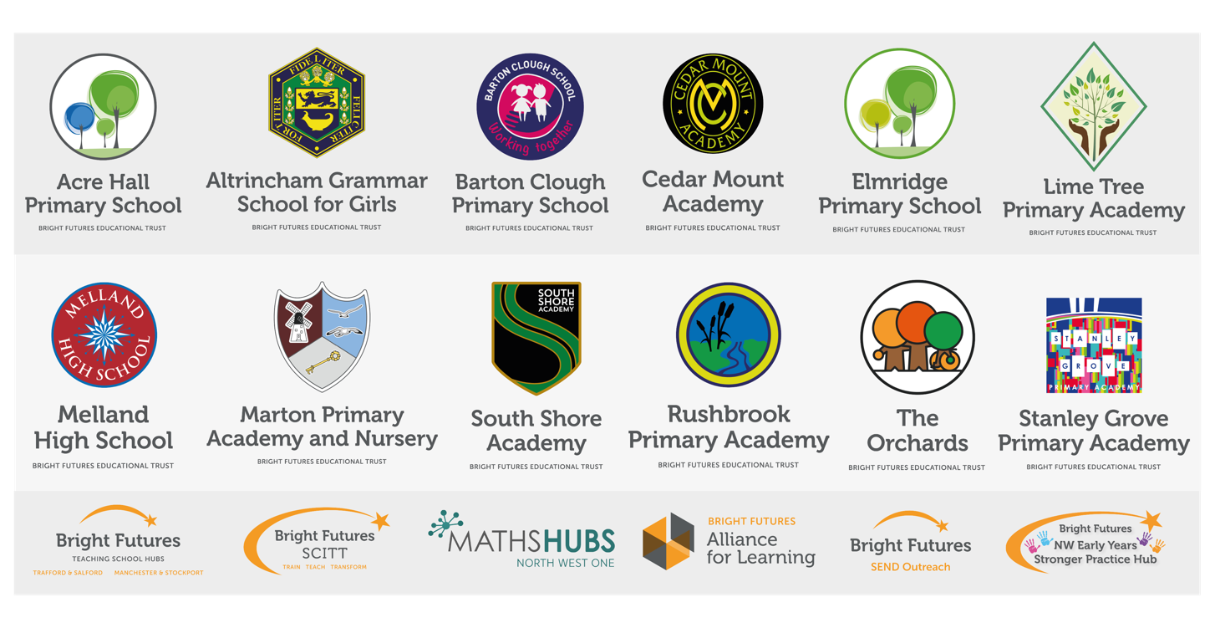
Our schools have their own identities, form one organisation and have one employer, Bright Futures Educational Trust. Bright Futures’ Board of Trustees maintains strategic oversight of the Trust and delegates some of its responsibilities to the Executive Team, Heads of School and local governing bodies. We place a high value on integrity and probity and take seriously our accountabilities for making the best use of public money. How decisions are made is described in our delegation framework. You can find out more about the Trustees and the Executive Team on our website: About Us - Bright Futures Educational Trust (bright-futures.co.uk)
The central team includes the Executive Team: John Stephens, CEO; Edward Vitalis, Chief Operating Officer; Gary Handforth, Director of Education; Lisa Fathers, Director of Development, Partnerships and Teaching School Hubs and Lynette Beckett, Director of People & Strategy. The focus of these roles is to work with schools, providing high quality and timely guidance, leadership, challenge, and support. In addition to the executive team, we have central operations for finance, communications and marketing, HR, educational psychology, and digital technologies. Please see our website brochure which explains our central operations: Why-Join-Bright-Futures

Bright Futures Professional Development Institute is an important part of the Trust. The Institute is the home of all professional development and school improvement resource in Bright Futures. The Institute is also where all of our outward facing work happens. Underneath this umbrella we have several hubs. The Alliance for Learning (AFL) which provides school improvement services and CPD to over 700 schools, a North West Maths’ Hub NW1 Maths Hub, providing mathematics training and coaching to 500 schools, and a SCITT (School Centred Initial Teacher Training) Bright Futures SCITT, which is the largest in the North West. Within the Institute, Bright Futures also has two Teaching School Hubs, serving Manchester, Stockport, Salford, and Trafford. Bright Futures Send Outreach is another service which we provide across the Northwest. We have also been designated as an Early Years Stronger Practice Hub under the name of Bright Futures North West Early Years Stronger Practice Hub providing guidance and support to settings across the region.

Collaboration and strong relationships form one of the ‘commitments’ in our Strategy and all components of the Bright Futures’ family work closely together. Our Strategy was developed collaboratively and can be found on our website: Our Strategy.

Altrincham Grammar School for Girls
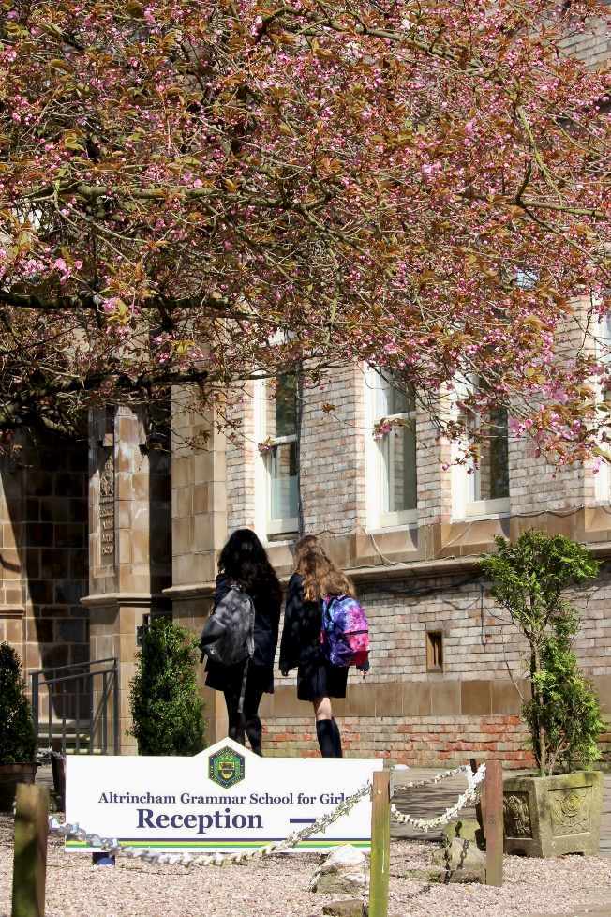
Altrincham Grammar School for Girls (AGGS) is a highly successful single sex 11 -18 academy in the South Trafford area. AGGS was in the first cohort of schools to be designated a national teaching school in 2011. AGGS is the lead school in ‘The Alliance for Learning’, which comprised schools of every type and phase, plus universities, throughout a wide geographical area. The impact of teaching school activities has been felt within the Trust and far beyond. We have a reputation for excellence regionally and nationally, of which we are very proud.

AGGS is committed to providing equal opportunity in recruitment and employment to all individuals. We will consider candidates without regard to race, ethnicity, gender, religion, sexual orientation and identity, national origin, age, military or veteran status, disability or any other legally protected status; and without discrimination based on socioeconomic, marital, parental or caregiving status, or any of the previously listed characteristics or statuses.

We value the diversity of our staff and reject any form of harassment, discrimination or victimisation. The Bright Futures Educational Trust vision is: ‘the best for everyone, the best from everyone’. To achieve this, we create and maintain a work environment and culture where people from different backgrounds, and with varying lifestyles, interests, opinions and responsibilities, treat each other with dignity and respect. It is a climate in which our staff feel safe and are inspired and motivated to be their best.

Our school is dedicated to sustaining and promoting diversity with respect to recruitment, promotion, training and general treatment during employment. We are actively seeking to extend the diversity of our staff. Furthermore, we welcome candidates who have not had previous experience of working in a grammar school.

We aim to ensure that our recruitment processes set up all candidates for success. At interview our aim is to provide a positive experience. We don’t want to catch anyone out, but rather to provide the opportunity for all candidates to be themselves and show us what they are capable of.

WHY WORK FOR US?

We offer a great opportunity to join an organisation which really lives its values. Our working environment is very inclusive and whilst you can expect to be challenged in your role, you will be supported through professional learning, treated fairly and with dignity and respect. Please see the Equality,
Diversity, an Inclusion statement on our website.

Terms and Conditions
Salary: School Teachers Terms & Conditions pay range. You will also be rewarded a TLR 2B for your responsibilities as Head of Department, with an annual value of £5,023.
Pension: Local government pension scheme. Please take a look at the website:
Teachers Pension Scheme: https://www.teacherspensions.co.uk/

Other: We offer salary sacrifice schemes for purchasing bikes used for travel to work and technology for personal use, through monthly interest free salary deductions.
We also offer opportunities for professional development.

For a full explanation of our employment offer please see the booklet on our website:
Our-Employment-Terms-November-2022.pdf (bright-futures.co.uk)

How to Apply
We can only accept completed application forms, rather than CVs. This is because the regulatory guidelines of
Keeping Children Safe in Education (2021), require us to check various details of job applicants and an identical
application format for each candidate enables us to do this. We use a process that does not identify personal
characteristics to the shortlisting panel. This is part of our commitment to equalities and diversity.
NO AGENCIES PLEASE.

Our application form is available online, along with the disclosure of criminal background form. The portal link is https://bfet.jotform.com/230642366130952. Alternatively, you can click Apply Now on this role via the current vacancies page of our website. Please upload the forms by 9 am on Wednesday 22 March.

The selection process may be conducted virtually, so candidates will need access to a device with a camera and a microphone to participate. However, we will confirm this following the closing date. The selection will take place during the week commencing 27 March. You will be notified after the closing date whether you have been shortlisted.

Keeping Children Safe in Education
Bright Futures Educational Trust is committed to safeguarding and promoting the welfare of children and young people and we expect all staff and volunteers to share this commitment. This post is exempt from the Rehabilitation of Offenders Act 1974; pre-employment checks will be carried out and references will be sought for shortlisted candidates and successful candidates will be subject to an enhanced DBS check and other relevant checks with statutory bodies.

Data Privacy
You can read the details of how we use the personal data that you provide us with in our Job Applicants’ privacy notice on our website: Applicant Privacy Notice
JOB DESCRIPTION
Head of Citizenship and PSHE

JOB SUMMARY
Citizenship and PSHE are taught together as a discrete, timetabled subject. The successful applicant will be responsible for overseeing the tailor-made schemes of work at KS3 and KS4 and will be accountable for student progress and development within this subject. As a subject that is well-respected by the students, it is important that citizenship and PSHE education lives up to its relevant, interactive and challenging nature. The person appointed will be expected to maintain high standards of teaching and learning across the citizenship curriculum, to maintain high levels of student achievement within this subject and to support the school in its desire for every student to develop their potential to the full and flourish as an individual. Previous experience of delivering citizenship and/or PSHE is essential. The ideal candidate would have experience in supporting others in the delivery of PSHE. We seek to appoint a candidate with excellent subject knowledge and a genuine passion for developing citizenship and PSHE, who will relate well to students and deliver lessons in a manner which will encourage enthusiasm for the discipline.

The current curriculum is in line with the National Curriculum and statutory guidance but also creates opportunities to extend student’s knowledge beyond this. There are strong themes of diversity, sustainability, action, consent, mental wellbeing and politics and political action across all year groups. The department offers GCSE Citizenship Studies (AQA). The subject attracts a high number of students; currently there two classes in each of Years 10 and 11. Students achieved excellent results; in 2022 63% of grades awarded were Grade 9. There is a strong theme of active citizenship across the department, with all students having the opportunity to undertake an ‘Action’ in Year 9.

Extra-curricular activities are an integral part of the department and it is hoped that the successful applicant will continue to support and grow these. For example, the current range of activities on offer includes: Model United Nations, Politics Society and Amnesty International Club. Many of the activities are student-led. The department also offers students opportunities outside the classroom, with annual GCSE trips to London, Manchester and Shrewsbury Prison. Many links have also been formed with local politicians and organisations who enhance the subject’s delivery eg the Politics Project.

The description for the post of Head of Citizenship/PSHE should be read with the generic job description ‘TLRs for Heads of Department’ (see Appendix) and applied accordingly. A more specific outline of the responsibilities for this post can be found below.

KEY RESPONSIBILITIES AND ACCOUNTABILITIES
The post will involve responsibility for:
- The management and monitoring of delivery of PSHE and citizenship at KS3 and KS4, including liaison with heads of department and the leadership team regarding the cross-curricular delivery of citizenship.
- Overseeing and updating of the curriculum for all the key stages.
- Developing and delivering the department development plan.
- Managing and maintaining resources and sourcing of new resources for staff and students.
- Planning and implementing reporting and assessment of PSHE and citizenship across KS3 and KS4.
- Liaising with other citizenship leaders.
- Keeping abreast of developments and cascading to colleagues when appropriate.
- Contributing to school policies and awards pertaining to PSHE and citizenship eg relationships and sex education.
- Maintaining a high profile for PSHE and citizenship within the school.
- Ensuring active citizenship opportunities are offered across the school.
- Overseeing, monitoring and developing the other teachers of citizenship, trainee teachers and other relevant groups.
- Providing input into training days, induction training etc.
- Publishing competitions and opportunities for students and helping with the applications for such awards e.g. UK Youth Parliament and mock elections.
- Maintaining contact with existing external speakers, organising timetabled talks and sourcing of new external speakers as appropriate.

General leadership responsibilities
- Developing and maintaining a culture of high expectations.
- Updating the Principal and other senior leaders on the effectiveness of citizenship/PSHE provision
- Leading by example as a teacher, and as a manger, achieving high standards of pupil attainment and progress, behaviour and motivation through effective teaching.
- Challenging under-performance at all levels and ensure corrective action and follow up.
- Supporting the development and maintenance of school policies and practices to ensure consistent application.
- Planning, chairing and organising meetings as appropriate.
- Attending and contributing to HoD’s meetings as well as ensuring that the department is represented in all matters within school relating to the curriculum.
- Sustaining effective, positive relationships with all staff, pupils, parents/carers, governors and the local community.
- Liaising effectively with all stakeholders including parents/carers, feeder schools, secondary schools, business and community partners, in line with strategic objectives.
- Maintaining clear expectations and high standards of professionalism.
- Attending school events and activities as directed by the Principal.
- Contributing to, and sometimes leading, research projects for AGGS and/or the Trust.
- Managing budget(s) in line with areas of responsibility.
School-wide Responsibilities
- Being aware of and acting upon relevant school policies and, in particular, those associated with child protection/safeguarding children and health and safety issues.
- Being responsible for maintaining a clean and tidy environment.
- Attending relevant meetings as required.
- Acting as a role model for the pupils in school.
- Acting as an ambassador for school and ensuring that the school’s high standards are promoted at all times.

Additional Specific Responsibilities
- Carry out the duties of a form tutor
- Support the school in its open evenings and award evenings.
- Support the school in its entrance examination.
- Ensure departmental support is available to students on GCSE and A level results days.

General Duties
- Carry out a share of supervisory duties in accordance with published schedules. Fulfil the conditions of employment of school teachers as laid down in the Pay and Conditions Document.
- Any other relevant duties requested by the Principal.

PERSON SPECIFICATION
Category | Essential | Desirable | Method of assessment
Qualifications, Education, training | - Good Honours Degree in relevant subject.  - QTS  - Recent relevant in-service training. | - Professional qualification e.g. NPQLT | - Application form  - Certificates
Relevant Experience | - Successful teaching experience including the teaching of citizenship/PSHE at key stage 3.  - Contribution to the work of a citizenship/PSHE department including involvement in course planning, development and evaluation. | - Experience of teaching citizenship GCSE.  - Experience of responsibility within a citizenship/PSHE department or other relevant area.  - Experience of the role of form tutor.  - Experience in developing whole-school policies and strategies.  - Evidence of leading CPD effectively. | - Application form  - Interview
Knowledge, skills, and abilities | - Excellent oral and written communication skills.  - Excellent ICT skills  - Ability to exercise effective classroom management and encourage good behaviour.  - An enthusiasm for citizenship and PSHE and the ability to generate this in others.  - Clear understanding of appraisal procedures for teaching and associate staff.  - Ability to lead and work as part of a team.  - Ability to plan, organise, review and adapt.  - Knowledge of recent citizenship/PSHE issues and of current resources for citizenship/PSHE teaching. |  | - Application form  - Interview
Personal Qualities/Other | - Ability to manage, motivate, support and inspire trust in others.  - Ability to formulate, monitor, evaluate and review plans and policies.  - Ability to lead INSET.  - Ability to confront and resolve problems.  - Ability to innovate and manage change. |  | - Application form  - Interview
Safeguarding | Commitment to demonstrating a responsibility for safeguarding and promoting the welfare of young people |  | - Application form  - Interview  - Task
Our Values | Community: Evidence of working together for a common purpose and encouraging diversity |  | - Interview  - Tasks
 | Integrity: Evidence of doing the right things for the right reason |  | - Interview  - Tasks
 | Passion: Evidence of taking personal responsibility, working hard and having high aspirations |  | - Interview  - Tasks

Bright Futures Educational Trust is committed to safeguarding and promoting the welfare of children and young people and we expect all staff and volunteers to share this commitment. This post is exempt from the Rehabilitation of Offenders Act 1974; pre-employment checks will be carried out and references will be sought for shortlisted candidates and successful candidates will be subject to an enhanced DBS check and other relevant checks with statutory bodies.

APPENDIX
TLRs for Heads of Department
Where there are seconds in the department, Heads of Department need to identify the area of responsibility/ies they would wish their second to take on as areas for development under their leadership. It is expected these roles and responsibilities will change annually or biennially. The Head of Department still maintains the overall responsibility for the department, sets the standard of leadership within the department and exercises his/her leadership on behalf of the Leadership Team.

Head of Department to take responsibility for:-

Personnel issues:
- The induction of ECTs including: weekly monitoring meetings, lesson observations and feedback, all other obligations as set out in the guidelines for ECT induction.
- The induction of new staff, teaching and associate.
- The induction of trainee teachers including: weekly monitoring meetings, lesson observations and feedback, all other obligations as set out in the guidelines for trainee teacher induction.
- Appraisal.
- Professional development of staff, both teaching and associate, within the department.
- Effective deployment of staff.
- Ensuring that all members of staff are issued with/have access to relevant student data.
- Supporting colleagues in the use of new technologies especially in the areas of teaching and learning, assessment and reporting.
- Ensuring the appropriate use of ICT by staff is embedded at all key stages.
- Feeding back formally to colleagues from heads of department or other relevant meetings.
- Organising external examination entries with the examination officer.
- Contributing to the departmental content of the KS3, KS4 and KS5 booklets.
- Holding regular meetings within the department and sending a copy of agenda and action points/minutes to the leadership team and the office manager (by email please).
- Overseeing implementation of dress code and punctuality within department.
- Monitoring staff absence and its effect on teaching and learning.
- Monitoring the quality of teaching and learning within the department.
- Liaison with assistant vice-principals on matters relating to timetabling and most effective use of human resources.
- Advising the principal on staffing issues, responsibility allocation with job descriptions and appointments to the department.
- Ensuring that recruitment, meeting and subsequent feedback to candidates is carried out in a professional manner.
- Liaising with the school librarian on the purchase of appropriate resources and the organization of special displays.
- Fostering and supporting a good working relationship within the team and the whole school including associate staff, senior staff and line managers.
- Reporting regularly to the leadership team on the department’s successes, areas for improvement and proposed future developments.

Pupil and student responsibilities
- Providing reading and research lists for students in Year 11 going into Year 12.
- Regular monitoring of books and marking.
- Overseeing department SOWs and resources.
- Ensuring that homework of quality is set in line with the school policy.
- Encouraging, supporting and coordinating the department’s extra-curricular activities.
- Ensuring provision for SEND, G+T, EAL and other groups.
- Co-ordination of the department to ensure that pupils and students are encouraged and able to access help when required.
- Regularly inviting specialist speakers into school and organising specialist excursions.
- Ensuring pupils are using appropriate numeracy and literacy strategies in their work.
- Annual update of departmental handbook.
- Regular review of syllabus requirements.
- Review of examination results, including strategies for improvement.
- Overseeing target setting for students and for the department.
- Overseeing that subject specialist support and advice is available for examination results days for students and senior staff.
- Ensuring the department’s behaviour policy is up to date and followed.
- Updating senior staff on departmental developments and pupil progress.
- Ensuring pupils are using appropriate ICT in their work.

Physical resources
- Ensuring that colleagues within the department will take care of teaching rooms, corridor areas, stock rooms etc. including furniture and maintain them to high standards.
- Referring on health and safety issues as per school policy.
- Creating and maintaining an attractive teaching environment, monitoring displays of pupils’ work and ensuring that such examples are correct and of a high standards.
- Completing annually capitation review and bid.
- Completing the DDP (Department Development Plan), including the mid-year review and contributing to the SDP (School Development Plan).
- Ensuring that the shared school target is a focus for members of the department.
- Ensuring effective use of resources including the quality of ICT hardware and software within the department.

Parents and the wider community
- Contributing to school developments such as school to school support.
- Supporting and contributing where appropriate to the cross-curriculum e.g. citizenship; enterprise education; careers; ICT.
- Reporting termly to the Principal on the department for the Principal’s report to governors.
- Overseeing the department’s contribution to various publications such as the school newsletter, including publicizing the department’s successes.
- Overseeing the production of quality reports to parents.
- Overseeing the preparation for open evening and morning, 6th form open evening and Year 9 options evening.
- Working with senior tutors and senior staff in promoting the aims and ethos of the school.
- Working towards a harmonious and supportive partnership between all parties in the school.
- Participating in delivering relevant training or INSET to colleagues within and outside the department as and when required.
- Carrying out regular lesson observations and learning walks to ensure the standard of teaching and learning in the department is consistently high and to support the teaching school initiatives.
- Carrying out any other relevant duties/responsibilities as and when requested by the Principal.
- Supporting the work and aims of the Bright Futures Educational Trust.

