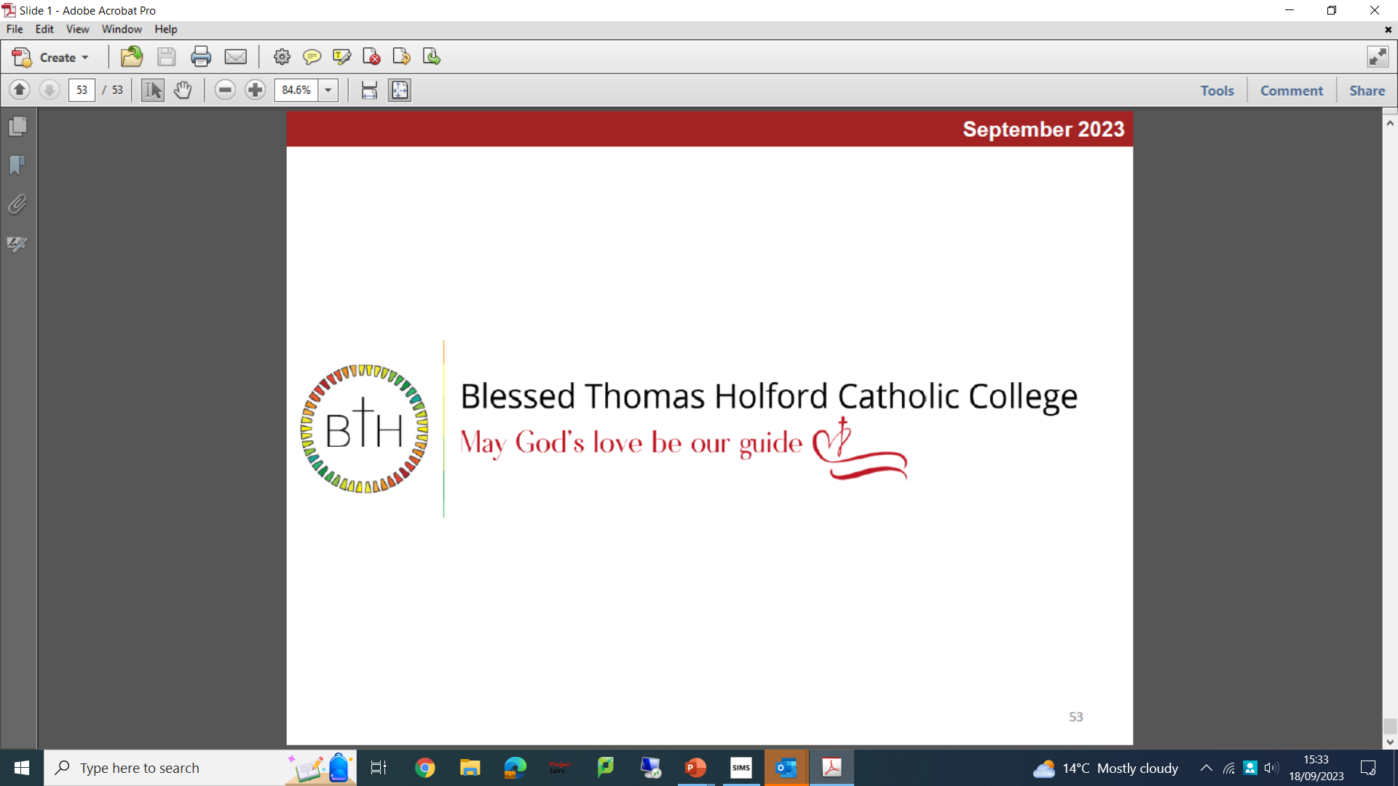

January 2024

Welcome Letter from Mrs Hogg, Headteacher

Thank you for your interest in the post of Head of Computing
Our motto is ‘may God’s love be our guide.’ God’s love is kind, patient, and hopeful. It always protects and perseveres. However, love is not easy, and it takes strength to open our hearts to all, as God’s love is not guided by arrogance, resentment, envy, judgement, or selfishness. So, our daily prayer is may God’s love be our guide in our college, in the classroom, in our decisions, on the playground, in our friendships, in our learning, in our curriculum, in our thoughts, in our conversations, in our welcome and in the person we are yet to become.’
What makes Blessed Thomas Holford Catholic College standout is our commitment to the young people in our care, encouraging and inspiring every child to fulfil their God given potential and to flourish. We place as much emphasis on the pastoral care and faith development of the child as we do on academic excellence.
We are a happy and vibrant 11-18 college, and our academic tradition fosters a culture of enquiry and creativity. We value curiosity and thoughtfulness, and we are ambitious for our students to achieve success whatever their aspirations.
All our staff have true pastoral hearts and take time to ensure every child is known, their strengths supported, and development needs overcome. I would encourage you to visit Blessed Thomas Holford Catholic College and find out more about our welcoming inclusive college.
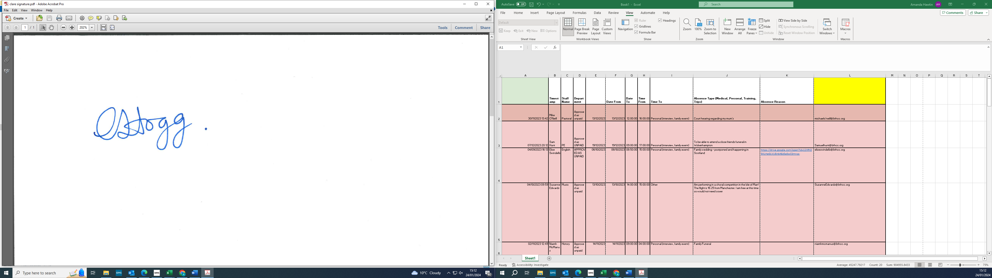
Mrs C Hogg
Headteacher

