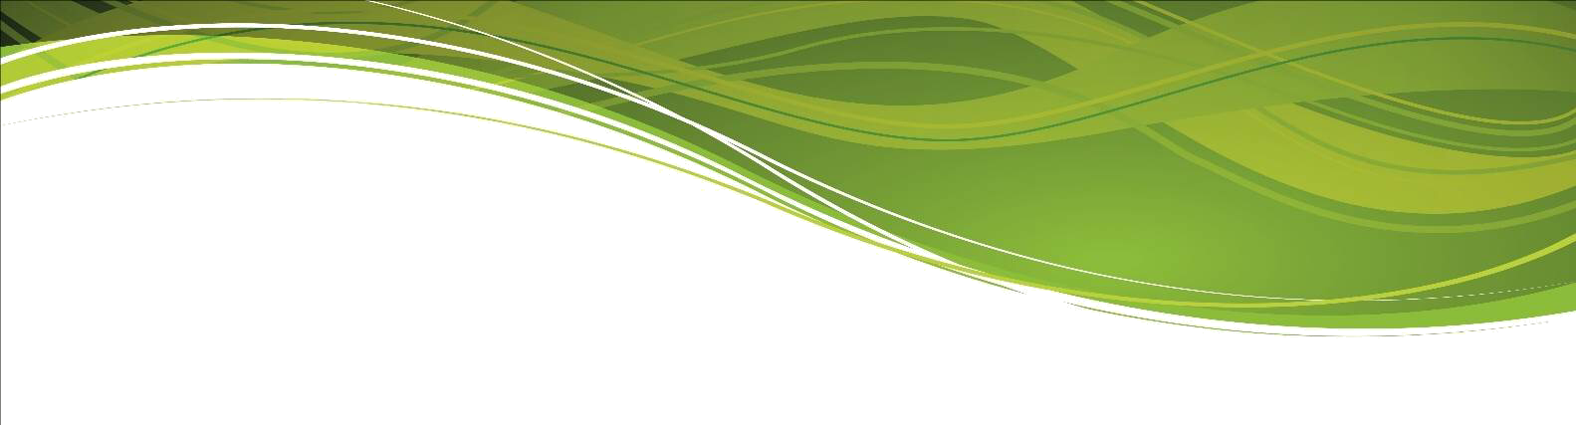

English Department

The English Department at Millom School is composed of a highly dedicated and supportive team with a desire to raise standards and aspirations across the school age and ability range.

Excellent use is made of objective data to set demanding targets and monitor progress. A range of resources allow staff to deliver the English curriculum in a fashion conducive to bringing about the sustained development of the students' knowledge-base and conceptual understanding. Effective use is made of group work, interactive whiteboard activities and investigative approaches to learning.

Cross-departmental and cross-phase work is a continued focus. The school has developed links with feeder primary schools and contributes to the transition process.

Personnel and Examination Performance Summary
The successful candidate will work alongside highly dedicated teachers of English. There are considerable complementary strengths within the team which offers a broad skills base. The success of the English department is built upon a clear vision, team work, good humour and a desire to continually improve. The department has a strong track record with respect to examination performance, repeatedly exceeding national average data re both attainment and progress measures at GCSE and A-Level.

Departmental Organisation - setting and specification information
In Year 7, English is taught in mixed ability groups.
In Year 8 and Year 9, there is a high attainment profile class and 2 mixed ability groups. Setting decisions are informed by close monitoring of internal assessment data, supplemented by objective assessment data.

In Year 10 and Year 11, the pupils are set based on internal assessment data, supplemented by external, objective data. The department offers the WJEC Eduqas English language GCSE (9 - 1) and WJEC Eduqas English literature GCSE (9 - 1) syllabi.

The Sixth Form are following the WJEC Eduqas GCE A level in English literature specification.

Departmental Organisation – room allocation
Currently, all the teachers in the department teach in their own classroom. Each room has a network point and each of the classrooms is equipped with an interactive whiteboard.

Departmental Organisation – schemes of work and learning materials
The department operates by providing students with an education which comprises a three-year Key Stage 3 and a two-year Key Stage 4. The department has developed and resourced a series of schemes of work which are 'progression mapped' from Key Stage 2 to Key Stage 5. In order to supplement the resources we have developed, we use WJEC Eduqas endorsed textbooks and resources.

