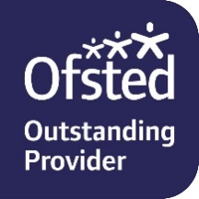
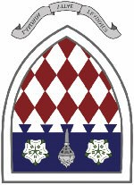
Spalding High School
www.spaldinghigh.lincs.sch.uk
Required for September 2023 Head of Art and Design
(TLR 2b) £4680 Main Scale/UPS

The Governing Body are seeking to appoint a motivated and dynamic Head of Art and Design. The Art and Design Department has a proven track record of success at GCSE and A Level. Our new Head of Art and Design will be an outstanding professional who has the necessary leadership qualities to drive the department forward and continue to raise standards. The successful candidate will be a dynamic and inspiring classroom teacher, with a strong commitment to further developing outstanding teaching and learning across the department and at each Key Stage.

Spalding High School is an 11-18 academically selective community girls’ grammar school with boys in the sixth form and has an excellent reputation within the local community and region. We are a popular, happy and successful school with strong support from governors, parents, students and a dedicated and highly experienced team of staff. In 2022 our examination results placed us as one of the highest-ranking state schools in Lincolnshire and we regularly feature on the Times Parent Power List of Top Performing State Schools. Students come from throughout South Holland as well as from Cambridgeshire, Norfolk and Peterborough.

We are a progressive school with an innovative curriculum and a rich and diverse extra-curricular programme. Our commitment to developing the whole person prepares students well for the challenges and opportunities that they will face in the rapidly changing world in which they live.

Personal development from childhood to adulthood is also of great importance to us. Our students grow into independent, articulate young adults who take responsibility for their lives and make decisions about their futures in an informed and intelligent way. We are proud of our excellent pastoral care and guidance that ensures that no student is lost in the crowd.

We are looking forward to meeting you and hope that you will want to join us in taking this happy and highly achieving school to the next stage of its development.

Our school is committed to safeguarding and promoting the welfare of young people and expects all staff and volunteers to share this commitment. Any offer of employment will be subject to an enhanced background check by the Disclosure and Barring Services, employment references and medical clearance.

Closing date: Monday, 20th March 2023 at 12 noon
For further information including an application pack, please visit our website
http://www.spaldinghigh.lincs.sch.uk/jobs.asp

To arrange an informal visit, please contact:
Mrs Suzanne Kingerley, Headmistress’ PA on (01775) 722110 or email Suzanne.kingerley@spaldinghigh.lincs.sch.uk
Completed applications to be returned to Mrs S Kingerley, Headmistress’ PA

