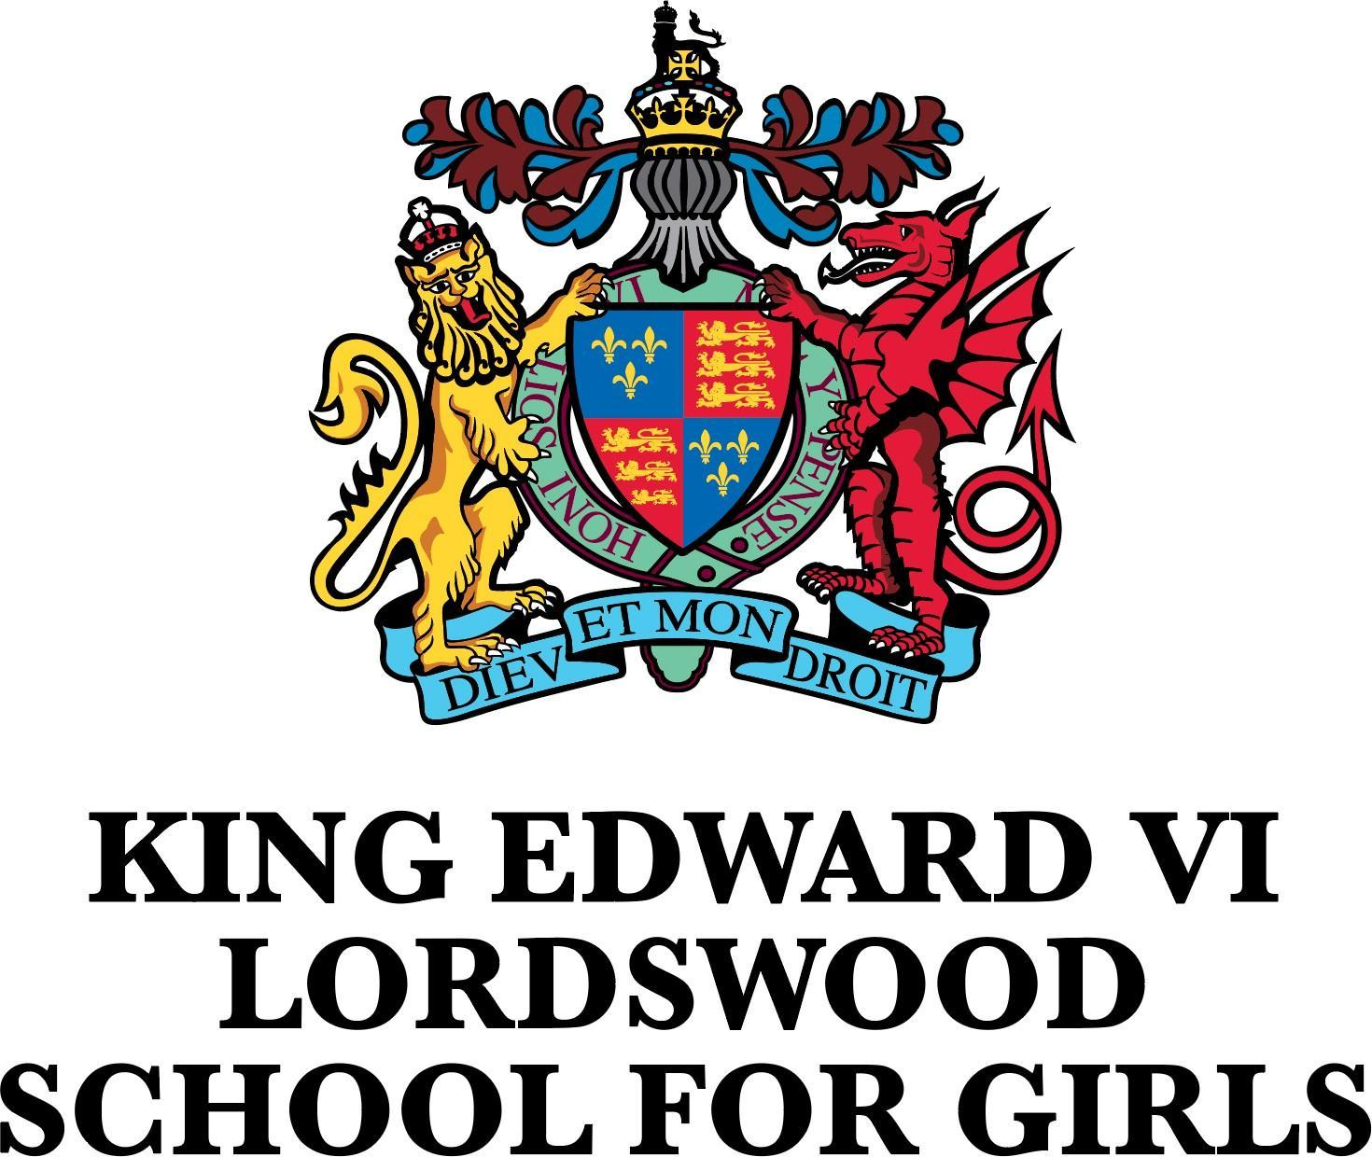

**Job title: Head of Department for PSHCE**

|  |  |
| --- | --- |
| **Job Summary** | |
| **Salary:** | **MPS/UPS plus TLR 2B** |
| **Hours:** | **Permanent, Full-Time** |
| **Location:** | **KEVI Lordswood School for Girls, Harborne, Birmingham B17 8QB** |
| **Start date:** | **September 2025 or January 2026** |
| **Closing date:** | **12 noon Tuesday 10th June 2025** |
| **Job overview** | |
| **Are you an enthusiastic and committed PSHCE specialist looking to make an impact on young people's lives?**  King Edward VI Lordswood School for Girls is seeking to appoint someone who believes passionately about making a difference to the lives of every student and who does so with integrity, humility and relentless positivity.  The successful candidate will work as part of a strong team and will be willing to participate in all aspects of school life including support for extracurricular clubs, events and trips.  Our PSHCE department lies at the heart of our school’s mission to nurture well-rounded and resilient young people. As a PSHCE teacher, you’ll play a vital role in shaping students’ understanding of the world and themselves—from mental health and relationships to citizenship, digital safety, and financial literacy. You’ll be joining a supportive, forward-thinking department committed to inclusive, values-driven education. We offer opportunities for professional development, cross-curricular collaboration, and innovation in how we deliver PSHCE in a constantly changing world. If you’re driven to empower students with the knowledge and skills they need for life, inspire critical thinking, debate and social awareness in the classroom and beyond, our department is the place to make that impact.  We are looking for a teacher with infectious enthusiasm and excellent communication skills with an ability to develop and maintain positive relationships with students, colleagues and parents. Extracurricular opportunities are a key part of school life and the successful candidate will play a key role in providing opportunities for students beyond the classroom.  In return we are offering the successful candidate the opportunity to work in a thriving community, composed of kind and respectful students who are dedicated to their learning and colleagues who are caring, compassionate and committed. Staff and students have extremely positive relationships underpinned by our school value of ‘respect’. We are a happy and caring school which values and takes pride in diversity and celebrates individuality.  If our vision and values match your own philosophy, we would welcome an application.  **VISITS:**  All potential applicants are invited to visit the school prior to submitting an application. Visits will take place at  **3.00 p.m. on Wednesday 4th June and 9.00 a.m. and 3.00 p.m. on Thursday 5th June 2025**. Please email [PA@lsg.kevibham.org](mailto:PA@lsg.kevibham.org) to book a place.  **APPLICATION:**  There is no requirement to submit a letter of application in addition to the personal statement on the application form.  Personal statements should be no more than 1000 words.  Applications via CV will not be accepted.  **DEADLINE FOR APPLICATIONS: 12 noon Tuesday 10th June 2025**  **SHORTLISTING: Thursday 12th June 2025**  **INTERVIEW DATE: 8.30 a.m. Tuesday 17th June 2025**  *The Schools of King Edward VI in Birmingham is an educational charity supporting eleven schools and is committed to safeguarding and promoting the welfare of children and young people and expects all staff and volunteers to share this commitment.*  *Shortlisted candidates will have online content checks undertaken before the interview.*  *The successful applicant will also be subject to an enhanced DBS check. Please note, where a role involves engaging in regulated activity relevant to children, it is a criminal offence to apply for the role if the applicant is barred from engaging in regulated activity relevant to children.*  *King Edward VI Academy Trust in Birmingham is committed to equal opportunities in employment and positively welcome your application irrespective of your age, disability, gender reassignment, marriage and civil partnership, pregnancy and maternity, race, religion or belief, sex, or sexual orientation.*  *This post is covered by Part 7 of the Immigration Act (2016) and therefore the ability to speak fluent and spoken English is an essential requirement for this role.*  *Charity Number 529051* | |
| **How to Apply** | |
| A full job description and an application pack for this post can be found at: https://lsg.kevibham.org.  Completed application forms should be forwarded to [**PA@lsg.kevibham.org**](mailto:PA@lsg.kevibham.org) **by 12 noon on Tuesday 10th June 2025.** | |

|  |
| --- |
| **About King Edward VI Lordswood School for Girls** |
| **About the school**  King Edward VI Lordswood School for Girls offers an excellent academic education within a happy and purposeful community. High quality teaching and valuing each individual are central to our approach.  All students are encouraged to realise their fullest potential, to live and work in harmony with others and to be ambitious for their futures. Students are supported in their work by a team of highly professional and caring staff.  Student outcomes are significantly above national figures, but this is not what makes us most proud.  Our school is a community and, whilst we value academic success, this is not the only objective of our school.  We pride ourselves in growing good citizens, we help to develop individuals who have the knowledge, skills and the desire to make a difference to the world in which they live.  *“Together, we thrive and add value to the world” (mission statement)*  We achieve this by supporting our students to become ready, respectful and resilient individuals. These strands carry through all aspects of life at our school.  *“This welcoming and empowering school inspires pupils to reach their potential. Pupils are ready to learn, respectful in conversation and resilient in the face of challenges. They feel safe in school. Pupils know staff are there to help them when they need it.” (Ofsted 2024)*  We always put students at the heart of every decision that we make and will continue to do so whilst we strive for constant improvement.  Thank you for taking time to explore if King Edward VI Lordswood School for Girls would be the right school for you. We hope you love our school as much as we do. If you cannot find the information you are looking for, please don’t hesitate to contact the school office who will do everything that they can to assist.  **Why join us**  Excellent working conditions that include:   * Supportive, enthusiastic and committed colleagues * Operate in line with school teacher terms and conditions * Automatic enrolment in workplace pension scheme * Subscribed to the DfE wellbeing charter * Additional Trust training day each year * Access to a range of CPD and training tailored to your needs * Unlimited access to TES develop * Opportunities to develop both within the school and across the trust * Catering on training days * Employee assist programme (including counselling services) * Cycle to work scheme * Annual flu vaccination (for those who don’t qualify under the NHS) * Free eye test * Software to support with role completion e.g. Studybugs, GCSE pod * Buddy system for first year of employment * Workroom for all teachers * Free car parking for all staff * Free laptop to complete school work * Free exercise classes * Free tea, coffee, milk and sugar * Free access to TES magazine * Free access to ‘The Key for School Leaders’ * Only one meeting/after school event per week * Consistent night for all after school activities * Online parents’ evenings * Staff recognition programme * Staff wellbeing committee * Social events (in school and out of school) * Reprographics department to undertake printing   **About the Trust**  The King Edward VI Foundation, Birmingham, is a progressive charitable organisation which has supported excellence in education across the City since 1552. Our schools are diverse in nature but have a common purpose and commitment to achieving our mission of:  *“Making Birmingham the best place to be educated in the UK”.*  Our Academy Trust currently consists of two independent schools, six selective, and six non selective academies. Our recent expansion into a wider diversity of local communities is enabling us to accelerate our strategies for improving the life chances of young people in Birmingham, whatever their background.  The King Edward VI Academy Trust Birmingham (“the Academy Trust”) was established in 2017 and is made up of the academies outlined above. The academies receive back office central support services including governance, from the Foundation Office (a central support services function), with several staff being seconded from the Foundation to deliver support services to the Academy Trust and the academies themselves.  Our highly focused five-year strategy aims to build on our existing strengths and heritage and deliver our ambitious growth strategy which aims to bring in a further five academies over the next five years. |