BROUGHTON HALL CATHOLIC HIGH SCHOOL
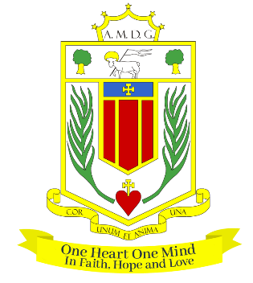
Yew Tree Lane

Liverpool, L12 9HJ

Telephone 0151 541 9440 / Fax 0151 259 8448
E.mail: smithg@broughtonhall.com
Head Teacher: Mrs S O’Rourke B.A. (Hons), PGCE

Role: HEAD OF DEPARTMENT– Religious Education
Additional Allowances: TLR1B
Contract: Permanent/Full-Time
Closing Date: 3rd March 2025
Interview Date: As soon as possible after the closing date
Start Date: 1st September 2025 or sooner

Suitable for: MPS/UPS

The Governors wish to appoint a first rate, enthusiastic Head of Department for RE with the ability to teach across the full age and ability range. We are looking for a committed candidate to fulfil this important role and to provide leadership in the Catholic Life and mission of the school. If you are highly motivated, have a passion for RE and have the ability to inspire our pupils then we would love to hear from you. It is a requirement for the candidate to be a practicing Catholic.

The RE Department is a successful, supportive one and offers qualifications at both Key Stages 4 and 5. The department is equipped with 5 well-appointed classrooms and is well-resourced.

The successful candidate will be:
- An outstanding classroom practitioner with a proven track record of delivering good and
outstanding lessons.
- Someone who is passionate about RE and has the ability to inspire a love of subject
- Committed to the school’s vision and demonstrating compassion through the mission
statement
- Dedicated in ensuring students achieve the best outcomes.

About Broughton Hall Catholic High School
Broughton Hall is a Catholic High School is an Ofsted rated Good provider (2022), which is proud of our strong Catholic ethos and values. The school has an excellent reputation and promotes an inclusive education which develops creativity, confidence and independence. The school is committed to the continuous professional development of all staff including Aspiring Leaders, NPQML and NPQSL programmes.

For further information about the school and Application Pack please visit the school’s website www.broughtonhall.com

Broughton Hall Catholic High School is committed to safeguarding and promoting the welfare of children and we expect all staff and volunteers to share this commitment to keeping children safe. Any offer of employment will be subject to statutory pre-employment checks including satisfactory references and Enhanced DBS and Barred List checks. This post is exempt from the provisions of the Rehabilitation of Offenders Act - accessed here - and shortlisted candidates will be required to disclose any relevant criminal history prior to interview.

