**Contract Term: Permanent/Full-Time**

**Headteacher**

**Salary Scale: MPS/UPS with TLR 1B**

**Headteacher**

**Interview Date:**  **To be confirmed**

**Headteacher**

**Shortlisting Date: 4th March 2025**

**Headteacher**

**Closing Date: 3rd March 2025**

**Headteacher**

**Start Date: 1st September 2025**

**Headteacher111**

**Role: Head of Department – Religious Education**

**Broughton Hall Catholic High School**

Founded in 1928 under the trusteeship of the Sisters of Mercy, Broughton Hall Catholic High School, an all-girls Catholic secondary school in Liverpool, provides the very best in modern education based on the Gospel values of mutual respect and care.

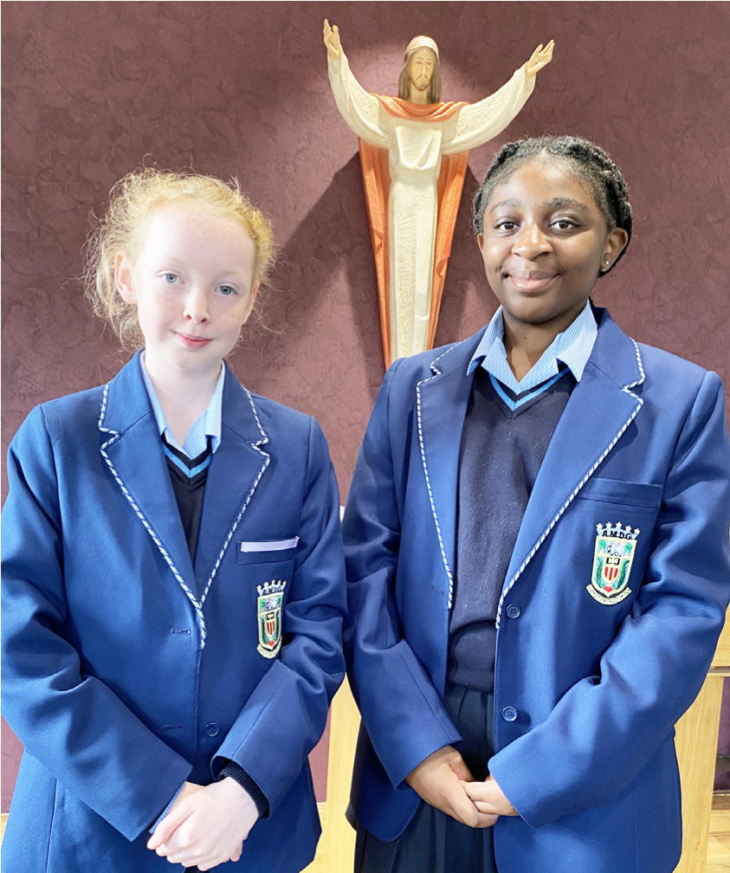

The central aim of our school is to provide excellent educational opportunities enabling each pupil to develop their God given talents, to grow in confidence and self-esteem and to fulfil their potential.

As a Catholic school Broughton Hall centres its mission on the person of Jesus Christ, and promotes the Gospel values throughout the school community and in all aspects of school life: spiritual, academic, pastoral, and personal. By proclaiming and living out the faith of the Catholic Church, we support each other in shared experiences of teaching and learning, prayer, worship and charity. Our mercy values permeate throughout our community.

Broughton Hall is Ofsted rated as a “Good” provider (November 2022).

Our facilities are bright, spacious, high tech and designed to meet the needs of all our pupils. We have a separate 6th Form facility, which is shared with our neighbouring boys school Cardinal Heenan Catholic High School. A full range of extra-curricular activities are provided to further the creative, sporting and academic talents of each pupil and offer Outward Bound and Duke of Edinburgh Award schemes as well as the opportunity to attend educational visits and residential trips.

We pride ourselves on our high expectations of all pupils and have an **‘Ambition for All’** policy. Whatever your role within the school, you will share these values and be able to encourage and motivate pupils with your passion, presence and personality.

Our school motto ‘**Cor Unum et Anima Una’** - One Heart and One Mind, reflects the strong sense of community amongst pupils, staff, parents and Governors.

School has a weekly Newsletter – please **click here** to view our latest edition. <https://www.broughtonhall.com/newsletter/>

**Welcome**

Thank you for your interest in the position of Head of Subject for Religious Education.

Religious Education at Broughton Hall has been recognised for its quality of teaching and learning of RE by the Quality Mark award, when it received Gold. The Religious Studies Department is dedicated to understand and use subject knowledge to achieve its objectives.

This pack has been designed to help you should you choose to submit an application form, which we sincerely hope you do. We hope it answers your initial questions, but if not, please do not hesitate to contact us and we will endeavour to help you through your application process.

Broughton Hall Catholic High School is the largest all-girls school in Liverpool and serves many different areas making us a vibrant a diverse school. Our aim is to be a good school in all areas and we are seeking staff to apply to work with to be of that journey. Ofsted rated the school as “Good” in November 2022.

We work hard to ensure Broughton Hall Catholic High School remains a friendly and welcoming environment for all those who work, study or visit here and hope that you are the person we are looking for to bring creativity and innovation to the role.

The school actively supports the training of middle leaders through well-respected Teaching Leaders’ programme. Opportunities for promotion exist for suitable candidates. Our staff are passionate about teaching and are committed to develop exciting and stimulating lessons that not only engage students.

We look forward to hearing from you.

**Sarah O’Rourke**

**Head Teacher**

**We Offer**

* Pensions Scheme – Teacher Pension Scheme for teaching staff or Merseyside Pension Fund for support staff
* Regular training and development programme
* Access to occupational health
* An enhanced Occupational Health & Well-Being App (Smart Clinic) with access to a wide variety of services e.g.
* Virtual GP
* 24 hour employee assistance line
* Physiotherapy
* Mental Health Services
* Self-support and guidance tools
* Cycle2Work Scheme
* Tax Free Childcare Vouchers
* Supportive work environment where all staff are valued
* Continuous professional development for all staff and follow a whole school approach to staff performance and development

And that’s not all, we place the outcomes of the children in our school at the heart of everything we do, so you’ll wake every day in the knowledge that your role will have a significant positive impact on the lives of others.

**Equal Opportunities**

Broughton Hall Catholic High school is an equal opportunities employer.

We welcome applicants from all backgrounds and value everyone as an individual. We are committed to organisational practices, which promote diversity and inclusion for all employees and volunteers regardless of age, gender reassignment, marriage or civil partnership status, pregnancy and maternity status, disability, race (including colour, nationality, ethnic or national origin), religion or belief, sex, or sexual orientation. Connecting these differences creates a productive environment in which everyone feels valued.

Monitoring information in relation to job applicants will be to assist us in equality monitoring. The recruitment panel will not have access to job applicant’s monitoring information.

To assist us in monitoring the operation of equal opportunities policy, and for no other reason, please ensure you complete and submit the Equal Opportunities Monitoring Form with your application form.

**Safeguarding & Enhanced DBS Checks**

Broughton Hall Catholic High School is committed to safeguarding and promoting the welfare of young people and expect all pupils, staff, volunteers and visitors to share this commitment

All posts are subject to an enhanced DBS check and full pre-employment checks to comply with the current Keeping Children Safe in Education statutory guidance for schools.

All staff will be expected to follow Broughton Hall Catholic High School’s child protection policies, code of conducts and managing allegations against staff procedures.

All roles in school, including this post, are exempt from the Rehabilitation of Offenders Act (ROA) 1974. The Ministry of Justice’s guidance on Rehabilitation of Offenders Act 1974 and the Exceptions Order 1975 provides information about which convictions must be declared during job applications and can be accessed [here](https://www.gov.uk/government/publications/new-guidance-on-the-rehabilitation-of-offenders-act-1974).

All applicants must therefore declare all previous convictions and cautions, including those which would normally be considered ‘spent’ except those received for an offence committed in the United Kingdom if it has been filtered in accordance with the DBS filtering rules. Information about filtering offences can be found in the DBC Filtering Guide, which can be accessed [here](https://www.gov.uk/government/publications/dbs-filtering-guidance).

By engaging in this recruitment process, shortlisted candidates consent to an online search in line with the Keeping Children Safe in Education Statutory Guidance 2022.

**Advert**

# **Role:** **HEAD OF DEPARTMENT– Religious Education**

**Additional Allowances: TLR1B**

**Contract: Permanent/Full-Time**

**Closing Date: 3rd March 2025**

**Interview Date: As soon as possible after the closing date**

**Start Date: 1st September 2025**

# **Suitable for: MPS/UPS**

The Governors wish to appoint a first rate, enthusiastic Head of Department for RE with the ability to teach across the full age and ability range. We are looking for a committed candidate to fulfil this important role and to provide leadership in the Catholic Life and mission of the school. If you are highly motivated, have a passion for RE and have the ability to inspire our pupils then we would love to hear from you. It is a requirement for the candidate to be a practicing Catholic.

The RE Department is a successful, supportive one and offers qualifications at both Key Stages 4 and 5. The department is equipped with 5 well-appointed classrooms and is well-resourced.

The successful candidate will be:

* An outstanding classroom practitioner with a proven track record of delivering good and

outstanding lessons.

* Someone who is passionate about RE and has the ability to inspire a love of subject
* Committed to the school’s vision and demonstrating compassion through the mission

statement

* Dedicated in ensuring students achieve the best outcomes.

**About Broughton Hall Catholic High School**

Broughton Hall is a Catholic High School is an Ofsted rated Good provider (2022), which is proud of our strong Catholic ethos and values. The school has an excellent reputation and promotes an inclusive education which develops creativity, confidence and independence. The school is committed to the continuous professional development of all staff including Aspiring Leaders, NPQML and NPQSL programmes.

For further information about the school and Application Pack please visit the school’s website www.broughtonhall.com

__________________________

*Broughton Hall Catholic High School is committed to safeguarding and promoting the welfare of children and we expect all staff and volunteers to share this commitment to keeping children safe. Any offer of employment will be subject to statutory pre-employment checks including satisfactory references and Enhanced DBS and Barred List checks. This post is exempt from the provisions of the Rehabilitation of Offenders Act* - *accessed* [*here*](https://www.gov.uk/government/publications/new-guidance-on-the-rehabilitation-of-offenders-act-1974) *- and shortlisted candidates will be required to disclose any relevant criminal history prior to interview.*

**Job Description**

|  |  |
| --- | --- |
| Purpose | To lead, manage, develop, and be accountable for the department team including the curriculum at all Key Stages in order to ensure the highest possible standards of pupil achievement, personal development and well-being both within the curriculum and beyond. |
| Location | Broughton Hall Catholic High School, West Derby, Liverpool |
| Reporting to | A member of SLT |
| Responsible for | A Head of Department must provide leadership and direction for the subject and ensure that it is managed and organised to meet school and subject aims and objectives.  The post holder will be responsible for all department teaching and extra-curricular providers. |
| Working Time & Conditions | These will be as specified in the latest School Teachers Pay and Conditions Document. Attendance at school functions beyond the working day including Parents/Awards Evenings will be required. |
| Safeguarding children | The post holder must safeguard and promote the welfare of the children and young people at Broughton Hall Catholic High School |
| Salary | MPS/ UPS  Plus TLR 1B |

**OVERVIEW**

At the heart of the role of Head of Department is the provision of professional leadership to secure high quality teaching and learning, effective use of resources, improving standards of achievement for all students, and the promotion of students’ personal development and well-being. A Head of Department must provide leadership and direction for the subject and ensure that it is managed and organised to meet school and subject aims and objectives. A Head of Subject plays a key role in supporting, guiding and motivating teachers in all faculty departments. Heads of Subject evaluate the effectiveness of teaching and learning, the subject curriculum and progress towards targets for students and staff in order to inform future priorities for the school. The policy and practice of monitoring within the school provides the information for evaluation and action. A Head of Department identifies needs in their own subject areas and recognises that these needs must be considered in relation to the overall needs of the school. It is also important that a Head of Department has an understanding of how their department contributes to school priorities and to the overall education and achievement of all students.

Throughout their work the Head of Department ensures that practices improve the quality of education provided, meet the needs and aspirations of all students and help to continue to raise standards of achievement in the school.

**DIMENSIONS**

The post holder will be responsible for the following, with reference to the national framework for middle

leaders:

* The strategic direction and development of the department at KS3, 4 and 5
* Teaching and learning
* Leading and managing staff
* Pupil progress and standards of achievement
* The efficient and effective deployment of staff and resources

**ACCOUNTABILITIES**

**The strategic direction and development of the subjects**

* To support the production of an annual departmental development plans, which contributes to the achievement of the School Improvement Plan, and which involves all the subject staff in its design and evaluation.
* To contribute to the setting expectations and goals for colleagues and pupils in relation to standards of achievement and behaviour.
* To as appropriate, represent the department in the wider school community and liaise with the rest of the school, governors, partner schools, the Local Authority, further and higher education, industry, outside agencies, examination boards etc.
* To keep up to date with national developments in the subject areas, teaching practice and methodology.
* To help develop current systems with regard to health and safety, risk assessments, collection and storage of valuables and other key procedural requirements.
* To contribute to the development of the school’s trips and extra-curricular Humanities education programme.

**Teaching and learning**

* To contribute significantly to the development and implementation of effective teaching and learning strategies, including ICT-based developments and new technologies.
* Have an active input in the creation, consistent implementation and improvement of schemes of work which encapsulate key school learning strategies
* Act as a role model in leading subject staff in own high quality teaching
* To contribute to the development and implementation of effective department assessment policies, within the framework of those for the whole school.
* To promote and support extra-curricular activities, which enrich and support the learning and experience of all pupils, and increases their participation in school life.
* To ensure homework where applicable, is set in line with school policy, and recorded departmentally.

**Leading and managing staff**

* To monitor, support/challenge and professionally develop staff so that they are effective in their role(s) and provide high quality teaching and learning; the above to include participating in and leading the school’s programmes of staff training and development.
* To ensure that Performance Appraisal is carried out according to school and national regulations and that staff receive regular feedback, which supports progress against their PM objectives. To support the professional development of staff, for example through the sharing of good practice; participating in the school’s programmes of staff training and development.
* To participate in Performance Management process according to school and national regulations, including lesson observations.
* To fulfil the Teaching Standards according to school and national expectations.

**Pupil progress and standards of achievement**

* Within the framework of whole-school policies, to set and monitor appropriately challenging subject targets for pupils, which will make a measurable contribution to the fulfilment of those for the whole school; to manage interventions to maximise pupil progress.
* Help establish and implement policies and practices for assessing, recording and reporting on student achievement and to assist in setting targets for further improvement.
* To maximise achievement by ensuring that any examination entries are maximised and non-entries are minimised; to assist with the management and conduct of examinations.
* To ensure effective communication with parents/carers, so they are kept up-to-date with curriculum developments and their children’s progress.
* Writing reports on students and attending meetings with parents.
* To track different groups of students’ progress and put in a clear intervention plan where gaps exist.

**The efficient and effective deployment of staff and resources**

* To manage efficiently the available resources of staff, space, finance, and equipment within the limits and guidelines laid down.
* To provide a stimulating environment, including maintaining the content of displays that promote interest and learning.
* Form constructive relationships with staff including team working and mutual support

# **Other Specific Duties**

* Coordinate standards verification and sampling processes across the department.
* Attend relevant training and meetings to keep up to date with latest developments.
* To undertake any other duty as specified by the School Teachers Pay and Conditions Document not mentioned in the above.
* Employees are expected to be courteous to colleagues, to be professional and punctual in the execution of their duties and responsibilities, model Gospel values and provide a welcoming, professional environment to visitors and external colleagues.
* Whilst every effort has been made to explain the main duties and responsibilities of the post, each individual task may not have been identified; therefore employees will be expected to comply with any reasonable request from a manager, including ad hoc projects, to undertake work of a similar level that is not specified in the job description.

The job description is current at the date shown, but, in consultation with you, may be changed by the Head Teacher to reflect or anticipate changes in the job commensurate with the grade and job title.

**Person Specification**

**Post Head of Department – Religious Education**

**Pay Spine Main/Upper Scale plus TLR 1B**

**Date September 2025**

**Responsible to A Member of SLT/Headteacher**

**1. QUALIFICATIONS AND TRAINING**

* University honours graduate
* Postgraduate teaching qualification
* Proven track record of success in career to date
* Evidence of continuing professional development

**2. TEACHING and PASTORAL EXPERIENCE**

* Successful teaching experience
* Teaching experience in KS3, 4 and 5
* Evidence of consistently good and outstanding teaching and learning
* Evidence of cascading outstanding teaching and learning practices in school or a range of schools
* Evidence of excellent classroom management skills
* Outstanding knowledge of Assessment Practice and its effective use
* Strong subject knowledge
* Knowledge of current curriculum and extra-curricular developments in your subject area
* A good understanding of progress data and its use
* The ability to differentiate to provide appropriate challenges for all learners
* Evidence of putting in place successful intervention strategies to raise achievement
* Evidence of pastoral experience, including taking responsibility for a form group

**3. LEADERSHIP AND MANAGEMENT**

* The ability to inspire, enthuse, develop and support colleagues
* The ability to evaluate and improve standards of teaching and learning within a department
* Experience of conducting Performance Management and desire to develop other colleagues

**4. PERSONAL QUALITIES**

* A practicing Catholic
* A willingness to learn and develop new skills
* A willingness and flexibility to work outside normal school hours
* The ambition to continue to progress in your career
* A desire to make a difference to the lives of young people
* An excellent attendance record
* Resilience and a sense of humour

**5. EQUAL OPPORTUNITIES AND EDUCATIONAL COMMITMENT**

* A proven commitment to inclusion
* A proven commitment to curriculum access and opportunity
* A proven commitment to comprehensive education
* A proven commitment to professional development
* Support for the school’s specialist status
* Support the school unreservedly in its commitment to safeguarding and promoting the welfare of children, young people and vulnerable adults.

**Department Overview**

**Background**

Religious Education at Broughton Hall has been recognised for its quality of teaching and learning of RE by the Quality Mark award, when it received Gold. The Religious Studies Department is dedicated to understand and use subject knowledge to achieve its objectives. It seeks to explore the religious dimension of life and to give pupils a chance to be aware of the nature and effect of religious experience. We are a thriving successful department, and our teaching conforms to the doctrines of the Roman Catholic Church. In the light of our mission statement, we endeavour to interpret human knowledge and experience in the light of Gospel values.

In November 2023 Ofsted rated the school as a ‘good provider. Our last Section 48 Inspection took place in November 2018, at which point we were rated as Good with outstanding leadership and management. As a department we work in partnership with the school’s Chaplain.

The department is hardworking, forward thinking team. Relationships within the department are strong. The department’s accommodation is situated in close proximity on the B corridor. Rooms are bright and airy. The department benefits from a good range of ICT and other teaching resources.

**Staff**

The department consists of 5 full time specialists.

**Curriculum Rationale**

The KS3 RE curriculum builds on the work done at KS2 by enabling students to develop knowledge not only of Christianity but also of other world religions. Students reflect on what it means to have a faith and to develop their own spiritual knowledge and understanding. This is achieved by encouraging students to explore and respond to these aspects of religion and draw upon their own experiences. We help the students learn **about** religions as well as **from** religions. We are currently planning and implanting the Religious Education Directory at KS3. Pupils are responding well to the changes and both staff and pupils are becoming more confident with the content.

The KS4 RE curriculum follows Eduqas Route B – Catholic Christianity and Judaism, and at KS5 A level Eduqas, Philosophy, Ethics and Judaism. We have a General RE programme too where years 12 and 13 attend one lesson per week.

The KS5 curriculum is OCR, Philosophy of Religion, Religion and Ethics and Developments in Christian Thought.

**Progression model**

The key drivers of progression are related to three aims in RE, they involve: extending and deepening knowledge, asking questions and expressing views. This means that generally through the key stages:

* The study of specific religions and worldviews become deeper and more comprehensive.
* Vocabulary becomes wider, more abstract and used competently.
* Enquiries, concepts, content and source materials become more challenging and complex, and concepts help form a coherent narrative in relation to the matters studied.
* Pupils will become more challenging and perceptive in the questions they ask why.
* Pupil’s will respond to more complex and closely identify with the material and sources they are studying.
* Pupil’s will complete a learning journey that maps out how they live as Covenant people (Sequencing and Mapping)

**Extra-Curricular**

The RE department offer a variety of school trips:

Catholic Church and Historical trip to Rome –Year 12 and 13

Faith tour of London – Year 8/9

Holocaust education trip to Krakow – Year 9



