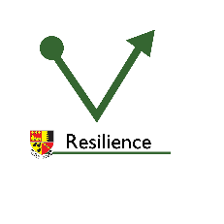
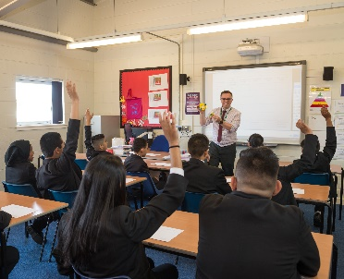
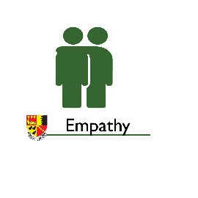
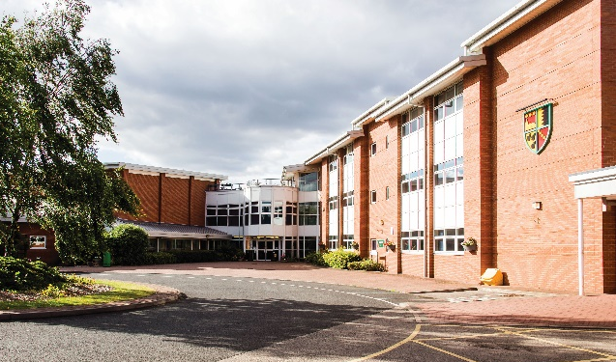
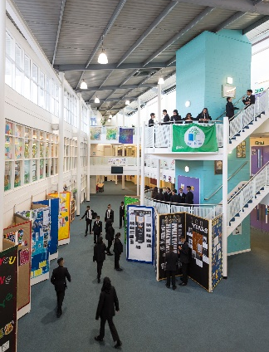
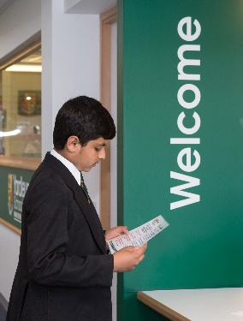
Head of EAL and MFL Teacher
INFORMATION PACK

12th January 2022 ref: WRN/AXS

Dear prospective candidate

Re: Head of EAL and MFL Teacher

I am really pleased that you are considering applying for a post at Yardleys School. We are incredibly passionate about our school. We care about one another and ensure that our teaching and support staff well-being and workload is kept high on our agenda. We work as a team to support one another and care deeply about providing the very best opportunities for our students to succeed, both academically and pastorally.

Our ‘gold status’ award from Investors in People demonstrates a deep and lasting commitment to employees to ensure they are looked after and supported. We believe that our staff are our most valuable resource and work extremely hard to ensure they are valued and developed.

We are extremely proud of our students and the diverse, multi-cultural community they represent.
They are also proud to be part of the Yardleys community and our recent Ofsted report cited exemplary student behaviour and caring relationships between staff and students, rooted in mutual respect.

Thank you for taking the time to consider our school. We have the highest expectations from our staff as our young people deserve no less. I hope, if you visit our school, that you will see for yourselves the very special place we feel it is and want to be a part of it.

Best Wishes

NEIL WARNER
Headteacher

Yardleys School
Reddings Lane
Tyseley
Birmingham
B11 3EY

Head of EAL and MFL Teacher (French or Spanish)

TLR 2c (current value: £2873p.a.)

Required for September 2022

Judged ‘Outstanding’ by Ofsted in 2010 and with a successful Section 8 inspection in February 2020, Yardleys is a thriving, vibrant and heavily oversubscribed 11-16 multi-ethnic stand-alone academy in Birmingham, with 933 students on roll. The diversity of the school population reflects the rich, cultural mix of the local area.
The school is highly focused on raising standards of pupil achievement and is successful at doing so. Yardleys is consistently in the top 20% of schools nationally and last validated data (2019) showed a progress 8 score of +0.48. Attainment is above the national average in the core subjects of Maths, English and Science.
The school motto “Working together for a better future” is far more than just words. The collaborative ethos which permeates the school is at the heart of our success. Excellent student behaviour and an extremely well organised school provide the foundation for teachers to focus on delivering outstanding lessons and continuously improving their practice.

We pride ourselves on offering all students the opportunity to develop skills needed to be successful global citizens.

This is an exciting opportunity for an ambitious, vibrant and forward thinking leader, to take responsibility of the development and success of our EAL learners in this new post. We currently have over 70% EAL learners, a small minority of whom are newly arrived. We wish to ensure these students have access to a full broad and balanced curriculum whilst receiving bespoke, tailored support for their individual needs. The successful candidate will also be an outstanding MFL practitioner and see the importance of ensuring our students develop excellent communication skills.

Yardleys offers a commitment to professional development opportunities, an excellent induction programme, a healthcare package, well-behaved students who are keen to learn and state of the art facilities.

To arrange a visit to the school, request more information and to apply please contact Salma Akhtar on:

T: 0121 675 0747
E: Recruitment@yardleys.bham.sch.uk

Or please also visit our website: www.yardleys-vle.com

Closing date: midday on Friday 21st January 2021

HEAD OF EAL
JOB DESCRIPTION

Teamwork is central to our philosophy and post holders are expected to be prepared to act flexibly in response to the day-to-day needs of our school.

Job Title: Head of EAL
Salary Scale: TLR 2c
Hours of work: Full-time
Responsible to: Head of Literacy

Job Purpose:
- To be responsible for building, developing and leading a successful EAL programme to support EAL students in accessing the full curriculum offer.
- To support teachers with effective EAL provision.
- To develop a curriculum for newly arrived students with the Head of Literacy
- To raise standards of achievement for EAL students in all year groups and all stages including the final GCSE assessments.
- To ensure all EAL students make good progress and ambitious targets for student performance are met in key stage 3 and 4.
Key Accountabilities are:

- Standards of achievement.
- Providing leadership, motivation and support for staff teaching EAL students including staff training where necessary.
- Providing a role model as a classroom teacher.
- Establishing and implementing, within the agreed timescales, short, medium and long-term plans for EAL provision.
- Developing effective policies, standard procedures and good practice.
- Monitoring, evaluating and improving work in the EAL programme, particularly standards of teaching, learning and overall pupil achievement.
- Actively contributing to the life of the school as a middle leader by supporting the ethos, policies and aspirations of the school.
- Ensuring the effective and efficient use of resources available.
- Ensuring high standards of learning outcomes, assessment and attainment of students.
- Monitoring standards of attainment and progress of EAL students through school tracking systems.
- To have an oversight of, and plan for, the training and development needs of staff (teaching and support) to support with effective EAL provision.
- To uphold and promote the school aims and values.

Key tasks are:

Leadership

  - To provide clear leadership to the provision of EAL across the school in order to guarantee improvements, by every member of staff and for every EAL student.
  - To lead and support the development of EAL students’ spoken and written skills across all year groups
  - To ensure that EAL students are able to access the full curriculum
- To assist teachers with advice about specific students’ EAL needs.

Planning

  - To plan, deliver and evaluate teaching and learning activities to suit EAL students under the direction of the literacy lead and other teachers where appropriate
- With the Head of Literacy, develop a curriculum for newly arrived students.
- To plan and run EAL intervention sessions for those pupils or groups of pupils who are underachieving.
  - To develop resources that inspire and develop students’ knowledge, skills and understanding to ensure they make progress in their learning.
  - To contribute and participate in regular professional development opportunities.

Teaching and learning

- To teach excellent lessons where there is exceptional learning thereby providing a role model to colleagues.
- To provide teaching support for students learning English as an Additional Language and direct activities with either individuals or groups of students to ensure increasing access to curricula and facilitate students’ physical, emotional and cognitive development.
- To support EAL students in and out of classrooms, in partnership with the class teacher, the SENDCo and other key stakeholders
- To prepare and maintain the learning environment to promote the development of language (e.g. preparing resources to help increase engagement).
- To provide additional support during Guided Reading time to EAL students.
- To collaborate with department leaders, subject teachers, SENDCo and parents to tailor their support appropriately to students.
- To investigate and build links with local agencies and schools.
- To ensure that there are appropriate and targeted resources in place to support EAL students
- To assist in the supervision of social interventions – such as a lunch club or other appropriate enrichment sessions to support EAL students
- To support and challenge colleagues to improve EAL students’ learning and achievement.

Assessment, recording and reporting

- Keep records of student EAL progress.
- Providing or contributing to oral and written assessments, reports and references relating to individual pupils and groups of pupils.
- Meet with parents/carers and report on progress, establish a good working relationship with families.
- Maintain records of meetings as directed.

Monitoring and evaluation

  - Under the direction of the Head of Literacy, baseline and monitor progress of EAL students in line with school policies.

Behaviour & safety

  - To oversee standards of student behaviour and discipline, monitoring the use of the school’s behaviour policy and intervening and supporting staff where necessary.

Management

  - To be responsible for the performance management of the Teaching Assistants responsible for EAL.
  - To ensure the subject is represented at appropriate school meetings and to provide opportunities for information/ideas to be fed back to and discussed with all staff.
  - To convene and chair meetings of relevant staff as necessary, ensuring that records are kept of decisions made and actions to be taken as a result.
- To attend line management and other meetings as required.
  - To ensure all administrative tasks relating to the efficient running of the subject area are carried out.
  - To ensure that capitation is spent appropriately and to keep the Head of Literacy informed of any financial needs.
  - To oversee the process by which the annual development plan is agreed and produced.
  - To ensure information and resources are available online for pupils, staff, parents and carers.

Line Management Responsibility for:

- Teaching Assistants responsible for EAL
- Responsible for persons providing support in the classroom.
General:
- This job description allocates duties and responsibilities, but does not direct the particular amount of time to be spent on carrying them out.
- To supervise and monitor learners’ behaviour and conduct both within and outside lessons as part of the school duty of care, pastoral and welfare support.
- A job description can never be fully descriptive. It is school policy that in the interests of continued professional development senior staff roles and responsibilities are reviewed and subject to change on a regular basis. It is expected that staff will, within reason, respond to unforeseen circumstances and emergencies as they arise, commensurate with their qualifications, experience and the situation.
- To uphold the school’s Safeguarding and Child Protection policies at all times.
- To uphold the school’s Equal Opportunities policy at all times.
- To perform any other duties commensurate with the role as required by the Headteacher.
- This allocation of duties is subject to regular review.

Job description issued on: …………………………………………………………………….……………………

Signature of Headteacher: …………………………………………………………………………………………

Copy received by: ………………………………………………………………………..………………………..

Date: ……………………………………………………………………………………………………………….

TEACHER
JOB DESCRIPTION

Teamwork is central to our philosophy and post holders are expected to be prepared to act flexibly in response to the day-to-day needs of our school.

NAME:

Job Title: Form Tutor/Class Teacher
Salary Scale: MPS
Hours of work: Full-time
Responsible to: Subject Line Manager
Job Purpose: To support the Headteacher in the raising of standards of pupils’
achievement.

Duties and Responsibilities:

Teaching:

In each case having regard to the curriculum for the school, and with a view to promoting the development of the abilities and aptitudes of the pupils in any class or group assigned to the postholder:

- planning and preparing courses and lessons which have the correct level of challenge and support.
- teaching, according to their educational needs, the pupils assigned to the postholder, including the setting and marking of work to be carried out by the pupil in school and elsewhere;
- assessing, recording and reporting on the development, progress and attainment of pupils;

Other activities:

- promoting the general progress and well-being of individual pupils and of any class or group of pupils assigned to the postholder;
- providing guidance and advice to pupils on educational and social matters and on their further education and future careers, including information about sources of more expert advice on specific questions; making relevant records and reports;
- making records of and reports on the personal and social needs of pupils;
- communicating and consulting with the parents of pupils;
- communicating and co-operating with persons or bodies outside the school; and
- participating in meetings arranged for any of the purposes described above;

Assessments and reports:

- providing or contributing to oral and written assessments, reports and references relating to individual pupils and groups of pupils;
Appraisal:

- participating in arrangements made in accordance with regulations for the appraisal of
performance and that of other teachers;

Review, induction, further training and development:

- reviewing from time to time methods of teaching and programmes of work;
- participating in arrangements for further training and professional development as a teacher including undertaking training and professional development which aim to meet needs identified in appraisal objectives or in appraisal statements;
- in the case of a teacher serving an induction period pursuant to the Induction Regulations, participating in arrangements for supervision and training.
Educational methods:

- advising and co-operating with the head teacher and other teachers (or any one or more of them) on the preparation and development of courses of study, teaching materials, teaching programmes, methods of teaching and assessment and pastoral arrangements;
Discipline, health and safety:

- maintaining good order and discipline among the pupils and safeguarding their health and safety both when they are authorised to be on the school premises and when they are engaged in authorised school activities elsewhere;
Staff meetings:

- participating in meetings at the school which relate to the curriculum for the school or the administration or organisation of the school, including pastoral arrangements;
Cover:

- Rarely and only in circumstances that are not foreseeable supervising and so far as practicable teaching any pupils where the person timetabled to take the class is not available to do so.
External examinations:

- participating in arrangements for preparing pupils for external examinations,
- assessing pupils for the purposes of such examinations and recording and reporting such assessments,
- participating in arrangements for pupils' presentation for and supervision during such examinations.

Administration:

- participating in administrative and organisational tasks related to such duties as are described above, including the direction or supervision of persons providing support for the teachers in the school; and
- attending assemblies, registering the attendance of pupils and supervising pupils, whether these duties are to be performed before, during or after school sessions.
General:
- This job description allocates duties and responsibilities, but does not direct the particular amount of time to be spent on carrying them out.
- To supervise and monitor learners’ behaviour and conduct both within and outside lessons as part of the school duty of care, pastoral and welfare support.
- A job description can never be fully descriptive. It is school policy that in the interests of continued professional development senior staff roles and responsibilities are reviewed and subject to change on a regular basis. It is expected that staff will, within reason, respond to unforeseen circumstances and emergencies as they arise, commensurate with their qualifications, experience and the situation.
- To uphold the school’s Safeguarding and Child Protection policies at all times.
- To uphold the School’s aims, ethos and values including the Yardleys School Charter.
- To uphold the school’s Equal Opportunities policy at all times.
- To perform any other duties commensurate with the role as required by the Headteacher.
- This allocation of duties is subject to regular review.

TLR 2 TEACHER
PERSON SPECIFICATION

SPECIFICATION | ESSENTIAL | DESIRABLE | HOW ASSESSED
Qualification | - Degree  - QTS |  | - Application checked by original documentation
Experience and Knowledge | - Excellent classroom practitioner  - Proven track record of exam success  - Have led on the development of an area of specialist subject  - Track record of successful intervention  - Good understanding of the National Curriculum and GCSE syllabus for specialist subject and its assessment requirements  - Class teaching across the ability range at KS3 and KS4  - An understanding of Equal Opportunities in relation to specialist subject |  | - Application  - Lesson observation  - Interview process  - References
Skills and Abilities | - Ability to apply a range of teaching styles and strategies that raise achievement  - Ability to apply positive behaviour management techniques  - Good ICT skills  - Excellent interpersonal skills  - Effective management skills for both people and resources | - Ability to offer a second subject | - Application  - Interview process  - References
Attributes and Attitudes | - Ability to demonstrate support and implementation of school’s aims and values  - A commitment to extracurricular activities  - A commitment to own professional development  - Excellent interpersonal skills  - Approachable, understanding and empathic  - Flexibility  - Energy and enthusiasm  - Good attendance and punctuality  - Good sense of humour  - Enhanced DBS clearance  - A commitment to safeguarding the welfare of children  - A commitment to equal opportunities |  | - Application  - Interview process  - References
Contra Indicators | - Criminal convictions involving offences against children  - Poor attendance record

INFORMATION FOR CANDIDATES

“This outstanding school exemplifies the very best in educational provision, showing that young people can achieve exceptionally well, irrespective of circumstances that for many would put them at risk of failure” – Ofsted 2010
Context and basic information
Yardleys School is a highly successful mixed 11-16 comprehensive and stand-alone academy serving an area of high socio-economic deprivation. Yardleys is a multi-cultural school which reflects the diversity of the local community. 97% of the students are from minority ethnic backgrounds. The percentage of pupils with English not as first language currently stands at 78%. The school also has more boys than girls (56% to 44%) on its roll. The school has a much higher than the national average number of students who are eligible for Pupil Premium.

Overall standards and reputation

The school has an excellent reputation both locally and across the city. This is reflected in the school being significantly over subscribed with a further increase in demand in recent years.

The school is highly focused on raising standards of pupil achievement and is successful at doing so. Yardleys is consistently in the top 20% of schools nationally and last validated data (2019) showed a progress 8 score of +0.48 despite the average attainment of students arriving in Year 7 being well below the national average. The progress of pupils is also above the national average in most subjects including Maths, English and Science. The achievement of boys and disadvantaged pupils have improved in recent years to above the national average.

The school was judged ‘outstanding’ in 2010 and was recently inspected in February 2020. This Section 8 inspection focussed on pastoral care, behaviour and safeguarding. We were delighted that Yardleys continues to be an outstanding school with inspectors highlighting a wide range of strengths and positive features.

There are well established and effective leadership roles and pastoral systems. This has resulted in a very well ordered school and where indicators such as attendance and exclusions are all better than national averages.

Other indicators of high standards include:

- Positive feedback from staff, pupils and parents
- High staff retention
- A well organised school
- Excellent standards of financial management and regulatory compliance

Vision and values

The school has two mottos; firstly the traditional words of ‘Keep Troth’ (keep faith) – which can be seen on the traditional school badge – signifies the school’s longstanding determination to foster belief and resilience in our young people. The second - ‘Working together for a better future’ - again identifies the ethos of collaboration but also the very clear ambition to continually improve the school, the life chances of our pupils and the wider community.

As well as the overall mission the school has three key aims which informs its work:
- To achieve academic excellence
- To educate the whole child
- To work collaboratively and ethically to deliver the highest standards of education

At the heart of everything that we do as a school community are our values of Positivity, Integrity, Empathy, Curiosity, Resilience and Reflection. These together with our three school rules of being ‘Ready, Respectful and Responsible’ are encapsulated in our Yardleys School Charter.
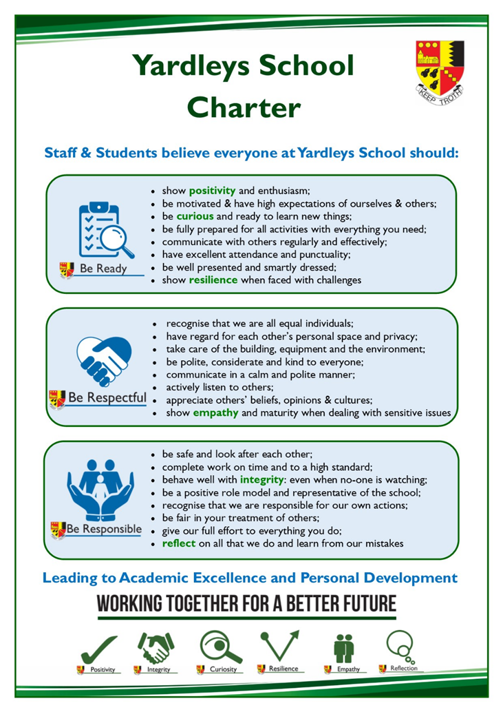

School leadership and governance
The Senior Leadership Team (SLT) comprises seven members: Headteacher, three Deputy Headteachers, two Assistant Heads and an Academy Business Manager. SLT members are highly visible around the school and proactively support children and adults alike. The senior team recognise the vital importance of both being organised and communicating regularly with staff. To this end they hold a daily briefing with all staff where notices, reminders and public ‘thank yous’ are shared every morning. School leadership and management is viewed very positively by staff.
There is also a wealth of experienced and effective middle leaders including Heads of Department/Subject, Heads of Faculty and Heads of Year. The school has moved towards more distributed leadership with some of these middle leaders having whole school responsibilities.
The school is a stand-alone academy having chosen to convert in 2013. The Governors recognise the important distinction between governance and management and work tirelessly to ensure the success of the school. Governors also regularly visit the school to see first-hand different aspects of the school in action.
School leaders and governors have identified several key priorities for the future development of the school including:

- Re-establishing normal school life and standards after the prolonged disruption of the Covid-19 pandemic
- To use the OFSTED template of ‘intent, implementation and impact’ to further develop the curriculum, particularly academically and at subject level
- To further improve standards of pupil safeguarding, attendance, behaviour, motivation and personal development
- To ensure the continued sustainability of the school through effective management of staffing, school finances and other resources

Staffing
One of the main factors in the sustained educational excellence at Yardleys can be attributed to the expertise, commitment and hard work of all staff. There are currently 100 members of staff including 62 teachers.
There is a distinct and highly valued ethos of collaboration and mutual support which makes Yardleys a special place to work. Another key feature at Yardleys is how all staff are respected and treated by both children and colleagues regardless of their role or position. Teachers understand the important role that support staff play in organising and managing issues away from the classroom, which allows them to focus on their classroom teaching and how this significantly reduces their workload.
The School places high importance on the training and professional development of all staff, particularly those new to the School. This includes an induction, mentoring, weekly training sessions and subject collaborative planning. Performance management is far more focused on improvements in teaching practice rather than just exam results. The School has consistently achieved Investors in People status, most recently achieving the Gold Award in 2021.

The Academic curriculum
The curriculum shares the same aims as the school, which means a focus on teamwork to provide an excellent academic education as well as one that educates the whole child.
Academically there is a broad and balanced curriculum. Subjects such as DT, Media Studies and RE are popular and successful choices for many pupils. The curriculum is moving to a three year KS3. All pupils study the three separate sciences rather than a combined course. There is also a general studies interdisciplinary course studied by all year 9, which looks broadly at world history and global issues.
At the core of the curriculum are the individual subjects and departments. The majority of these are highly effective and well-led with subject teams who are well qualified and experts in their fields. Consequently, there are very good standards of teaching and learning across the curriculum. Across all subjects we emphasise the learning of core knowledge and direct instruction as the most effective pedagogy but at the same time giving teachers and subjects the flexibility to develop their own curricula.
There is a school-wide focus on reading and literacy. We offer extra literacy lessons in Year 7 & 8 for pupils to improve their reading and writing. Many subjects have reading as a core element in their lessons. In addition, all pupils start the day with a 25-minute reading session led by form tutors.
Other features of the curriculum include: the use of knowledge organisers; providing whole class feedback and the use of online homework tasks and quizzes. Pupils are explicitly taught how to study and revise and are provided with a range of online resources to support them. Learning is checked through regular tests and all pupils sit internal exams during two whole school assessment weeks in December and July.
At the heart of the school’s CPD programme are subject mastery sessions where departments come together each week to further and deepen their subject knowledge, improve planning and develop their pedagogical skills and assessment practice. There are also many other opportunities for teachers and support staff to develop themselves professionally including a school CPD library and sharing good practice with each other.
In recent years school leaders have understood that whilst there needs to be monitoring and accountability of teaching and academic standards this needs to be balanced with professional trust, autonomy and workload. This ‘intelligent accountability’ (or what the educational commentator Mary Myatt calls ‘high challenge and low threat’) has seen the school adopt approaches such as collaborative subject reviews and a performance management system that values and rewards commitment to professional improvement rather than a judgment based purely on attainment data.

Educating the ‘whole child’
At Yardleys, we prize the education of the ‘whole child’ as much as academic success. There is an emphasis on traditional values, high standards and expectations in all aspects of school life. Yardleys has outstanding pastoral care including safety, behaviour and personal development. This is confirmed though positive staff and parent feedback as well as during the recent OFSTED inspection in February 2020. The school operates a year group system. The heads of year receive substantial non-timetabled, protected time to carry out their duties to a very high standard. As a result, teachers frequently comment that they are able to focus on teaching in this well-ordered school environment. Yardleys enjoys an excellent local and citywide reputation in this area and regularly attracts other practitioners who seek to learn from our outstanding pastoral team.
Pupils are very hard working and enjoy coming to the school (reflected in the school’s excellent attendance statistics). Behaviour is very good with pupils responding to the regular routines and consistent expectations. Pupils respond positively and demonstrate good leadership qualities when asked to become involved in school life such as organising charity events, participating in school council discussions or becoming prefects. The many displays of students’ work reflect the vibrant and creative nature of the school. The school offers a range of enrichment activities including the Duke of Edinburgh award scheme, educational visits, extra-curricular and sporting opportunities. The school also has a dedicated enrichment period on Wednesday afternoons, during which pupils can experience such activities as chess, knitting, origami, dance and jewellery-making alongside a range of sporting and other outdoor pursuits.
All teaching staff can expect to be form tutors. There are two form periods every day with the first focussed on reading and the second afternoon period on pastoral issues, homework completion, study skills and personal development.
In terms of personal development the school has introduced a new, taught course, which covers both statutory aspects (sex and relationships) as well as other important issues such as physical and mental health, careers education and personal finance. Students develop strong values of mutual respect and tolerance of those with different faiths, beliefs and characteristics.

Academy business management
Highly effective business management has, for years, provided the bedrock to the school’s high standards and successes. Consequently, the school is extremely well-organised, with well-established and highly effective systems which enable teaching staff to focus on their core business of educating children. This also impacts positively on staff workload and is a major factor in the school’s extremely high rate of staff retention and successful recruitment. As a result, all staff are valued equally because pupils and colleagues can clearly see the important role that everyone plays in the school.
There is excellent financial management and compliance which means the school has consistently set balanced budgets, has a healthy surplus and an impressive track record of audit and compliance.

Partnerships
A significant strength of the school in recent years has been its work to engage with a range of external partners locally, nationally and regionally. Yardleys School is part of a collegiate of local schools which offers a range of further support and opportunities for all staff. The school has strong working ties with the local schools, post-16 providers and the wider local community. The school also works with three ITT providers – the University of Birmingham, The King Edward Consortium and Teach First.

Premises and facilities
The school is fortunate to enjoy excellent facilities on a modern, single site which was re-developed under a PFI arrangement. The building is organised into faculty areas with extensive modern facilities for, in particular, ICT, Science, Mathematics, Sports and Performing Arts. The majority of teachers teach in the same location throughout the week. Other features include an interactive whiteboard and visualiser in every room and laptops being provided for teachers. We work hard to continually maintain and update our facilities, most recently adding two new classrooms and a multi-purpose hall in January 2019. Alongside the new building the school has extensive playing fields and a roof garden.

Thank you for your interest in our school. More information on many of the points in this document are available on the VLE – www.yardleys-vle.com

We look forward very much to receiving your application.

