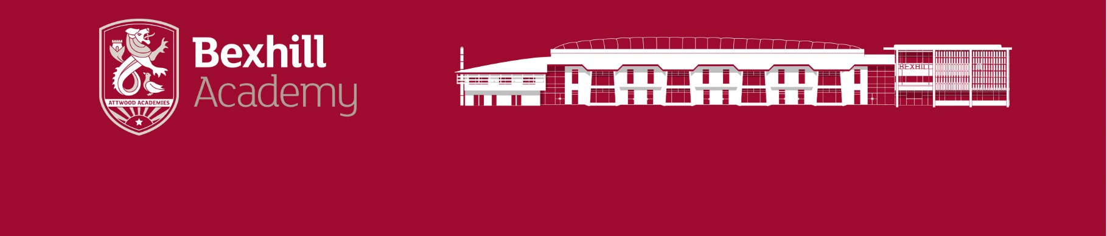  “Be Brilliant Today” | Head of Engineering and Design Technology
Head of Engineering and Design Technology
**An exciting opportunity for the right person to lead a growing faculty**
Whilst many schools around the country are either scaling down or completely closing their Engineering and Technology departments, here at Bexhill Academy we are doing the opposite. We are developing and scaling up our Technology with the hope of offering further technology subjects such as Textiles and Graphics in the future!

Although we already do have some of the best resources and one of the top workshops in the South East, we are actively investing more and more into our provisions for Engineering and Technology and here is why…

- We have a vision to create the top Engineering and Technology Department in the country.
- We fully believe in the benefits that a world-class Engineering and Technology Department can bring to our school, to our local community and to our pupils.
- We want our pupils to have the best outcomes, the best life skills, the best employability skills and to be equipped with the skills necessary to become the Engineers and Craftsmen or Craftswomen of the future.
- Our students share this vision and are driven and motivated to work with us to achieve this.
For the right candidate this is an exciting opportunity to lead a Faculty that is growing. Students are always excited to choose these options and work incredibly hard to succeed.
The successful candidates will:
- Be motivated and imaginative with a great passion Engineering and Technology – able to make a real difference to outcomes across the department.
- Have a commitment to quality learning and student development.
- Be committed to becoming the top Engineering and Technology Department in the country.
- Have a knowledge and experience of teaching Engineering and DT.
In return, we will offer you:
- Excellent facilities in a modern building.
- Access to a comprehensive programme of staff development – including supporting new middle leaders.
- Beautiful surrounding coastal and rural areas near to vibrant towns.
- Superior support from your colleagues and leadership within the school.

Salary: Main Scale / UPS + TLR2C.

Closing Date for applications: 9.00am on Tuesday 18th April.
Short Listing: Wednesday 19th April Interviews: Week commencing 24th April.
Informal conversations and visits are very welcome; if you would like to visit or discuss the post please contact Assistant Principal, Farouk Tumi, on Farouk.tumi@bexhillacademy.org

Please see our recruitment pack available on our website www.bexhillacademy.org
Completed Academy Teacher application forms should be sent to
academyhr@bexhillacademy.org. No CV’s, please complete the application form.

The Academy is committed to safeguarding and promoting the welfare of children and
young people and expects all staff and volunteers to share this commitment. The
successful applicant will be subject to an Enhanced DBS check.

