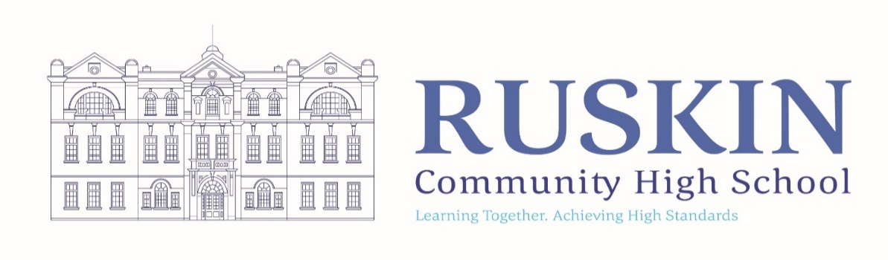
HEAD OF ENGLISH

FULLTIME/PERMANENT: UPR + TLR

CLOSING DATE: Friday 21st January at 12 noon
TO COMMENCE: Easter 2022, or sooner if possible. Sept 2022 will also be considered.

Ruskin Community High School is seeking to appoint a talented and ambitious Head of English to teach and lead the department across KS3 and KS4. The successful candidate will have excellent subject knowledge and a thorough understanding of curricular content and delivery.

The post holder will lead in the design of an engaging and challenging curriculum that inspires students to appreciate the subject and its application.

We are looking to appoint inspirational practitioners who have a passion for working with students to help them achieve beyond their aspirations and to also be highly organised, energetic and have the personality and drive to inspire and lead.

We would also welcome a colleague that has a presence in the classroom and someone seeking to be part of a strong team and wider school community.

If you would like a tour or wider discussion around the role, please contact the school. You can also visit our website.

For an application pack and further details of this position visit the School Website at www.ruskinhighschool.co.uk or email recruitment@ruskin.cheshire.sch.uk
Application forms must be returned for the attention of Miss H Goodwin, School Business Manager. It is acceptable to send applications via email to recruitment@ruskin.cheshire.sch.uk or by post to Ruskin Community High School, Ruskin Road, Crewe, CW2 7JT.

Please note – CVs will not be accepted.

Ruskin Community High School is an equal opportunities employer. Our school is committed to safeguarding and promoting the welfare of children and expects all staff to share this commitment. All posts are subject to enhanced DBS check, medical and references.

Telephone enquiries about the post will be welcomed if applicants require any further information at any time on 01270 560514.

The vacancy will close sooner if we receive a large number of applications.

Please be advised that this post will also be advertised on CEC Website, Ruskin Website and internally.

