|  |  |
| --- | --- |
|  | **St Mary’s Catholic High School** |

**Information Pack for Head of English**

**Required for September 2025**

St Mary’s Catholic High School has been serving the Catholic community in the North East Derbyshire for over 150 years. We are a geographically diverse community, who are united by the messages of Christ in the Gospel and the teachings of the Catholic Church.

It is our mission to ensure that each and every one of our pupils has the opportunity to fulfil their God-given potential, allowing them to ‘Live, Love and Learn in the Light of Christ’. We are committed to realising this through the provision of a highly ambitious but inclusive education rooted in academic excellence, holistic care, and religious formation.

Our broad and enriching curriculum sits alongside quality first teaching, outstanding pastoral support, and a comprehensive personal development programme to ensure our pupils go out into the world as knowledgeable, skilled, and confident citizens equipped with the capability and desire to contribute to the betterment of society.

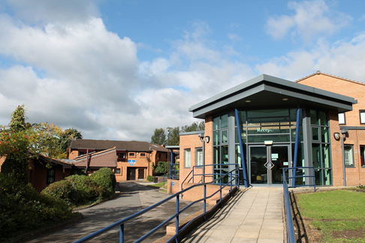 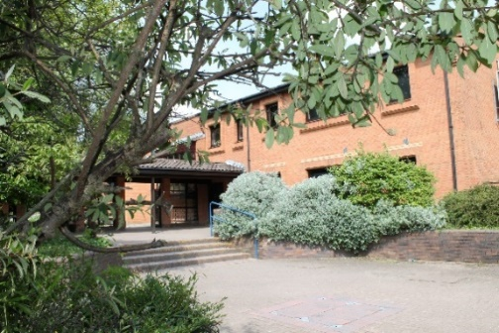

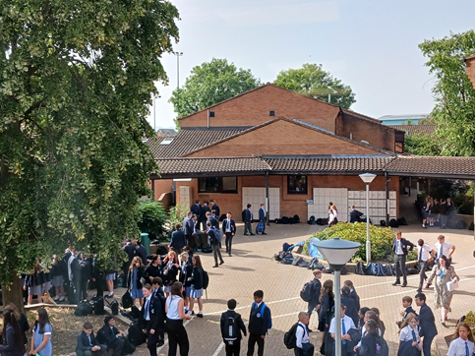 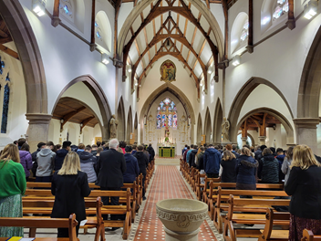

**“Live, Love and Learn in the Light of Christ”**

|  |  |
| --- | --- |
|  |  |

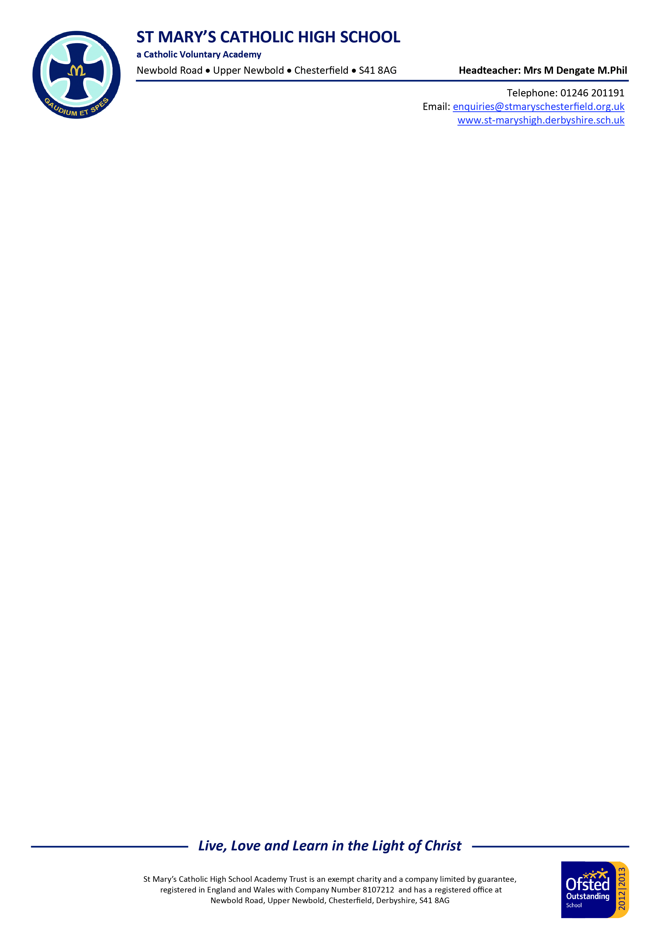

Dear Applicant

**Head of English**

Thank you for your enquiry regarding the above vacancy.

I am extremely proud to be Headteacher of St Mary’s Catholic High School. I believe that we are an excellent school and Ofsted judged us to be Outstanding in all areas when they visited us in June 2024, as did the Catholic Schools Inspectorate when they visited in March 2025.

St Mary’s is an 11-18 Catholic Voluntary Academy serving North East Derbyshire. We are a thriving, highly successful and over-subscribed school with a long and well established reputation. Indeed, our record of academic achievements is outstanding, with examination results consistently well above the national average.

Many people talk about the outstanding results achieved by St Mary’s and I am tremendously proud of the examination successes our young people achieve. However, my understanding of education is rooted in laying the foundations needed for life. I believe that school must enable children to build their spiritual life as well as their intellectual and moral capacity.

Through the commitment of all members of the school community and the talents of my outstanding teaching colleagues, we therefore aim to tap into our pupils’ sense of awe, wonder and curiosity and so contribute to their spiritual growth.

I sincerely believe that St Mary’s is a place where faith, hope and love are fostered because the school is part of such a broad and supportive community of families and parishes, who share our belief that teaching is not just about communicating content but about forming young people.

We aim to cultivate a deeply supportive culture in which professional development and well-being are championed and prioritised. Our staff are highly valued, and we firmly believe they are the key to our continued success.

You are very welcome to visit our school prior to application – please contact my PA, Mrs Gilding, to make arrangements. If you pay us a visit you will be met with courtesy and politeness from students and staff alike.

All staff employed by the school are subject to disclosure of enhanced criminal records. Applicants must be aware that any issues raised by this process may mean that the offer of employment is withdrawn. Evidence of identity and the right to live and work in the UK will also be scrutinised along with confirmation of the home address, professional status, and references before any offer of employment becomes permanent.

The closing date is 10**.00 am on** **8 May** **2025** and I look forward to receiving your application, which should be returned to my PA, Mrs Rachel Gilding.

Yours faithfully



**Mrs M Dengate**

**Headteacher**



**APPOINTMENT PROCEDURE**

Our appointment procedure will be based on the following:

• Shortlisting based upon skills and experience

• References and safeguarding checks prior to, during and after the interview process

• Lesson observation

* Professional discussion

• Formal interview panel

Applicants must complete the school’s Catholic Education Service application form and supporting documents (available from the school website or the Headteacher’s PA). We do not accept CVs and references will be sought prior to interview.

Closing date: **10.00 am on 8 May 2025**

Application forms should be returned to [rgilding@stmaryschesterfield.org.uk](mailto:rgilding@stmaryschesterfield.org.uk) or posted to Mrs Gilding at the school’s address.

**FURTHER INFORMATION FOR APPLICANTS**

St Mary’s has a rigorous child protection policy. The successful candidate will receive formal induction to the school, which will include child protection and safeguarding issues. All staff at the school are DBS (Disclosure Barring Service) checked.

The successful candidate will need to provide the following documents at interview:

* Proof of identity:

One proof of Photo ID:

Passport

or

Photo Driving Licence

* Two utility bills with your name and address
* Qualifications:

Original certificates

or

Proof of qualification (not photocopies)

**EQUALITY STATEMENT**

We will comply with the requirements of the Equality Act (2010) and are committed to ensuring that throughout our recruitment and selection processes no applicant is disadvantaged or discriminated against because of the protected characteristics of age, disability, gender, gender re-assignment, marriage or civil partnership, pregnancy or maternity, race, religion or belief and sexual orientation.

**SALARY**

You will be employed on the appropriate point of the main scale, or, where appropriate, on the Upper Pay Scale plus TLR 1:2.

**SAFEGUARDING**

St Mary’s Catholic High School is fully committed to safeguarding and protecting the welfare of its students. All offers of employment are provisional until such time as the school has undertaken appropriate safeguarding checks and is satisfied that successful candidates are suitable to work with children. All members of staff and volunteers are expected to familiarise themselves with the school’s child protection and safeguarding guidance and procedures and act accordingly.

**TEACHING, LEARNING AND THE CURRICULUM**

An ambitious, academic, and knowledge-rich curriculum that prepares students for the next stages of their lives is central to our provision. Our three-year Key Stage 3 enables pupils to study as broad a programme as possible for as long as possible, and we offer a full suite of traditional GCSE and A level subjects, alongside a range of vocational qualifications, to ensure that our curriculum meets the needs and aspirations of our students. Our curriculum is driven and underpinned by the knowledge and expertise of our highly capable staff.

Our teachers are proud to be champions of scholarship: we hold the very highest aspirations for the pupils in our care, and we cultivate and instil the positive academic behaviours that will enable students to become life-long lovers of learning.

At St Mary’s, we recognise that good and outstanding teaching takes many forms. The pursuit of excellence in Teaching and Learning is at the heart of our provision, and we celebrate the wide variety of teaching styles and pedagogical approaches that our staff take in ensuring outstanding pupil progress. We believe that pedagogical diversity is an asset and we are committed to maintaining and celebrating this through our approaches to professional development.

**PROFESSIONAL DEVELOPMENT**

St Mary’s prides itself on the way in which it welcomes and supports new staff. Each new member of staff is allocated a mentor who, alongside the line manager and other colleagues, can provide support and guidance, ensuring a smooth transition. A programme of weekly induction sessions provides the opportunity to meet key members of staff and to be introduced to school policies and procedures. Bespoke ongoing professional development is a priority, and all staff are able to access high-quality, carefully tailored training and development opportunities, including the observation of teaching and the sharing of practice. New staff are also warmly invited to join in a range of staff social activities and clubs.

A comprehensive programme of support is also in place for ECTs, and each ECT receives the guidance of an induction tutor, a departmental mentor, and a ‘buddy’, in the form of a recently qualified teacher. Training is highly personalised and a weekly programme of CPD offers a wealth of opportunity for professional development. Regular one to one meetings support an ECT through the induction process.

**MISSION AND ETHOS**

At St Mary’s, we are a community inspired by the belief that we are all God’s creation and as such we should ‘live, love and learn in the light of Christ’. We are an inclusive and welcoming school where students receive high-quality teaching in an environment underpinned by Gospel values such as compassion, care, and justice. The school’s mission is centred on the principle that as teachers, we are helping both ourselves, and our students, to become the people that God intended us to be. It is vital, we believe, that student progress and wellbeing is considered at all levels. By taking this holistic view, we believe that we are enabling our students to get the very best out of every opportunity provided here. Throughout the academic years we offer religious retreats and trips which enable our pupils to engage with their spirituality and to further embed their own key beliefs. The prayer and liturgical life of the school is important too, and as such, we follow the liturgical calendar of the Catholic Church and celebrate Mass at key points throughout the year. New staff are supported at all times by the Head of Chaplaincy.

**STAFF WELLBEING**

Staff wellbeing is important to the Headteacher and is of the utmost concern when key decisions are taken regarding the life of the school. The Headteacher operates an open-door policy and at all times staff are able to meet with their senior link colleague to discuss any concerns or issues they might have. Throughout the year, opportunities are given to develop and support the wellbeing of staff and each department will offer their own wellbeing opportunities. The school has a designated Head of Health and Wellbeing and access to external providers, to provide support.

**PASTORAL CARE**

St Mary’s strives to be a Catholic community in which the principles of care and respect are valued, with emphasis on the development of the young person through academic achievement, holistic personal development, and religious formation. We aim to give every pupil the most appropriate opportunities to learn and develop to become the best that they can be. We take our ethos from Gospel values and work to draw out the potential in every young person.

The most important influences on a child’s values, attitudes and standards are those of family, home and community. We aim therefore, to work in close partnership with parents and carers to encourage all our pupils to have good manners, be kind and develop a sense of responsibility, self-discipline, respect for themselves, for others and for their environment. We recognise that education is a collaborative and cooperative enterprise and that although we emphasise our role in meeting individual needs, those needs must be met within the shared community life of the school and within an atmosphere which is positive, supportive, and conducive to learning.

It goes without saying that every member of staff has a role to play in Pastoral Care in St Mary’s.  Every teacher is expected to be interested in a child’s overall development and should be trying to encourage good social and moral habits as well as academic potential.  Good relationships between staff and pupils are extremely important. The key to any successful Pastoral System and to the success of the school are the qualities, abilities and commitment shown by the Form Tutor.   With such a large pupil population the form teacher is the “lynchpin” of the Pastoral System in St Mary’s.  The Form Tutor is supported by the Head of Year, the Head of Key Stage, and the Leadership Group.

**Key Pastoral Staff**

Designated Safeguarding Lead Miss H McKay

Deputy Designated Safeguarding Lead Mrs M Bowerman

Deputy Headteacher (Behaviour & Attitudes) Mr A Breedon

Assistant Headteacher (i/c Sixth Form) Mr P Maydom

Head of Key Stage 3 Mr J Slater

Head of Key Stage 4 Miss E Drury

PSHE & Careers Lead Dr E Dando

Director of Inclusion & SENDCO Mr C Atkinson

**Heads of Year**

Year 7 Mrs C Thurlow

Year 8 Miss V Barker

Year 9 Mr R Hancock

Year 10 Miss C Egan (Acting)

Year 11 Mrs D Shaw

Year 12 Mr A Peach

Year 13 Mr M Bigg

**Wellbeing Team**

Counsellor Ms M Bhaumik

Family Resource Worker & Early Help Co-ordinator Mrs M Bowerman

Pupil Welfare & Early Help Support Worker Mrs R Torinsci-Furness

First Aid Lead Miss F Gibson

**PUPIL BEHAVIOUR, SUPPORT AND DISCIPLINE**

At St Mary's, positive behaviour is recognised and rewarded at every opportunity; everyone is encouraged to achieve, and success is celebrated at all levels. The value of service and *giving back* is promoted by all to help our young people understand that our core duty throughout life is to do our best for one another; and in doing this we may open our young people's minds to the inner meaning and coherence in life and all creation.

A high standard of behaviour and courtesy is demanded of pupils both inside and outside school.

Our pastoral system at St Mary's provides the framework to ensure behaviour and welfare policies are applied fairly, appropriately, and consistently across the school. Our behaviour and welfare policies underpin all aspects of school life, and our Catholic ethos is imbued through robust and rigorous procedures to reward, support and guide pupils. Our approach is underpinned and executed by the Gospel values of compassion, tolerance and forgiveness. Our behaviour policy provides the firm foundation to support the delivery of a first-class education for all.

It is the Headteacher's responsibility working with the Leadership Group and Heads of Key Stage to make judgements and interpret the behaviour policy on the day-to-day issues which the school faces in meeting our Mission Statement to ***live, love and learn in the light of Christ***. It is for **all staff** to play their part in making sure that the attitudes to learning and standards of discipline, behaviour and appearance, are of the highest order.

St Mary's Catholic High School believes that achieving success is a shared responsibility between the pupil, parents/carers, and staff and as such, parents/carers are asked to sign the home-school agreement. School will notify and involve parents/carers when a pupil is being successful, as well as when things go wrong. Parents/carers are asked to alert school to anything that may affect their own child’s behaviour or that of other pupils. Teachers will try to provide learning opportunities that are interesting and challenging and which match the ability of our pupils. All staff are expected to model the behaviour and attitudes they expect from pupils, listen to pupils when they have a problem, and follow school processes and procedures to offer the relevant support.

**GCSE (Or Equivalent) – Key Stage 4 Results**

|  |  |  |  |
| --- | --- | --- | --- |
|  | 2022 | **2023** | **2024** |
| **Progress 8** | 0.28 | 0.37 | **0.5** |
| **Attainment 8** | 60.25 | 57.80 | **56.6** |
| **Basics (9-4 English & Maths)**  **(9-5 English & Maths)** | 84.2  69.8 | 83.0  67.5 | **83.4**  **63.2** |
| **Entering the English Baccalaureate** | 94 | 103 | **82** |
| **Gaining English Baccalaureate**  **(GCSE in English, Maths, 2 Sciences, Humanity and a Language) %** | 45.0 (Std Pass)  40.1(Stg Pass)  Avg. point score 5.50 | 46.1 (Std Pass)  39.3(Stg Pass)  Avg. point score 5.36 | **34.1 (Std Pass)**  **28.8 (Stg Pass)**  **Avg. point score 5.21** |
| **Destinations - students staying in education or employment after KS4** | 100% | 100% | **96.59%** |
| % grades 9-7 | 45.4 | 42.5 | **33.2** |
| Number of Students in Year 11 | 202 | 206 | **205** |
| Girl / Boy ratio | 56/44 | 48/52 | **52/48** |

**Post 16 – Key Stage 5 Results (A level)**

|  |  |  |  |
| --- | --- | --- | --- |
|  | **2022** | **2023** | **2024** |
| **The progress students have made compared with students across England** | N/A | N/A | **N/A** |
| **Average points per entry** | 38.09 | 36.63 | **38.4** |
| **Average grade per A Level entry** | B- | B- | **B** |
| **2+ A*AB in facilitating subjects** | 19.7% | 23.5% | **27.8%** |
| **Best 3 A levels** | B-  37.81 | B-  36.63 | **B**  **39.55** |
| **Achieving A* - E grades %** | 99.4% | 99.4% | **100%** |
| **Achieving A* - B grades %** | 59.6% | 55.3% | **64.4%** |
| **Number of students at the end of Y13** | 167 | 165 | **149** |
| **Girl / Boy ratio** | 63%/37% | 58%/42% | **66%/34%** |

**INFORMATION ABOUT THE ENGLISH DEPARTMENT**

The English Department is a very supportive, energetic and successful part of the school. It is housed in a purpose-built suite of classrooms around a departmental office, and is staffed by the equivalent of eight full time specialist teachers. They comprise a well-established committed team with a progressive, research-driven, balanced approach: the mission is to drive students’ communication skills to the highest possible levels, as well as to explore human experience through touch-stone literary works. Our results are outstanding.

In Year 7 the children are organised into mixed ability classes within two broad ability bands. They are then taught in sets from Year 8 onwards.

The Department is well resourced in terms of texts and ICT facilities. The school has a Drama Hall, and the Library is housed in very attractive premises and is staffed by a specialist Librarian.

There is a long tradition of public speaking and debating in the school. The Department is very involved locally, regionally and occasionally in the wider national arena in these sort of events. All Year 8 pupils take part in a verse speaking/poetry writing competition as part of their English work, and all Year 9 pupils are involved in Inter House Debating.

At both GCSE and GCE A Level, the Department teaches English Language and English Literature. For A level the Department uses the AQA syllabus. The two courses are taught as separate subjects.

For GCSE, again the Department uses AQA. All pupils are entered for both English Literature and English Language at this level and there is some flexibility of text choice for class teachers.

Results are outstanding year on year and a successful candidate would be expected to play a big part in maintaining and improving those results.

Exam results for the past 3 years are:

**GCSE ENGLISH LANGUAGE**

|  |  |  |  |  |  |  |  |  |  |  |  |
| --- | --- | --- | --- | --- | --- | --- | --- | --- | --- | --- | --- |
|  | **9** | **8** | **7** | **6** | **5** | **4** | **3** | **2** | **1** | **U** | **No entered** |
| **June 2022** | 12 | 21 | 34 | 43 | 37 | 31 | 21 | 2 | 1 | 0 | **202** |
| **June 2023** | 9 | 14 | 28 | 47 | 37 | 32 | 27 | 8 | 2 | 0 | **204** |
| **June 2024** | 4 | 8 | 32 | 59 | 48 | 25 | 17 | 7 | 1 | 0 | **201** |

**GCSE ENGLISH LITERATURE**

|  |  |  |  |  |  |  |  |  |  |  |  |
| --- | --- | --- | --- | --- | --- | --- | --- | --- | --- | --- | --- |
|  | **9** | **8** | **7** | **6** | **5** | **4** | **3** | **2** | **1** | **U** | **No entered** |
| **June 2022** | 14 | 18 | 26 | 41 | 43 | 34 | 19 | 5 | 0 | 0 | **200** |
| **June 2023** | 11 | 23 | 34 | 37 | 39 | 31 | 13 | 9 | 3 | 1 | **201** |
| **June 2024** | 9 | 17 | 33 | 34 | 45 | 35 | 22 | 4 | 1 | 0 | **197** |

**A LEVEL ENGLISH LANGUAGE**

|  |  |  |  |  |  |  |  |  |  |
| --- | --- | --- | --- | --- | --- | --- | --- | --- | --- |
|  | **A\*** | **A** | **B** | **C** | **D** | **E** | **N** | **U** | **No entered** |
| **June 2022** | 4 | 12 | 10 | 13 | 1 | 2 | 0 | 0 | **42** |
| **June 2023** | 1 | 4 | 6 | 5 | 4 | 0 | 0 | 0 | **20** |
| **June 2024** | 0 | 2 | 9 | 3 | 0 | 0 | 0 | 0 | **14** |

**A LEVEL ENGLISH LITERATURE**

|  |  |  |  |  |  |  |  |  |  |
| --- | --- | --- | --- | --- | --- | --- | --- | --- | --- |
|  | **A\*** | **A** | **B** | **C** | **D** | **E** | **N** | **U** | **No entered** |
| **June 2022** | 5 | 5 | 7 | 2 | 4 | 0 | 0 | 0 | **23** |
| **June 2023** | 4 | 4 | 5 | 1 | 0 | 0 | 0 | 0 | **14** |
| **June 2024** | 5 | 1 | 9 | 1 | 1 | 0 | 0 | 0 | **17** |



St Mary’s Catholic High School

Job Description & Person Specification

Head of English

**Safeguarding & Equality**

St Mary’s Catholic High School is fully committed to safeguarding and promoting the welfare of its students. All members of staff will be vetted according to established procedures. All members of staff will familiarise themselves with the school’s child protection and safeguarding guidance and procedures and act accordingly.

To comply with the requirements of the Equality Act (2010) and the school’s commitment to ensure that no employee is disadvantaged or discriminated against because of the protected characteristics of age, disability, gender, gender re-assignment, marriage or civil partnership, pregnancy or maternity, race, religion or belief and sexual orientation.

**Purpose of the Post:**

To be responsible for all aspects of strategic leadership, standards, and Teaching and Learning within the English Department, together with the general management of the department, staff and post-holders.

**Generic responsibilities:**

* To promote and emphasise the distinctive Christian/Catholic ethos of our school.
* To carry out the duties of a general classroom teacher as set out in a separate job description.
* Where appropriate - to be a form tutor (as set out in a separate job description).
* To carry out a share of supervisory duties and cover duties in accordance with published lists and rosters.
* To abide by the generic terms and conditions as set out in the contract of employment and conditions of service.
* To have high expectations of all pupils and be committed to raising their educational achievement and progress.
* To demonstrate and promote positive values, attitudes, behaviour and appearance which we expect from our pupils.
* To contribute to, and share responsibility in, the corporate and faith life of the school.
* To treat pupils consistently, with respect and consideration.

**Main Areas of Responsibility and Accountability:**

* To provide strategic leadership and ensure that the highest standards of pupil progress and achievement are secured.
* To lead a highly expert team of teaching staff and Key Stage Coordinators.
* To deliver ongoing improvements in the attainment and progress of disadvantaged and LAC pupils.
* To work collaboratively with colleagues to develop the curriculum and all work of the department.
* Regard for, and support of, the distinctive ethos of our school.
* The maintenance and improvement of high standards of learning and teaching across all years 7 to 13.
* The active use of school data in order to implement effective strategic decisions and intervention.
* The analysis of national, whole school and departmental data in order to monitor and improve levels of progress across all key stages.
* The development of appropriate teaching methods to implement the delivery of the curriculum.
* The development of a culture of high expectations and staff well-being, within the department.
* The creation of a climate whereby excellent teaching and learning is the norm.
* The establishment and maintenance of standards of pupil welfare, behaviour, and discipline and its impact on learning.
* The line management and quality assurance of the work of the department, its day-to-day operation and its evaluation in response to external requirements, the requirements of the school, examination boards and DfE.
* The development and delivery of an agreed marking and assessment policy.
* The establishment of policies in line with school requirements and initiatives for the assessment, recording and reporting of students’ achievements.
* The development of departmental schemes of work and overall strategic leadership of co-curricular activities.
* The monitoring (including lesson observation) and evaluation of the work of the teachers in the department, via appropriate quality assurance.
* To be a positive role model for both staff and pupils at the school.
* The deployment of all staff in the department, and advising the time-tabler thereof.
* The establishment and implementation of policies concerning staff development, departmental INSET requirements, induction of staff new to the school, programme for ITT teachers and other personnel visiting the school.
* The organisation and effective use of the departmental budget, including the allocation of departmental resources.
* Liaison with the Learning Support Department and any other relevant persons for proper and effective provision for students with additional needs.
* The evaluation and analysis of departmental statistics including target-setting.
* The liaison with the Leadership Group on all matters connected with the department.
* The attendance at all meetings as directed by the Headteacher.
* The completion of administration required by external examination boards.
* The overseeing of all departmental facilities, timetable, and other resources.
* To keep abreast of subject knowledge, national developments, inspection findings etc.
* The full participation in the Appraisal scheme as set out by the Headteacher.

**Person Specification**

**Head of English**

|  |  |  |  |
| --- | --- | --- | --- |
| **Attributes** | **Essential** | **Desirable** | **How identified** |
| Qualifications | * Qualified Teacher Status * Good honours degree and teaching qualification. | * Relevant CPD | * Application * Certification |
| Experience | * Previous or current curriculum post-holder experience * Values driven * Outstanding teaching ability, backed up by outstanding outcomes * Tailored teaching that challenges and supports students * High quality curriculum development |  | * Application * Interview * References |
| Knowledge & Skills | * High expectations and empathy which motivate and challenge students and staff * Understanding the importance of holistic education * Excellent subject and curriculum knowledge * Hold others to account * Highly tailored planning * Effective use of summative and formative assessment * Behaviour management to ensure a disciplined and holistic culture * Support colleagues to bring out the best in them | * Understanding the importance of holistic education * Hold others to account * Strong analytical skills * Simplify complex issues and communicate with clarity | * Application * Interview * References |
| Character | * Strong moral purpose and drive for improvement * Willingness to offer co-curricular provision * Mission-focussed * Confident humility * Motivated, enthusiastic and flexible * Excellent interpersonal skills * Good sense of humour * Desire to develop yourself * Ability to give, receive and act on feedback * Strong attention to detail * Ability to work under pressure * Commitment to the full life of the school * Student-focussed * A role model |  | * Application * Interview * References |

How to find us:

St Mary’s Catholic High School

Newbold Road

Chesterfield

Derbyshire S41 8AG

Telephone number: 01246 201191

We are situated in North East Derbyshire close to Chesterfield town centre, a thriving and popular market town in the Derbyshire Peak District. We have good access to Sheffield, Derby and Nottingham via the M1.





BY CAR

Exit M1 Junction 29 or 30, following signs towards Chesterfield

If you wish to use your Sat Nav to find us, use postcode S41 8AG. Please park in the main car park (overflow parking available in the Bus Bay until 3.00 pm)