

WALTHAMSTOW SCHOOL FOR GIRLS
“NEGLECT NOT THE GIFT THAT IS IN THEE”

Head of Faculty ICT

Candidate Information Pack

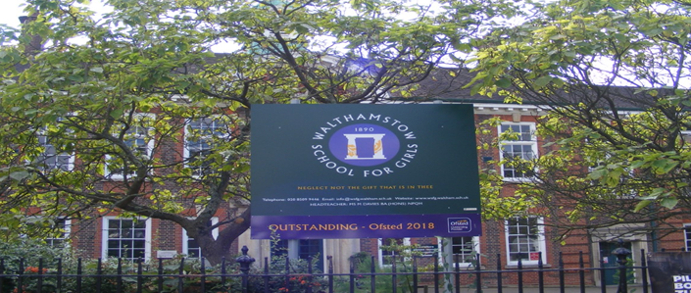

Required for September 2021
A job share would be considered for this post
The Head of Faculty must be able to deliver and lead on either the Economics GCSE or Computer Science GCSE course.

Welcome letter from Meryl Davies, Headteacher

February 2021

Dear Applicant
Thank you for requesting an application pack for the post of Head of Faculty - ICT.
Walthamstow School for Girls is a high achieving, oversubscribed, diverse school which is regularly in the top 10% nationally for progress, significantly above the national average in all key indicators, and is at the centre of the vibrant local community of Waltham Forest (the first London Borough of Culture). We have an ambition to become ‘world class’ and a commitment to work with other professionals both locally, nationally and internationally, through our Erasmus links. We won the national High Aspiration Award for the progress made by disadvantaged students and have won SSAT Achievement and Progress awards annually since 2014. We have been awarded the SSAT Exceptional Education standard twice; in 2017, for Leadership through Moral Purpose, and, in 2018, for Systems: use of assessment, data, policies and monitoring to support teaching and learning. We were awarded Teaching School and National Support School Status in September 2017. In June 2018, following a Section 8 inspection, we were awarded an Ofsted ‘outstanding’ judgement in all categories.
Our students are ambitious and hard-working; they embrace the range of opportunities offered to them both during and beyond the school day. This is highlighted not only by our exceptional examination results but also by the maturity of the girls, their sense of responsibility, community and fun. They are a delight to work with.
We offer excellent facilities to both staff and students. Our acclaimed architect designed site is an oasis of green and a pleasure to work in. It is well served by transport connections, being just ten minutes’ walk away from Walthamstow Central tube and overground station and five minutes’ walk from the popular Walthamstow ‘village’, and creative and restaurant quarter. We pride ourselves on working hard to retain our role as an important part of the local community. Examples of this commitment can be seen in our weekly Greensheets. Our staff are inclusive and friendly, with regular social and wellbeing events as well as charity fundraising.
We are committed to Safer Recruitment practices and procedures and shortlisted applicants will be questioned about their commitment to the safeguarding of young people. The successful candidate will be subject to an enhanced DBS clearance.
Thank you for taking an interest in this position. I do hope that having read more about the school you will decide to apply for the post. I look forward to receiving your application. Please note that it will not be possible to give feedback to unsuccessful applicants, other than those called for interview. Thank you for your understanding and good luck with your career in education.
Helen Marriott
Headteacher, MA (Cantab), NPQH

About Walthamstow School for Girls

History

In January 1890, a circular stated that a “school for girls” was to be opened in Walthamstow. Miss Hewett was appointed as the first Headmistress and remained until she retired in 1924. There were 49 girls, whose ages ranged from 7-16 years. At this time there were only five teachers, two of whom were graduates.
Our original building was in West Avenue Road and when student numbers grew the school moved to Church Hill House, where a church now stands. It was in September 1913 that 243 girls came to the present building with the Greek Amphitheatre being added in the 1920s. In January 2010 our most recent refurbishment and rebuilding work was completed as part of the Building Schools for the Future Programme. This work has given us the unique blend of traditional and state of the art facilities that we currently enjoy at our school.
Our school in 2020
Walthamstow School for Girls is a high achieving, oversubscribed, diverse school which is regularly in the top 10% nationally for progress, significantly above the national average in all key indicators at Key Stage 4, and is at the centre of the vibrant local community of Waltham Forest (the 2019 and first London Borough of Culture). Our most recent results can be found on our website.
We have an ambition to become ‘world class’ and a commitment to work with other professionals both locally, nationally and internationally, through our Erasmus links. We won the national High Aspiration Award for the progress made by disadvantaged students in 2015 and have won SSAT Achievement and Progress awards annually since 2014.
We have been awarded the SSAT Exceptional Education standard twice; in 2017, for Leadership through Moral Purpose, and, in 2018, for Systems: use of assessment, data, policies and monitoring to support teaching and learning. We were awarded Teaching School and National Support School Status in July 2017. In June 2018, following a Section 8 inspection, we were awarded an ‘outstanding’ judgement in all categories.
“Middle Leaders are exceptional and collaborate well to share best practice. They drive their teams with energy and enthusiasm. They share the strong moral purpose of the Headteacher to ensure that no pupil is left behind. As a result, outcomes for pupils are outstanding, giving them essential life chances.” Ofsted 2018.
Students and staff
Every one of our 900 students is valued equally as an individual with different gifts and talents, reflecting our commitment to the school motto “Neglect not the gift that is in thee”. We offer strong pastoral support and regular monitoring, target setting and dialogue with students and parents/carers.
Our students are encouraged to express themselves, to be creative, to have high aspirations and to challenge stereotypes. There is a strongly ethos of equality at this school.

Our students are also ambitious and hard-working; they embrace the range of opportunities offered to them both during and beyond the school day. This is highlighted not only by our exceptional examination results but also by the maturity of the girls, their sense of responsibility, community and fun. They are a delight to work with.
One of the school’s strengths is the quality of the staff we are able to attract and keep. Our teachers ensure lessons are stimulating and challenging. Students work with enthusiasm and interest in classrooms where there is a calm atmosphere suitable for learning. The broad and balanced curriculum ensures that all students are extremely well equipped to continue their education.
Our environment

We offer excellent facilities to both staff and students. Our acclaimed architect designed buildings and facilities make a stunning learning and working environment. Our £18 million rebuild project, completed in 2010, dramatically extended and enhanced our accommodation. We have state-of-the-art facilities in science, technology and performing arts, as well as a fantastic dining hall, two assembly halls and social areas.
Situated in beautiful landscaped grounds, the school’s outside space encourages play and creativity as well as quiet reflection and study. Unusually for a London school, our buildings are surrounded by mature trees and lawns, a pond area and our Greek amphitheatre. We have an allotment area which invites students to learn how to grow fruit and vegetables, some of which are then used by our chef.
Our site is an oasis of green and a pleasure to work in. It is well served by transport connections, being just ten minutes’ walk away from Walthamstow Central tube and rail station and five minutes’ walk from the popular Walthamstow ‘village’, creative and restaurant quarter. We pride ourselves on working hard to retain our role as an important part of the local community. Examples of this commitment can be seen in our weekly Greensheets. Our staff are inclusive and friendly, with regular social and wellbeing events as well as charity fundraising.
Educating and empowering young women
Our role is to educate tomorrow’s women to be confident, articulate and able to discuss and debate intelligently. Through a range of activities and opportunities, students are helped to develop their leadership qualities, their sense of community and global responsibility as citizens of the world in line with our G.R.E.E.N. values.



Our G.R.E.E.N. Vision

The G.R.E.E.N. values
 | The value GROWTH is based on the work by Carol Dweck on growth mindset. Having a growth mindset encourages the belief that we can all improve at whatever we put our minds to with practice and perseverance. It encourages learning, effort and stickability. It also promotes the importance of reflection and criticism as tools to move us forward.
 | The value RESILIENCE represents the notion that, on any learning journey, there will be obstacles. With RESILIENCE and perseverance, these obstacles can be overcome and the final goal more rewarding. The key is not to be fearful of these obstacles and to accept that mistakes and challenges are an important part of learning. The learning line is an effective symbol for resilience and for assessment for learning.
 | The value ENERGY is the centre of our vision. It encourages focus and enthusiasm from everyone. This ENERGY could be represented in the attitude of students as well as in staff morale, parent and governor involvement. It promotes positivity and supports all of the other G.R.E.E.N. values.
 | The value EMPATHY promotes community spirit in many dimensions. It signifies self-awareness as well as respect for each other despite our differences. In addition to this, it illustrates that none of us are alone on our learning journey and that, through collaboration, success can be greater.
 | The value NEWNESS is vital in an ever changing world. This encourages us to be open to new ideas, techniques, technologies and challenges. It encourages us all to step out of our comfort zones as this is where the deepest learning and the greatest success can be achieved.
“The school’s values of Growth, Resilience, Energy, Empathy and Newness (GREEN) are lived by staff and pupils in all aspects of the school’s work.” Ofsted 2018.

What staff value about the school

- This school feels safe, kind and caring. We are not driven by results – we seem to be driven to produce fabulous young women
- Ethos of the school, supportive colleagues and strong management with compassion
“There are very strong working relationships between staff and pupils based on mutual trust and respect.” Ofsted 2018

- I value the ethos of hard work in the students and how the school promotes kindness, tolerance and maturity amongst the students
- Atmosphere of diversity, respect and inclusion
- Freedom to teach in a range of styles

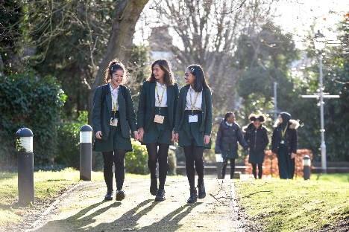

Job Description

The Governing Body and the Local Authority are committed to safeguarding and promoting the welfare of children and young people. The Headteacher must ensure that the highest priority is given to following the latest national guidance and regulations on safeguarding and child protection. This role is subject to an enhanced DBS check.
Job title: Head of Faculty (non-core) (HOF)

Reporting to: Leadership Team member line manager
Responsible for: Teaching staff and support staff within the faculty
Line management of: Deputy Head of Faculty (DHOF) and other named members of the faculty
Liaising with: LT, other HOFs, Student Progress Leader (SPL), Student Support Services, relevant staff with cross-school responsibilities, relevant teaching and support staff, LEA personnel, governors, parents/carers and external agencies.
Working time: 195 days per year – full time. Attendance at identified calendared evets in school year
Salary / TLR Allowance: Classroom Teachers’ Pay Scale + TLR1b
Disclosure: Enhanced

Core Purpose | - To lead and manage the faculty  - To be accountable for student progress and attainment within the faculty  - To monitor student achievement levels and ensure that strategies are in place to maximise standards of attainment  - To develop and enhance the teaching practice of the other members of the faculty
Curriculum | - To ensure the provision of an appropriately broad, balanced, relevant and differentiated curriculum to meet the needs of all students studying in the faculty  - To assume direct responsibility for one subject within the faculty including the development of syllabi, resources, Schemes of Work (SOW) and assessment strategies  - To lead curriculum development for the faculty  - To keep up to date with national developments in the subject area and teaching practice and methodology  - To actively monitor and respond to curriculum developments and initiatives at national, regional and local levels and to disseminate this knowledge to faculty members  - To ensure that statutory requirements are met
Monitoring and Evaluation | - To assume responsibility for monitoring and evaluation of school policies and procedures within the faculty, and the teaching and assessment of members of the faculty.  - To lead Self Evaluation activities and carry out the activities as a means of improving faculty practice and identifying areas for development
Strategic Leadership | - To lead faculty colleagues in formulating aims, objectives and strategic plans for the faculty which have coherence and relevance to the needs of students and to the aims, objectives and strategic plans of the school  - To assume responsibility for writing, overseeing and evaluating the faculty improvement plan on an annual cycle  - To lead on the implementation and evaluation of one of the three school improvement plan (SIP) themes  - To plan the development of staff expertise to achieve faculty improvement plan objectives  - To monitor and evaluate the contribution and impact of faculty members to school improvement
Quality Assurance | - To ensure that all school policies are implemented by all faculty members  - To carry out lesson observations and feedback in line with the school’s Self Evaluation Policy  - To ensure high expectations and consistent excellent practice throughout the faculty  - To ensure consistently high standards of student behaviour in the faculty by role modelling, supporting colleagues, intervening and following up any incidents or issues  - To implement and evaluate the impact of improvement activities on the quality of teaching and learning in the faculty  - To identify appropriate attainment targets, monitor student standards and support the achievement of annual targets, in liaison with DHOFs where they are subject leaders  - To actively monitor, analyse and evaluate student progress and attainment, formatively and summatively  - To ensure the implementation of all school evaluation systems in line with the School’s Self Evaluation Policy
Resources | - To effectively manage and deploy teaching and support staff  - To effectively manage the faculty’s budget in order to progress SIP priorities, maximise attainment and meet the school’s aims of providing value for money.  - To bid for resources as part of the SIP  - To effectively manage physical resources, stock and faculty accommodation in order to maximise student attainment levels and ensure an ambience conducive to learning  - To ensure that risk assessments and Health and Safety checks are carried out in line with school policy
Staffing | - To be a performance manager for the post holders in the faculty, carrying out performance management reviews in line with school policy and setting challenging objectives  - To support other team leaders in the faculty in discharging their performance management duties and to monitor the effectiveness of performance management arrangements in the faculty  - To ensure that the career and professional development needs of all members of the faculty are addressed  - To oversee the arrangements made by the DHOFs for covering the lessons of absent staff in the faculty  - To support, guide and motivate faculty members  - To participate in the recruitment and interview process for members of the faculty  - To ensure effective induction of new staff in line with school procedures  - To promote teamwork and to motivate staff to ensure effective learning relations  - To be responsible for the day to day management of staff within the faculty and to act as a positive role model  - To provide advice to colleagues in the faculty on threshold, UPS, references, promotion, behaviour management, etc  - To delegate appropriately to postholders in the faculty cross curricular responsibilities for Challenge, SEN & ICT  - To organise faculty meetings and arrange chairing and minuting  - To support and challenge faculty members, including in circumstances where they are underperforming
Management Information | - To make use of analysis and evaluate performance data provided  - To identify and take appropriate action on issues arising from referrals, data and reports  - To produce reports on examination performance, supported by DHOFs where they are subject leaders  - To ensure that all faculty members use data appropriately to set targets, expectations and to differentiate their teaching
Communication | - To coordinate and oversee marking in line with school policy  - To quality control reports on students, supported by DHOFs where they are subject leaders  - To oversee feedback from the faculty to parents  - To prepare reports on the work of the faculty e.g. for governors  - To make contributions relating to the work of the faculty to school publications, LEA reports etc  - To keep faculty members informed of whole school matters and developments  - To provide the Headteacher with relevant pupil performance information  - To promote the work of the faculty  - To liaise with partner schools, primary schools, higher education establishments, industry, exam boards, awarding bodies and other relevant external agencies
Students | - To be responsible for effective and efficient timetable arrangements and organisation of teaching groups  - To be responsible for student behaviour, wellbeing and development within the faculty  - To support the SPL whose year group the HOF is attached to
School Ethos | - To contribute to the development of whole school policy as a member of the school forum and HOFs  - To represent the faculty at the above meetings  - To support the school ethos, aims and policies
Whole School Contribution | - To play a full part in the life of the school community, to support is distinctive aims and ethos and to encourage staff and students to follow this example  - To continue professional development  - To comply with the schools’ Health and Safety policy  - To undertake any other duty as specified by STPCD not mentioned above

This job description is carried out in accordance with provisions of the School Teachers’ Pay and Conditions document and within the range of teachers’ duties set out in that document.
The school will endeavour to make any necessary reasonable adjustments to the job and the working environment to enable access to employment opportunity for disabled job applicants or continued employment for any employee who develops a disabling condition.
This job description is current at the date shown but, in consultation with you, may be changed by the Headteacher to reflect or anticipate changes in the job commensurate with the grade and job title.
Each Head of Faculty may have specific duties on top of these generic ones.
March 2020

This school is committed to safeguarding and promoting the welfare of children and young people and expects all staff and volunteers to share this commitment.

Person Specification

 | Criteria | Essential | Desirable |  | Assessed by application | Assessed by selection process
 | Qualifications
1 | A good honours degree or equivalent | / |  |  | /
2 | Qualified Teacher Status (QTS) | / |  |  | /
 | Professional experience and knowledge
3 | Proven classroom expertise as a BT or have 1 or more years’ experience | / |  |  | / | /
4 | An ability to constantly monitor students’ achievements and adapt teaching to the needs of the class with the support of the Head of Faculty of teaching/working in a single sex educational environment | / |  |  | / | /
5 | Understanding and knowledge of the appropriate use of a range of differentiation techniques | / |  |  | / | /
6 | The ability to contribute to the work within the faculty, both as a member of a team and individually | / |  |  | / | /
7 | A commitment to the promotion of anti-sexism, anti-racism and equality of opportunity in all aspects of their work within the school | / |  |  | / | /
 | Professional aptitudes, qualities and skills
8 | A willingness to contribute to the extra-curricular activities within the faculty and support ongoing projects | / |  |  | /
9 | A willingness to learn new skills and develop existing skills as a part of a program of professional development, with the aim of using this development to further their career | / |  |  | / | /
10 | Personal qualities and skills that can contribute to the school’s pastoral system | / |  |  | / | /
11 | An ability to effectively organise their workload, be energetic and have a sense of humour | / |  |  |  | /

March 2020

This school is committed to safeguarding and promoting the welfare of children and young people and expects all staff and volunteers to share this commitment.

ICT and Computing Faculty Information

The whole school is networked; each workstation provides access to a personal user area, the internet (we have 1000Mb/s broadband), email and shared network areas for staff and pupils. The network has around 450 networked Dell PCs and 60 Dell laptops.

Our website is hosted by E4Education (www.wsfg.waltham.sch.uk). This is used to communicate with the community and external organisations. We have recently introduced Office365 across the school with all staff and students using this as the main platform to teach, learn, communicate and manage files. We are also using MS Teams as an alternative method to take class notes, set assignments and share files.

We utilise classroom management software called Impero. This can be used to monitor and control pupil’s use of the network and display a pupil’s screen on the interactive whiteboard. We have also established a new GREEN learning policy with Year 7 who all have access to their own iPad. This has established newer teaching strategies in the form of online apps and the use of Air Server to share files and to also project work on the interactive whiteboard.
All teachers are encouraged to make use of the ICT facilities to develop pupils’ knowledge and understanding in their area of the curriculum. The ICT Faculty has responsibility for the teaching of computing throughout Key Stage 3. Pupils in Year 7 and 8 have one hour of computing timetabled each week, and in Year 9 pupils have three hours of computing over two weeks. At Key Stage 4 students can opt to take, Computer Science GCSE(OCR) National Creative iMedia.

To maintain the curriculum network we have an IT Systems Manager and two Technicians employed by the school. We are currently using Windows 10 clients and a Window 2016 server.

There are five ICT suites with 30 PCs used to deliver the ICT curriculum. In addition, there are many networked computers across the school. Music has a suite of iMac computers. There are also four laptop trolleys (each with fifteen laptops) that are a bookable resource for faculties. All classrooms have an interactive whiteboard.

The main software used to manage student data is SIMS.



Staff Benefits

Outlined below are some of the additional benefits available to staff working at Walthamstow School for Girls.

Cycle 2 work scheme
This benefit offers staff the opportunity to make tax and national insurance savings whilst keeping fit at the same time.
Commitment to CPD
We actively encourage CPD to all staff. We regularly provide whole school CPD as part of the school calendar, as well as opportunities for individual CPD requests.
“I have been given some fantastic CPD opportunities with an amazing amount of training. My personal knowledge and confidence has increased immensely.”

Eye Tests
All staff using computer equipment should have eye and eyesight checks at regular intervals. Eyesight testing should also happen where staff experience visual difficulties, which may reasonably be considered to be caused by computer work. Staff working within schools in the London Borough of
Waltham Forest may be entitled to reimbursement of some costs associated with vision testing and the frames and lenses needed to enable them to work safely on display screen equipment.

Staff Wellbeing
As part of our CPD for staff we include session related to staff wellbeing. There are also opportunities for staff to participate in various activities as individuals.

At Walthamstow School for Girls we also offer a staff running club, Badminton club, Boxfit exercise sessions, yoga and the London Club (historical walks around London).
“Since joining WSFG I have felt totally reinvigorated and I am excited to teach again. This is undoubtedly because the atmosphere in school is a very positive one.”

Workplace Options - Employee Assistance Provider
A confidential counselling, help and information service is provided for all those employed by Waltham Forest and is available free of charge 24 hours a day, every day of the year. This service can help with a range of problems from practical everyday matters to sensitive and emotional issues. For further information please call 0800 328 1437 or contact: www.employeeassistance.org.uk

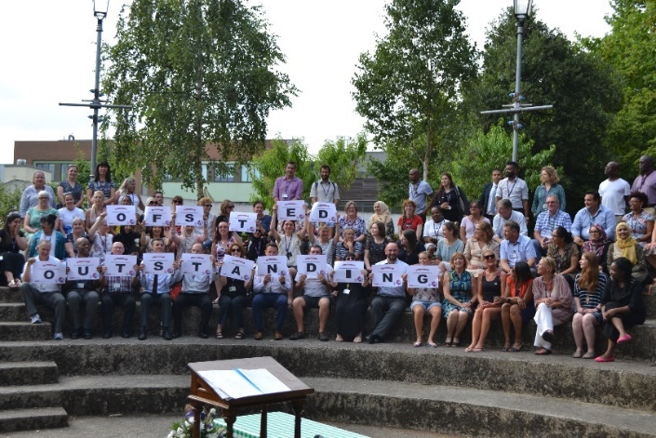

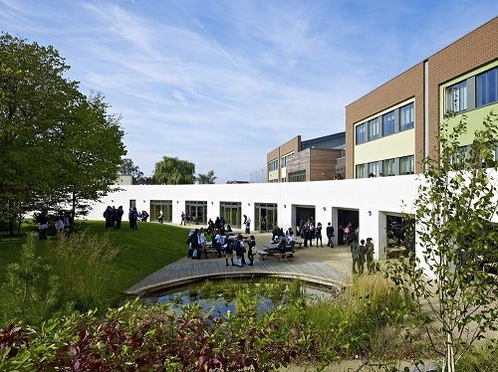

For further information about our school please visit our website: www.wsfg.waltham.sch.uk

