



Walthamstow School
For Girls

“Neglect not the gift that is in thee”

Policy Document

Safeguarding Policy

Author(s): LBWF

Ratification Date: December 2019

Next Review Date: December 2020

Reference: SG_POLICY_V2.0

CONTENTS | PAGE
1 Purpose and Scope | 3
2 Identifying Abuse | 4
3 Safeguarding Procedure in School | 6
Appendix AA - Thresholds for Social Care Intervention | 10
Appendix A – Referral Pathways | 12
Appendix B – Key Contacts | 13
Appendix C – Governors’ Whistleblowing Policy | 14
Appendix D – WSFG Safety & Welfare Concern Form | 22
Appendix E – Action | 23
Appendix F – MASH Referral Form | 24
Appendix G – Escalation | 34
Appendix H – Allegations/Concerns Against Staff CP Process | 36

1. PURPOSE & SCOPE

Our Commitment to Safeguarding
We believe that all children have a right to be safe and should be protected from all forms of abuse and neglect.
Although reporting concerns can be uncomfortable for staff, and be unpleasant for parents/carers/families, as a secondary community school we recognise that it is better to help children, young people and their parents/carers/families early, before issues escalate and become more damaging.
Because safeguarding is everyone’s responsibility, all staff are committed to recognising and reporting all concerns relating to child safety, wellbeing and, in particular, are vigilant to spot signs of abuse and maltreatment.
As such, we promise to:
- Be observant and alert to signs of abuse
- Be curious and question explanations given by parents / children / staff
- Be compassionate, honest and clear
- Ask for support when we feel at the limit of our experience / patience / skills
- Understand and follow school policies and procedures
- Work together with other agencies when appropriate to make sure that support for children, young people and parents/carers/families is effective and helps improve outcomes.

Children and young people learn and thrive best when they are healthy, safe and secure, when their individual needs are met, and when they have positive relationships with the adults caring for them.

WSFG aims to offer an environment where children feel welcome, safe, stimulated and where children are free to enjoy learning and developing in confidence.

The purpose of this policy is to safeguard and promote the welfare of children at our school.

Safeguarding and promoting the welfare of children is defined for the purposes of this policy as:
- Protecting children from maltreatment
- Preventing impairment of children’s health or development
- Ensuring that children grow up in circumstances consistent with the provision of safe and effective care
- Taking action to enable all children to have the best outcomes.
In order to take all necessary steps to keep children safe and well, WSFG will:
- Safeguard children both preventatively and responsively
- Ensure the suitability of adults who have contact with children
- Promote good health, effective management of medical conditions, and the development of self-care in children & young people
- Have clear standards of behaviour for staff / volunteers and children / young people
- Manage behaviour by anticipating possible concerns, prevention strategies, and clear, fair responses to challenging behaviour
- Maintain records that document safeguarding concerns over time, including low-level worries about a child or young people that together may paint a picture of concern
- Ensure that all policies and procedures relating to safeguarding and wellbeing are updated annually in collaboration with the board of governors.

Who is responsible for Safeguarding?
No single professional can have a full picture of a child’s needs and circumstances.
This policy applies to all staff, including paid staff, volunteers and sessional workers, agency staff, organisations contracted to deliver services within school, one-off visitors, students or anyone working on behalf of WSFG.
This policy relates to all children (anyone up to their 18th birthday) with whom WSFG works.
This policy will be readily available via our school website for professionals, parents and partners.
The policy will be made available to parents prior to children commencing and following each update. Support and consideration will be given to those parents for whom English is not a first language.

The voice of the child
Members of staff will endeavour to ensure that their approach is child- and family-centred. This means that they will consider, at all times, what is in the best interests of the child, and how to approach families with compassion and respect.
Staff will always seek to understand and give voice to the lived experience of a given child and young person within a school / college, at home and within their wider community, even if children and young people are unable / unwilling to express their experience themselves.

2. IDENTIFYING ABUSE

Being alert to abuse and to the fact that ‘it could happen here’ is crucial to safeguarding:
- An abused child will often experience more than one type of abuse, as well as other difficulties.
- Abuse reduces resilience in children and puts them at further risk of abuse throughout their lives.
- Abuse and neglect can happen over a period of time but can also be a one-off event.
- Child abuse and neglect can have major long-term impacts on all aspects of a child's health, development and well-being.

2.1 Indicators
The warning signs of child abuse and neglect can vary from child to child. All staff, including sessional staff, should log even minor concerns about incidents and behaviour changes, and any other worries about children and young people.
Abuse is a form of maltreatment of a child. Somebody may abuse or neglect a child by inflicting harm or by failing to act to prevent harm. Children may be abused in a family or in an institutional or community setting by those known to them or, more rarely, by others. Abuse can take place wholly online, or technology may be used to facilitate offline abuse. Children may be abused by an adult or adults or by another child or children.
There are four main categories of abuse and neglect:
- physical abuse
- emotional abuse
- sexual abuse
- neglect.

2.1.1 Physical Abuse
Physical abuse is deliberately physically hurting a child. It might take a variety of different forms, including hitting, pinching, shaking, throwing, poisoning, burning or scalding, drowning or suffocating a child.
Physical abuse can happen in any family, but children may be more at risk if their parents have problems with drugs, alcohol and mental health or if they live in a home where domestic abuse happens.
Babies and disabled children also have a higher risk of suffering physical abuse, and physical abuse in young children is more likely to lead to permanent injury or fatality.
Physical harm may also be caused when a parent or carer fabricates the symptoms of, or deliberately induces, illness in a child. Physical abuse can also occur outside the family environment.

2.1.2 Emotional Abuse
Emotional abuse is the persistent emotional maltreatment of a child. It is also sometimes called psychological abuse and it can have severe and persistent adverse effects on a child’s emotional development.
Although the effects of emotional abuse might take a long time to be recognisable, practitioners will be in a position to observe it, for example, in the way that a parent interacts with their child.
Emotional abuse may involve deliberately telling a child that they are worthless, or unloved and inadequate. It may include not giving the child opportunities to express their views, deliberately silencing them or ‘making fun’ of what they say or how they communicate. It may feature age or developmentally inappropriate expectations being imposed on children. These may include interactions that are beyond a child’s developmental capability as well as overprotection and limitation of exploration and learning or preventing the child from participating in normal social interaction.
It may involve seeing or hearing the ill-treatment of another, which includes coercive control and domestic abuse.
It may involve serious bullying (including cyberbullying), causing children frequently to feel frightened or in danger, or the exploitation or corruption of children. Some level of emotional abuse is involved in all types of maltreatment of a child, although it may occur alone.

2.1.3 Sexual Abuse & Exploitation
Sexual abuse is any sexual activity with a child. You should be aware that many children and young people who are victims of sexual abuse do not recognise themselves as such. A child may not understand what is happening and may not even understand that it is wrong.
Sexual abuse can have a long-term impact on mental health. Sexual abuse may involve physical contact, including assault by penetration (for example, rape or oral sex) or non-penetrative acts such as masturbation, kissing, rubbing and touching outside clothing. It may include non-contact activities, such as involving children in the production of sexual images, forcing children to look at sexual images or watch sexual activities, encouraging children to behave in sexually inappropriate ways or grooming a child in preparation for abuse (including via the internet). Sexual abuse is not solely perpetrated by adult males; women and children are also perpetrators.
Child sexual exploitation is a form of sexual abuse where children are sexually exploited for Money, power or status. It can involve violent, humiliating and degrading sexual assaults. In some cases, young people are persuaded or forced into exchanging sexual activity for money, drugs, gifts, affection or status. Consent cannot be given, even where a child may believe they are voluntarily engaging in sexual activity with the person who is exploiting them. Child sexual exploitation doesn't always involve physical contact and can happen online. A significant number of children who are victims of sexual exploitation go missing from home, care and education at some point.

2.1.4 Neglect
Neglect is a pattern of failing to provide for a child’s basic needs, whether it be adequate food, clothing, hygiene, supervision or shelter. It is likely to result in the serious impairment of a child’s health or development. Children who are neglected often also suffer from other types of abuse.
Neglect usually indicates a relationship issue between the parent and child.
A key task for staff and volunteers is to record all instances of neglect, however minor. This builds up a picture of the child’s lived experience and provides the crucial evidence required at point of referral.
There are many different aspects in which neglect can manifest:
- Physical Neglect or Deprivation of Needs
- Medical Neglect
- Supervisory Neglect
- Environmental Neglect
- Educational Neglect
- Emotional Neglect

2.1.5 Child & Young People’s Disclosures to Staff
Children and young people may disclose concerns to staff and may do so knowing that what they are disclosing is a concern, and sometimes they will be unaware that their disclosure will signal concerns.
Wherever possible, staff should make the time and space to listen and understand what the child / young person is disclosing. Don’t be afraid to respond with compassion and empathy and to ask open questions if you’re unsure about what the concerns are.

2.2 Especially Vulnerable Pupils

To ensure that all of our pupils receive equal protection, we will give special consideration to children who are particularly vulnerable.

This list provides examples of additionally vulnerable groups and is not exhaustive.
Children & Young People Especially Vulnerable
- Young carers
- Transgender children / young people
- Affected by parental substance misuse, domestic violence or parental mental health needs
- Asylum seekers
- Living away from home
- Vulnerable to being bullied, or engaging in bullying
- Living in temporary accommodation
- Live transient lifestyles
- Living in chaotic and unsupportive home situations
- Vulnerable to discrimination on the grounds of race, ethnicity, religion, disability or sexuality
- At risk of sexual exploitation
- Do not have English as a first language
- At risk of female genital mutilation (FGM)
- At risk of forced marriage
- At risk of being drawn into extremism.

3. SAFEGUARDING PROCEDURE IN SCHOOL

3.1 Designated Safeguarding Lead (DSL)

A Designated Safeguarding Lead (DSL) is appointed to support the management of safeguarding cases within the school / college. Their name and contact details are:
Kristine Pratt 0208 509 9435
The Deputy Designated Safeguarding Leads are:
Marianna Philippou 0208 509 9438
Jane Snowsill 0208 509 9436
Julie King 0208 509 9444
Meryl Davies 0208 509 9448
A DSL or Deputy will be on site at all times. Staff and volunteers should be able to access DSLs for advice, information and signposting at all times. If, for some reason, the DSL is inaccessible, staff and volunteers must make a referral without delay.
It is important that DSLs obtain a full and rich picture of children’s experience. As soon as staff identify indicators of concern, they should record all concerns regarding behaviour and wellbeing by email and if the concerns are serious, they should speak to the DSL without delay.
Although DSLs take responsibility for Safeguarding in school, Headteachers are ultimately responsible for all the children / young people in school. Headteachers should be contacted in the event that possible harm has been caused by a member of staff or volunteer.

3.2 Recording

Recording of concerns should take place as close in time to the incident as reasonably possible, by using the email system and from 2020 using the SAFEGUARD program.
There are shared computers in place for this purpose for those sessional members of staff who do not have their own computer.
Where concerns are serious, in addition to logging concerns, staff should seek to speak to a DSL immediately either in person or by phone.

3.3 Information sharing

The Data Protection Act 2018 and GDPR 2016 do not prevent, or limit, the sharing of information for the purposes of keeping children safe. Fears about sharing information must not be allowed to stand in the way of the need to promote the welfare and protect the safety of children.

Sharing information regarding safeguarding children and young people within school enables staff to be especially vigilant around certain children.

If in doubt about sharing, see: Information sharing: Advice for Practitioners Providing Safeguarding Services to Children, Young People, Parents and Carers 2018.

3.4 DSL Decision-Making
In consultation with MASH, if necessary, WSFG DSLs and involved staff will decide together:
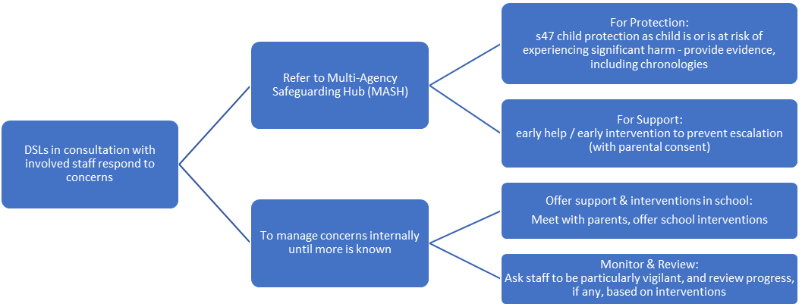

3.5 Referrals

Multi-agency Safeguarding Hub (MASH) is Waltham Forest’s single point of referral to social care for concerns regarding children, young people and vulnerable adults:
- Early Help (parental consent needed)
- Child in Need
- Child Protection
- Adult Safeguarding
Referrals to the Multi-agency Safeguarding Hub (MASH) should be made immediately when there is a concern that the child is suffering significant harm or is likely to do so.
It is good practice to notify MASH by phone and/or email to discuss the case prior to sending a written referral. This will help determine the level of intervention and will also give children’s social care and the police time to make arrangements to come and see the child that same day in school, if deemed necessary.
At WSFG the DSL ordinarily takes responsibility for the referral process, in consultation with staff who know the child. Still, there are circumstances where another member of staff must refer without delay:
- If for some reason (e.g. during the summer break), the DSL is not available, the referral should be made without delay by any other member of school staff.
- If you disagree with your DSL’s decision not to refer a case to MASH, it is your responsibility to refer the case, and to respectfully inform the DSL that you are doing so.
Should another member of staff refer instead, the DSL must be consulted and updated as soon as possible.

3.6 Reporting Procedure in School
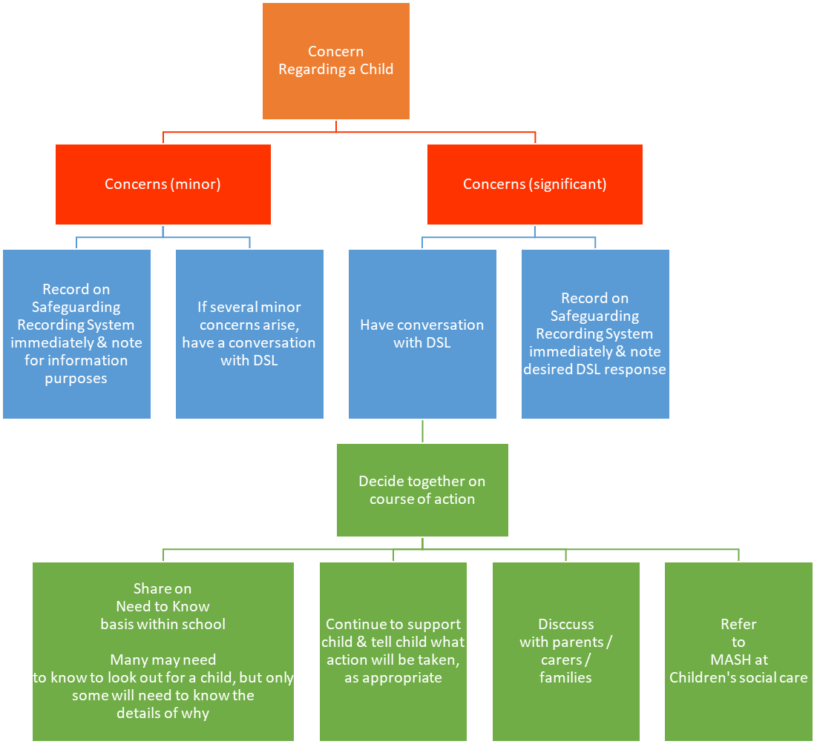

3.7 Allegations Against Professionals

All allegations against staff and volunteers must be reported to the Headteacher in the first instance, in confidence. The person against whom the allegation is made should not be notified at this point.
If harm is caused to a child by a member of staff or a volunteer, the referral should go to LADO.
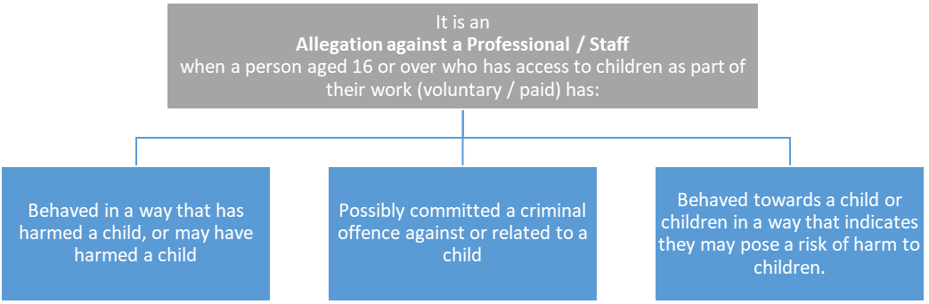
It is relatively rare for a child to make an entirely false or malicious allegation, although misunderstandings and misinterpretations of events do happen.
If a child does make a false allegation, there may be other concerns regarding their welfare.
The full procedures for dealing with allegations against staff can be found in Keeping Children Safe in Education (2019).

3.8 Initial Action by person receiving or identifying an allegation or concern
- Whilst allegations may be false, malicious or misplaced, they may also be founded in truth; all staff must report allegations even if they reasonably believe them to be false.
- All allegations must be investigated properly, in line with agreed procedures and outcomes recorded.
- Staff must treat all allegations seriously and keep an open mind.
- Make a written record of the information, including the time, date and place of incident/s, persons present and what was said and sign and date this.
- Immediately report the matter to the Headteacher/proprietor.
- Do not share allegations with any other member of staff, including the subject of the allegation.
- If the allegation is against the Headteacher, staff must report to chair of governors / trustees.
- If there is a lack of faith in the safeguarding governance, all staff can contact the local authority’s Designated Officers (also known as LADOs) directly, without delay:
020 8496 3646 / lado@walthamforest.gov.uk.

3.9 Whistleblowing

Whistleblowing is ‘making a disclosure in the public interest’ and occurs when a worker (or member of the wider school community) raises a concern about danger or illegality that affects others, for example pupils in the school or members of the public.

All staff are made aware of the duty to raise concerns about the attitude or actions of staff in line with the school’s Code of Conduct / Whistleblowing policy.

We want everyone to feel able to report any child protection / safeguarding concerns. However, for members of staff, parents or others who feel unable to raise these concerns internally, they can call the NSPCC whistleblowing helpline on: 0800 028 0285 (line is available from 8:00 AM to 8:00 PM, Monday to Friday) or email: help@nspcc.org.uk.

Staff are also able to contact the Local Authority Designated Officer lado@walthamforest.gov.uk or 0208 496 3646

APPENDIX AA

Thresholds for Social Care Intervention

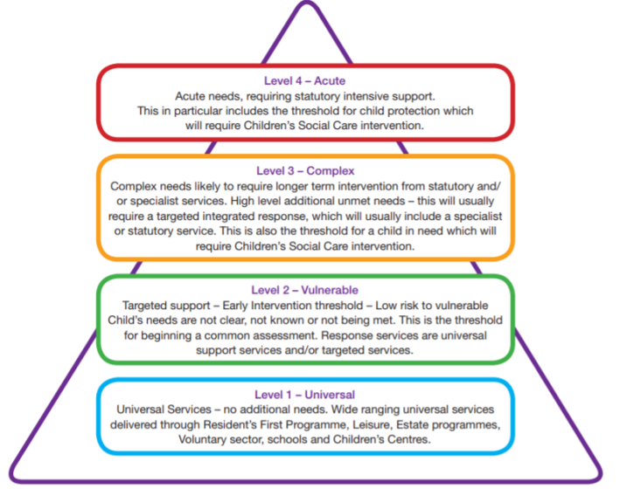
Level 1 – Universal
Universal services are key partners in the delivery of a preventative approach to improving outcomes for children and young people. Services delivered at the universal level meet the needs of the majority of children and young people. These ‘universal services’ are those services (sometimes also referred to as mainstream services) that are provided to or are routinely available to, all children and their families. Universal services are designed to meet the sorts of needs that should enhance the lives and wellbeing of all our children.

Most children will not require intervention beyond the universal level of support within the borough available to all children – these will not require social care intervention.

Level 2 – Vulnerable
Vulnerable needs requiring targeted support, when the needs of the child can no longer be fully met within Universal provision. These children and their families may have low level additional needs that are likely to be short term and that are sometimes known but unmet. In this context, a Common Assessment should be completed with the family and child or young person. At this point the Team around the Child and Family processes should commence if support is required from more than one professional service. The team is coordinated by a Lead Professional to provide a consistent link for the family.

WF Early Help and Threshold Criteria for Intervention lays out the agreed thresholds for intervention at different levels of risk to children and young people within Waltham Forest. Early Help intervention requires parental consent and engagement. Providing early help is more effective in promoting the welfare of children than reacting later. The aim is to prevent further issues arising and current issues escalating.
In cases where consent is not given for an early help assessment, practitioners should consider how the needs of the child might be met. If at any time it is considered that the child may be a child in need, or that the child has suffered significant harm or is likely to do so, a referral should be made immediately to MASH.

Level 3 – Complex
For children and young people whose needs are complex, the lead professional will be a social worker who will work closely with the child and family to ensure a single assessment and deliver the right support and intervention. These children will be eligible for social care services, outlined in a Children in Need plan, because they are at risk of moving to a higher threshold for intervention from specialist services. In most cases the social worker will act as the lead professional to coordinate the work of all agencies with the child and family. “Asset” is the risk assessment tool used to assess the likelihood of a Young Person going on to commit an offence and to identify what areas of work need to be undertaken to reduce this risk.

Section 17 of the Children Act 1989 places a general duty on every Local Authority to safeguard and promote the welfare of children living within their area who are in need and to promote the upbringing of such children, wherever possible by their families, through providing an appropriate range of services. A child in need is defined under the Children Act 1989 as a child who is unlikely to achieve or maintain a reasonable level of health or development, or whose health and development is likely to be significantly or further impaired, without the provision of services; or a child who is disabled. Local authorities are required to provide services for children in need for the purposes of safeguarding and promoting their welfare. Children in need may be assessed under section 17 of the Children Act 1989.

Level 4 – Acute
Acute Specialist Services are required where the needs of the child or young person are so great that statutory and /or specialist help and intervention is required to keep them safe or to ensure their continued development. These span the multi-agency partnership including; Children’s Social Care, Child and Adolescent Mental Health Services and Level 3 and 4 Youth Offending Services.
By effective integrated working in Waltham Forest, we aim to reduce the escalation of those children and families requiring targeted support to prevent more children requiring specialist and statutory interventions. To ensure the right support, in the right place at the right time.
In Waltham Forest, we are developing a confident integrated workforce with a common core of knowledge and understanding to support and intervene effectively to safeguard children young people and families.

A very small number of children for whom targeted support will not be sufficient will have more significant and acute needs which meet the threshold for Stage 4 intervention. This includes children who are experiencing significant harm or where there is a likelihood of significant harm and children at risk of removal from home.
s47 or Child Protection intervention is the process for children where there is reasonable cause to suspect that the child is suffering or likely to suffer significant harm (this includes immediate protection for children at serious risk of harm).
Appendix A

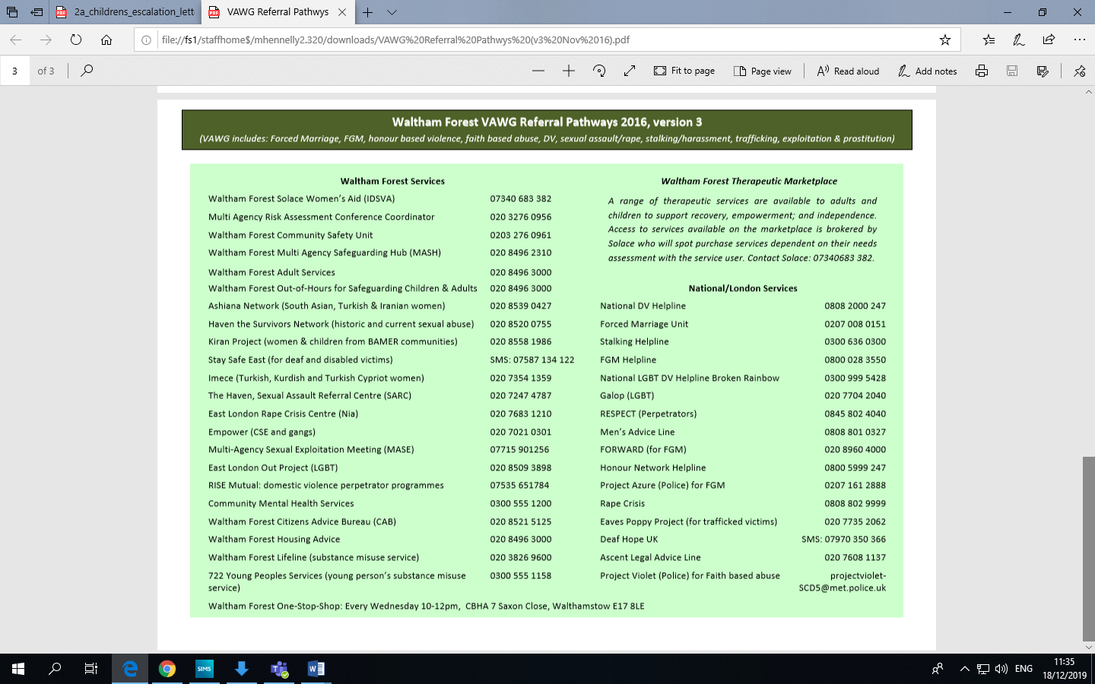
APPENDIX B

Key contacts for Child Protection Issues in Waltham Forest

Multi-Agency Safeguarding Hub (MASH)  Single point of referral for Early Help, Child Protection and Adults’ Safeguarding in Waltham Forest | Phone: 020 8496 2310  Mon-Thurs, 9am-5.15pm and Fri, 9am-5pm  Out of Hours: 020 8496 3000  Email: MASHrequests@walthamforest.gov.uk  N.B.: If you cannot get through by phone, send an email with your contact details, and you will get a same-day phone response during normal business hours
LADO Team  Allegations against staff and volunteers (ASV) | Phone: 020 8496 3646  Email: lado@walthamforest.gov.uk  N.B.: If you cannot get through by phone, send an email with your contact details, and you will get a same-day phone response during normal business hours
Safeguarding in Education Team  Consultations / Training / Support (traded service) | Phone: 020 8496 3646  Email: lado@walthamforest.gov.uk  N.B.: If you cannot get through by phone, send an email with your contact details, and you will get a phone response within 24 hours during normal business hours
Early Help | Phone: 020 8496 1517  Email: earlyhelp@walthamforest.gov.uk
Virtual School | Phone: 020 8496 1741  Email: virtual.school@walthamforest.gov.uk  Head of Virtual School: fay.blyth@walthamforestgov.uk
Special Educational Needs & Disability (SEND) Service  [ formerly known as Disability Enablement Service (DES) ] | Phone: 020 8496 6503  Email: senteam@walthamforest.gov.uk
Corporate Director Children’s Social Care (CSC)  Inter-agency Escalation of concerns beyond escalation to Team Manager for Children’s social care intervention | Phone: 020 8496 1907  Email: cspahub@walthamforest.gov.uk;  amana.gordon@walthamforest.gov.uk
Corporate Director Quality Assurance (QA)  Inter-agency Escalation of concerns beyond escalation to Team Manager for LADO intervention | Phone: 020 8496 3685  Email: cspahub@walthamforest.gov.uk; Darren.McAughtrie@walthamforest.gov.uk
Local Safeguarding Children Board (LSCB)  Local Safeguarding Partners (LSPs) | Email: strategicpartnerships@walthamforest.gov.uk
Child Death Overview Panel (CDOP) notifications | Phone: 020 8496 3691  Email: cdop@walthamforest.gov.uk
Female Genital Mutilation (FGM)  Community Safety | Refer via MASH.  Phone: 020 8496 3281  Email: Sylvie.lovell@walthamforest.gov.uk
Prevent  Community Safety | Refer via MASH.  Phone: 020 8496 3000  Mobile: 07816150037  Email: communitysafety@walthamforest.gov.uk; Amy.Strode@walthamforest.gov.uk
Gangs  Community Safety | Refer via MASH.  Email: Adeolu.Solarin@walthamforest.gov.uk
Adolescent Safeguarding Lead Children’s Social Care | Refer via MASH.  Email: Reanne.Turner@walthamforest.gov.uk
Harmful Sexual Behaviour Lead Children’s Social Care | Refer via MASH.  Email: tracey.goddard@walthamforest.gov.uk  Tel: 020 8496 5027  Mob: 0797 476 8433
MARAC / DRM queries | Refer via MASH.  Dianne.Andrews@walthamforest.gov.uk
Mental Health First Aid /  Public Health | catherine.hutchinson@walthamforest.gov.uk
Private Fostering | Refer via MASH.  Email: Pamela.Levy@walthamforest.gov.uk  Phone: 020 8496 1575
Violence against women and girls (VAWG) & Domestic Abuse one-stop-shop | Refer via MASH.  Email: vawg@watlhamforest.gov.uk; domesticabuseadvice@walthamforest.gov.uk

APPENDIX C

Walthamstow School
For Girls

“Neglect not the gift that is in thee”

Policy Document

Governors’ Whistleblowing Policy

Author(s): Meryl Davies

Ratification Date: December 2019

Next Review Date: December 2022

Reference: WB_POLICY_V1.0

CONTENTS | PAGE

SECTION 1: OUTLINE OF POLICY
1.1 Introduction | 3
1.2 When Might the Whistleblowing Policy Apply? | 3

SECTION 2: OUTLINE OF PROCEDURE
 | 4
2.1 What Action Should the Whistleblower take? | 4
2.2 How Will the Matter be Progressed? | 4
2.3 Respecting Confidentiality | 4
2.4 Raising Unfounded Malicious Concerns | 5

SECTION 3: CONCLUSION
3. Conclusion | 5

APPENDICES
Appendix A: LBWF Whistleblowing Policy | 6

SECTION 1 | OUTLINE OF POLICY

1.1 INTRODUCTION
The staff and Governors of Walthamstow School for Girls seek to run all aspects of school business and activity with full regard for high standards of conduct and integrity. In the event that any member of the school community become aware of activities which give cause for concern, the following whistleblowing policy, or code of practice, has been established which acts as a framework to allow concerns to be raised confidentially and provides for a thorough and appropriate investigation of the matter to bring it to a satisfactory conclusion.

The provisions of this policy apply to matters of suspected fraud and impropriety and not matters of more general grievance which would be dealt with under the grievance procedures.

Throughout this policy, the term whistleblower denotes the person raising the concern or making the complaint. It is not meant in a pejorative sense and is entirely consistent with the terminology used by Lord Nolan as recommended in the Second Report of the Committee on Standards in Public Life: Local Spending Bodies, published in May 1996

The governors of Walthamstow School for Girls are committed to tackling fraud and other forms of malpractice and treat these issues seriously. The governors recognise that some concerns may be extremely sensitive and have therefore developed a system which allows for the confidential raising of concerns within the school environment but also has recourse to an external party outside the management structure of the school.

The governors are committed to creating a climate of trust and openness so that a person who has a genuine concern or suspicion can raise the matter with full confidence that the matter will be appropriately considered and resolved.

1.2 WHEN MIGHT THE WHISTLEBLOWING POLICY APPLY?

The type of activity or behaviour which the governors consider should be dealt with under this policy includes:

- Manipulation of accounting records and finances,
- Inappropriate use of school assets or funds,
- Decision making for personal gain,
- Any criminal activity,
- Abuse of position,
- Fraud and deceit,
- Serious breaches of school procedures which may advantage a particular party (for example tampering with tender documentation, failure to register a personal interest).

SECTION 2 | PROCEDURES

2.1 WHAT ACTION SHOULD THE WHISTLEBLOWER TAKE?
We would hope that, in most cases, issues can be raised with a line manager or a member of the senior management team and resolved. If not:-

Step one

The whistleblower should contact:-

Meryl Davies, Headteacher (M.Davies@wsfg.waltham.sch.uk) or
Gillian Barker, Chair of Governors (G.Barker@wsfg.waltham.sch.uk)

They may prefer to raise the matter in person, by telephone (via the Headteacher’s PA, tel: 020 8509 9448), or in written form, marked private and confidential, addressed to one of the individuals above. All matters will be treated in strict confidence and anonymity will be respected wherever possible.

Step two

The whistleblower may consider the matter too serious or sensitive to raise within the internal environment of the school. In this case, the matter should be referred to the Director of Governance, London Borough of Waltham Forest, Mark Hynes, on 020 8496 4791 in the first instance Mark.Hynes@walthamforest.gov.uk. Alternatively in cases of suspected fraud the Assistant Director – Audit and Anti-Fraud, London Borough of Waltham Forest Gemma Young, on 020 8496 4620, (Gemma.Young@walthamsforest.gov.uk).

The Local Authority has its own procedures for dealing with such matters and will ensure every effort to respect the confidentiality of the Whistleblower.

In addition, information and advice can be obtained from the charity Public Concern at Work. This charity offers free legal advice in certain circumstances to people concerned about serious malpractice at work. Their literature states that matters are handled in strict confidence and without obligation. Their helpline number is 020 7404 6609.

2.2 HOW WILL THE MATTER BE PROGRESSED?
The individual(s) in receipt of the information or allegation (the investigating officer(s)) will carry out a preliminary investigation. This will seek to establish the facts of the matter and assess whether the concern has foundation and can be resolved internally. The initial assessment may identify the need to involve third parties to provide further information, advice or assistance, for example involvement of other members of school staff, legal or personnel advisors, the police, the Department for Education.

2.3 RESPECTING CONFIDENTIALITY
Wherever possible, the governors will respect the confidentiality and anonymity of the whistleblower and will as far as possible protect him/her from reprisals. The governors will not tolerate any attempt to victimise the whistleblower or attempts to prevent concerns being raised and will consider any necessary disciplinary or corrective action appropriate to the circumstances.

2.4 RAISING UNFOUNDED MALICIOUS CONCERNS
Individuals are encouraged to come forward in good faith with genuine concerns in the knowledge that they will be taken seriously. If individuals raise malicious unfounded concerns or attempt to make mischief, this will also be taken seriously and may constitute a disciplinary offence or require some other form of penalty appropriate to the circumstances.

SECTION 3 | CONCLUSION

3. CONCLUSION
Existing good practice within the school in terms of its systems of internal control both financial and non-financial and the external regulatory environment in which the school operates will ensure that cases of suspected fraud or impropriety rarely occur. This whistleblowing policy is provided as a reference document to establish a framework within which issues can be raised confidentially internally and if necessary outside the management structure of the school. This document is a public commitment by governors that concerns are taken seriously and will be actioned.

December 2019

SECTION 4 | APPENDIX A

LONDON BOROUGH OF
WALTHAM FOREST

WHISTLEBLOWING POLICY

Policy Version | 3
Approved by Governance Board | December 2019
Approved by Audit & Governance Committee | December 2019
Effective From | December 2019
Policy Review Due Date | December 2022
This policy supersedes all previous versions

CONTENTS LBWF WHISTLEBLOWING POLICY
 |  | Page
1 | Introduction | 3
2 | What is whistleblowing? | 3
3 | Aims and scope of this policy | 3
4 | Safeguards | 4
 | Harassment or victimisation | 4
 | Confidentiality | 4
 | Immunity from disciplinary action | 5
5 | Anonymous allegations | 5
6 | How to raise a concern | 5
7 | How the Council will respond | 6
8 | The responsible officer | 7
9 | How the matter can be taken further | 7

1 INTRODUCTION
1.1 Employees are often the first to realise that there may be something seriously wrong within the Council. However, they may not express their concerns because they feel that speaking up would be disloyal to their colleagues or to the Council. They may also fear harassment or victimisation. In these circumstances it may be easier to ignore the concern rather than report what may just be a suspicion of malpractice.
1.2 The Council is committed to the highest possible standards of openness, probity and accountability. In line with that commitment we expect employees, and others that we deal with, who have serious concerns about any aspect of the Council's work to come forward and voice those concerns. It is recognised that most cases will have to proceed on a confidential basis.
1.3 The policy document makes it clear that you can do so without fear of victimisation, subsequent discrimination or disadvantage. This whistle-blowing policy is intended to encourage and enable employees to raise serious concerns within the Council rather than overlooking a problem or 'blowing the whistle' outside.
1.4 The policy applies to all employees and those contractors working for the Council on its premises, for example, agency staff, consultants, and external contractors.
1.5 This policy is in addition to the Council's complaints procedures and other statutory reporting procedures, in particular Public Interest Disclosure Act (PIDA) 1998 and Enterprise and Regulatory Reform Act (ERRA) 2013.
2 WHAT IS WHISTLEBLOWING?
2.1 Whistleblowing is where a worker reports suspected wrongdoing at work. Officially this is called making a ‘qualifying disclosure’ in the public interest. A worker can report things that fall within the scope of paragraph 3.2 below.
3 AIMS AND SCOPE OF THIS POLICY
3.1 This policy aims to:
- Encourage workers to feel confident in raising serious concerns and to question and act upon concerns about practice;
- Provide avenues for workers to raise those concerns and receive feedback on any action taken;
- Ensure that workers receive a response to their concerns and that they are aware of how to pursue them if you are not satisfied;
- Reassure workers that they will be protected from possible reprisals or victimisation if they have a reasonable belief that they have made any disclosure in good faith.

3.2 There are existing procedures in place to enable workers to lodge a grievance relating to their own employment. The whistle-blowing policy is intended to cover major concerns that fall outside the scope of other procedures. The types of disclosure that are covered by PIDA are:
- That a criminal offence has been committed, is being committed or is likely to be committed,
- That a person has failed/is failing/is likely to fail to comply with any legal obligation to which he is subject;
- That a miscarriage of justice has occurred, is occurring or is likely to occur;
- That the health or safety of any individual has been, is being or is likely to be endangered;
- That the environment has been, is being or is likely to be damaged, or
- That information tending to show any matter falling within any one of the preceding paragraphs has been, is being or is likely to be deliberately concealed.

3.3 This policy does not replace the Council’s complaints procedure or the grievance procedure.
4 SAFEGUARDS
4.1 Harassment or Victimisation
4.1.1 The Council is committed to good practice and high standards and wants to be supportive of workers.
4.1.2 The Council recognises that the decision to report a concern can be a difficult one to make. If what the worker is saying is true, they should have nothing to fear because they will be doing their duty to their employer and those for whom they are providing a service.
4.1.2 The Council will not tolerate any harassment or victimisation (including informal pressures) from a worker’s colleagues, peers, managers or from external sources, and will take appropriate action to protect workers when they raise a concern in good faith.
4.1.3 Any investigation into allegations of potential malpractice will not influence, or be influenced, by any disciplinary or redundancy procedures that already affect a worker.

4.2 Confidentiality
4.2.1 All concerns will be treated in confidence and the Council will keep a worker’s identity confidential if they so wish. However, a worker’s ability to rely on the protections afforded by the whistleblowing policy will be lost if they expose themself as the whistle blower, or as the source of the allegation, by making it known to others, either before or after making a whistle-blowing referral.
4.2.2 At the appropriate time, however, a worker may need to come forward as a witness.
4.3
Immunity from Disciplinary Action
4.3.1 If workers bring information about a wrongdoing to the attention of their employers, they are protected in certain circumstances under the PIDA. However the whistle-blowing policy does not provide a worker with immunity from disciplinary action and they cannot rely on the protection afforded by the policy if they have:-
    - Undertaken inappropriate or unethical conduct;
    - Failed to comply with the council’s policies, procedures or standing orders; legislation or statutory regulations;
    - Been responsible for a misuse of public office or public funds;
    - Committed fraud, corruption or other conduct which is an offence or a breach of law;
    - Made the disclosure without good faith or without believing it to be substantially true;
    - Made the disclosure for personal gain.
- Under ERRA, workers must also make disclosures in the reasonable belief that doing so was in the public interest in order to enjoy protection under PIDA.

5 ANONYMOUS ALLEGATIONS
5.1 No protection is provided by this policy or PIDA to a worker who makes anonymous allegations. Concerns expressed anonymously will be considered at the discretion of the Council.
6 HOW TO RAISE A CONCERN
6.1 As a first step, a worker should raise concerns with their immediate manager. This depends however, on the seriousness and sensitivity of issues involved and who is suspected of the malpractice. For example, if a worker believes that management is involved they should make their disclosure to the Chair of Governors.
6.2 Concerns must be raised in writing and should include the following information:
- The background and history of the concern (giving relevant dates);
- The reason why the worker is particularly concerned about the situation.

6.3 The earlier a worker expresses their concern the easier it is to take action.
6.4 Although workers are not expected to prove beyond doubt the truth of an allegation, they will need to demonstrate to the Chair of Governors that there are reasonable grounds for their concerns.
6.5 A worker can obtain advice/guidance on how to pursue matters of concern by telephoning the Council’s HR Service.
6.6 If ultimately a worker feels they have to take the matter externally, they may contact Public Concern at Work on 020 7404 6609. Public Concern at Work are a registered charity whose services are free and strictly confidential.

7 HOW THE COUNCIL WILL RESPOND
7.1 Upon receiving your allegation, the Director of Governance will consider its content, the issues and risks identified, the seriousness of the worker’s concern and which officer or department of the Council is best placed to take action or investigate the matter.
7.2 In order to protect individuals and those accused of misdeeds or possible malpractice, initial enquiries will be made to decide whether an investigation is appropriate and, if so, what form it should take. The overriding principle which the Council will have in mind is the public interest. Concerns or allegations which fall within the scope of specific procedures (for example, grievance; fairness at work; formal complaints; child protection; or discrimination issues) will normally be referred for consideration under those procedures.
7.3 Some concerns may be resolved by agreed action without the need for a detailed investigation. If urgent action is required, this will be taken before any investigation is conducted.
7.4 In some instances it may be more appropriate to refer the matter to an external body to deal with, such as the police, Her Majesty’s Revenue and Customs (HMRC) or the Home Office.
7.5 Within twenty working days of a concern being raised, the Director of Governance will contact the worker to:
- Acknowledge that the concern has been received;
- Indicate how the council proposes to deal with the matter;
- Give an estimate of how long it is likely to take to provide a final response;
- Tell the worker whether any initial enquiries have been made and whether further investigations will take place, or if not why; and
- Supply the worker with information on staff support mechanisms.

7.6 The amount of contact between the Chair of Governors or the officers considering the issues and the worker will depend on the nature of the matters raised, the potential difficulties involved and the clarity of the information provided. If necessary, the Council will seek further information from the worker.
7.7 The Council will take steps to minimise any difficulties which a worker may experience as a result of raising a concern. For instance arranging meetings away from the work place or where a worker is required to give evidence in criminal or disciplinary proceedings, the Council will arrange for the worker to receive advice about the procedure.
7.8 The Council accepts that a worker may need to be assured that the matter has been properly addressed. The Council will therefore inform the worker of the outcome of any investigation, subject to legal constraints.
8 THE RESPONSIBLE OFFICER
8.1 The Chair of Governors has overall responsibility for the Whistleblowing Policy.
9 HOW THE MATTER CAN BE TAKEN FURTHER
9.1 This policy is intended to provide a worker with an avenue within the Council to raise concerns, and hopes that the worker will be satisfied with any action taken. However if they are not, and they feel it is right to take the matter outside the Council, the following are possible contact points:
- Public Concern at Work (020 7404 6609), a registered charity whose services are free & confidential
- The external auditor;
- Your trade union;
- Your local Citizens Advice Bureau;
- Relevant professional bodies, regulatory organisations or a relevant voluntary organisation;
- The police.
9.2 If a worker does take the matter outside the Council, they should ensure that they do not disclose confidential information.
APPENDIX D

WSFG SAFETY AND WELFARE CONCERN FORM

Date: ________

Safety and Welfare Concern Form (to be written ASAP after not during your conversation with the child)

Child’s Name: | Class: | DOB: | Gender:

Date: | Time: | Place: | Name of person completing this form (please print):

Nature of Concern/Conversation (continue on a separate sheet if necessary)

Describe any marks you may have seen – noting size and position (refer to body map)

Name of person you reported your concerns to

Action to be taken / recommendations from the designated member of staff
Signed: Position:
Return the completed form to the Designated Safeguarding Lead / Deputy ASAP

APPENDIX E
APPENDIX F


Request for Help and Support or Protection

Guidance

If you do not have direct access to Waltham Forest Families Information system then this form should be completed and emailed, to the MASH team:

Tel: 0208 496 2310 | Email: MASHrequests@walthamforest.gov.uk

(for NHS.net accounts please can you send to MASHrequests@walthamforest.gov.uk.cjsm.net )

Requests for Help and Support and or Protection must be made via this form and all relevant sections MUST be completed in order to support a good referral.
For guidance please refer to the Threshold Document http://www.walthamforest.gov.uk/pages/servicechild/mash-profession- als.aspx

You can make a ‘Request for Help and Support’ if you think a child or family has additional needs which require a multi-agency intervention, for example, persistent truanting, chronic/ recurring health problems, or behaviour is harmful to self and others. Before making this request you should gain consent of the child/young person or family concerned.

However, if you are worried that a child is at risk of significant harm i.e. through abuse or neglect you should make a ‘Request for Protection’. In this case you should inform the parents unless this will endanger the child’s safety.

FEED BACK TO REFERRERS

- We will ensure that your referral reaches the correct team and that you receive a written response to your referral within 48 hours of receipt of a fully completed form (24 hours if there are Protection concerns). This is automatically generated by the Families Information System.

- If you do not hear back from us regarding the outcome and/or progress of your referral, please contact the MASH Administrator on 0208 496 2310 who will inform you of your referral.

- If you encounter any difficulties in relation to your referral that you wish to bring to the attention of a Senior Manager, please contact the Head of Service for Safeguarding and Family Support on 0208 496 2310

Contact Details

Details of person making contact
Name:
Agency / Team:
Role / Job title:
Address
Contact Number(s):
Date of this request:

Consent / Information sharing:
Note: Consent must always be sought unless it puts a child at further risk to do so.

Has the parent or child / young person consented to the requested being made | Yes |  | No

The child / young person knows about the referral: | Yes |  | No
If no, please state the reason(s):

The parent / carer knows why the referral is being made: | Yes |  | No
If no, please state the reason(s):

The parent / carer understands and agrees to agencies sharing information: |  | Yes |  | No
If no, please state the reason(s):
Request Type
Please state what your primary request is for:
Request for help and support (Complete section A & B)
Request for protection (Complete section A & C)
Section A - Information about the child/ren and family

Parents/carers details of subject child / young person:

 | Mother |  | Father
Full name of parent:
Address of parent:
occupation:
Address:
Contact Number(s):
Add details of all subject(s)  Child/ren Young Person |  | - UPN - Unique Pupil Number  - Other Name(s) – Aliases/ Also Known As/ Previous Name(s)  - DOB – Date of Birth  - EDD – Expected Date of Delivery  - EHC – Education, Health & Care plan  Note: A statement of special Educational Needs, has been replaced by an EHC plan as of 1st Sep 2014

NHS ID | UPN ID | First name | Surname | DOB / EDD | Age | Gender | Address | Ethnicity | Religion | Has EHC plan

Does the child/children have any known disabilities

Details of family / household members:

First Name | Surname | DOB / EDD | Age | Gender | Address | Relationship with subject(s) | Parental Responsibility | Ethnicity | Religion

Details of other significant people not living in the household:

First Name | Surname | DOB / EDD | Age | Gender | Address | Relationship with subject(s) | Parental Responsibility | Ethnicity | Religion

Communication needs (including language) regarding any of the people named above

Legal status / Immigration status regarding any of the people names above:

Presenting issues

Please select all presenting issues that apply

Child / Young Person:
Abuse / Neglect Emotional Abuse |  | Abuse/ Neglect – Neglect |  | Abuse / Neglect – Physical Abuse
Abuse / Neglect Sexual Abuse |  | Alcohol Misuse |  | Anti-social Behaviour
Beyond Parental Control |  | Challenging Behaviour |  | Emotional Neglect
Child Missing Education |  | Domestic Abuse |  | Drugs Misuse
Elective Home Education |  | Female Genital Mutilation |  | Intentionally homeless
Gangs |  | Honour Based Violence |  | Forced marriage
Learning Disability |  | Mental Health |  | Missing from Education
Missing from Home |  | No Recourse to Public Funds |  | Physical Disability or illness
Privately Fostered |  | Protection / At Risk |  | Self-Harm
Sexual Harmful Behaviour |  | Sexual Exploitation |  | Socially Unacceptable Behaviour
Trafficking |  | Unaccompanied Asylum Seeking Children |  | Under 16 Year Old Pregnancy
Violent Extremism/Radicalisation |  | Young Carer |  | Child / Young Person In Need
School Attendance

Parent / Carer
Alcohol Misuse |  | Domestic Abuse |  | Drug Misuse
Intentionally Homeless |  | Learning Disability
No Recourse to Public Funds |  | Physical Disability or illness

General:
Alcohol Misuse |  | Domestic Abuse |  | Drug Misuse
Family Breakdown |  | Family Dispute |  | Financial Support
Learning Disability |  | Mental Health |  | Physical Disability or illness

Key agencies involved:
Add name, agency and contact details of all professional involved.
Name |  | Address
Role |  | Contact number(s)
Agency |  | Email address

Details of lead professional:

Name:
Agency / Team
Role / Job title
Address
Contact Number(s):
E-mail Address

The purpose of this section is to assist the inter-agency assessment. Where you do not know on this area please record ‘Not Known.’ (NK) Record the strengths as well as areas of need or risk so that resources can be directed appropriately.

Information supporting this referral:

Child/Young Person’s developmental needs/risk factors

 | Y | N | N/K | Y | N | N/K
 | NEED/RISK |  |  | STRENGTHS
Health
Emotional
Behavioural Development
Education
Identity
Family
Social Relationships
Social Presentation
Self-care

Parents/carers capacity to respond to child / young person:

 | Y | N | N/K | Y | N | N/K
 | NEED/RISK |  |  | STRENGTHS
Basic Care
Ensuring safety
Emotional Warmth
Stimulation
Provision of guidance
Boundaries
Stability

Please add any additional details here:
Section B – Request for Help and Support

What led to this referral:
What support has been provided to date to the child / young person or family:
Has this supported any positive changes for the child / young person:
What further support do you think is needed:
What are the outcomes you would like to see as a result:

Has an Early Help Assessment been completed:
Yes |  | No |  | If Yes, please attach the Early Help Assessment to this referral.
Have you discussed this case with a WF Early help Co-ordinator? |  |  |  |  | Yes |  | No
Who else has provided information to inform this request

Please attach or send any other assessments that have been completed.

Section C – Request for Protection

Please state why you think the child / young person has met the threshold for a social care assessment:
Section D – Information to referrer ( to be completed by Local Authority)

Once you have submitted this form the information will be collated and our Multi Agency Team will make a decision about the next step. This decision will be made within 48 hours of receipt of a fully completed form (24 hours if there are Protection concerns) and you will be notified accordingly.

Response to referrer form completed: |  |  |  |  |  |  |  | Date sent to referrer
Yes |  |  | No
Completed
Outcomes
Early Help Services |  |  |  |  |  |  | Children’s Social Care
Contact Name
Contact Number(s):

Thank you for your request for Help and Support or Protection

APPENDIX G
June 2019
Dear Colleague,
Re: How to escalate professional concerns about a child

I would like to advise you and staff in your organisation who have a child protection responsibility how to take action using the appropriate channels when you believe that your professional opinions have not been acted on appropriately. Please disseminate this advice widely to appropriate staff. For example, if you have concerns regarding the lack of response to professional opinions and judgements expressed by your staff about safeguarding matters including concerns that social care services are not taking appropriate actions regarding the well-being of a child or are not responding in a timely fashion to your concerns. Below is a flow chart and the relevant telephone numbers to support escalating your concerns:
Concern or disagreement arises with another agency and
you are unable to find a mutually agreeable way forward with the practitioner(s) to resolve the issue
After 5 working days or a timescale that protects the child from harm (whichever is less)


Care and Support

You escalate the concern or difficulty to the appropriate line manager(s) to resolve the issues
within 5 working days or a timescale that protects the child from harm (whichever is less)

You escalate the concern or difficulty to the next appropriate manager(s) to resolve the issues
within 5 working days or a timescale that protects the child from harm (whichever is less)

A senior member of staff in your organisation escalates the concern or difficulty to the next appropriate senior manager(s) to resolve the issues
within 5 working days or a timescale that protects the child from harm (whichever is less)

If necessary, repeat this process until the most senior member of staff in your organisation escalates the concern or difficulty to the most senior member of staff in that organisation
In the first instance please raise any concerns directly with the manager of the allocated worker. If there is no allocated social worker please speak to the manager of referral and advice as below
Team Manager Multi-Agency Safeguarding Hub (MASH) / Referral and Advice | 020 8496 2317  07776 589603

If you feel your concerns have still not been acted on appropriately then please escalate your concerns to the relevant head of service
Head of Service – MASH | 020 8496 4831  07929 205 209
Head of Service – Settings and Workforce Safeguarding | 020 8496 3628  07791 559 789
Head of Service Safeguarding and Family Support | 020 8496 1375
Head of Service Corporate Parenting | 020 8496 2184  020 8496 3274  020 8496 2186
Head of Service Quality Assurance | 020 8496 3250

Where you remain concerned following your discussion with the head of service, a senior member of staff in your organisation should then speak to the relevant Assistant Director:
Assistant Director, Safeguarding and Family Support | 020 8496 1907  0798 070 3139
Assistant Director, Corporate Parenting | 020 8496 1907  079 8070 3139
Assistant Director, Quality Assurance | 020 8496 3685

If there still remains concerns following the discussion with an Assistant Director, a senior member of staff in your organisation should then speak to:
Corporate Director for Care & Support, Families and Homes Directorate | 020 8496 3205

If concerns still remain, the most senior manager in your organisation should speak to:
Deputy Chief Executive, Families and Homes Directorate | 020 8496 3501

It is important that concerns are speedily escalated within the management structure for Care & Support until a satisfactory resolution of the concern is secured.

Other agencies
If you have any concerns related to the safeguarding practice of any other agencies, in the first instance please speak to the team manager of the practitioner as per the flow chart above, and if you remain concerned please follow the stages accordingly by asking for the next appropriate manager to speak to and involving your own manager(s) and senior managers as required.

Schools | Director of Learning and Systems  Leadership | 020 8496 6616  07816 135 090
Barts Health at Whipps Cross  Hospital | Named Nurse for Safeguarding | 020 8539 4414
Police | Detective Chief Inspector, North East  Command, Borough Police | 020 7230 4591  07595 011 449
Community Health Services, school nursing, health visitors, child and adolescent mental  health services | Named Professional for Safeguarding, NELFT | 0300 555 1201 -  53340  07808 736 295
Waltham Forest Clinical  Commissioning Group (WFCCG) | Designated Nurse for Safeguarding and  Looked After Children, WFCCG | 020 3688 2670  07930 195 306

If you have any general enquiries, please contact Zahra Jones, Strategic Partnerships Coordinator for WFSCB on 020 8496 3231/07968 693 191, alternatively email Zahra.Jones@walthamforest.gov.uk Please bring this letter to the attention of all staff.

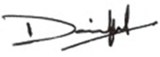
Yours sincerely,
Dave Peplow, Waltham Forest Safeguarding Children Board Independent Chair

APPENDIX H
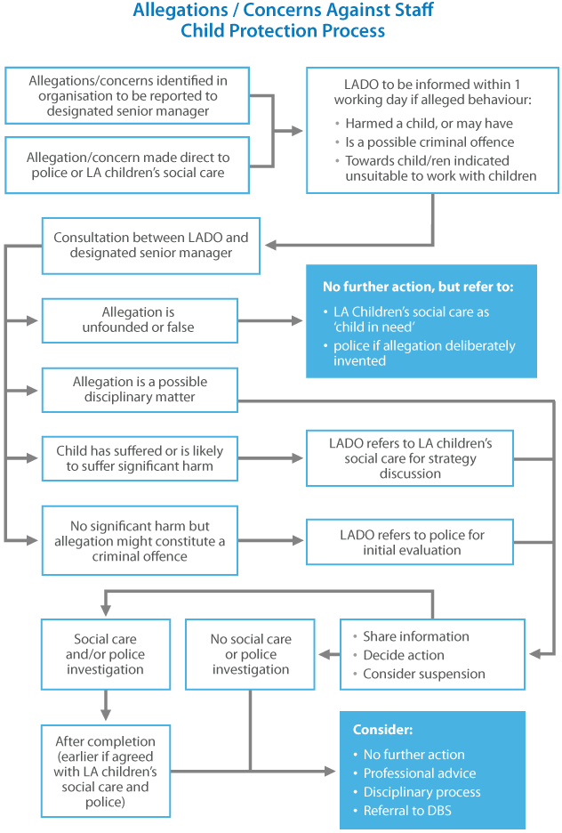
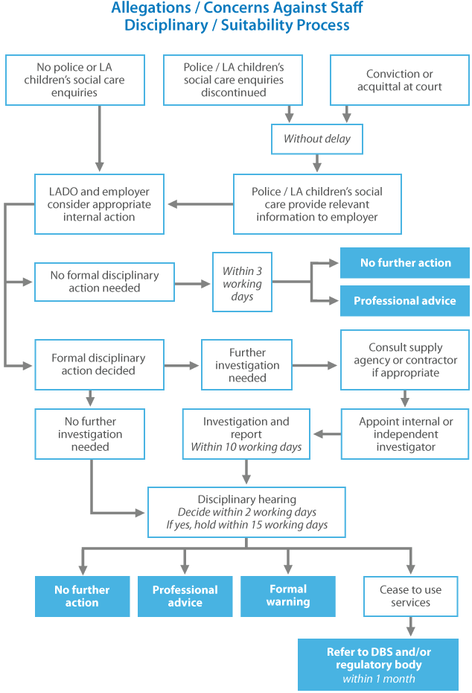

This website has been designed and is powered by tri.x and is the copyright of the London Safeguarding Children Board

