
Broughton Hall Catholic High School
INFORMATION PACK
HEAD OF FACULTY:
SOCIAL SCIENCES
(Psychology Specialist)
With TLR And R&R Allowance

Start Date: 1st January 2024
Closing Date: 10.00am 12th October 2023
Shortlisting Date: After the closing date
Interview Date: Week beginning
16th October 2023

Salary Scale: MPS/ UPS With TLR
2b £5,020 And R&R Allowance £2,000
For 3 years

Contract Term: Permanent/Full-Time
http://www.broughtonhall.com/information/vacancies.php

Broughton Hall Catholic High School
Founded in 1928 under the trusteeship of the Sisters of Mercy, Broughton Hall Catholic High School, an all-girls Catholic secondary school in Liverpool, provides the very best in modern education based on the Gospel values of mutual respect and care.

The central aim of our school is to provide excellent educational opportunities enabling each pupil to develop their God given talents, to grow in confidence and self-esteem and to fulfil their potential.

As a Catholic school Broughton Hall centres its mission on the person of Jesus Christ, and promotes the Gospel values throughout the school community and in all aspects of school life: spiritual, academic, pastoral, and personal. By proclaiming and living out the faith of the Catholic Church, we support each other in shared experiences of teaching and learning, prayer, worship and charity. Our mercy values permeate throughout our community. We are proud of our strong Catholic ethos and values.

Broughton Hall is Ofsted rated as a “Good” provider (November 2022).

Our facilities are bright, spacious, high tech and designed to meet the needs of all our pupils. We have a separate 6th Form facility, which is shared with our neighbouring boys school Cardinal Heenan Catholic High School. A full range of extra-curricular activities are provided to further the creative, sporting and academic talents of each pupil and offer Outward Bound and Duke of Edinburgh Award schemes as well as the opportunity to attend educational visits and residential trips.

We pride ourselves on our high expectations of all pupils and have an ‘Ambition for All’ policy. Whatever your role within the school, you will share these values and be able to encourage and motivate pupils with your passion, presence and personality.

Our school motto ‘Cor Unum et Anima Una’ - One Heart and One Mind, reflects the strong sense of community amongst pupils, staff, parents and Governors.

We Offer

- Pensions Scheme – Teacher Pension Scheme for teaching staff or Merseyside Pension Fund for support staff
- Regular training and development programme
- The school is committed to the continuous professional development of all staff including Aspiring Leaders, NPQML and NPQSL programmes.
- Access to occupational health
- Cycle2Work Scheme
- Tax Free Childcare Vouchers
- Supportive work environment where all staff are valued
- Continuous professional development for all staff and follow a whole school approach to staff performance and development

And that’s not all, we place the outcomes of the children in our school at the heart of everything we do, so you’ll wake every day in the knowledge that your role will have a significant positive impact on the lives of others.

Equal Opportunities

Broughton Hall Catholic High school is an equal opportunities employer.

We welcome applicants from all backgrounds and value everyone as an individual. We are committed to organisational practices, which promote diversity and inclusion for all employees and volunteers regardless of age, gender reassignment, marriage or civil partnership status, pregnancy and maternity status, disability, race (including colour, nationality, ethnic or national origin), religion or belief, sex, or sexual orientation. Connecting these differences creates a productive environment in which everyone feels valued.

Monitoring information in relation to job applicants will be to assist us in equality monitoring. The recruitment panel will not have access to job applicant’s monitoring information.

To assist us in monitoring the operation of equal opportunities policy, and for no other reason, please ensure you complete and submit the Equal Opportunities Monitoring Form with your application form.

Safeguarding & Enhanced DBS Checks
Broughton Hall Catholic High School is committed to safeguarding and promoting the welfare of young people and expect all pupils, staff, volunteers and visitors to share this commitment

All posts are subject to an enhanced DBS check and full pre-employment checks to comply with the current Keeping Children Safe in Education statutory guidance for schools.

All staff will be expected to follow Broughton Hall Catholic High School’s child protection policies, code of conducts and managing allegations against staff procedures.

All roles in school, including this post, are exempt from the Rehabilitation of Offenders Act (ROA) 1974. The Ministry of Justice’s guidance on Rehabilitation of Offenders Act 1974 and the Exceptions Order 1975 provides information about which convictions must be declared during job applications and can be accessed here.

All applicants must therefore declare all previous convictions and cautions, including those which would normally be considered ‘spent’ except those received for an offence committed in the United Kingdom if it has been filtered in accordance with the DBS filtering rules. Information about filtering offences can be found in the DBC Filtering Guide, which can be accessed here.

By engaging in this recruitment process, shortlisted candidates consent to an online search in line with the Keeping Children Safe in Education Statutory Guidance 2022.

Welcome

Thank you for your interest in the position of Head of Faculty for Social Sciences.

This is an excellent opportunity for an ambitious professional to lead a team of well qualified teachers who share a common sense of purpose and high expectations of what students can achieve. Health and Social is a very popular subject at KS4 and KS5 with many students pursuing careers in the health care profession. Psychology has developed to become one of our largest and most successful A Levels. Level 3 Applied Law was recently introduced and has proven popular with students.

This pack has been designed to help you should you choose to submit an application form, which we sincerely hope you do. We hope it answers your initial questions, but if not, please do not hesitate to contact us and we will endeavour to help you through your application process.

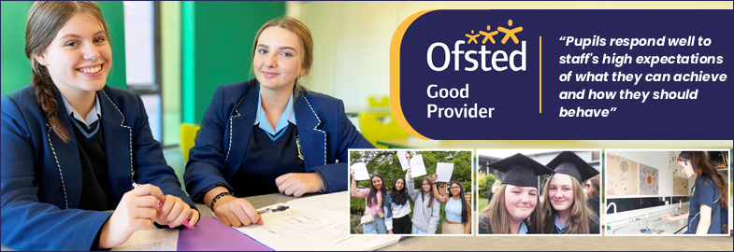

Broughton Hall Catholic High School is the largest all-girls school in Liverpool and serves many different areas making us a vibrant a diverse school. Our aim is to be a good school in all areas and we are seeking staff to apply to work with to be of that journey. Ofsted rated the school as “Good” in November 2022.

We work hard to ensure Broughton Hall Catholic High School remains a friendly and welcoming environment for all those who work, study or visit here and hope that you are the person we are looking for to bring creativity and innovation to the role.

The school actively supports the training of middle leaders through well-respected Teaching Leaders’ programme. Opportunities for promotion exist for suitable candidates. Our staff are passionate about teaching and are committed to develop exciting and stimulating lessons that not only engage students.

We look forward to hearing from you.

Gerard Preston
Head Teacher

Advert

HEAD OF FACULTY: Social Sciences (Psychology Specialist)
Required for January 2024

SALARY: MPS/UPS PLUS TLR 2b (£5,020) And R&R £2,000 for 3 years
CONTRACT: Permanent Role
HOURS: Full-Time
CLOSING DATE: Thursday 12th October 2023 at 10.00 am
INTERVIEWS TO BE HELD: Week beginning Monday 16th October

Governors are seeking to appoint a first rate, enthusiastic Head of Faculty for the Social Sciences. We are looking for a well-qualified graduate to lead our successful faculty. This is an excellent opportunity for an ambitious professional to lead a team of well qualified teachers who share a common sense of purpose and high expectations of what students can achieve.
Health and Social is a very popular subject at KS4 and KS5 with many students pursuing careers in the health care profession. A-Level Psychology has developed to become one of our largest and most successful A Levels with high numbers of students continuing their love for the subject at Higher Education. Level 3 Applied Law was recently introduced and has proven popular with students.
The school actively supports the training of middle leaders through the well-respected Teaching Leaders' programme. Opportunities for promotion exist for suitable candidates. Our staff are passionate about teaching and are committed to develop exciting and stimulating lessons that not only engage students.

The successful candidate will be a leader who is:-
- an outstanding classroom practitioner with a dedication and desire for teaching and learning
- passionate about Social Sciences and has the ability to inspire and foster a love of learning
- committed to the school’s vision and demonstrating compassion through the mission statement
- dedicated in ensuring students achieve the best outcomes

About Broughton Hall Catholic High School
Broughton Hall is a Catholic High School is an Ofsted rated Good provider (Nov 2022). We are proud of our strong Catholic ethos and values. The school has an excellent reputation and promotes an inclusive education which develops creativity, confidence and independence. The school is committed to the continuous professional development of all staff including Aspiring Leaders, NPQML and NPQSL programmes.

Applications are by way of the school’s application form together with covering letter. Please visit www.broughtonhall.com for more information about the school and the Department.

Broughton Hall Catholic High School is committed to safeguarding and promoting the welfare of children and we expect all staff and volunteers to share this commitment to keeping children safe. Any offer of employment will be subject to statutory pre-employment checks including satisfactory references and Enhanced DBS and Barred List checks. This post is exempt from the provisions of the Rehabilitation of Offenders Act 1974 (as amended in 2013 & 2020) and shortlisted candidates will be required to disclose any relevant criminal history prior to interview.

‘By engaging in this recruitment process, shortlisted candidates consent to an online search in line with the Keeping Children Safe in Education Statutory Guidance 2023’
Job Description
HEAD OF FACULTY: Social Sciences

Purpose | To lead, manage, develop, and be accountable for the department team including the curriculum at Key Stages 4 and 5 in order to ensure the highest possible standards of pupil achievement, personal development and well-being both within the curriculum and beyond.
Location | Broughton Hall Catholic High School, West Derby, Liverpool
Reporting to | A specified Senior Leadership Team member.
Responsible for | The post holder will be responsible for all department teaching and extra-curricular providers.  A Head of Faculty must provide leadership and direction for the subject and ensure that it is managed and organised to meet school and subject aims and objectives.
Working Time & Conditions | These will be as specified in the latest School Teachers Pay and Conditions Document. Attendance at school functions beyond the working day including Parents/Awards Evenings will be required.
Safeguarding children | The post holder must safeguard and promote the welfare of the children and young people at Broughton Hall Catholic High School
Salary | MPS/ UPS With TLR 2b (£5,020) and R&R £2,000 for 3 years

OVERVIEW
At the heart of the role of faculty is the provision of professional leadership to secure high quality teaching and learning, effective use of resources, improving standards of achievement for all students, and the promotion of students’ personal development and well-being. A Head of Faculty must provide leadership and direction for the subject and ensure that it is managed and organised to meet school and subject aims and objectives. A Head of Subject plays a key role in supporting, guiding and motivating teachers in all faculty departments. Heads of Subject evaluate the effectiveness of teaching and learning, the subject curriculum and progress towards targets for students and staff in order to inform future priorities for the school. The policy and practice of monitoring within the school provides the information for evaluation and action. A Head of Faculty identifies needs in their own subject areas and recognises that these needs must be considered in relation to the overall needs of the school. It is also important that a faculty leaders have an understanding of how their department contributes to school priorities and to the overall education and achievement of all students.

Throughout their work the faculty leader ensures that practices improve the quality of education provided, meet the needs and aspirations of all students and help to continue to raise standards of achievement in the school.

DIMENSIONS
The post holder will be responsible for the following, with reference to the national framework for middle leaders:

- The strategic direction and development of the department
- Teaching and learning
- Leading and managing staff
- Pupil progress and standards of achievement
- The efficient and effective deployment of staff and resources

ACCOUNTABILITIES

The strategic direction and development of the subject

- To produce an annual subject development plan, which contributes to the achievement of the School Improvement Plan, and which involves all the subject staff in its design and evaluation.
- To set expectations and goals for colleagues and pupils in relation to standards of achievement and behaviour.
- To represent the department in the wider school community and liaise with the rest of the school, governors, partner schools, the Local Authority, further and higher education, industry, outside agencies, examination boards etc.
- To keep up to date with national developments in the subject area and teaching practice and methodology.
- To oversee the development of the Extended Project Qualification.
- To develop current systems with regard to health and safety, risk assessments, collection and storage of valuables and other key procedural requirements.
- To lead the development of the school’s extra-curricular physical education programme.

Teaching and learning

- To contribute significantly to the leading of the development and implementation of effective teaching and learning strategies, including ICT-based developments and new technologies.
- To contribute significantly to leading the development and implementation of effective department assessment policies, within the framework of those for the whole school.
- To promote and support extra-curricular activities, which enrich and support the learning and experience of all pupils, and increases their participation in school life.
- To ensure homework where applicable, is set in line with school policy, and recorded departmentally.

Leading and managing staff

- To monitor, support/challenge and professionally develop staff so that they are effective in their role(s) and provide high quality teaching and learning; the above to include participating in and leading the school’s programmes of staff training and development.
- To ensure that Performance Appraisal is carried out according to school and national regulations and that staff receive regular feedback, which supports progress against their PM objectives.

Pupil progress and standards of achievement

- Within the framework of whole-school policies, to set and monitor appropriately challenging subject targets for pupils, which will make a measurable contribution to the fulfilment of those for the whole school; to manage interventions to maximise pupil progress.
- To maximise achievement by ensuring that examination entries are at an appropriate tier and non-entries are minimised; to assist with the management and conduct of examinations.
- To ensure effective communication with parents/carers, so they are kept up-to-date with curriculum developments and their children’s progress.
- Writing reports on pupils and attending meetings with parents.
- To track different groups of students’ progress and put in a clear intervention plan where gaps exist.

The efficient and effective deployment of staff and resources

- To manage efficiently the available resources of staff, space, finance, and equipment within the limits and guidelines laid down.
- To provide a stimulating environment, including maintaining the content of displays that promote interest and learning.

Other Specific Duties

- To promote and safeguard the welfare of the children and young people you are responsible for, or come into contact with.
- To undertake the above responsibilities in addition to those held by a standard scale teacher at the school.
- To undertake any other duty as specified by the School Teachers Pay and Conditions Document not mentioned in the above.
- To act in compliance with data protection principles in respecting the privacy of personal information held by the school.
- Whilst every effort has been made to explain the main duties and responsibilities of the post, each individual task may not have been identified; therefore employees will be expected to comply with any reasonable request from a manager, including ad hoc projects, to undertake work of a similar level that is not specified in the job description.

The job description is current at the date shown, but, in consultation with you, may be changed by the Head Teacher to reflect or anticipate changes in the job commensurate with the grade and job title.

Person Specification

1. QUALIFICATIONS AND TRAINING
- University honours graduate
- Postgraduate teaching qualification/QTS or commitment to achieve soon after recruitment
- Proven track record of success in career to date
- Evidence of continuing professional development
- MIDAS Certificated (desirable)

2. TEACHING and PASTORAL EXPERIENCE
- Successful teaching experience
- Teaching experience in KS5 and preferably KS4
- Evidence of consistently good and outstanding teaching and learning
- Evidence of cascading outstanding teaching and learning practices in school or a range of
schools
- Evidence of excellent classroom management skills
- Outstanding knowledge of Assessment Practice and its effective use
- Strong subject knowledge
- Knowledge of current curriculum and extra-curricular developments in your subject area
- A good understanding of progress data and its use
- The ability to differentiate to provide appropriate challenges for all learners
- Evidence of putting in place successful intervention strategies to raise achievement
- Evidence of pastoral experience, including taking responsibility for a form group

3. LEADERSHIP AND MANAGEMENT
- The ability to inspire, enthuse, develop and support colleagues
- The ability to evaluate and improve standards of teaching and learning within a department
- Experience of conducting Performance Management and desire to develop other colleagues

4. PERSONAL QUALITIES
- A willingness to learn and develop new skills
- A willingness and flexibility to work outside normal school hours
- The ambition to continue to progress in your career
- A desire to make a difference to the lives of young people
- An excellent attendance record
- Resilience and a sense of humour

5. EQUAL OPPORTUNITIES AND EDUCATIONAL COMMITMENT
- A proven commitment to inclusion
- A proven commitment to curriculum access and opportunity
- A proven commitment to comprehensive education
- A proven commitment to professional development
- Support for the school’s specialist status
- Support the school unreservedly in its commitment to safeguarding and promoting the
welfare of children, young people and vulnerable adults.

Faculty of Social Sciences
Overview

The Psychology and Health and Social Department at BHCHS is a successful department. It currently consists of 3 graduate specialist teachers, including a HoD who teach the full range of the Psychology and Health curriculum between them. Both of these subjects are two of the most popular in the sixth form.

Many students choose to continue their post 18 studies within these subject areas and the department supports the students well with adequate information, advice and guidance and signposting to relevant opportunities.

Based in a dedicated sixth form building, the teaching of Years 12 and 13 takes place in a specialist teaching room. All classrooms boast interactive whiteboards that are supported by computers and internet access.

In Psychology we follow the AQA A-Level course. Level 3 Applied Law was recently introduced and has proven popular with students. Btec Health and Social is offered at Level 2 and 3. Students have the opportunity to attend a range of visits and conferences as part of the course offer.
We benefit from a collaborative relationship with Cardinal Heenan to enable sharing of good practice, planning and moderation. The department promotes high quality teaching and learning with high levels of student engagement and challenge at its core.

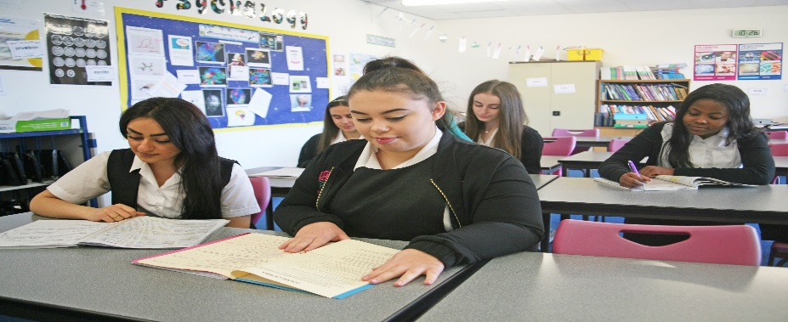
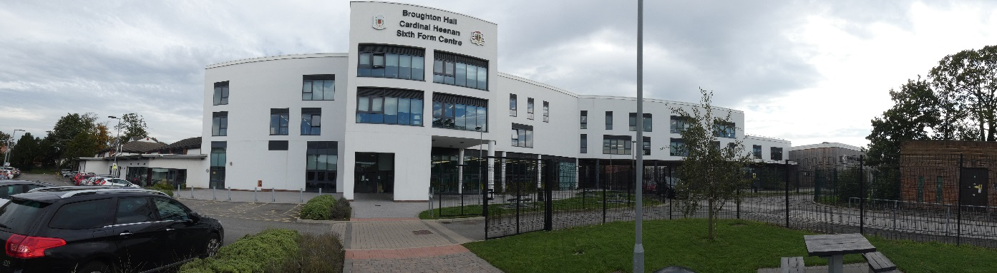

This post is subject to an enhanced DBS disclosure and the post holder must be committed to safeguarding the welfare of children. No job description can be fully comprehensive, and from time to time the successful candidate may have to undertake other professional duties as directed by the Head Teacher. In addition, candidates should understand their role may well broaden and that all roles will be reviewed regularly to ensure the team is working as efficiently as possible.

