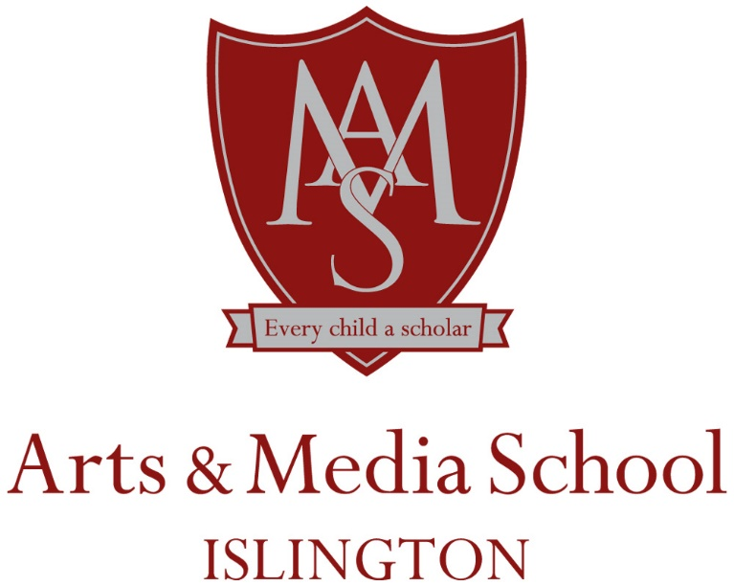

Head of Geography
September 2021
Full time, permanent contract

Salary Grade: M1 – M6 + TLR 2B
Actual Salary: £32,157 - £42, 624pa + £4783 dependent upon experience

Arts & Media School Islington is a state comprehensive school situated in North London. A vacancy has arisen for a Head of Geography within our community following the promotion of the current post holder.

We are a good school and our curriculum has a strong academic core that is enhanced by creative teaching. Our diverse community of learners makes our school an exciting place to be. We serve a local area that features a wide range of ethnic and social backgrounds and we are committed to ensuring that our students enjoy a creative and rich educational experience that prepares them for further education. We are a caring school that builds the culture within on our cornerstones of Confidence, Aspiration, Reflection and Respect.

The opportunity is now available for another colleague to join us on our journey to ensure that every child is a scholar.

Tours of the school: arranged to suit by calling the admin office
Closing date for applications: Thursday 20th May 2021 – 12.00pm
Interviews: Tuesday 25th May 2021.

