CANDIDATE RECRUITMENT PACK

HEAD OF HOUSE (ASSISTANT HEADTEACHER)

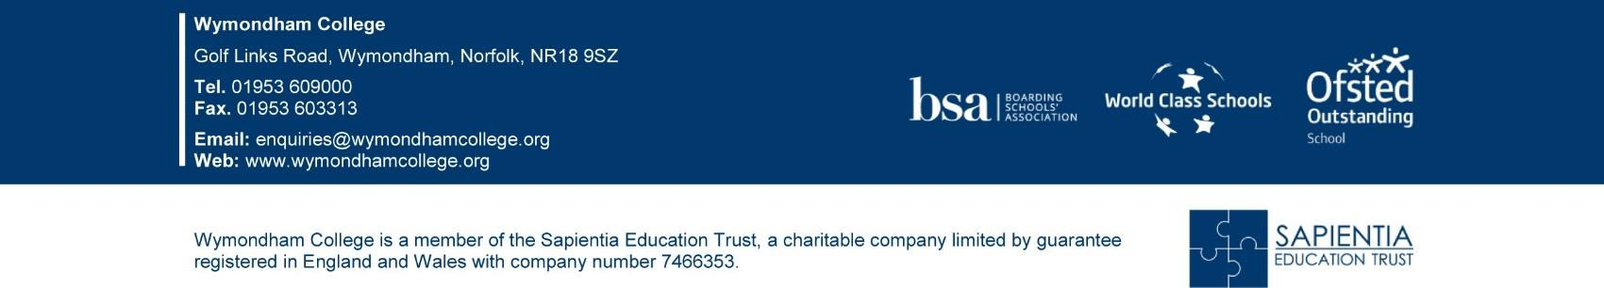

CONTENTS

Letter from Headteacher and CEO 3

Background and Context 5

Job Description 8

Person Specification 10

Terms and Conditions 11

How to apply 12

Dear Applicant

I am delighted to outline what is a really exciting opportunity and hope that this briefing pack will both motivate and inspire you to apply for this key boarding leadership role at Wymondham College.

Wymondham College is the largest state boarding school in the UK and one of the highest achieving non-selective state secondary school in East Anglia. Wymondham College is rated “outstanding” by Ofsted for both education and boarding, part of the Sapientia Education Trust (SET) established by the College.

Wymondham College achieved World Class School status in 2016 and is the current ‘Secondary School of the Year’ in the Pearson National Teaching Awards.

Wymondham College offers:
- A strong commitment to developing the whole child
- Achievement that is viewed in its broadest sense
- A belief that all can and will achieve
- Learning outside the classroom is highly valued and actively promoted (Wymondham Life)
- Character education is integral to our work - developing resilience, self-esteem and a can-do approach – we call this our Floreat Programme
- CPD and Staff development is central to our improvement strategy
- A diverse student community and a broad international outlook (e.g. partner schools in China, Argentina, France, Spain and Czech Republic)
- We never settle for less than outstanding as our latest Ofsted report indicates.

Sapientia Education Trust provides:
- Opportunities for CPD and Career Development in a rapidly growing, successful Multi-Academy Trust
- Mentoring programmes to support senior leaders
- Links with a range of partner schools, both in Secondary and Primary
This is a tremendous opportunity to join us as we move into an exciting phase of College development. You will have the opportunity to lead and support the teams to shape the future of one of the great state schools. We view the position as a fantastic professional opportunity that will provide an ideal platform for the successful candidate to potentially move on to Headship or leadership in a MAT in the future.

The successful candidate will be ambitious, student focused and resilient, they will believe in the power and moral purpose of education and insist on the highest standards for all of our students. Ultimately, they will want and have the capacity to make a difference. Informal visits to the College are welcomed; please contact Dan Browning, Headteacher in the first instance (via his Secretary, Mary Lawson, secretary@wymondhamcollege.org). If this excites you, please apply!

The closing deadline for applications is: Noon, Friday 18 February 2022, with interviews held on Thursday 3 and Friday 4 March 2022.

Best wishes,
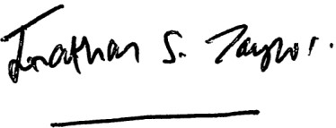
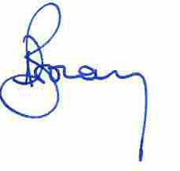
Jonathan Taylor Dan Browning
CEO Sapientia Education Trust Headteacher

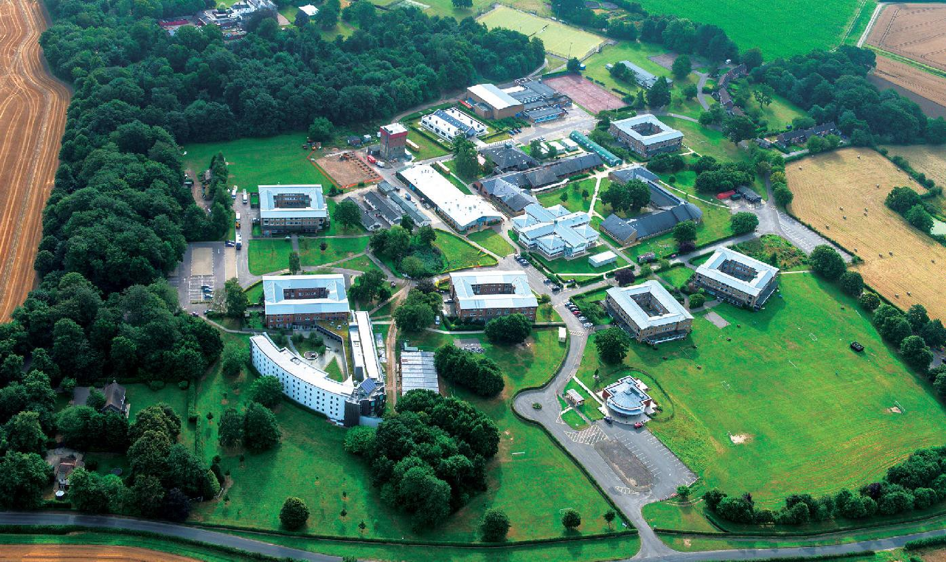
BACKGROUND INFORMATION

The College
Wymondham College is the largest state boarding school in the UK, with around 600-650 boarding students and 800 day students. We are a mainstream 11 – 18 non-selective state school, serving a very broad and diverse student community. We have a large Sixth form, with just under 500 students. The College is proud to be one of the great, distinctive state schools. Over the past few years’ the College has secured numerous accolades – these include: ‘Outstanding’ Ofsted inspections in education and boarding, World Class Schools Award, International Schools Award, Top 50 Schools Sunday Times parent power Award, Good School Guide endorsement and even selection to the Tatler Guide to the best state schools. We are a leading member of the Boarding School Association (BSA) and one of the few state schools to be admitted to the HMC group of highest performing Independent schools. In 2021 we were named ‘Secondary School of the Year’ in the Pearson National Teaching Awards.

GCSE and A Level performance is extremely high as are our value-added scores making us the highest performing Sixth Form in East Anglia.

As a boarding school extra-curricular life and character development is core to our work. We run an extensive range of extra-curricular activities and our students excel in a wide range of areas – Arts, Sport and International opportunities are all exceptionally strong. We also have our own Combined Cadet Force (CCF) with Army and RAF sections.

Student Admissions
The College has always been co-educational and has been organised in co-educational, combined day and boarding houses since the 1970s. The College is non-selective other than for a small number of places allocated for students with sporting or musical aptitude in Year 7 and the operation of a Minimum Qualifying Standard for entry into the Sixth Form. We are heavily oversubscribed for day places, with typically over 250 applications for our Year 7 day places.

School Funding
As a state funded boarding school all education at Wymondham College is free but parents (or sometimes charitable trusts or local authorities) pay a fee to cover the costs of the boarding provision at the College. The fee is much less than that which is charged by independent boarding schools and this, along with the fact that half of the College comprises of local day students whose parents pay nothing for them to attend, gives Wymondham College a very inclusive and down to earth ethos.

Boarding
Boarding remains central to the Wymondham College ethos and experience. Some 650 of the College’s students board on a full or weekly basis. Most boarders come from East Anglia, but there are a significant number of students from further afield in the UK, from continental Europe, the Gulf and Hong Kong. Service Children are well represented among the student body. The Ofsted Boarding Inspection in 2019 judged boarding at the College to be “Outstanding”. The College is delighted to have secured Outstanding in all areas of our latest Ofsted boarding inspections in 2008, 2012, 2017 and 2019.

Sixth Form
The large Sixth Form of nearly 500 students is an important feature of the College. The Lincoln Sixth Form Centre was extended in 2008 and provides over 200 boarding spaces (of which 115 are in single en-suite rooms) and a focus for the life of the whole Sixth Form. Sixth Formers benefit from outstanding support and an extensive programme of enrichment opportunities, including work experience and visiting speakers tailored to their needs. The annual Lincoln Lecture is an opportunity for students to attend a lecture given by a speaker of national or international renown and there is a parallel lecture on scientific subjects, the Sam Peel Lecture. Student leadership is a major feature of Sixth Form life. Members of the Headteacher’s Council are elected by their peers and undertake a wide range of representative, ambassadorial and organisational responsibilities on behalf of the student body as a whole. Student Subject Leaders are appointed by each academic department to act as advocates for the subject and to run activities and provide support for younger students. The Lincoln Junior Common Room runs a successful programme of events for the Sixth Form.

Curriculum
More information regarding our curriculum can be found here:

Main School Curriculum Overview - Wymondham College Sixth Form Curriculum Overview - Wymondham College

Governance
Wymondham College has a strong and active Local Governing Body (LGB), sitting underneath the SET Trust board. The LGB play a vital role in the wider leadership and accountability of the College.

There is an active Old Wymondhamians Association and a Parent Staff Association (PSA) which raises significant amounts of money to support a wide range of College projects.

Brief History
Wymondham College was established in the aftermath of World War Two on the site of one of the largest American Army Hospitals in the European theatre. Its foundation was driven by the vision of Dr (later Sir) Lincoln Ralphs, then Director of Education for Norfolk. The Ralphs family remain closely connected to the College. Lincoln Ralphs’s vision was to create a boarding school which would be a centre of excellence which children from all backgrounds could attend and which would bear comparison with boarding schools in the independent sector.

In 2020 the Wymondham College Prep School opened on the College campus and in September 2021 moved into its new multi-million home here with boarding for Year 5/6 in Underwood Hall, a new purpose-built boarding house.

JOB DESCRIPTION:

HEAD OF HOUSE (ASSISTANT HEADTEACHER)

Job Purpose
As Head of one of our five Main School boarding houses, the successful applicant will be responsible for the academic supervision and pastoral care of over 180 students, approximately 50% of whom will be boarders. They will be required to lead a team of up to 30 teaching and support staff.

The post is fully residential and the successful applicant will be provided with a three bedroom flat within the Boarding House.

Line Manager
Deputy Headteacher (Boarding and Behaviour)

General Responsibilities
The Head of House is responsible to the Headteacher for the operation of the boarding house in accordance with the National Minimum Standards for Boarding Schools and College Policies.

They are responsible for setting a positive tone of achievement and involvement in the house, for planning the effective use of house resources (including staff and delegated budgets), for the welfare, pastoral care, attainment and progress of all students allocated to the house, for the good order and discipline of all members of the House and for leading the house team of teaching, boarding and other support staff.

Wymondham College is committed to safeguarding and promoting the welfare of children and young people and expects all staff and volunteers to share this commitment.

A non-exhaustive list of specific responsibilities for the role is below and you will be required to undertake other duties and responsibilities as may reasonably be required.

Specific Responsibilities
- Be responsible through the Deputy Headteacher (Boarding and Behaviour) to the Headteacher for all matters pertaining to the good order of the House and the behaviour, welfare and pastoral care, attainment and progress of the students who are allocated to the House and any others as required by the Headteacher,
- Other than in exceptional circumstances and with the agreement of the Headteacher, reside in the boarding House at least five nights a week whilst the College is in session;

- Refer student matters relating to Child Safeguarding to the Designated Safeguarding
Lead as required in the College’s safeguarding policy,
- Take responsibility for the organisation and operation of the House staff team to ensure continuous and adequate cover and supervision of the students in the House. This includes arranging for the cover of absent colleagues from their house duties,
- Develop an appropriate range of House activities, taking account of the needs and interests of all students but paying particular attention to the needs of boarders,
- Manage the House tutorial team and the effectiveness of the Tutor system within the House, including the delivery of the minimum entitlement for students,
- Act as line manager to the Deputy Head of House, House Matrons and other House staff and ensure that their duties are properly discharged,
- Lead the House team by example, setting realistic but challenging targets for the House team and monitor progress against those targets, taking effective action to address underperformance and rewarding outstanding performance as appropriate,
- Monitor the performance of all students in the House against agreed targets, intervening as required to support their academic performance, behaviour, attendance, participation in extra-curricular life or general welfare,
- Liaise and communicate with parents and carers of students in the House as necessary,
- Take a significant role in the reporting of holistic progress to parents/carers,
- Participate in the duty rota for the supervision of meals and other duties within the College as directed,
- Operate the House in accordance with College policies and procedures and in a manner which conforms to the National Minimum Standards for Boarding Schools;
- Ensure that students in the House make full use of Wymondham Life opportunities and that they adhere to the high standards of discipline and appearance,
- Convene regular meetings of the House staff, ensuring that records are kept appropriately,
- Manage the delegated House budget, the House Bank, and any other funds for which they are responsible, efficiently and within College financial procedures;
- Participate in the promotion of the College, including assistance as required with the interviewing of candidates for boarding places, the organisation of House open days and open evenings and the attendance at marketing events,
- Attend Heads of House/Raising Achievement and Progress and other meetings as required,
- Lead, or to arrange for others to lead, House Assemblies and attendance at Sunday services in the Chapel,
- Participate in appropriate professional development activities and the Performance Management scheme in operation at the College. This may include 360-degree appraisal involving colleagues, students and parents/carers at least once every two years.

The Job Description will be reviewed annually as part of Wymondham College’s Performance Management

PERSON SPECIFICATION

Qualifications
  - Qualified to degree level
  - Qualified Teacher Status

Personal Competencies
  - The ability to communicate clearly and tactfully using appropriate methods and an awareness of the impact of your own communication on others,
  - Able to maintain positive relationships with all and able to work as an effective and flexible part of a team; willing to change methods of work and routines to benefit the team,
  - Willingness to accept responsibility for your own actions; the ability to prioritise effectively, meet deadlines and accept challenges.

Professional Competencies
  - Have a successful track record of leading boarding education in either the state or independent sector,
  - Have previous experience of impacting on student outcomes with a proven track record of total commitment to helping every student achieve their very best and make progress,
  - Have excellent understanding of what constitutes excellence in learning,
  - Have a keen understanding of data and be able to analyse patterns in performance over time,
  - Be a positive role model for students and staff on a day-to-day basis,
  - Collaborate effectively with staff, parents/carers and students,
  - Liaise and work with partner schools, HEIs, Examination Boards and other relevant external agencies in the pursuit of continued improvement,
  - Excite and engage visitors about the College at Open Evenings and all other events,
  - Have very high expectations of the learning of all students at all times.

TERMS AND CONDITIONS
This post is offered on a full time, permanent basis to start in September 2022.

Remuneration
This post is paid on the Leadership Scale Point 12: £55,339 per annum.

All payments are pensionable under the Teachers’ Pension Scheme.

Wymondham College staff enjoy a number of non-contractual benefits, including free refreshments and all meals during term-time for boarding staff when on duty.

The post is fully residential and the successful applicant will be provided with a three bedroom flat within the Boarding House.

Pre-employment Checks
All applicants must be prepared to undergo a number of checks to confirm their suitability to work with children and young people. The Trust reserves the right to withdraw offers of employment where checks or references are deemed to be unsatisfactory.

HOW TO APPLY
To apply, please submit an application form together with a supporting statement outlining your suitability for the role. Your supporting statement should outline how you satisfy the qualifications and experience elements of the person specification. For candidates invited to interview, these responses will be explored further together with the other elements of the person specification.

Apply online at www.wymondhamcollege.org/vacancies
or contact the HR Dept, Wymondham College, Norfolk NR18 9SZ. Tel: 01953 609012 Email: hr@se-trust.org

Closing date for applications: Noon, Friday 18 February 2022
Interviews will be held Thursday 3 and Friday 4 March 2022
Wymondham College is an equal opportunities employer. We are committed to safeguarding and promoting the welfare of young people and expect all staff to share this commitment. Any offer of employment is subject to a satisfactory ‘Enhanced with a Barred List Check’ through the Disclosure and BarringService.

We strongly advise you to take up the opportunity to visit the College and informally meet with the Headteacher prior to submitting an application – please contact Mary Lawson, secretary@wymondhamcollege.org to arrange.

