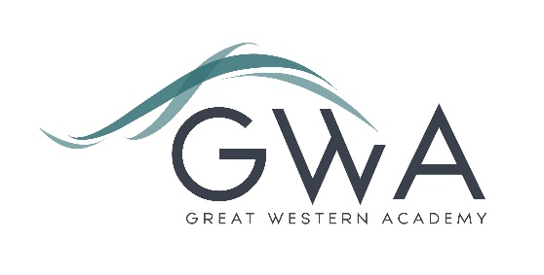

Information for Applicants

Head of House (MPS/UPS + TLR 1a £9,272)
Full-time
Great Western Academy opened in 2018 with students in year 7, with the Sixth Form opening in 2019. The Academy now has over 950 students across all year groups with the first year 11 cohort sitting GCSE exams last summer and achieving strong results, including a positive Progress 8 overall and, individually, for two thirds of the cohort. We have already had three years of excellent A-level outcomes, with students reaching impressive university, apprenticeship and work-based destinations, including three to Oxford and Cambridge and apprenticeships with prestigious organisations.

Our three Heads of House are key middle leaders in the school, responsible – with support from senior leaders and non-teaching pastoral leads - for all aspects of our ‘Care’ provision. Full details can be found in the advert and job description. If you have questions prior to application or would like to visit or speak with Principal please contact recruitment@gwacademy.co.uk.

Our House system is special to the school, with students and staff feeling a strong allegiance to their House and enjoying the friendly competition it provides, driven by ACE points for Achievement, Care and Excellence, and by a series of events.

Great Western Academy aims to radically improve the life chances of every student who attends. Our brand new building and state-of-the-art facilities help us to achieve this, but it is the fantastic team of staff who turn our vision into reality. If you have the proven ability to inspire students in the classroom and beyond then this provides you with an exciting opportunity to further shape your practice and develop your career.
Application process

Please complete the application form, and the equalities form, supplied and enclose a supporting letter, either in the space provided on the application form or as a separate document. The application form should be completed in full in black ink or type. A CV is not required and should not be submitted as part of the application.

Your supporting letter should be no more than 2 sides of A4 (with a font size no smaller than 11) and should enhance your application by providing further information, matched to the person specification, about your suitability for the post. This should include evidence of the impact on student outcomes you have made in your career to date.

Electronic applications should be returned via email to recruitment@gwacademy.co.uk

Closing Date: 9am on Tuesday 7th May 2024
Interviews: Interviews will take place later that week or in the week beginning 13th May

Please note we may interview before the closing date (and close the advert early) depending on the suitability, and number of, applicants.

References: References will be taken up prior to interview.
The interview process will include observation of your teaching, and a variety of other tasks and activities.
Great Western Academy is committed to safeguarding and promoting the welfare of children, young people and vulnerable adults and we expect all staff to share this commitment and undergo appropriate checks. All posts within the Trust are therefore subject to an Enhanced DBS and barred list check.

