HEAD OF ICT & BUSINESS
MPS/UPS + TLR 2c (£7,368) + R&R available for outstanding candidate
Candidate Pack

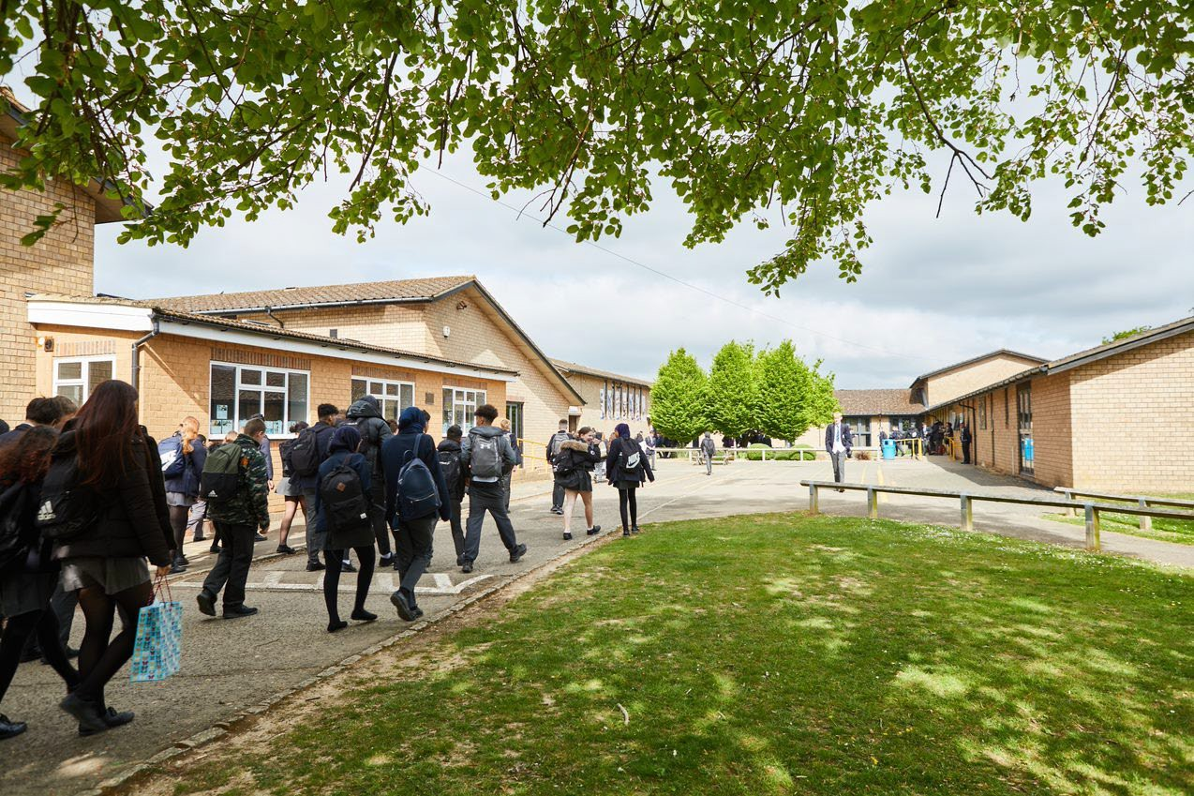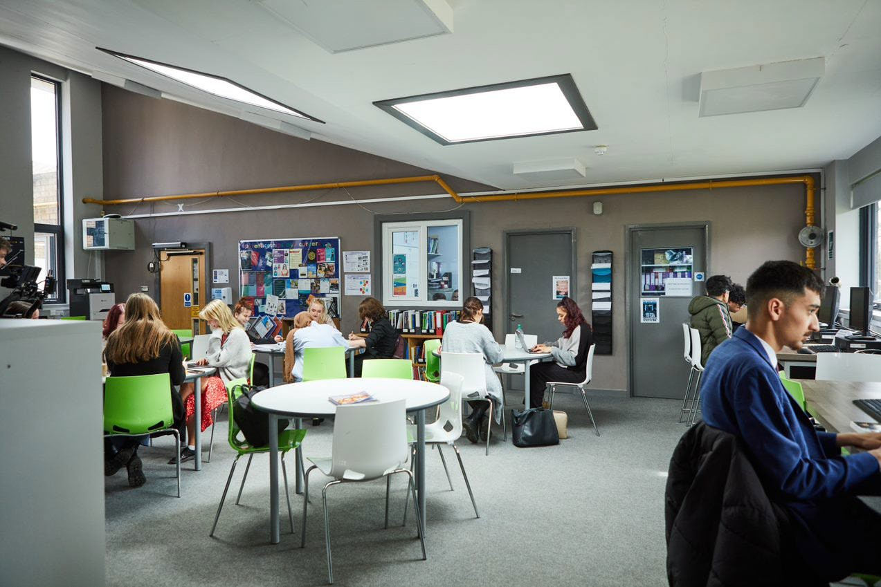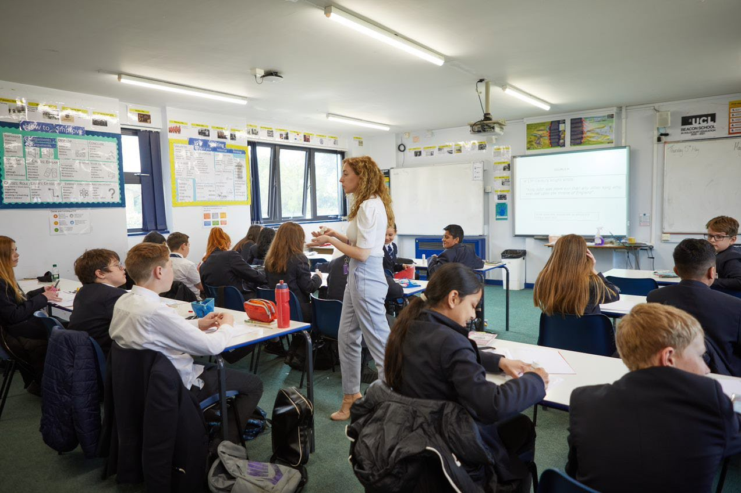
Welcome Letter from the Headteacher

Dear Prospective Candidate

Thank you for your interest in the position of Head of ICT & Business at Sir William Ramsay School.

I joined Sir William Ramsay School as the new Headteacher in May and am committed to getting the school back to ‘Good’ as quickly as possible. Clarity, consistency and rigour are central to our plans to ensure that all students enjoy learning and make good progress. Our plans include significant developments in high quality teaching and learning, the introduction of ambitious targets, a focus on developing excellent teaching, meaningful homework and improvements in behaviour for learning. We are also rolling out a digital learning 'One to One Device' strategy across the school to ensure that students can receive innovative teaching and access state of the art resources at both home and school.

We are looking to appoint a dynamic Head of ICT & Business to contribute to the development of this successful area.

The ideal candidate will have a belief in the ability of all students to achieve and a passion for raising student achievement. You will have a desire to strive for continuous school improvement and a commitment to team work as well as a sense of fun.

If you would like to find out more about the role or to arrange a conversation with the Deputy Head, please contact KGray@swr.school

I will hope to meet you in the near future.

Yours faithfully

Paul Ramsey
Headteacher

Vision and Values at Sir William Ramsay School

Empowering Everyone to Achieve

Vision
A community where every voice counts, where talent and creativity are brought to life, where students grow in confidence, build resilience and are prepared for the rest of their lives.

Values
- We are respectful – we always treat people, property and the environment with kindness and consideration
- We are ambitious – we ask for help when we need it and strive to be the best we can be
- We are reliable – we do what is asked of us and deliver on our commitments
- We are resilient – we prepare for the future and adapt and grow from challenges

Mission
We aim to achieve our vision by:
- Raising students above the ordinary by developing and delivering lifelong learning which transforms lives
- Ensuring every person feels valued, safe and happy
- Enabling students to feel proud of themselves, and to take pride in the success of others
- Promoting a culture of mutual respect where everyone is treated as a valued member of the school community
- Encouraging positive communication so that words and actions are thoughtful, supportive and motivational
- Placing parents and carers at the heart of the life of the school
- Having highly dedicated and well-qualified staff who are committed to continuous professional development
- Adopting an ethos of continuous improvement within all aspects of school life

Equality
Sir William Ramsay is an inclusive and diverse community. We work to eliminate all forms of discrimination on the grounds of ethnic origin, religion, sexual orientation, gender, disability or ability.
This is achieved via the following principles:
- Ensure that students have the opportunity to reach their potential in all areas of school life
- Ensure that parents and students can make choices free from prejudice and stereotyping
- Oppose any form of racism, sexism, disability discrimination, homophobia or any other form of discrimination
- Value every student’s language and cultural background
Job Description

Job Title: | Head of ICT & Business
Aim and Main Job Purpose: | And accountable for the learning, achievement, behaviour, well-being and personal development of all students across the Faculty ensuring equality of opportunity for all  And accountable for leading, managing and developing the curriculum areas within the Faculty.  And accountable for the development of high-quality teaching within the department.  And being accountable for achieving the highest possible standards in work and conduct.

Purpose of The Job
- To lead the development of curriculum in line with the whole school Curriculum Intent.
- To lead on the development and implementation of resources, schemes of work, policies, assessment, teaching, learning and behaviour strategies across the Faculty.
- To lead on the day-to-day management, budget and operation of the Faculty, including effective deployment of staff and physical resources.
- To lead on the monitoring of progress, learning, interventions, behaviour and teaching in the Faculty and use this information to improve the quality of provision.
- To ensure that there is consistency across the Faculty in the implementation of policies and procedures.
- To promote the school’s vision and its values of “Respect, Ambition, Reliability, Resilience”.
- To act as a positive role model and to lead by example.
- To create and deliver engaging lessons to diverse groups of students at all levels.
- To promote and inspire enthusiasm for learning and for subjects.
- To promote high standards of student behaviour.

Main Responsibilities as a Head of Faculty
- To ensure that all members of the Faculty are familiar with and implement its aims and objectives.
- To write and monitor an annual Faculty Improvement Plan following school guidance.
- To write and implement a Faculty Handbook.
- To lead curriculum development for the whole Faculty
- To actively monitor and respond to curriculum development and initiatives at a school, local and national level.
- To be responsible for the development of literacy, numeracy, British Values, well-being and SMSC within the Faculty.
- To keep up to date with national developments in the subject area and teaching practice and methodology.
- To establish common standards of practice within the Faculty and develop the effectiveness of teaching and learning across the Faculty.
- To monitor student progress, learning and teaching in the department and use this information to improve the quality of provision and student outcomes.
- To ensure timely and effective interventions are in place to address student progress issues.
- To ensure the school and Faculty behaviour policy is implemented consistently in the Faculty so that effective learning can take place.
- To ensure the maintenance of accurate and up-to-date information in the school’s management information system.
- To ensure staff within the Faculty keep up to date records of marks/assessments.
- To analyse and evaluate performance data provided.
- To identify and take appropriate action on issues arising from data systems and reports and to set deadlines where necessary and review progress on the action taken.
- To produce reports on examination performance, including the use of value-added data.
- To provide the Governing Body with relevant information relating to the Department performance and development.
To ensure effective communication/consultation as appropriate with the parents of students.
- To line manage, challenge and support the Deputy Head of Faculty and any teachers or Support Staff as required in the school’s annual organisation tree.
- To work with the SLT to ensure that staff development needs are identified and that the appropriate programmes are designed to meet such needs to ensure high quality teaching.
- To participate in the interview process for staff posts when required and to ensure effective induction of new staff in line with school procedures.
- To be responsible for the efficient and effective deployment of staff, working with the SLT Link and Timetabler.
- To manage the available resources of space, staff, money and equipment efficiently within the limits, guidelines and procedures laid down; including managing effectively the Faculty budget, acting as a cost centre holder ensuring best value, requisitioning, organising and maintaining equipment and stock, and keeping appropriate records.
- To make appropriate arrangements for classes when staff are absent, ensuring appropriate cover within the Faculty liaising with the Lead Cover Supervisor/relevant staff to secure appropriate cover within the department
- Working with the Professional Tutor to assist/support the development of staff within initiatives such as NQT, OTT and PGCE.
- To lead the development of effective subject links with partner schools and the community, attendance where necessary at liaison events in partner schools and the effective promotion of subjects at Open Days/Evenings and other events such as Awards Evenings.

Main Responsibilities as a Classroom Teacher
- To prepare and deliver high quality, engaging and challenging lessons to a range of classes of different abilities and ages, differentiating work as required, considering prior knowledge and incorporating literacy and numeracy.
- To incorporate the strategies in place for students, for example from Student Passports, into planning so individual needs are met.
- To monitor student progress and put in place appropriate intervention strategies as required.
- To mark work, give appropriate feedback and maintain records of students’ progress and development.
- To be accountable for the students taught attainment, progress and outcomes.
- To maintain accurate and up-to-date electronic management information as required by the school such as safeguarding, progress data, test scores, student behaviours and achievements, notes of meetings with parents, interventions in place etc.
- To maintain up to date subject knowledge.
- To devise and write new curriculum materials for the team as required by the Head of Faculty.
- To select and use a range of different learning resources, ICT and equipment.
- To liaise with Learning Support Assistants (LSAs) or other professionals in the classroom to ensure that they know the teacher’s expectations for students they are supporting.
- To prepare students for qualifications and external examinations.
- To manage student behaviour in the classroom and on the school premises, and appropriate, consistent and effective measures in cases of misbehaviour.
- To undertake pastoral duties, such as being a Form Tutor, and supporting students on an individual basis through academic and personal difficulties.
- To communicate in a professional manner with parents/carers about their child’s progress.
- To support other colleagues.
- To promote positive self-esteem amongst students.
- To encourage positive attitudes and good behaviour amongst students.
- To develop social and emotional skills amongst students.

Other Responsibilities
- To be aware of and comply with the codes of conduct, regulations, policies, procedures.
- To work as part of a team.
- To be generally responsible for safeguarding and promoting the welfare of students.
- To encourage positive attitudes and behaviours and set high expectations for all colleagues and students.
- To be responsible for own and team health and safety including well-being.
- To meet the Teacher Standards at a level relevant to the post-holder’s career stage.
- To actively participate in the School’s appraisal system.
- To do Continued Professional Learning as agreed with the Line Manager.

This job description is current at the date indicated below but, in consultation with the postholder, it may be changed by the Headteacher to reflect or anticipate changes in the post commensurate with the grade or job title.
The Business & ICT Department

Team members share a commitment to raising standards of student achievement. We are keen to promote a department which accommodates a broad range of interests and abilities, whilst ensuring that every student is encouraged to reach their maximum potential. If you are enthusiastic, flexible, enjoy challenges and are committed to help us offer excellence in Business then you are the person to join our progressive and forward-thinking team.

The Business & ICT Curriculum
At KS3, students study the fundaments of ICT and Computer Science. They will explore a variety of topics to introduce them to programming and Computer Science as well as strengthen their IT skills. These topics include; hardware/software, computational thinking, programming, spreadsheets and word processing.

At KS4 we offer both the Cambridge National in Marketing and Enterprise, and Information Technology. At GCSE, students will develop independence through controlled assessments, putting into practice the skills they have learnt in lessons. There is also an opportunity to expand and develop on a wide variety of techniques and skills, in order to respond to an exam question.

Students in the 6th form have the opportunity to study BTEC in Business and Information Technology. We cover units that aim to enthuse the students’ passion for the subject and prepare them for their next step in Higher Education or Industry.

Looking to the future we aim to expand our offering and introduce GCSE and A-level Computer Science.

Business and IT Facilities
The Business and IT department are based in a large suite of 5 dedicated computer rooms. In addition to this, students in year 10 and 7 have their own device to allow them to give them access to software and resources in all their subjects. There are computers available for both subjects with a range of creative suites for digital work.

Extra-Curricular Activities
The department currently offers a programming club for both KS3 and KS4, which we look to build upon. The classrooms are open afterschool on most nights for students to drop in and catch up on work as and when they choose.

How to Apply

If you wish to discover more about this exciting opportunity, need any further information or you wish to have an informal discussion, please contact Kerry Gray: KGray@swr.school or 01494 815211.

Please email your completed application form to: jointheteam@swr.school

Closing Date: Noon – Monday 27th March 2023
Interviews: Thursday 30th March 2023

Sir William Ramsay School is committed to safeguarding and promoting the welfare of children and young people and expects all staff and volunteers to share this commitment. We will ensure that all our recruitment and selection practices reflect this commitment.

All successful candidates will be subject to DBS checks along with other relevant pre-employment checks.

