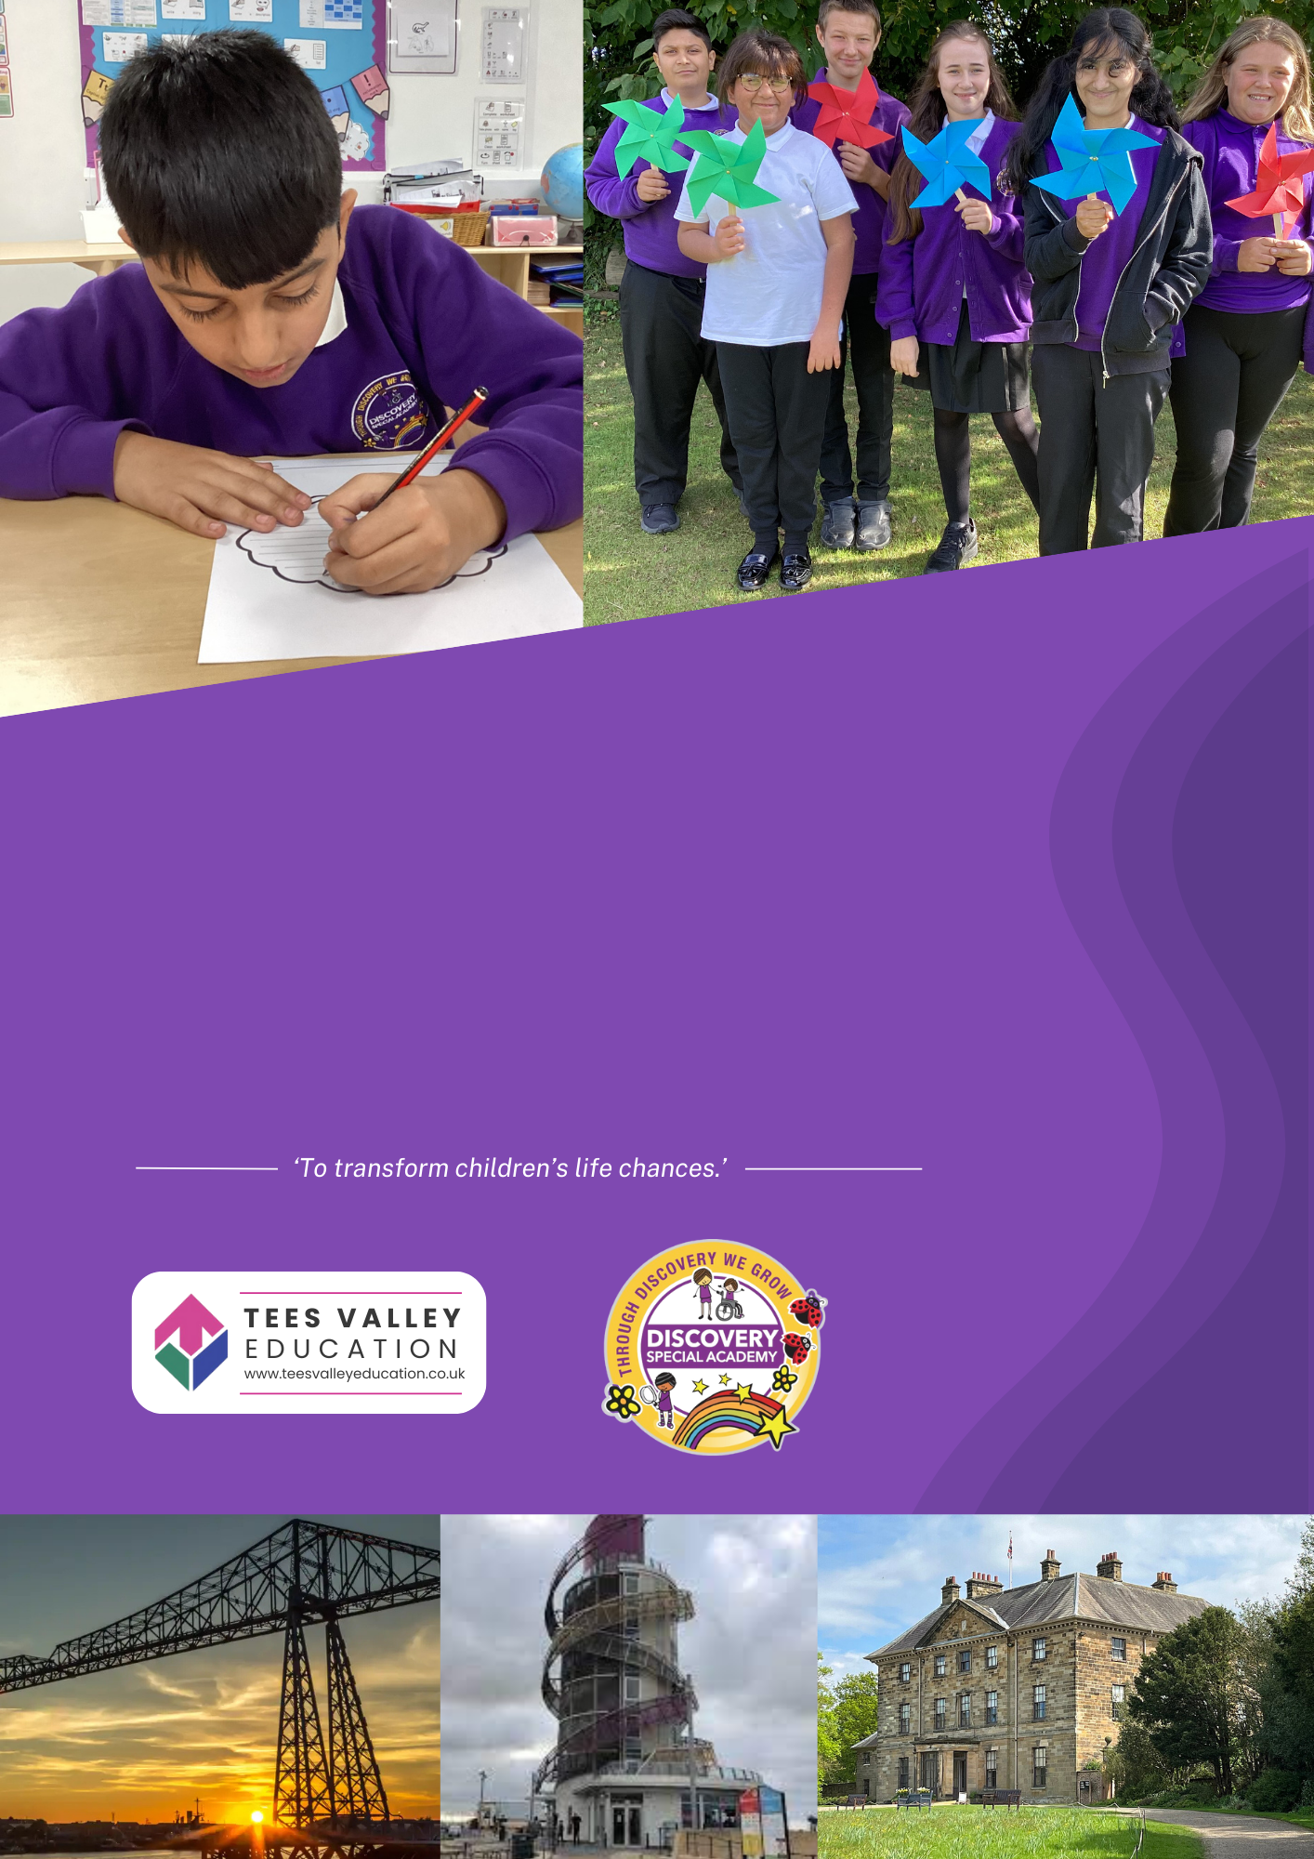

Head of Inclusive and Pastoral Education
Discovery Special Academy

Job Ref: DSA384

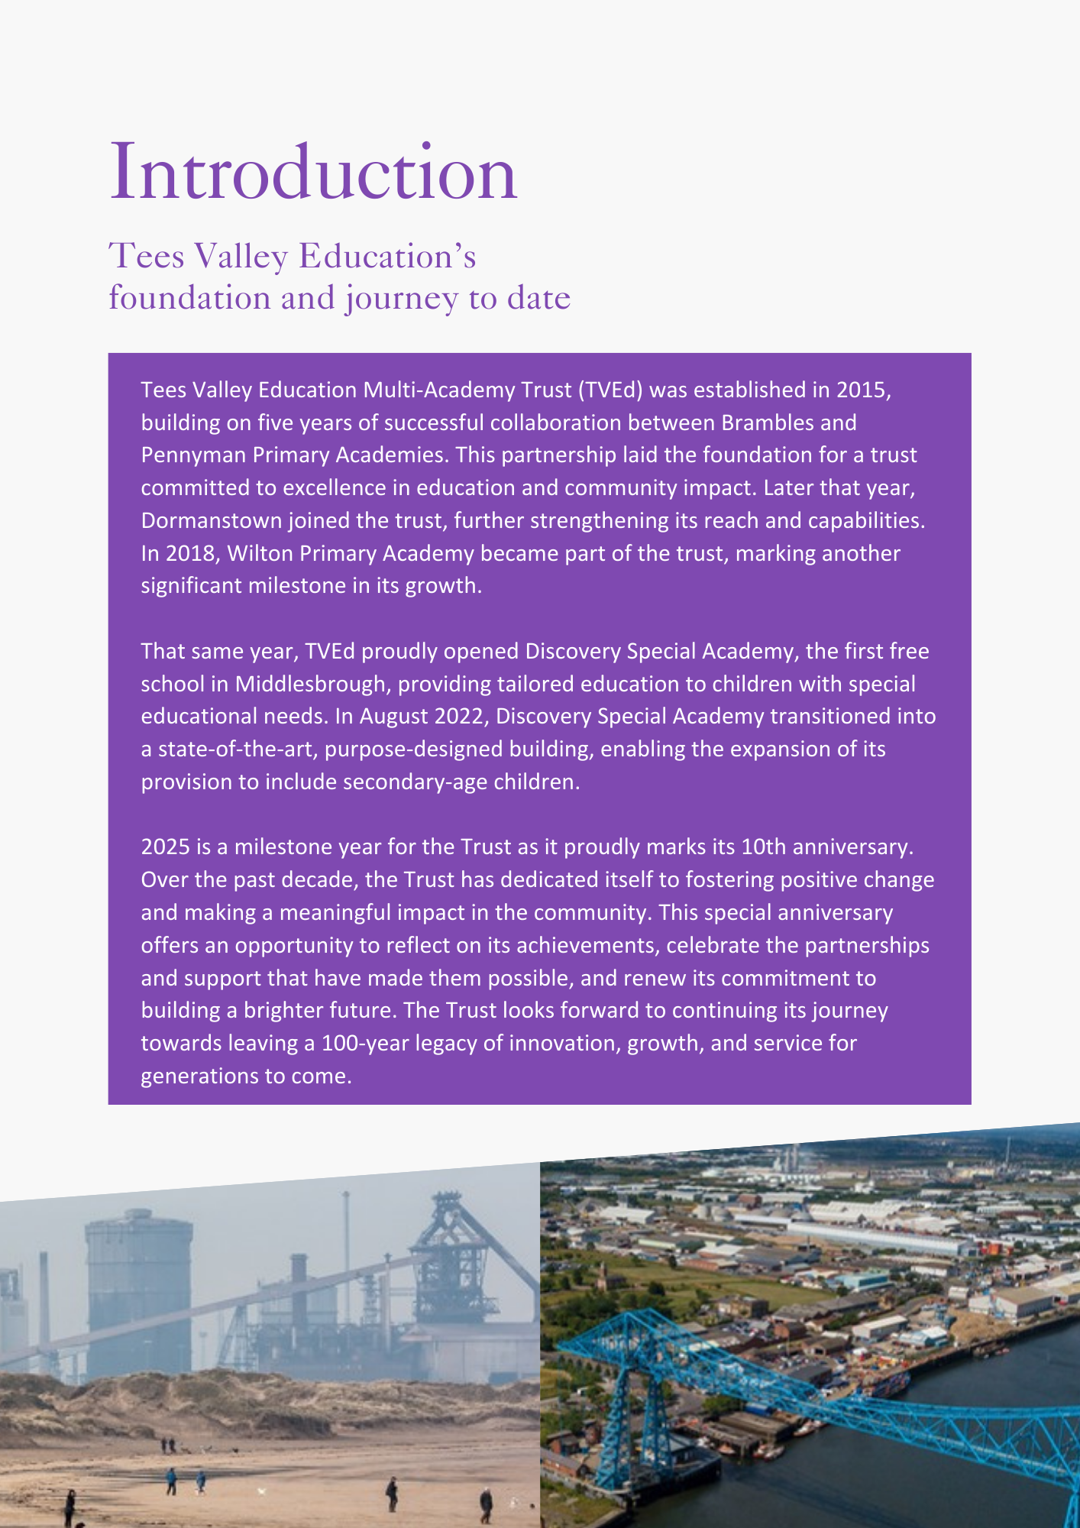

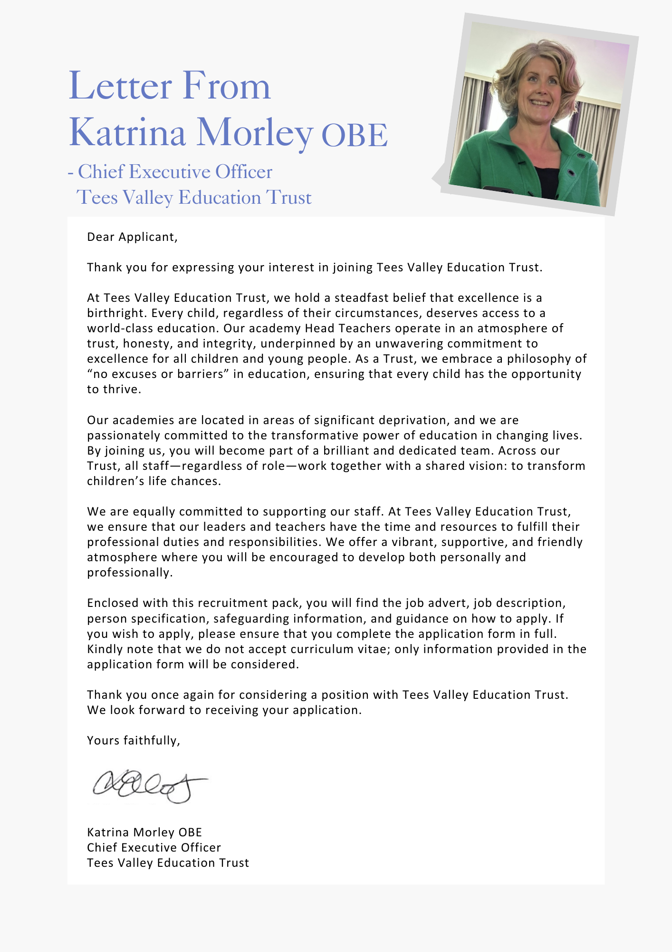

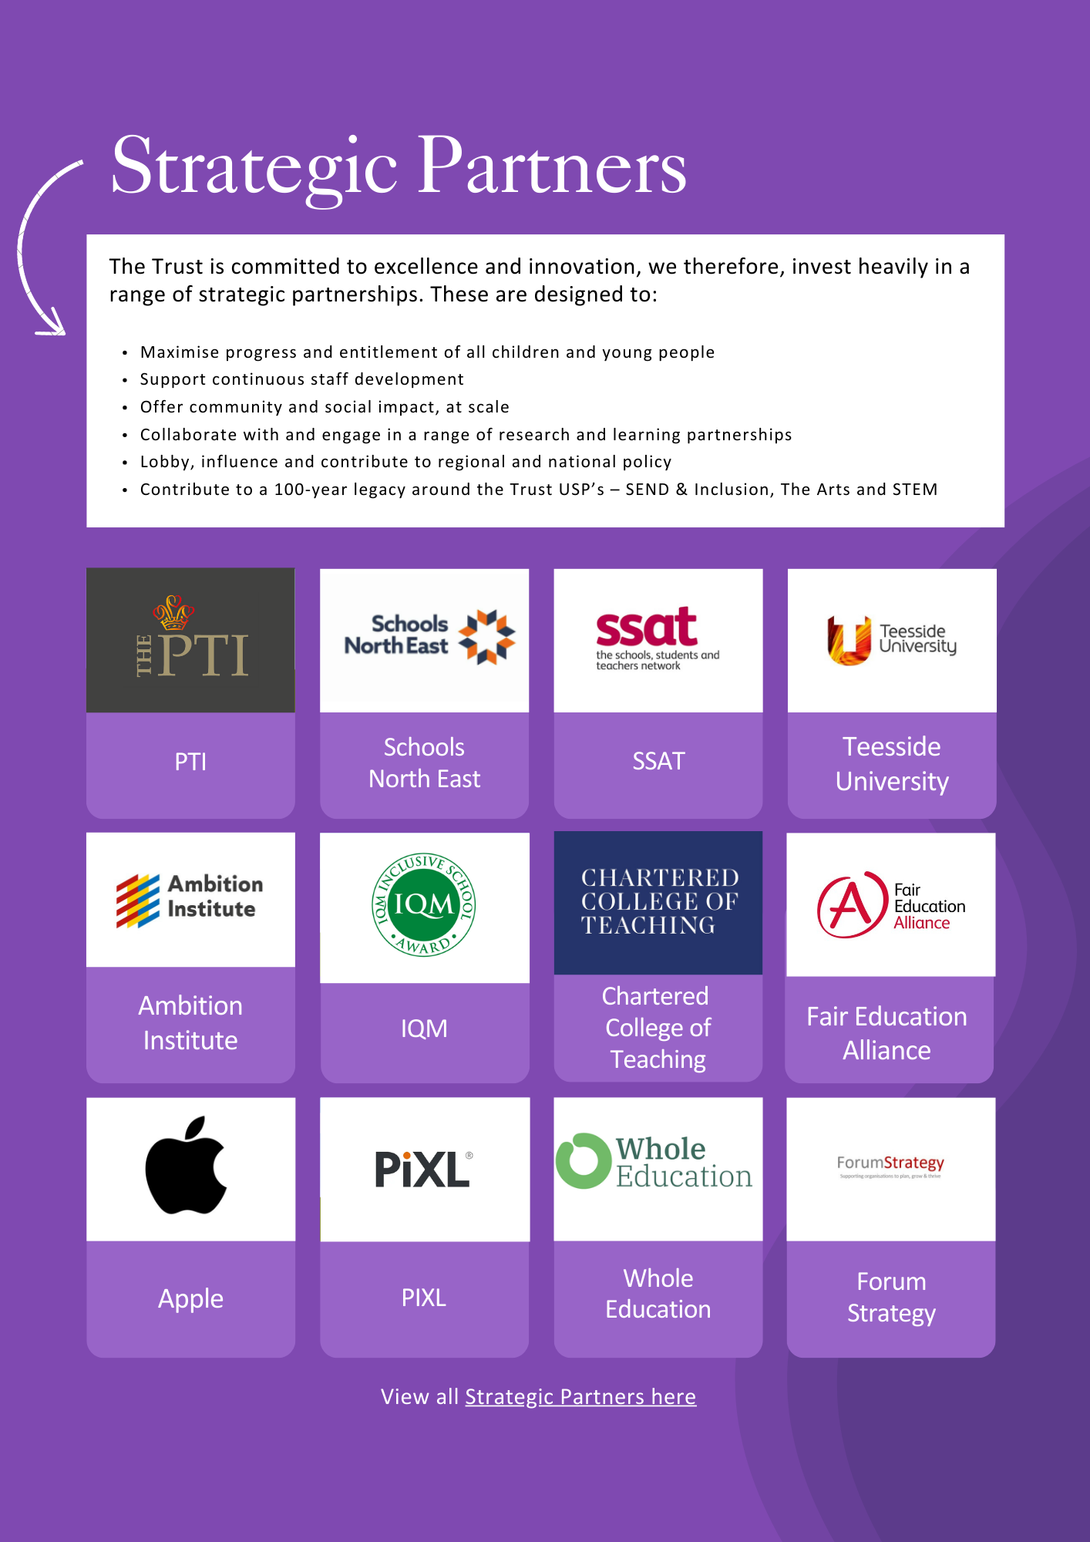

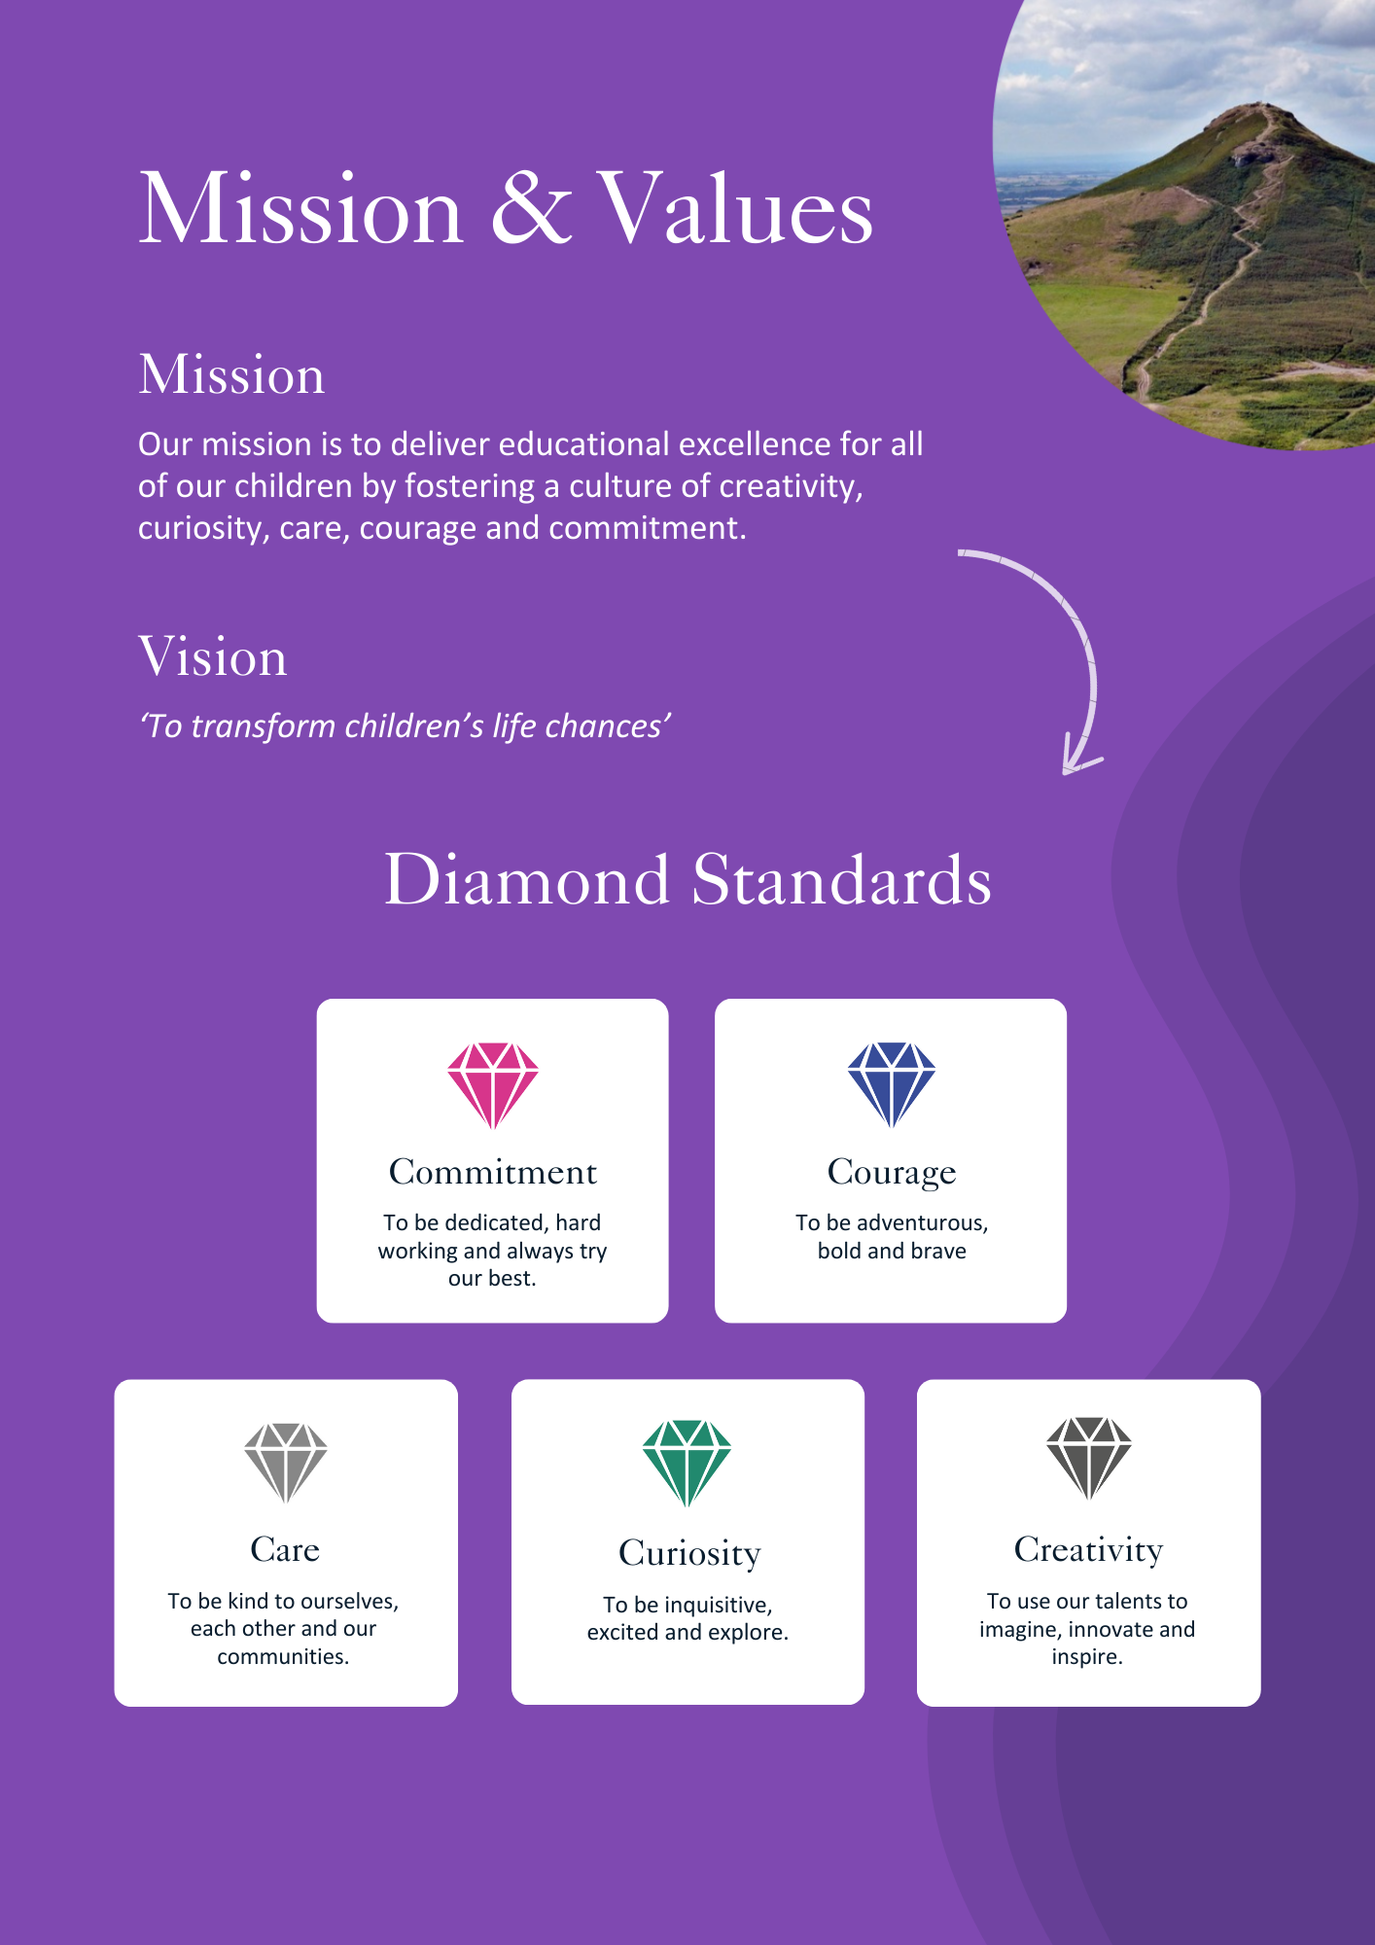

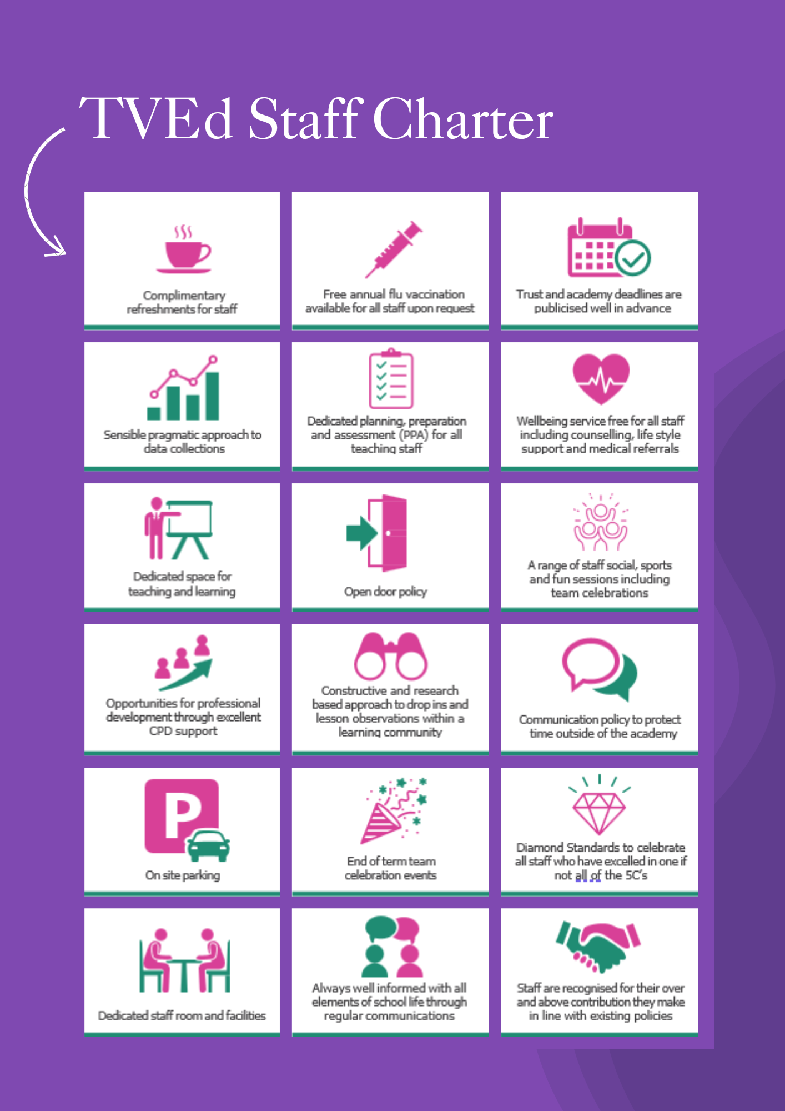

ADVERTISEMENT

Head of Inclusive and Pastoral Education
Status: Permanent, full time
Required: June 2026 or as soon as possible thereafter
Salary: L15 to L19 £73,104 to £80,653
Hours: 32.5
Reporting to: Deputy CEO for Inclusion, Standards and Sustainability
Academy base: Discovery Special Academy (With central and academy based work)

About the Trust
The Trust was established in 2015 and provides education and enrichment activities to more than 1200 children across five Academies, located in Middlesbrough and Redcar and Cleveland local authority areas. Academies within the Trust are:
- Brambles Primary Academy (2 to 11 years),
- Discovery Special Academy (2 to 16 years),
- Dormanstown Primary Academy (2 to 11 years),
- Pennyman Primary Academy (2 to 11 years), and
- Wilton Primary Academy (3 to 11 years).

About the role we are looking to appoint:
As part of the Trust’s commitment to strengthening inclusion at every level, and in response to the national SEND and Inclusion reforms, the Trust has reviewed its structure. The SEND and inclusion team has been enhanced at academy level through the appointment of Deputy Headteachers with a lead for Pastoral and Inclusion and at a Trust level with the permanent appointment of a Deputy CEO for Inclusion, Standards and Sustainability. Therefore, Trust has created a new senior leadership opportunity for an individual who is deeply committed to inclusive education and to securing excellent outcomes for all children, particularly those with special educational needs and disabilities, Head of Inclusive and Pastoral Education.
This structure is designed to deliver sustainable improvement and to continue to grow inclusive provision, underpinned by a culture of creativity, curiosity, care, courage and commitment.
Working closely with the Deputy CEO for Inclusion, Standards and Sustainability, the Trust SEND Business Manager, children, families and multi-agency partners, the postholder will be a strategic lead in shaping and delivering the Trust’s inclusion strategy, ensuring high-quality provision, meaningful access to enrichment, and strong alignment with national and local policy developments. The role will report directly to the Deputy CEO for Inclusion, Standards and Sustainability.
What we are looking for:
We are seeking to appoint a pro-active, enthusiastic, energetic and reliable senior leader who is deeply committed to inclusive and pastoral education, and who has experience of leading excellent educational provision. The postholder will champion meaningful access to learning, enrichment and support for all pupils, as well as developing curriculum, with a particular focus on pupils with SEND, and will lead the Trust’s approach to securing excellent outcomes, equity and belonging.
The postholder will provide Trust-wide strategic and operational leadership for access to education and inclusion for children and young people aged 2–16 with Special Educational Needs and Disabilities (SEND). The role will lead on quality assurance of key SEND and inclusion processes and will represent the Trust in stakeholder and system networks, advocating for pupils’ needs and promoting evidence-informed best practice.
Through strong partnership working and robust systems, the Head of Inclusive and Pastoral Education will help ensure pupils with SEND receive appropriate support and achieve the best possible outcomes, and that Trust standards are consistently upheld.
What the Trust will provide the successful candidate with:
- A workplace where all staff are valued and treated with respect as outlined within the Trust’s Diamond Standards
- A passionate, enthusiastic and supportive Leadership Team
- A listening and learning organisation where all staff are encouraged to be curious and share ideas for the Trust/academies/team to improve
- Hard working, committed and dedicated staff who strive to gain the best outcomes for all children across the Trust’s academies
- Dedicated approach to children’s learning to encourage them all to be the best they can be
- Career enhancement opportunities within areas of interest as well as supporting ongoing professional development and training specific to job role
- Dedicated line manager to discuss work streams and capacity
- Free access to the Trust’s Wellbeing offer, which includes counselling, access to GP, Mindfulness and so much more.
- Free parking
- Enrolment into the Teachers Pension Scheme
- All teaching contracts are employed on Standard Teaching Pay and Conditions.
- Benefits of the Trust’s Staff Charter which can be found at TVED Staff Charter.
Safeguarding requirements for the role:
Tees Valley Education Multi Academy Trust is committed to safeguarding and promoting the welfare of children. All appointments will be subject to a satisfactory enhanced DBS check.
This post is exempt from the Rehabilitation of Offenders Act 1974 and, therefore, all convictions, cautions and bind-overs, including those regarded as “spent” must be declared. The Trust’s Recruitment of Ex-Offender policy can be requested or visit the Trust’s website.
Applications are invited from prospective candidates who demonstrate that they can meet the essential criteria set out in the person specification and who have the vision, values and tenacity to join an outstanding team and help continue the journey towards excellence.

JOB DESCRIPTION
Head of Inclusive and Pastoral Education

JOB PURPOSE
The National Standards of Excellence for Headteachers (2015) define high standards within a self-improving school system. These standards are designed to inspire public confidence, raise aspirations, secure high academic standards in the nation’s schools, and empower the teaching profession.
The Head of Inclusion and Pastoral Education strategically and operationally supports the Deputy CEO for Inclusion, Standards and Sustainability in delivering exceptional outcomes for pupils at Tees Valley Education Trust. As Head of Inclusion and Pastoral Education, you will ensure high-quality provision, robust safeguarding, strong staff development and effective day-to-day operational leadership within SEND and Inclusion.
The postholder provides Trust-wide strategic leadership for inclusive practice and SEND-informed curriculum design. This includes leading the development and continuous improvement of the Trust’s inclusive curriculum model (including the IF-SF+ curriculum and adaptation for mainstream SEND), setting expectations and standards for implementation across academies, and establishing robust quality assurance so that pupils with SEND access consistently high-quality education. Working alongside the Deputy CEO for Inclusion, Standards and Sustainability, the postholder helps to shape and operationalise the Trust SEND and Inclusion strategy and provides expert leadership to colleagues across the Trust and wider system.

ETHICS AND PROFESSIONAL CONDUCT
As a senior leader of Tees Valley Education Trust, the Head of Inclusion and Pastoral Education is expected to demonstrate consistently high standards of principled and professional conduct, and to model the Trust values in academy and trust-wide work.

STRATEGIC LEADERSHIP
- Support the Deputy CEO to develop and deliver the trust inclusion vision, culture and strategic priorities, based on robust evidence, consultation and performance information.
- Create environments in which all staff are required to treat all people fairly, equitably, and with dignity and respect.
- Inspire, encourage and support staff to develop their own skills and subject knowledge, and to support each other.
- Ensure all staff are held to account for their daily professional conduct and practice, emphasising the distinctive nature of the trust in SEND and Inclusion.
- Support the Deputy CEO in structuring staffing appropriately to engage the best from everybody in SEND and Inclusion.
- Support the Deputy CEO to develop and deliver strategic and operational plans that secure the Trust vision for SEND and inclusion.
- Lead the Trust Inclusion of Education strategy to improve outcomes, reduce disadvantage gaps and strengthen inclusive culture and practice across all academies and improve life chances.
- Set Trust-wide expectations for inclusive curriculum design, adaptation and accessibility (including the IF-SF+ curriculum), ensuring coherence and consistency across phases and settings.
- Provide written and verbal reports, as required, to senior Trust leaders and the Trust Board on the quality and impact of inclusive education and SEND-informed curriculum delivery.
- Build effective partnerships with external agencies and stakeholders, representing the Trust through inclusion and SEND-related networks and system collaborations.
- Plan and work with teachers to develop skills in teaching, learning and assessment.
- Implement a culture of open classrooms as a basis for sharing best practice within and between academies, drawing on and conducting relevant research and robust data analysis.
- With the Deputy CEO, lead the implementation of SEND reforms.

QUALITY OF EDUCATION
- Ensure that statutory requirements for the National Curriculum are met and that all children are enabled to access a broad, balanced and relevant curriculum.
- Effectively utilise the Trusts’ system for assessing, recording and reporting of children’s progress and that it is clearly understood and owned by all leaders irrespective of title.
- Lead trust-wide quality assurance of inclusive education, including scheduled review activity, standards checks and impact evaluation across academies.
- Ensure priority to developing exceptional quality teaching and learning– being a beacon of outstanding practice and research - developing and delivering CPD across the Trust.
- Design, commission and deliver professional development that builds staff confidence and competence in inclusive practice, SEND-informed teaching and adaptive pedagogy.
- Maintain a consistent and continuous focus on pupil achievement and attainment at academy and trust level, ensuring high-quality assessment practice and effective use of information.
- Ensure excellent teaching through an analytical understanding of how pupils learn, underpinned by evidence-informed curriculum and pedagogical approaches.
- Work with academy leaders to ensure environments and learning routines across the Trust enable pupils with SEND to thrive, with strong support for wellbeing and pastoral needs.
- Ensure close partnership with parents/carers and external agencies, including strategic approaches to multi-agency working for pupils with complex needs.
- Encourage and model initiative, teamwork and working in partnership to evaluate, reflect and actively appraise pedagogy including with outside partners e.g. universities etc.

STATUTORY AND LEGISLATIVE COMPLIANCE
- Be up to date with all statutory SEND and inclusion legislative compliance, ensuring leaders across the trust are aware of their responsibilities in this and with the DCEO, quality assure this.
- With the Trust SEND and Inclusion Business Manager, support leaders across the trust in preparing for admissions appeals and exclusion panels.
- Support Trust leaders and Designated Safeguarding Leads to meet statutory responsibilities for behaviour and attendance.
- Contribute to Trust-wide strategic, curriculum-led financial planning for inclusion and SEND, advising on effective deployment of resources to maximise impact.
- Ensure compliance with relevant statutory responsibilities and Trust policies relating to SEND, inclusion and curriculum accessibility.
- As a lead member of the Trust SEND and Inclusion Team, lead and oversee the implementation of SEND reforms across the Trust, translating national policy into clear operational guidance, ensuring statutory compliance, and monitoring impact to secure improved outcomes for pupils with SEND.
- Maintain political and financial astuteness, work within a clear set of principles which are centred on delivering the Trust vision, ably translating Trust, local, and national policy into the daily operational SEND and Inclusion context.
- Manage the TRUST CPOMS platform and report to the DCEO on safeguarding and behaviour.

PEOPLE STRATEGY
- Through quality assurance; support improvement and recognise excellent practice.
- Lead and manage delegated staff, including the Trust SEND and Inclusion Business Manager, SEND case officers and Trust Safeguarding and Welfare Lead.
- Lead safeguarding meetings, supporting Designated Safeguarding and Pastoral Leads to discharge their duties, maintaining up to date practice and utilising current research.
- Ensure high quality professional development based on analysis of data and performance to support Trust SEND and Inclusion priorities.
- Distribute leadership throughout the organisation, forging teams of colleagues who have distinct roles and responsibilities and hold each other to account for their decision making.
- Assess the current and future quality of the teaching profession through high quality training and sustained professional development for all staff, including leaders, teachers, support staff, trainee teachers, Newly Qualified Teachers and Recently Qualified Teachers specifically in the areas of SEND and Inclusion.
- Identify emerging talents, coaching current and aspiring leaders across the Trust in a climate where excellence is the standard, leading to clear succession planning.
- Monitor and support staff by identifying and addressing areas for development and building on their strengths to support Trust succession planning.
- Maintain close involvement with the Deputy CEO in recruiting, retaining and deploying staff appropriately so that the goals and targets for the Trust can be achieved.
- Assist the Deputy CEO in the recruitment and selection of staff in SEND and Inclusion across the trust.
- Ensure that all staff carry out their professional duties in accordance with their job description and with national guidance and regulation, and moral duties in accordance with the outstanding expectations across the Trust.

GOVERNANCE AND ACCOUNTABILITY
- Lead, coach and influence leaders and staff across the Trust to strengthen inclusive practice and improve consistency of provision.
- Line manages and/or coordinates trust-wide SEND and inclusion and curriculum workstreams (as agreed), ensuring clear objectives, delivery milestones and impact measures.
- Monitor the performance of delegated staff rigorously, fairly and transparently; address under-performance and support sustained improvement.
- Identify and develop talent across the Trust to build capacity and succession in inclusive education leadership.
- Engage with a range of research – by the Trust and external organisations to contribute to local, regional and national policy development.
- Inspire and influence others - within and beyond the academy - to believe in the fundamental importance of education in young people’s lives and to promote the value of education.
- Develop and encourage working partnerships with a wide variety of stakeholders, in the best interests of the children across the Trust.
- Assist senior leaders, staff and governors to translate the strategic plan for the Trust into action plans that identify clear achievable targets and outcomes. These plans will consider the diversity, values and experience of the academy and the community.
- Assist other senior leaders, staff and governors across the Trust to rigorously evaluate progress towards targets and outcomes, feeding into Trust committees as required.
- Assist the Deputy CEO in ensuring that all Trust policies for SEND and Inclusion are regularly appraised where appropriate and updated with staff and governor involvement.

SYSTEM LEADERSHIP AND CIVIC RESPONSIBILITY
- Maintain safe, calm and well-ordered environments for all pupils and staff, focused on safeguarding, behaviour and high outcomes.
- Foster a culture of collaboration and professional development among staff to share best practices and build capacity across the Trust.
- Ensure the highly effective management of children’s pastoral well-being is actively promoting outstanding outcomes in attendance and behaviour within the Trust.
- Support and promote the Trust as an outward-facing organisation, working with other academies/schools and professionals - in a climate of mutual support and challenge.
- Encourage purposeful and strong inter-academy links across the MAT and between partner and local schools.
- Improve all aspects of delivery working across the MAT and regionally.
- Support the Deputy CEO and trustees in creating and maintaining good working relationships in SEND and Inclusion.
- Identify and encourage mutually supportive working relationships with relevant agencies including Social Services and Health professionals
- Maintain the Trust values in everyday work and practice.
- Develop and encourage working partnerships with parents and carers.
- Maintain the complexities associated with areas of deprivation and the link to educational performance.
GENERAL RESPONSIBILITES
As a Leader within the Trust, you are also expected to:
- Undertake any additional duties as could be reasonably required.
- Work at any location across the Trust
- Undertake additional training and other learning activities and performance development as required
- Develop familiarity with relevant legislation such as UK General Data Protection Regulation (UK GDPR) and Health and Safety at Work etc. Act 1974 to ensure the Trust is fully always protected.

PERSON SPECIFICATION
Head of Inclusive and Pastoral Education
QUALIFICATIONS | E/D
Degree or relevant qualification and experience. | E (1)
Qualified Teacher Status. | E (2)
Evidence of substantial leadership development and ongoing professional learning | E (3)
SEND/Inclusion-specific leadership development (e.g., NPQ/other accredited programmes) | D (1)
EXPERIENCE
Successful recent experience as a senior leader, with demonstrable impact on outcomes for pupils with SEND and/or vulnerable learners | E (4)
Experience of leading inclusive curriculum development and/or trust-wide/large-scale improvement work | E (5)
Experience of quality assuring provision across teams/settings (e.g., reviews, audits, deep-dives) and converting findings into measurable improvement | E (2)
Experience of designing and delivering professional development for colleagues beyond own setting | E (2)
Experience of training, coaching and mentoring colleagues across groups of academies/schools | E (6)
Managing a budget and resources linked to the delivery of academy development/improvement plans | E (7)
Experience of reporting to senior leaders/governance and influencing strategic decision-making | E (8)
Evidence of developing, monitoring and evaluating key aspects of academy provision including supporting the identification of priorities based on data analysis and performance outcomes | E (9)
Experience of working in a highly political environment and liaising with senior leaders in local authorities, DfE, Trust Board and other strategic stakeholders. | D (2)
KNOWLEDGE, ABILITIES AND SKILLS
A proven track record as an outstanding leader | E (11)
Expert knowledge of the SEND Code of Practice and evidence-informed inclusive practice | E (12)
Strong understanding of assessment/data and the ability to evaluate impact across multiple settings | E (13)
Ability to lead, coach and influence others, building trust-wide consistency and capacity | D (3)
Outstanding organisational skills with the ability to self-direct as well as work successfully within a multidisciplinary team. | E (14)
Highly successful experience of leading and managing whole academy regarding teaching & learning, raising standards of attainment and achievement across academies. | E (15)
The ability to work productively and positively with a range of colleagues both internally and externally, upholding the Trust values and ethos. | E (16)
Able to use accountability measures to ensure that effective teaching and learning strategies raise pupil attainment and achievement, and impact on wider life outcomes within mainstream and SEND | E (17)
Excellent interpersonal skills. | E (18)
Experience of conducting staff induction, mentoring and performance management for impact. | E (19)
Working Knowledge of the governance arrangements of a multi-academy Trust and the interrelationship with DfE and ESFA/external stakeholders. | D (4)
Working knowledge of the mechanisms of the Trust/ Challenge Board and the ability to support and contribute to strategic reporting | D (5)
Tenacity, enthusiasm and drive. | E (21)
Ability to/willingness to contribute to the whole academy and Trust context (including INSET) and with external bodies. | E (22)
A role model for learning, actively seeking professional development opportunities. | E (23)
Political awareness of both national and regional agendas (for example, disadvantage, SEND and community development). | E (24)
Commitment to attend conferences and events representing the Trust at both a strategic and operational level, delivering training, contributing strategically to the organisation, as well as learning. | E (25)
Experience forging supportive and, when necessary, challenging relationships both internally and externally to consistently drive academy improvement and children’s life chances. | E (26)
E – Essential, D - Desirable
Important: In the first instance, applications are assessed against the criteria listed above, in addition to overall presentation, use of standard English and grammatical accuracy.

Where applications do not meet the expected standard, they will be rejected before being matched to the person specification.

HOW TO APPLY AND EXPLANATORY NOTES OF THE PROCESS

An application form is attached below. Application packs can be downloaded or printed directly from the Trust website www.teesvalleyeducation.co.uk or requested from the academy. Only applications via the Trust’s official application form will be accepted. Please do not submit a CV as substitute for part or full application form, the information will not be accepted or considered.
If you are submitting your completed application form by e-mail to recruitment@tved.org.uk - please be aware the academy cannot be responsible for any formatting anomalies when printing. If you are unable to submit an electronic application form, handwritten or electronic printed copies should be posted or hand delivered to the following address for the attention of Mrs Lucy Simpson

Tees Valley Education
c/o Pennyman Primary Academy
Fulbeck Road
Middlesbrough
TS3 0QS

Shortlisting Process
After the closing date, short listing will be conducted by a panel, who will match your skills/experience against the criteria in the Person Specification. You will be selected for interview entirely on the contents of your application form, so please read the Job Description and Person Specification carefully before you complete your form.
Shortlisted candidates will receive:
- Letter confirming interview details.
- Details of original ID documentation is required to confirm candidates. Photocopies or certified copies are not accepted.
- Criminal Record Self-Declaration Form, which must be brought on the day of the interview in the sealed envelope provided.

References for successful Candidate/s
We may seek references for shortlisted candidate/s and we may also approach previous employers for information to verify experience or qualifications before the interview. Any relevant issues arising from references will be taken up post interview.

Interview process
In addition to candidates’ ability to perform the duties of the post, the interview will also explore issues relating to safeguarding and promoting the welfare of children, including:
- Motivation to work with children and young people
- Ability to form and maintain appropriate relationships and personal boundaries with children and young people
- Emotional resilience in working with challenging behaviours
- Attitudes to use of authority and maintaining discipline

Conditional Offer: Pre-Employment Checks
Any offer to a successful candidate will be conditional upon:
- Verification of right to work in the UK
- Receipt of at least two satisfactory references (if these have not already been received)
- Verification of identity checks and qualifications
- Satisfactory enhanced DBS check
- Verification of professional status such e.g. QTS Status, NPQH (where required)
- Satisfactory completion of a Health Assessment
- Satisfactory completion of the probationary period (where relevant)
- Where the successful candidate has worked or been resident overseas in the previous five years, such checks and confirmations as may be required in accordance with statutory guidance.
Please contact the academy office on 01642 2248333 to arrange a visit.
For your information, the recruitment timetable is detailed below:

Closing date: Thursday 14th May 2026 at 9:00am
Shortlisting date: Thursday 14th May 2026
Interview date: Monday 18th May 2026

UK General Data Protection Regulation
Refer to our privacy policy on how we will process your personal data including how you can request to access your personal data via Tees Valley Education website: http://www.teesvalleyeducation.co.uk.

EQUALITIES INFORMATION AND OBJECTIVES STATEMENT

As an academy we ensure that our vision, values and ethos meet the expectations of the equality and diversity guidelines and legislation set out by the Equality and Human Rights Commission. This includes the following 9 protected characteristics:
- Age
- Disability
- Gender Reassignment
- Marriage and Civil Partnerships
- Pregnancy and Maternity
- Race
- Religion or belief
- Sex
- Sexual Orientation

Objectives Statement
- To support children’s sensory, academic and communication skills to enable them to develop holistically.
- To ensure high expectations across all aspects of the academy (as outlined in objective 1) to ensure children make the best progress according to their individual starting points.
- To continue to monitor attendance of all groups of children in the academy.
- To review levels of parental and pupil engagement in learning and academy life, across all activities and ensure equality and fairness in access and engagement.
- To ensure the academy environment is as accessible as possible to pupils, staff and visitors.


