May 2023

Dear Sir/Madam

Re: Head of Learning

Firstly, thank you for your interest in the position of a Head of Learning.

St Edmund’s is a Catholic Voluntary Aided Secondary School situated in the heart of Portsmouth. We were graded as Outstanding by Ofsted (2016) in all categories.

Spirituality and Achievement are at the core of everything we do. St Edmund’s has a warm family feel to it with Christianity being our soul and achievement our heart.

Students attend the school from a wide area and are diverse in their backgrounds, making the school an exciting place to teach. The school provides a safe, caring and academically challenging environment for students to achieve their potential.

Our Mission Statement is “I can do all things with the help of God who strengthens me” which encompasses all we strive to do.

Would you please complete the enclosed paperwork and return it to me before the closing date of Friday 26th May 2023 marking the envelope “HOL23”.

This school has a robust safeguarding policy. All applications will be scrutinised and DBS checks will be carried out promptly.

I look forward to receiving your completed application and thank you for your interest in St Edmund’s Catholic School.

If you do not hear from the School within three weeks of the closing date, your application has been unsuccessful on this occasion.

Yours Faithfully

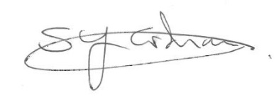
Mr S Graham
Headteacher

