Head of Mathematics and Computing
Thank you for your interest in this post.
It is an exciting time to join us. We are looking for the right person who can help develop the computing curriculum across our small rural academy set in the Yorkshire Dales National Park.

Role | Head of Mathematics and Computing
Pay | MPS/UPS TLR 2a
Deadline | Friday 20th May 2022. 12 noon
Visit (optional) | On request
Interviews | w/c 23rd May 2022

Contents
1.. Introduction
. 2.. Our Context
. 3.. Our Environment
. 4.. Our Values
. 5 . The Post: Job Description
. 6.. The Post: Person Specification

1 | Introduction

People say Settlebeck School is a special place and we believe this is seen in the warmth of relationships, the ‘family feel’ ethos where each pupil is treated as an individual, high expectations and achievement for all.

We are seeking someone to lead a small mathematics and computing department, with the expertise to lead, develop and deliver an exciting curriculum, which inspires our students.

In return, we can offer you an opportunity to join a community with ambition; this is a truly wonderful place to teach. We would welcome applications from candidates who are committed to inclusion and ensuring that all pupils achieve their potential. This post would suit aspiring or experienced middle leaders.

We appreciate that there is much more that you would want to know and, therefore, encourage you to get more of a ‘feel’ for the life of our school by visiting our website;
www.settlebeck.org. If you would like arrange a visit prior to application, please contact Juliet Proctor, PA to the Headteacher proctorj@settlebeck.org /015396 20383

. 2.. Our Context

Settlebeck School has been proudly serving the Sedbergh and the surrounding area for over 70 years and is at the heart of its community.  The school also benefits from wide-ranging links and partnerships within the Cumbrian educational community and particularly the South Lakes Federation, which is a long-established federation of 10 secondary schools, Kendal College and the University of Cumbria.  We have a truly comprehensive intake with 200 students, 11-16, currently on roll. As a strategically resourced provision for young people with autism, the successful candidate must be fully committed to inclusion. Visitors are always impressed by our family atmosphere, the warmth of relationships between staff and students and value for the individual.  We are committed to providing high quality teaching and learning, a broad and balanced curriculum, focused on the needs of the individual, and a truly inclusive provision which is underpinned by our core values.  We are considered a ‘Good’ school by Ofsted, having last been inspected in 2018. | 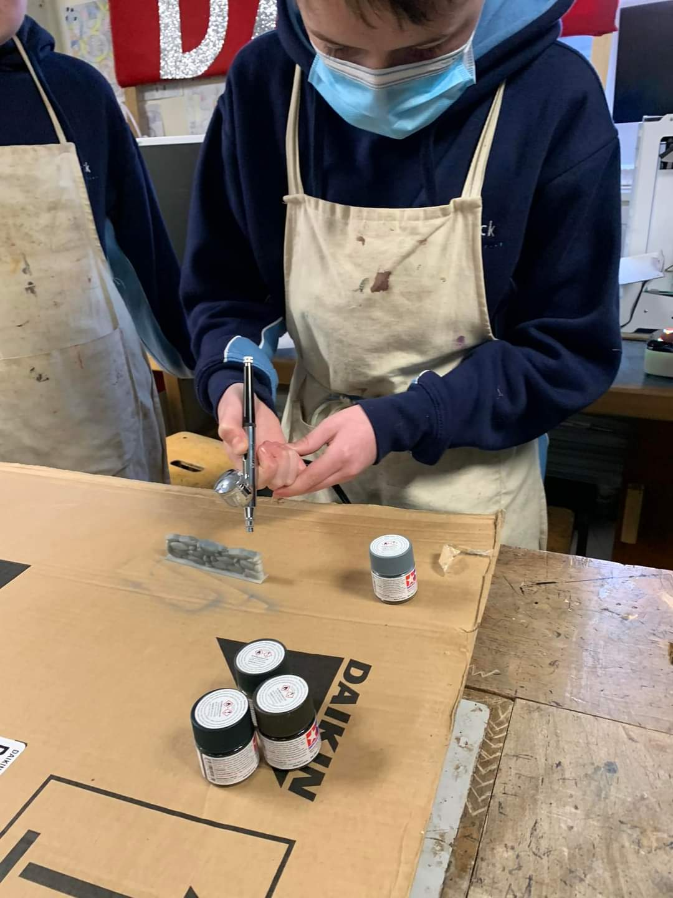  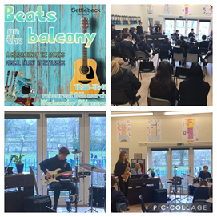

. 3.. Our Environment

Settlebeck School is situated in the beautiful market town of Sedbergh, which borders the Lake District and Yorkshire Dales National Park.

We serve a prosperous and beautiful area of South Lakeland and North Yorkshire, with pupils drawn from as far away as Hawes, Askrigg, Kirkby Stephen, Kendal and Lancaster, as well as those living in and local to Sedbergh. Although rural, we are only 5 miles from the M6.

Since 2017, the school has undergone a number of successful refurbishment projects to upgrade its facilities and this, alongside the extensive outdoor spaces with views of the surrounding fells, makes it a lovely place to learn.

Someone coming to work here, as well as enjoying the advantages of the natural environment, can expect the opportunity to encounter pleasant, amenable, motivated students and friendly, supportive colleagues. You will be given every opportunity to pursue professional development, while being encouraged to perform to the highest standards.

. 4.. Our Values
Our core values of respect, responsibility and aspiration underpin and inform all aspects of school life.  Whether speaking to parents at an Open Evening, helping a young person make decisions about their future or appointing staff, our values are at the core.  Our pupils contribute to the daily life of the school and help shape our practice and live our values through the student leadership team, student council and house system. | 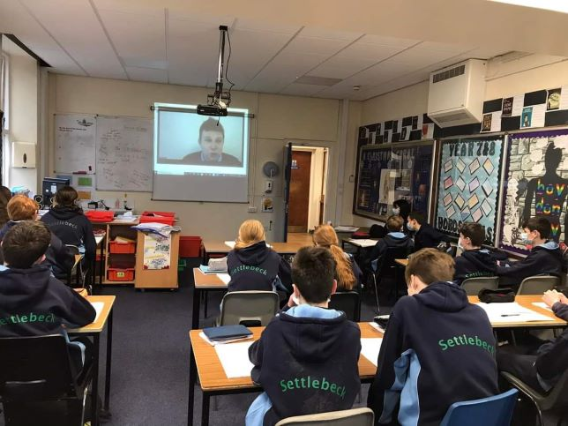

. 5 . The Post: Job Description
Post Title: Head of Mathematics and Computing
Contract | Full time, permanent
Salary | MPS/UPS TLR 2a
Responsible to | Headteacher
Start Date | September 2022
Core Purpose
The Head of Mathematics and Computing is responsible for raising the standards of teaching and learning, levels of student progress and exam performance within the mathematics and computing department.

Responsibilities
Monitoring Progress

- To monitor the progress of all students within mathematics and computing, ensuring that performance is in line with the school’s aspirational targets
- To ensure that students with special educational needs are making appropriate progress and that their needs, as set out in their EHCP (if applicable), are being met
- To take action in support of the subject teacher when underachievement is identified, ensuring that all interventions are logged. Initiate dialogue with the relevant tutor, Year Leader, SENDco or Deputy Headteacher (Teaching and Learning) as necessary
- To review examination performance, identifying strengths and weaknesses. Take action to address identified weaknesses
- To disseminate the outcomes of analysis of examination results to the departmental team, ensuring that they are aware of any implications of the findings that affect their practice
- To take the lead in maintaining discipline and good order within the department. Support departmental staff with individual cases of indiscipline as necessary, using a wide range of strategies. Seek advice from the relevant Year Leader and obtain their support if required
- To oversee the preparation of subject and progress reports within the department, ensuring that they are quality assured and completed by the deadline

Teaching and Learning/Curriculum

- To ensure the highest quality of classroom teaching through an insistence on the school’s teaching and learning policy being applied by all members of department
- To support the development of teaching skills through classroom observation, coaching and the dissemination of good practice
- To encourage departmental staff to go on development and training courses, through effective use of the staff development budget
- To carry out regular book checks, to ensure consistency
- To apply the school’s appraisal policy to every member of the department in a timely fashion
- To ensure that continuity of learning occurs in the event of the absence of the normal subject teacher
- Lead the review, construction and resourcing of the curriculum by ensuring the subject is planned, implemented and reviewed within the framework of both national and internal policy
- To prepare, review and revise as necessary those schemes of work which include appropriate differentiation and meet all National Curriculum and public examination specification requirements

Leadership of the department
- To foster a positive atmosphere of teamwork within the department
- To set the highest possible personal example to the department through your own professionalism
- To ensure all school policies are applied evenly by all members of the department
- To carry out an annual departmental review with the designated link member of the senior leadership team, and provide any other reports that might be required; these will include the action plan following from an analysis of student performance within the department
- To hold departmental meetings in accordance with the school calendar. Clear agendas need to be established, which focus on teaching and learning. Outcomes of meetings should be recorded
- To determine entries for public examinations in consultation with departmental staff
- To induct new members of staff into the department, ensuring that appropriate mentoring is supplied
- To encourage the provision of, and participation in, extra-curricular activities
- To ensure that a stimulating learning environment is maintained throughout the departmental area
- To allocate pupils to teaching groups in such a way as to ensure that their needs are most appropriately met
- To allocate departmental staff to teaching groups in order to ensure the best match between the requirements and the teacher’s expertise
- To authorise spending of the department’s capitation in accordance with the school’s financial procedures, ensuring that spending is appropriately targeted and properly accounted for
- To assist with the recruitment procedures when departmental staff are being sought
- To ensure that the departmental area is maintained in such a way that Health and Safety obligations are met
- To ensure that equipment and resources within the department are properly maintained, recorded in the inventory and that periodic checks are carried out
Other main responsibilities
- Maintain high expectations for yourself and student behaviour at all times
- Ensure that safeguarding is given a high priority at all times
- To be involved in annual appraisal arrangements as determined by the current school teachers’ pay and conditions document and school policy
- To undertake an annual identification of professional development and training requirements with a line manager as part of the appraisal process
- To participate in all directed time activities as identified by the calendar and the duty rota
- Acting as a role model in terms of attitude, dress (including adhering to the school dress code for teaching & non-teaching staff) and interaction with others

6.. The Post: Person Specification
 | essential | desirable | evidenced by
Qualifications | Qualified to degree level in Maths or Computing  Qualified Teacher Status  3 A’Level passes at A* to C (or equivalent) |  | Qualifications  References
Knowledge and Experience | At least 3 years teaching across the age and ability range including GCSE Mathematics and GCSE Computing  Successfully used strategies to improve student attainment  Experience of supporting students of different abilities and/or SEND  Proven track record of successful examination results  In-depth knowledge of the requirements of the National Curriculum in maths at Key Stage 3 and 4 | Led department strategies to improve the progress of pupils | Application  References  Interview
Skills | Excellent classroom practitioner  Strong interpersonal and communication skills  Ability to be part of a team  Ability to lead and manage others  Ability to manage a departmental budget  Ability to work under pressure and meet deadlines  Ability to monitor, review and evaluate the work of the department against current Ofsted criteria | A willingness to develop knowledge and skills to contribute to the wider school. | Application  Interview
Personal Qualities | Able to work effectively as part of a team  Enthusiastic and self-motivated  Have an understanding of child-safeguarding issues and successful use of measures that promote and ensure the safeguarding of children  Able to motivate and inspire students and staff  A commitment to inclusion  Innovative and uses own initiative  Committed to own professional development  Be flexible, collaborative and resilient. |  | Interview  References

How to apply
Please return your completed application form and letter of application to Juliet Proctor, Headteacher’s PA, by post or email proctorj@settlebeck.org

If you require further information or wish to discuss any issues, please do feel free to get in touch with Juliet Proctor, PA to the Headteacher as the first point of contact.
015396 20383
proctorj@settlebeck.org

www.settlebeck.org
Twitter: @SettlebeckS
Facebook: Settlebeck School

